Connor Petri
CS-158A
Lab 2

Checkpoint 1:
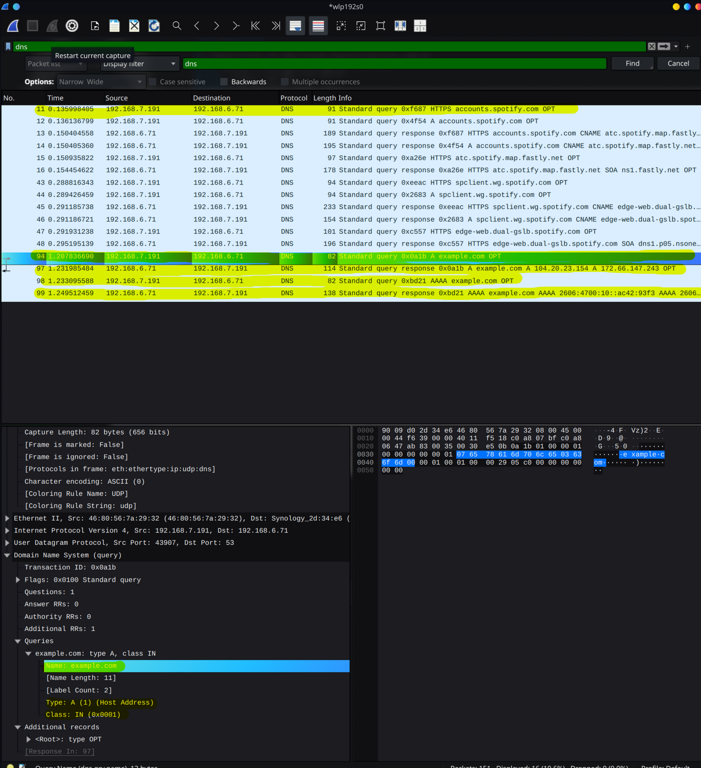
4 DNS packets appeared with the target IP of 192.168.6.71, which is the IP of the local DNS server on my home network. Other DNS packets were sent to Spotify’s servers from the client running on my laptop. (Pictured: 4 queries; resolver ip 192.168.6.71; name example.com; type A; class IN)
Checkpoint 2:
I recorded a TTL of 2 minutes 56 seconds. When that timer expires, the record does as well and I have to fetch a fresh one from DNS. Pictured below are Name: example.com; Type A; Class IN; TTL 2 min 56 sec.
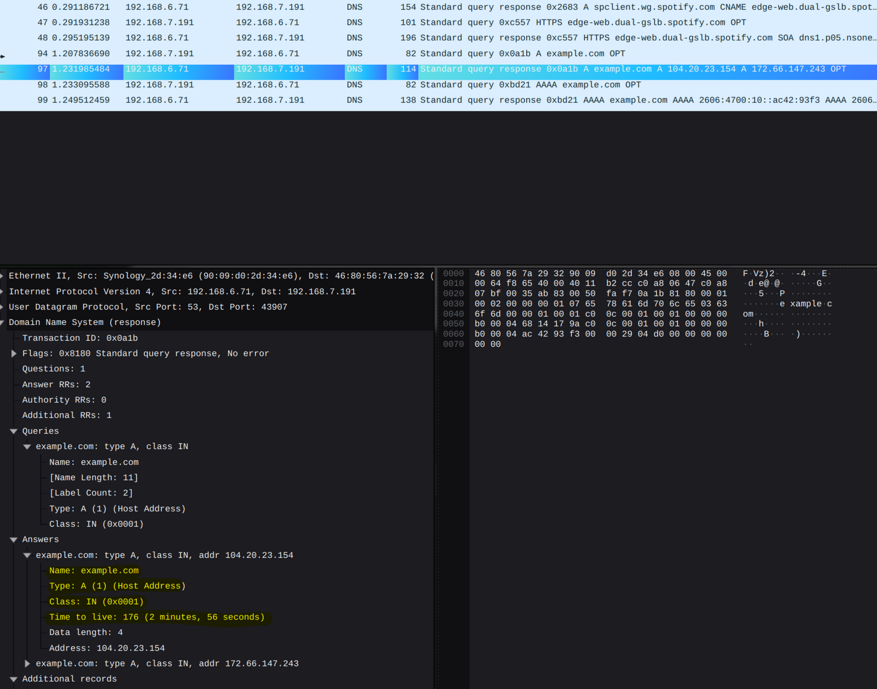

Checkpoint 3:
I predicted that my OS would need a fresh query rather than using the cached data because it has been longer than the TTL on the response packet. This matched what I saw running the query again.
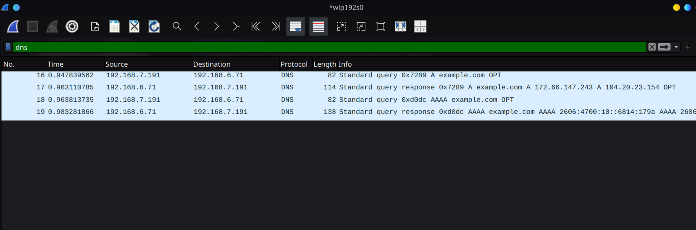
Checkpoint 4
a. I do not see the queries directly. It is routed through my local DNS server and returns a pointer to dns.google
b. The RD and RA values were both 1. This combined with just the 2 calls
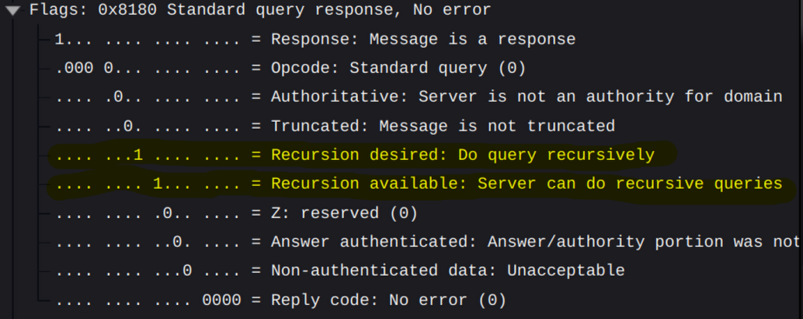
RD and RA are both 1

