*Maintainer: Connor Wool*

*CougTech | CUE 302*

*Effective: December 14, 2016*

*CougTech customer logger*

Design and Reference Guide

Table of Contents

Version History 3

SECTION 1: Introduction to the System 4

Purpose of the system 4

An example of use 4

SECTION 2: Implementation of the Customer Logger System 5

The different pages of the program 5

A normal issue process diagram 5

SECTION 3: Placing the Program onto a laptop 6

Do I need to install anything? 6

How do I put my project on the front laptop? 6

# Version History

|  |  |  |  |
| --- | --- | --- | --- |
| Version | Date | Description | Reason |
| 0.1 | 12/14/16 | Development version, for testing | Added new features, such as quick picks, and names in ticket subject |
| 1.0 | 12/14/16 | First version of the new features to be in-use in the live environment | New features are tested, and though some edge cases exist, it’s ready to be tested in the live environment. |
|  |  |  |  |
|  |  |  |  |

# SECTION 1: Introduction to the System

## Purpose of the system

The CougTech Customer logger system exists to make tracking customer tickets easier. It allows customers to create their own tickets in the OTRS system, which are then picked up by the tech while working on issues. This helps replace the previous process, where techs had to manually create a ticket for each customer interaction, and there was a very low actual rate of ticket creation. By having each customer create their own ticket on a mostly automated system, it offloads some of the ticketing work to the customer, and has succeeded in increasing the percent of customer interactions that are tracked on the OTRS system.

## An example of use

A customer named John Smith comes into CougTech looking for help installing Windows Updates. They are greeted at the front desk, and asked to create a ticket on the Customer Logger. They input their WSU ID number (8 digits long), and press enter. Next, they are asked if they have an appointment, and select no. The next page asks them to briefly describe their issue. They select “software”, and type a description into the box at the bottom, “need help installing Windows Updates”. Finally, they are taken to the confirmation screen, and the greeter will have them take a seat.

At this point, the customer’s interaction with the system is now complete.

The Customer Logger will now package up the information and sent it as an email to the OTRS ticketing system. In addition, it spoofs the client’s WSU email address so that the ticket originates from the customer. How this is managed will be discussed later.

The greeter will take the new ticket in the OTRS queue and will assign it to the tech currently helping the customer.

# SECTION 2: Implementation of the Customer Logger System

## The different pages of the program

The CougTech customer logger is set up as a series of pages that interact with the user, gather information, and share information among themselves.

## A normal issue process diagram

The following diagram shows the flow of control between the different pages of the program during a normal logger use. In this case, the customer does not have an appointment.

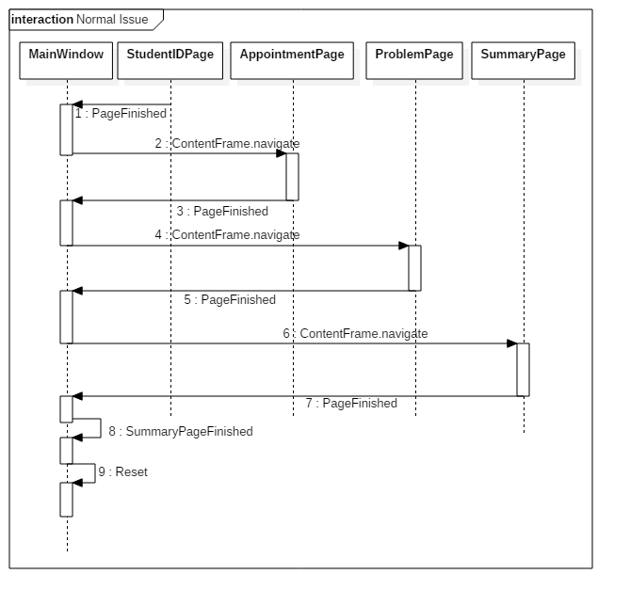

Figure : A Normal Issue Process Diagram

Of note is the fact that each page fires off an event when it is complete (for our purposes, when the “enter” button is pressed on that page). This event is caught by the “MainWindow”, and causes the next page in the sequence to be displayed. The overall effect is that the “MainWindow” class is the “traffic director” for the program’s execution.

# SECTION 3: Placing the Program onto a laptop

## Do I need to install anything?

Nope. While previous versions of this project did include an installer, it was never actually used, just packed along with the other code files.

This project is simple enough that a production build from any x64 windows machine *should* work on the laptop at the front. THIS CANNOT BE GUARANTEED.

## How do I put my project on the front laptop?

To have the project start running live on the front desk system, complete the following steps:

1. Clone the project from the CougTech GitHub repository onto your own computer
   1. “git clone https://github.com/CougTech/CustomerLogger”
2. Open the project in visual