**Document Title:** Ticket System Defined

**Created:** 10-12-2012

**Department:** Information Technology

**Purpose:** to utalizing the System effeciently by defining and illustrating the use and purpose of various parts of the Ticket System.

**Definition**:

There have been a few changes made to the Ticket System, specifically the Admin Section as of 10/01/2012.

Below is the list of changes as they appear under the “Edit Ticket” option:

1. 

A **Repeat Issue** is defined as an expected occurrence of an IT problem.

An example of this is the PakTime License renewal that occurs every 60 days; another is a locked Solarsoft account. This option serves a reporting value.

1. 

The **Sub System** option is dependent upon the **System** option. Specifically, the intent is to display a list of all sub classifications of the selected **System**. Currently, this option only displays sub classifications related to SolarSoft. This option is also available on the end user’s Ticket System.

1. 

There has been an additional option added to the **Priority** list:

‘**911/Escalation’**

This is reserved for the highest of issues that demands immediate attention from the I.T. department.

1. 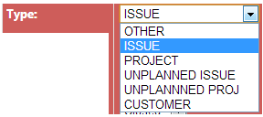

There are 5 options available:

* Issue – an I.T. related Issue
* Project – defined as a business need that requires extensive planning as a result of cost & time.
* Unplanned Issue – an unexpected result of an I.T. scenario.
  + - Example: a laptop video card malfunction
* Unplanned Proj – an unexpected issue that requires a plan of action to resolve and prevents or solves future issues from reoccurring.
* Customer – select this option only if an issue is visible at the customer end.

Example: an ASN Failure

1. 

There are 4 **Status** options:

* 1. Closed – an issue has been resolved
  2. Open – an issue has not been resolved
  3. On-Hold – an issue that requires a time interval constraint (issuer is unavailable)
  4. Waiting – an issue has been addressed and the assignee has initiated the request for further direction.

1. 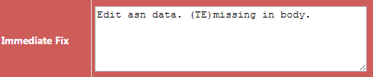

This field requires a brief description of the immediate steps taken to resolve this issue.

1. 

This is a timestamp label that auto-populates when **Status** (See #5) field has been set to “**Closed**”

1. 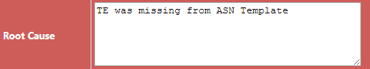

This input field requires an extensive description of what went wrong after further analysis.

1. 

This timestamp label is auto-populated when text has been entered into the **Root Cause** input field.

1. 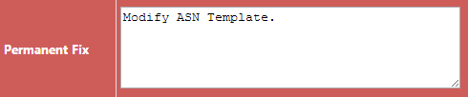

This input field requires full disclosure on what was done to prevent this issue from re-occurring.

1. 

A timestamp that auto-populates when input has been detected in the “**Permanent Fix”** input field.

1. 

This input field requires an estimation of the time taken to resolve this issue; **please use minutes.**

1. 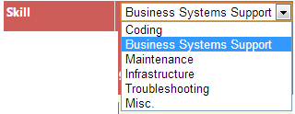

The purpose of this field is to classify each ticket according to the skill type required to resolve the issue.

There are 6 options available:

1. Coding – SQL, ASP & C# skillset (William)
2. Business Systems Support – ERP & business process support (Jon, William)
3. Maintenance – systems maintenance, disaster recovery and server up keep (All IT Staff)
4. Infrastructure – hardware & software maintenance, servers and other company sensitive hard & software ware (Richi, Srdjan)
5. Misc. – general issues not necessarily classified using the above options (All IT Staff)
6. 

This field option is reserved by the assignee to designate if the issue has been immediately resolved, verified and corrected from reoccurrence.

There are 2 options:

1. Open
2. Closed – *Please set this option to* ***“Closed”*** *the ticket once it’s been resolved and all fields have been appropriately populated.*
3. 

This timestamp field is populated only when the IT status option **“Closed”** has been selected.

**Additional Reporting Added:**

1. 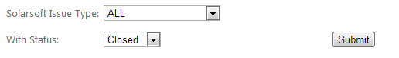

This produces a report for all Issues Related to Solasoft.