**Draft:**

* Overview
* Basic operation
* Flowchart
* Requirements
* Function definitions
* Discussion

**Overview:**

This python script is designed to produce a list of times and positions of observable satellite passes on a given night, given a list of satellites and a observation site. The script can be run from command line. Below is an example of the output of the script. The first column is the name of the satellite, the second and third are the observation times. The next four columns are the RA and Dec of each observation time.



**Basic operation:**

1. Make sure python and anaconda are installed. Then from the anaconda prompt install skyfield with the command: pip install skyfield
2. Navigate to the downloaded and extracted folder
3. Run with command: create_schedule.py
4. Enter configuration filename: either filename or filename.txt are allowed as inputs

**Configuration file:**

Line 1: Date in format YYYY, MM, DD

Line 2: Satellite SATCAT numbers separated with semicolons

Line 3: Longitude

Line 4: Latitude

Line 5: Timezone in python format

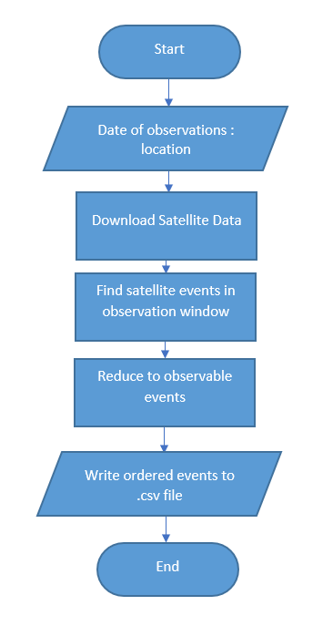**Flow Chart:**

**Function Definitions:**

Can be found in the docstrings in the python file

**Requirements:**

* Knowledge of equatorial coordinates
* Understanding of UTC and related time formats
* Understanding of terrestrial coordinates of satellites: what does the function difference in line 328 do?
* Understanding of requirements for satellite observation: what does it mean for a satellite to be sunlit
* How do you plan to make observations: you need to decide what sort of images you want to take, and adjust the code where necessary