System Requirements Specifications

*DigiDiet* (name subject to change)

**Client:**

Morgan Madeira

**Developer Team (Team 3):**

Connor Cook

Matt Law

Brent Mattox

Austin Murdock

Michael Neary

1. Introduction
   1. Purpose of This Document

This document explains the features of the DigiDiet web application, a social website for people to share and review recipes. It goes into detail about the required functions of the web application, and how each component will work together. The intended audience of this document is the DigiDiet developer team named on the cover page and the customer Morgan Madeira.

* 1. Purpose of the Product

DigiDiet is designed to be a web application for people to easily create, share, and rate recipes. There is a large community of home cooks/bartenders each with unique recipes and this web application will provide a platform for the people to share their recipes and ideas with each other.

* 1. Product Scope

The DigiDiet web application consists of 14 use cases including: creating a new account, logging in, viewing a profile, uploading a recipe, rating a recipe, writing a comment, searching for a recipe, viewing user statistics, receiving notifications, flagging comments, recipe approval, assigning moderators, banning users, and removing comments. Refer to the diagrams below for the scope of each use case. Refer to section two for details on each use case

1.3.1 Use Case: Create Account

1. Create Account

User

Account/Login System

1.3.2 Use Case: Log onto Web Application

1. Log onto

website

User

Account/Login System

1.3.3 Use Case: View a Profile

3. View a Profile

User

Account/Login System

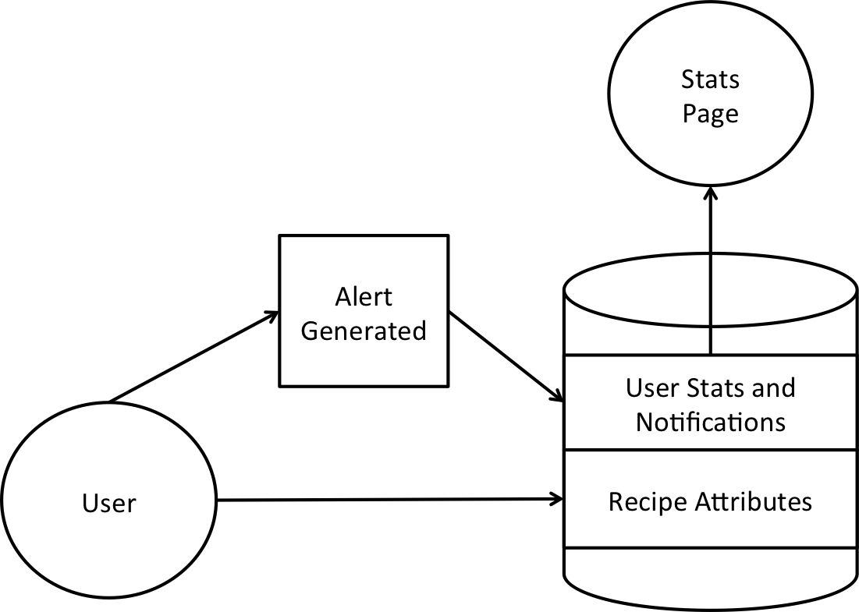

1.3.4 Use Case: User Notifications

1.3.5 Use Case: User Search

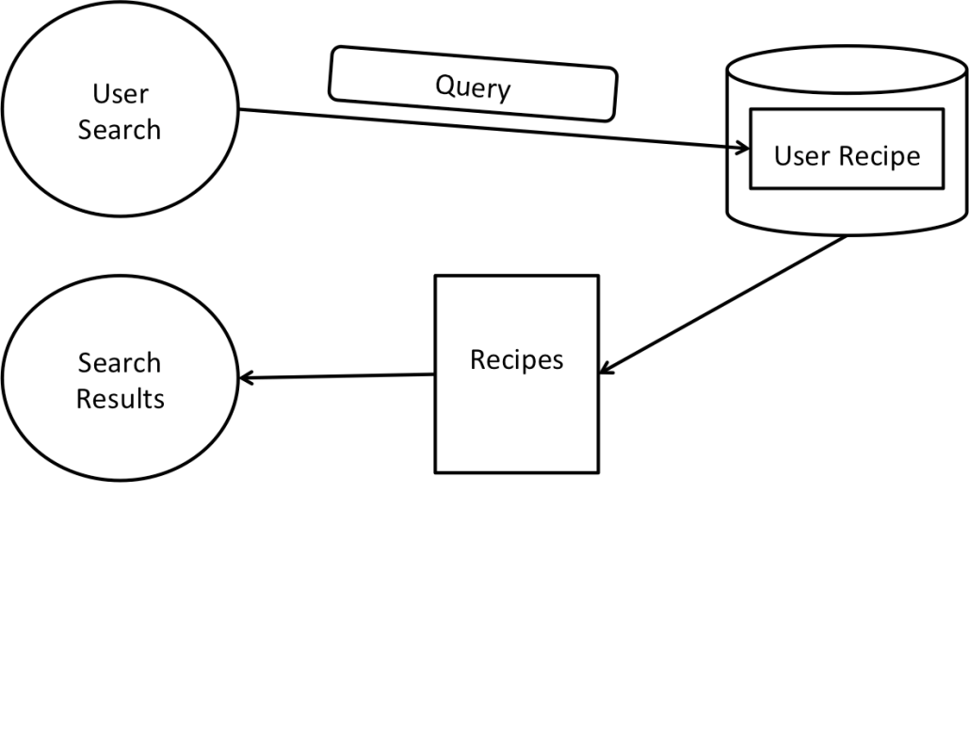

1.3.6 Use Case: Banning a User

User Database

Admin flags user as banned

Notification System

User is notified of ban and whether or not they can appeal

1.3.7 User Case: Deleting a comment

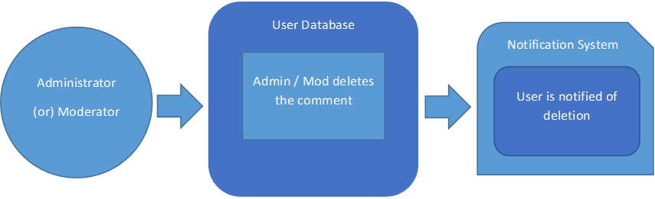

1.3.8: Use Case: User Statistics

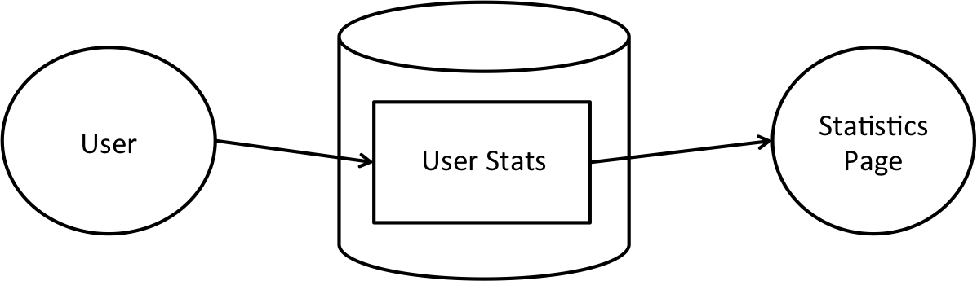

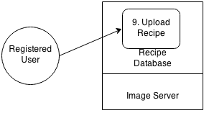1.3.9 Use Case: Upload a Recipe

1.3.10 Use Case: Rate a Recipe

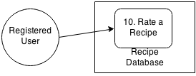

1.3.11 Use Case: Comment on a Recipe

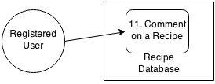

1.3.12 Use Case: Flag a Comment

User

User Database

Notification System

12. Flag a comment

12. Flag a comment

1.3.13 Use Case: Review a Recipe

Moderator

User database

13. Review a recipe

1.3.14 Use Case: Assign a Moderator

Administrator

14. Assign a moderator

User Database

1. Functional Requirements

|  |  |  |
| --- | --- | --- |
| **Number** | 01 | |
| **Name** | Create a new account. | |
| **Summary** | A user may create an account to gain the ability to post and review content. | |
| **Priority** | 5 | |
| **Preconditions** | User must access the website. | |
| **Postconditions** | The user will have an account and be logged into the site. | |
| **Primary Actor** | A user of the web site | |
| **Secondary Actors** | account/login system | |
| **Trigger** | User wants to create an account, and selects the new account button when logging in. | |
| **Main Scenario** | **Step** | **Action** |
|  | 1 | The user accesses the home page of the website. |
|  | 2 | The user clicks the button to create a new account. |
|  | 3 | The user enters their personal information, and chooses a username/password. |
|  | 4 | The system creates a new account for the user |
|  | 5 | The system logs the user into the site |
|  | 6 | The user is shown a message congratulating them on their new account, and is brought to the home page. |
| **Extensions** | **Step** | **Branching Action** |
|  | 3a | The user’s chosen username already exists in the database. |
|  | 4a | The system is unable to create a new account (improper email, name, Facebook, etc.) |
| **Open Issues** | How do we handle a user being unable to create an account for any reason? | |

|  |  |  |
| --- | --- | --- |
| **Number** | 02 | |
| **Name** | Log onto the site | |
| **Summary** | User can log onto the site and access all of their content | |
| **Priority** | 5 | |
| **Preconditions** | User must have an account. | |
| **Postconditions** | User will be logged into the site | |
| **Primary Actor** | A user of the website | |
| **Secondary Actors** | account/login system | |
| **Trigger** | User selects the button to log in. | |
| **Main Scenario** | **Step** | **Action** |
|  | 1 | User directed to login screen. |
|  | 2 | User enters username and password. |
|  | 3 | Account/login system checks for a match between the username and password. |
|  | 4 | Account/login system logs the user into the site. |
| **Extensions** | **Step** | **Branching Action** |
|  | 3a | Username and password do not match |
| **Open Issues** | How do we handle a username and password that do not match?  How do we secure passwords? | |

|  |  |  |
| --- | --- | --- |
| **Number** | 03 | |
| **Name** | View a profile | |
| **Summary** | A user can view their profile or the profile of another user. | |
| **Priority** | 4 | |
| **Preconditions** | User must be logged in. | |
| **Postconditions** | User will have a profile displayed on their screen. | |
| **Primary Actor** | User of the website | |
| **Secondary Actors** | Account system | |
| **Trigger** | User clicks on a username or searches for a user. | |
| **Main Scenario** | **Step** | **Action** |
|  | 1 | User requests a profile. |
|  | 2 | Account system pulls information of user whose profile was requested. |
|  | 3 | Profile information is displayed for the user requested. |
| **Extensions** | **Step** | **Branching Action** |
|  | 2a | User requested does not exist. |
| **Open Issues** | Who is allowed to view profiles? Only users who are logged in? | |

|  |  |  |
| --- | --- | --- |
| **Number** | 04 | |
| **Name** | User Will Receive Notifications | |
| **Summary** | User will receive notifications about their recipes | |
| **Priority** | 10 | |
| **Preconditions** | The user will have previously uploaded (a) recipe(s) | |
| **Postconditions** | The user will receive a notification | |
| **Primary Actor** | A user or moderator of the website | |
| **Secondary Actors** | The recipe interface and recipe database system | |
| **Trigger** | User leaves a comment for User’s recipe or a moderator removes a recipe | |
| **Main Scenario** | **Step** | **Action** |
|  | 1 | A user’s comment is stored in the database or user’s recipe is removed from the database |
|  | 2 | A notification is generated indicating the action taken in step 1 |
|  | 3 | Users ‘statistics’ page is updated under notifications with the message generated in step 2 |
| **Extensions** | **Step** | **Branching Action** |
|  | 3a | The system is unable to update the users statistics page and attempts to notify an administrator |
| **Open Issues** | What do we want to do if the system is unable to notify an administrator? | |

|  |  |  |  |
| --- | --- | --- | --- |
| **Number** | 05 | | |
| **Name** | Flag a comment | | |
| **Summary** | A user may declare (i.e. flag) a comment to be unacceptable, inappropriate, etc. | | |
| **Priority** | 4 | | |
| **Preconditions** | User must access the web site, have an account, and a comment must exist. | | |
| **Postconditions** | The comment is flagged for review (i.e. added to a review list or queue) | | |
| **Primary Actor** | A user of the web site | | |
| **Secondary Actors** | Notification system | | |
| **Trigger** | A user decides to flag a comment by selecting the flag button for that comment | | |
| **Main Scenario** | **Step** | **Action** | |
|  | 1 | The user selects the flag comment button for the comment they wish to flag | |
|  | 2 | The task of reviewing the comment is added to a review list (e.g. a queue) | |
|  | 3 | The user is thanked, and notified that the comment has been flagged for review | |
|  | 4 | System moderators and administrators are notified that a comment has been flagged for review | |
|  | 5 | A moderator or administrator reviews the content of the comment | |
|  | 6 | The comment is removed | |
|  | 7 | The comment is removed from the review list (e.g. a queue) | |
| **Extensions** | **Step** | **Branching Action** | |
|  | 5a | The moderator or administrator is unsure whether the comment should be removed, and so notifies other administrators for a vote | |
|  | 6a | The comment is allowed to remain | |
| **Open Issues** | 1 | | Regardless of the moderator’s/administrator’s decision, should the comment be automatically removed after a certain number of users flag the comment? |

|  |  |  |
| --- | --- | --- |
| **Number** | 06 | |
| 1. **Name** | Comment on Recipes | |
| **Summary** | A user can comment on a recipe that has been posted on the site | |
| **Priority** | 3 | |
| **Preconditions** | The user will have an account and be logged into the site, viewing a recipe. | |
| **Postconditions** | The user's comment will be appended to the recipe | |
| **Primary Actor** | A user of the website | |
| **Secondary Actors** | The recipe interface and recipe database system | |
| **Trigger** | User clicks on the comment option for a recipe | |
| **Main Scenario** | **Step** | **Action** |
|  | 1 | System prompts user for comment input |
|  | 2 | User enters comment and hits submit |
|  | 3 | System adds comment for given recipe in database |
|  | 4 | System thanks user if successful |
| **Extensions** | **Step** | **Branching Action** |
|  | 4a | System informs user there was an error and returns to recipe |
| **Open Issues** | Do we want to enforce a character length limit on comments? Should we have profanity filters? | |

|  |  |  |
| --- | --- | --- |
| **Number** | 07 | |
| **Name** | Searching | |
| **Summary** | User will be able enter a search queries and receive a list of recipes based on relevance | |
| **Priority** | 3 | |
| **Preconditions** | The user will enter ascii text | |
| **Postconditions** | The user will see a list of related recipes | |
| **Primary Actor** | The User | |
| **Secondary Actors** | The search page and the recipes database | |
| **Trigger** | The user clicks on their user account link | |
| **Main Scenario** | **Step** | **Action** |
|  | 1 | User clicks on search link |
|  | 2 | User enters a search query |
|  | 3 | Database is searched and matching results are pulled |
|  | 4 | Results are sorted by relevance |
|  | 5 | Results are displayed to the user |
| **Extensions** | **Step** | **Branching Action** |
|  | 2a | If the user does not enter ascii text, a message will be displayed to the user |
|  | 3a | If not results are found, a message will be displayed to the user |
| **Open Issues** | How we will determine ‘relevance’ | |

|  |  |  |
| --- | --- | --- |
| **Number** | 08 | |
| **Name** | User Statistics | |
| **Summary** | User will be able to view statistics about their account | |
| **Priority** | 4 | |
| **Preconditions** | The User has made an account and is logged in | |
| **Postconditions** | The users statistics page will be populated with information about the user from the database. | |
| **Primary Actor** | The User | |
| **Secondary Actors** | The view (statistics page) and user database system | |
| **Trigger** | The user clicks on their user account link | |
| **Main Scenario** | **Step** | **Action** |
|  | 1 | User click on their view account link at top of page |
|  | 2 | Users statistics are pulled from the database |
|  | 3 | User is redirected to their statistics page |
|  | 4 | Statistics page is populated with User stats |
| **Extensions** | **Step** | **Branching Action** |
|  | 2a | The system is unable grab a statistic about the user from the database and an error message is displayed. If the system is unable to find the user in the database, an error is displayed and a notification is sent to an administrator. |
| **Open Issues** | Should other users be able to visit another users statistics page via URL? (add step about checking login) | |

|  |  |  |
| --- | --- | --- |
| **Number** | 09 | |
| 1. **Name** | Upload a Recipe | |
| **Summary** | A registered user can upload a recipe to the site | |
| **Priority** | 5 | |
| **Preconditions** | The user will have an account and be logged into the site | |
| **Postconditions** | The user's recipe will be uploaded for review by the moderators | |
| **Primary Actor** | A user of the website | |
| **Secondary Actors** | The user interface, file server, and recipe database system | |
| **Trigger** | User clicks on the option in his/her profile to upload a recipe | |
| **Main Scenario** | **Step** | **Action** |
|  | 1 | System prompts user for recipe name and description |
|  | 2 | User enters recipe name and description |
|  | 3 | System prompts user for recipe ingredients |
|  | 4 | User enters recipe ingredients |
|  | 5 | System prompts user for recipe steps and step pictures |
|  | 6 | User enters recipe steps |
|  | 7 | System prompts user for main recipe picture |
|  | 8 | User browses file prompt to select the recipe picture |
|  | 9 | User hits submit |
|  | 10 | Picture files are uploaded to the image server |
|  | 11 | Interface system sends request to database system to add recipe to recipe table with all entered information and image file information and pending flag set |
|  | 12 | Interface system notifies user if upload was successful |
| **Extensions** | **Step** | **Branching Action** |
|  | 6a | User selects to upload a picture for a step |
|  | 6b | System opens file browser to allow user to select file to upload |
|  | 6c | User selects file to upload and clicks upload |
|  | 6d | System caches file information to upload file when user hits submit |
|  | 8a | System informs user that he/she has selected an invalid file and reprompts |
|  | 9a | System reprompts user for missing required data (main picture, ingredients, description, steps) |
| **Open Issues** | Do we want a separate table for pending recipes or should we put them in the same table with a flag set for review? Should we have a limit on the number of images or file type/size? Should we allow videos? Should image file uploads begin asynchronously before hitting submit? How can we secure the uploading system?  Note: many of these prompts may take place at the same time but in linear succession on a single view. | |

|  |  |  |
| --- | --- | --- |
| **Number** | 10 | |
| 1. **Name** | Rate Recipes | |
| **Summary** | A user can rate a recipe posted on the site out of 5 stars | |
| **Priority** | 3 | |
| **Preconditions** | The user will have an account and be logged into the site, viewing a recipe. | |
| **Postconditions** | The recipe's 5 star rating will be adjusted according to the user's rating and the user will not be able to rate it again. | |
| **Primary Actor** | A user of the website | |
| **Secondary Actors** | The recipe interface/display and recipe database system | |
| **Trigger** | User clicks on the rate button near recipe's rating | |
| **Main Scenario** | **Step** | **Action** |
|  | 1 | System checks if user has already rated this recipe |
|  | 2 | Interface prompts user for rating out of 5 |
|  | 3 | User enters rating and confirms entry |
|  | 4 | System updates rating in database |
|  | 5 | System thanks user if successful |
| **Extensions** | **Step** | **Branching Action** |
|  | 1a | System informs user that he/she has already rated this recipe and returns to recipe |
|  | 5a | System informs user there was an error and returns to recipe |
| **Open Issues** | Do we want to prevent users from rating a recipe more than once? | |

|  |  |  |
| --- | --- | --- |
| **Number** | 11 | |
| **Name** | Recipe review | |
| **Summary** | Moderators will review recipes for content before allowing them to be posted | |
| **Priority** | 3 | |
| **Preconditions** | A recipe post must be awaiting review | |
| **Postconditions** | The recipe is posted or not posted | |
| **Primary Actor** | Moderator | |
| **Secondary Actors** | System maintaining the list of recipes to review | |
| **Trigger** | Moderator selects a recipe from the review list | |
| **Main Scenario** | **Step** | **Action** |
|  | 1 | Moderator selects a recipe from the recipe review list |
|  | 2 | Moderator inspects the recipe to make sure content is appropriate (e.g. accuracy, nothing offensive) |
|  | 3 | The moderator allows the recipe to be posted |
|  | 4 | The recipe is removed from the recipe review list |
| **Extensions** | **Step** | **Branching Action** |
|  | 3a | The recipe is not allowed to be posted |
| **Open Issues** | Should a user be notified if their recipe is not allowed to be posted?  Scalability issue: how of we handle a large user base with this requirement? | |

|  |  |  |
| --- | --- | --- |
| **Number** | 12 | |
| **Name** | Assigning moderators | |
| **Summary** | Administrators may select users to become moderators | |
| **Priority** | 3 | |
| **Preconditions** | A user who wants to become a moderator must exist | |
| **Postconditions** | The user account is changed to a moderator account | |
| **Primary Actor** | Administrator | |
| **Secondary Actors** | Account management database | |
| **Trigger** | An administrator decides to make a user a moderator | |
| **Main Scenario** | **Step** | **Action** |
|  | 1 | The administrator selects a user they wish to make a moderator |
|  | 2 | The user is notified that they have been selected to become a moderator |
|  | 3 | The user accepts the account status of moderator |
|  | 4 | The account management database is updated to show that the user is now a moderator |
| **Extensions** | **Step** | **Branching Action** |
|  | 3a | The user declines the account status of moderator |
|  | 4a | The account management database is not updated because the user declined moderator account status |
| **Open Issues** |  | |

|  |  |  |
| --- | --- | --- |
| **Number** | 13 | |
| **Name** | Ban a user | |
| **Summary** | An administrator may ban a user, preventing them from using their account for anything besides appealing the ban. (Cannot post, edit, review, comment, etc) | |
| **Priority** | 3 | |
| **Preconditions** | The user must have an account. | |
| **Postconditions** | The user is flagged as “banned” and may no longer submit content, comment on content, review content, or otherwise participate in the site. | |
| **Primary Actor** | Administrator | |
| **Secondary Actors** | User | |
| **Trigger** | Administrator clicks a “ban user” link found on the offending users profile page, visible only to the Administrator. | |
| **Main Scenario** | **Step** | **Action** |
|  | 1 | Administrator clicks the “ban user” link. |
|  | 2 | The administrator is prompted to confirm their decision, and clicks “yes”. |
|  | 3 | The administrator is given the option of allowing the offending user to appeal their decision. |
|  | 4 | The user is flagged as banned and barred from further participation in the site. |
| **Extensions** | **Step** | **Branching Action** |
|  | 3a | If the administrator allows the user to appeal the decision, the user is notified about the ban and is given the option to appeal it. Pending a review, the user remains banned from the site. |
|  | 3b | The administrator who banned the user is notified of the appeal and given the chance to reexamine their decision. |
|  | 4a | The ban is upheld by the Administrator and the user remains banned. |
|  | 4b | The ban is dropped by the Administrator, the user is unflagged as “banned” and can once again participate in activities on the site. |
| **Open Issues** | Should a ban make the users profile page empty, unlisted, otherwise publicly indicated as “banned”?  Should there be tiers to the bans to strip certain privileges (like just posting comments), or to enact a site-wide ban that prevents them from even logging in?  Should ban notices be delivered as a Notification to the User, or as an email to the users provided email address? | |

|  |  |  |
| --- | --- | --- |
| **Number** | 14 | |
| **Name** | Remove a comment | |
| **Summary** | Administrators and moderators can remove comments. | |
| **Priority** | 4 | |
| **Preconditions** | The comment exists and the user removing the content is either an administrator or a moderator. | |
| **Postconditions** | The comment is removed from the database. | |
| **Primary Actor** | Administrator / Moderator | |
| **Secondary Actors** | Comment, User who posted the Comment | |
| **Trigger** | Administrator / Moderator clicks on the “remove comment” icon next to a comment. | |
| **Main Scenario** | **Step** | **Action** |
|  | 1 | “Remove Comment” icon is clicked. |
|  | 2 | The administrator / moderator is prompted to confirm their decision. (“Are you sure you would like to delete this comment?”) |
|  | 3 | The comment is deleted |
|  | 4 | The user who posted the comment is notified. |
| **Extensions** | **Step** | **Branching Action** |
|  | 2a | The administrator / moderator decides not to delete the comment. |
| **Open Issues** | Should the user be given the option to appeal the deletion of the comment? Should the moderator or administrator be able to reverse their decision? | |

1. Use Case Tests
   1. **Use Case Test 1 – Create a New Account**

Navigate to homepage. Click button to create new account. Enter test information. Make sure incorrect information is not allowed to be entered. After information is accepted, check the database to ensure a new user entered has been entered.

* 1. **Use Case Test 2 – Log onto Website**

Navigate to homepage. Click button to log in. Enter username and password for already created account. Verify user has access that’s been granted to them (regular user/mod/admin).

* 1. **Use Case Test 3 – View a User Profile**

Log in as already entered user. Navigate to that user’s profile. Verify that all information in presented on that page. Navigate to another user’s page. Verify that all information accessible to that user is present.

* 1. **Use Case Test 4 – User Receive Notifications**

Log in as a user, and have someone else logged in as another user. Have one user comment on another user’s recipe, and check that the notifications of the user who created the recipe to ensure a comment notification has been created.

* 1. **Use Case Test 5 – Flag a Comment**

Log in as a user. Navigate to a recipe. Scroll down to comment section. Press the flag button on a comment. Log in as a moderator to ensure the flag has been created.

* 1. **Use Case Test 6 – Comment on a Recipe**

Log in as a user. Navigate to a recipe. Press the button to write a test comment on that recipe. Check the database to see if the comment has been stored properly. Refresh the page to see that the comment shows up.

* 1. **Use Case Test 7 – Search**

Log in as a user. Enter a search term in the search bar at the top. Ensure that relevant search terms appear. Also ensure that if an improper search term is entered then a proper error message is displayed.

* 1. **Use Case Test 8 – Get User Statistics**

Log in as a user. Navigate to the user statistics page. Ensure that all necessary stats are posted and they pertain to that specific user. Enter sample data in the database for this user to ensure that the calculations are done correctly.

* 1. **Use Case Test 9 – Upload a Recipe**

Log in as a user. Navigate to the upload recipe page. Go through steps to upload a recipe, make sure that if improper information is put in that the appropriate error message is displayed. After entering a recipe, make sure that the recipe is in the database correctly.

* 1. **Use Case Test 10 – Rate a Recipe**

Log in as a user. Navigate to a recipe that has not been entered by that user. Click the button to rate that recipe. Check the database to check that the rating has been entered.

* 1. **Use Case Test 11 – Moderator Reviews a Recipe**

Log in as a moderator. Make sure that a recipe has been uploaded and is ready for review. Review that recipe accordingly. Check to see if recipe is public or not. Check database to see if proper action (deletion or not) has been taken.

* 1. **Use Case Test 12 – Assign a Moderator**

Log in as an admin. Go to admin page, add a user that is currently in the database to the moderator list. Log in as that use to see if given proper moderator privileges.

* 1. **Use Case Test 13 – Ban a User**

Log in as an admin. Go to user and select ban. Check to make sure if user has been banned in the database, and that they were properly notified.

* 1. **Use Case Test 14 – Remove a Comment**

Log in as moderator and admin. Go to a recipe that has been flagged, mark it to be removed. Check to make sure it has been removed from database and no longer appears when the recipe is accessed.

1. Non-Functional Requirements

|  |  |
| --- | --- |
| Items | Priority (1-5 lowest-highest) |
| Must follow Spiral development process. | 5 |
| Must use a PHP framework. | 1 |
| Must have bi-weekly updates with customer. | 4 |
| Must utilize Github to store the project. | 5 |
| All code will be well documented. | 4 |
| Must adhere to group set coding standards. | 4 |
| Application will use MVC design. | 3 |
| Site will be secure. | 5 |
| Utilize only publicly available technologies. | 5 |

1. UI

See User Interface Design Document for DigiDiet.

1. Deliverables

Our customer will receive hard copies of:

* System Requirements Specifications
* System Design Document
* User Interface Design Document
* User Manual
* Administrator Manual

Our customer will receive an electronic copy of:

* The web application
* All aforementioned hard copies of documents
* All source code
* Software required for the website to function properly

1. Open Issues

|  |  |
| --- | --- |
| Issue | Description |
|  |  |