Administrator Manual

digidiet

Client:
Morgan Madeira

Developer Team (Team 3):
Connor Cook
Matt Law
Brent Mattox
Austin Murdock
Michael Neary

April 26, 2014
digidiet
Administrator Manual

Table of Contents

Page

1. Introduction 4

1.1 Purpose of This Document 4
1.2 References 4

2. System Overview 5

2.1 Background 5
2.2 Hardware and Software Requirements 5

3. Administrative Procedures 5

3.1 Installation 6
3.1.1 The AMP Stack 6
3.1.2 Apache Modules 6
3.1.3 Database Migrations 7
3.1.4 PHP Settings and Extensions 7
3.1.5 Laravel and Composer 8
3.1.6 digidiet 8
3.2 Routine Tasks 8
3.2.1 Reviewing Comments 8
3.2.2 Posting Announcements 9
3.2.3 User Assistance 10
3.2.4 Bug Fixes 10
3.3 Periodic Tasks 10
3.3.1 Assigning Moderators 10
3.3.2 Banning Users 11
3.3.3 Removing Comments 12
3.3.4 Removing Recipes 13
3.4 User Support 13

4. Troubleshooting 13

4.1 Dealing with Error Messages and Failures 14
4.2 Known Bugs and Limitations 14

Appendix A – Peer Review Sign-off 15

Appendix B – Document Contributions 17
1. Introduction

1.1 Purpose of This Document

The Administrator Manual is intended to provide administrators with the knowledge and information necessary to install and maintain the digidiet website in proper working condition. An overview of the website, and basic hardware and software requirements for the system are provided in Section 2. Step-by-step procedures, with screen shots when necessary, will be outlined in Section 3 to assist administrators with installation and maintenance of the website. Other system documents and online resources may be referenced throughout this manual. Please refer to Section 1.2, References, for more information regarding other resources.

  - References

Apache Friends. (2014). XAMPP. Retrieved from https://www.apachefriends.org/index.html

Apache Software Foundation, The. (2014). Apache HTTP Server Version 2.4 Documentation. Retrieved from https://httpd.apache.org/docs/2.4/

Cook, Connor, et al. (2014). System Design Document (SDD). Retrieved from https://github.com/UMBC-CMSC345/Section-2-Team-3/tree/master/Docs/SDD

Laravel Book. (2014). Managing Databases with Migrations. Retrieved from http://laravelbook.com/laravel-migrations-managing-databases/

Neary, Michael, et al. (2014). System Requirements Specification (SRS). Retrieved from https://github.com/UMBC-CMSC345/Section-2-Team-3/tree/master/Docs/SRS

Otwell, Taylor. (2014). Laravel Installation. Retrieved from http://laravel.com/docs/installation#install-laravel

WampServer. (2014). Start With WampServer. Retrieved from http://www.wampserver.com/en/

2. System Overview

2.1 Background

System administrators are responsible for overseeing website content, assigning moderators, banning users, troubleshooting, and overseeing bug fixes and new version releases to ensure proper website functioning.

The website content, including pictures, recipe text, profile text, and comment text should be kept at a “PG rating.” While “PG rating” is ambiguous, for the digidiet website, it can be considered to mean “No nudity, profanity, or offensive material.” Again, since “offensive material” is ambiguous, a flagging system is in place to allow users to choose for themselves what they deem offensive. It is the administrator’s job to ensure that material that is continuously flagged is reviewed and/or removed from the website. Users who violate content rules may be issued a warning via email or banned outright at the administrator’s discretion. Additionally, administrators are responsible for posting announcements that appear on the website’s homepage.

The administrator is also responsible for assigning moderators. Assigning moderators is not mandatory, but may be helpful in reviewing flagged content. Aside from the ability to receive flagged content notifications, review flagged content, and remove flagged content, moderators’ privileges are equal to that of a user’s privileges.

Administrators are responsible for ensuring timely troubleshooting assistance for all users and moderators. Emails regarding troubleshooting that are received by system administrators and other system support groups should be handled appropriately to ensure optimal user satisfaction. Bug fixes and website updates, including new version releases and minor code updates, are also overseen by system administrators.

2.2 Hardware and Software Requirements

The system may be run on Windows, Mac and Unix-based operating systems. An AMP (Apache 2.4.4, MySQL 5.6.12, PHP 5.4.12) server stack is required for integrating the server, database, and source code. PhpMyAdmin 4.0.4 is recommended for database management, and comes standard with most AMP stacks. Additionally, Laravel 4.0 or later, and Composer are required. Please see section 3.1 for more information regarding downloading and installing various tools and resources.

A 64-bit operating system is also recommended. RAM and CPU speed requirements primarily depend on the number of connections the Apache server must manage, although 1 GB of RAM and 1 GHz CPU clock speed should suffice.

A broadband internet connection with a minimum data transfer rate of 256 kbit/second is recommended.

3. Administrative Procedures

This section describes the software installation procedures for running the digidiet website, including setting up the database and server. Also, routine tasks for maintaining digidiet are discussed, along with recommendations for handling user support.

3.1 Installation

Installing Apache, MySQL, and PHP (AMP), and Laravel are discussed in the following subsections. The following subsections pertain to using Apache as a local server; however, Apache provides assistance for creating a remote server. Please visit “https://httpd.apache.org/docs/2.4/” (Apache 2014) for Apache-related support.

3.1.1 The AMP Stack

Many AMP stacks are available for download on the world wide web; however, Wamp is strongly recommended for machines running Windows, while XAMPP (Apache, MySQL, PHP, Perl) is a great cross-platform alternative. A LAMP stack, designed for machines running Linux, may also be used; however, the stack’s components are not consistent across vendors. If a LAMP stack is chosen for use, then it should contain Apache 2.4.4 or later, MySQL 5.6.12 or later, and PHP 5.4.12.

Download and installation instructions for Wamp can be found at “http://www.wampserver.com/en/” (WampServer 2014).

Download and installation instructions for XAMPP can be found at “https://www.apachefriends.org/index.html” (Apache Friends 2014).

3.1.2 Apache Modules

The following Apache modules should be enabled:

(1) access_compat_module
(2) actions_module
(3) alias_module
(4) allowmethods_module
(5) asis_module
(6) auth_basic_module
(7) authn_core_module
(8) authn_file_module
(9) authz_core_module
(10) authz_groupfile_module
(11) authz_host_module
(12) authz_user_module
(13) autoindex_module
(14) cgi_module
(15) dir_module
(16) env_module
(17) include_module
(18) isapi_module
(19) log_config_module
(20) mime_module
(21) negotiation_module
(22) rewrite_module
(23) setenvif_module
(24) php5_module

3.1.3 Database Migrations

The digidiet database was built using migrations, and should be maintained using new migrations. Please refer to “http://laravelbook.com/laravel-migrations-managing-databases/” (Laravel Book 2014) for information regarding database management using migrations.

3.1.4 PHP Settings and Extensions

The following PHP settings should be enabled:

(1) output buffering
(2) y2k compliance
(3) expose php
(4) display errors (recommended)
(5) display startup errors (recommended)
(6) log errors (recommended)
(7) report memleaks (recommended)
(8) track errors (recommended)
(9) file uploads
(10) allow url fopen

The following PHP extensions should be enabled:

(1) php_curl
(2) php_fileinfo
(3) php_gd2
(4) php_mbstring
(5) php_mysql
(6) php_mysqli
(7) php_openssl
(8) php_pdo_mysql
(9) php_pdo_sqlite
(10) php_phar
(11) php_zip

3.1.5 Laravel and Composer

Laravel 4.0 or later, and Composer are required for digidiet installation, and both may be downloaded from the Laravel website. Laravel and Composer download and installation instructions can be found at “http://laravel.com/docs/installation#install-laravel” (Otwell 2014).

3.1.6 digidiet

To install digidiet for use on a local server, simply place the source root directory, called digidiet, inside the web root directory (e.g. www) of the server directory (e.g. wamp), and then access the local host address via a web browser. A common directory structure on Windows machines is wamp/www/digidiet.

3.2 Routine Tasks

A couple of routine administrative tasks should be performed to keep the digidiet website organized and user-friendly. Routine administrative tasks include reviewing flagged comments, posting announcements, assisting users with troubleshooting, and fixing bugs in the site software. Several other periodic tasks – discussed in the next section – should be performed by administrators to keep the digidiet website in proper working order.

3.2.1 Reviewing Comments

An administrator should review the content of flagged comments for profanity, racism, sexism, and any other reasonably offensive content, and objectively determine whether the comment should be removed or allowed to remain. Note that digidiet should treat all of its users respectfully and equally – all users should be treated with courtesy and fairness. Comment deletion is shown in Figure 3.1.

From the homepage:

(1) Login as an administrator
(2) From the navigation bar, hover over the administrator username
(3) Select Control Panel
(4) Select the Post Management tab
(5) Select the thumbs down icon under Deletefor the desired comment to delete the comment
(6) Select the thumbs up icon under Delete for the desired comment to keep the comment

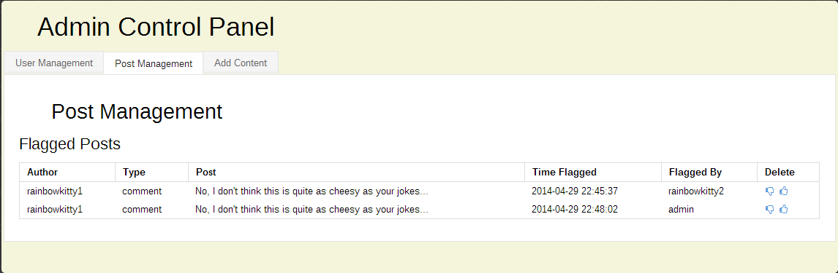
Figure 3.1

3.2.2 Posting Announcements

Administrators should post site-specific announcements, including news regarding site updates, and any other information deemed relevant by an administrator. Other announcements can be made at the administrator’s discretion. The announcements will appear under the Announcements section of the homepage. Please note, digidiet is intended to be a fun and friendly site with content that is appropriate for all audiences. Figure 3.2 shows how an administrator can post announcements to the site homepage. Figure 3.3 shows the announcement, “digidiet’s first announcement!” displayed on the homepage.

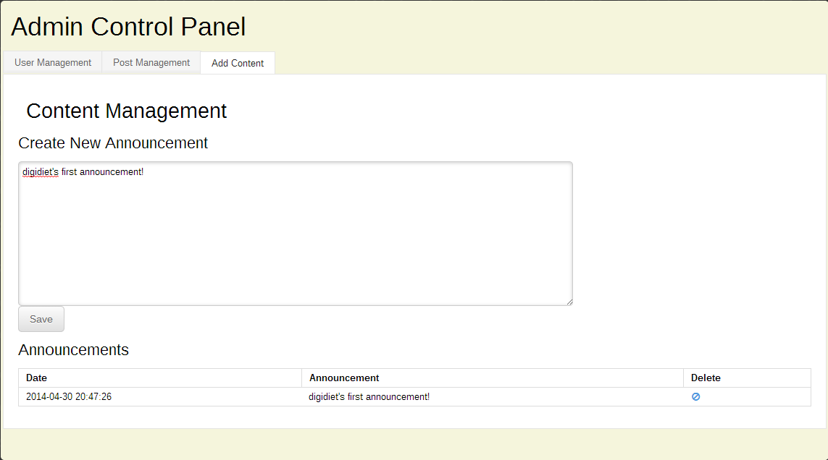
Figure 3.2
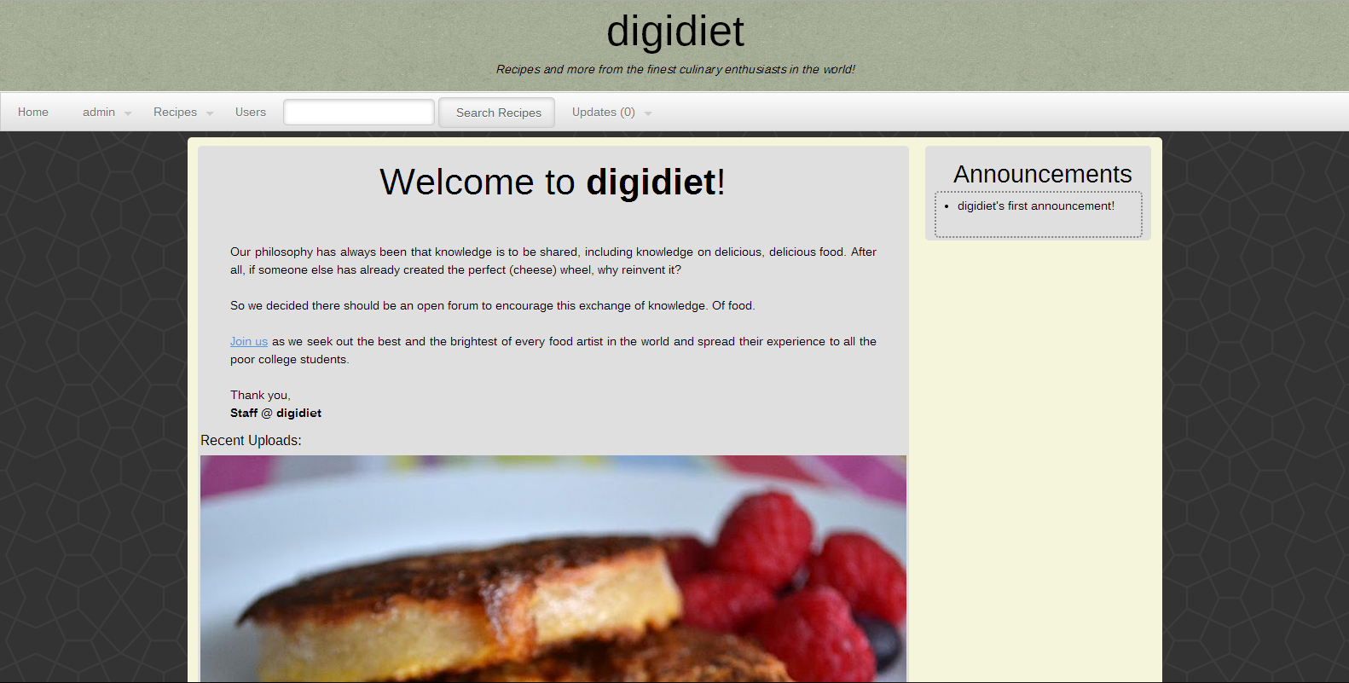
Figure 3.3
3.2.3 User Assistance

Refer to Section 3.4, User Support, for a guide on how to assist users with troubleshooting.

3.2.4 Bug Fixes

Refer to Section 4, Troubleshooting, for a guide on how to deal with site-specific software bugs, including error messages and failures.

3.3 Periodic Tasks

An administrator may need to perform various tasks periodically to ensure the digidiet website remains in proper working order. Aside from fixing bugs and updating software, an administrator may need to assign moderators, ban users, remove comments, and/or remove recipes.

3.3.1 Assigning Moderators

An administrator may assign/de-assign moderators at the administrator’s discretion at any time. In addition to having all user-functionality, moderators may also review and remove comments and recipes. Moderators (and administrators) receive email notifications when comments and recipes are flagged. Figure 3.4 shows how an administrator can assign/de-assign moderators. The user, rainbowkitty0 is changed to a moderator in Figure 3.4.

From the homepage:

(1) Login as an administrator
(2) From the navigation bar, hover over the administrator username
(3) Select Control Panel
(4) Select the User Management tab
(5) Select the drop down menu under Change Role for the desired user
(6) Select the desired role, and then press the Save button

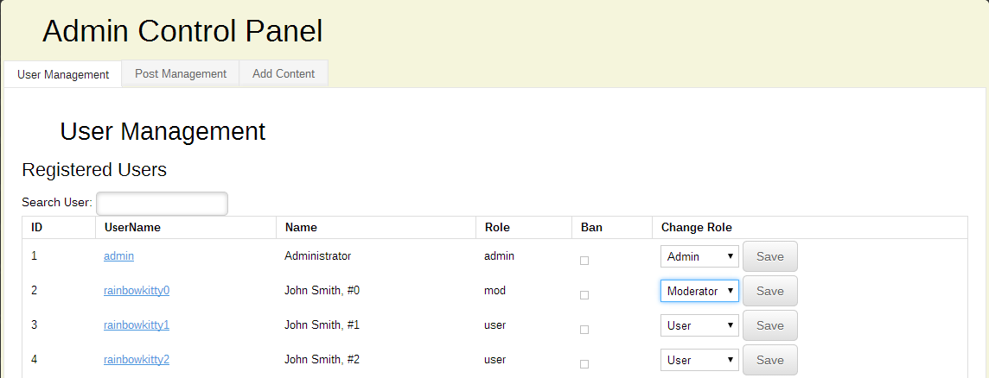
Figure 3.4

3.3.2 Banning Users

Any user who continuously posts inappropriate content, or who is discourteous to other users should be banned by an administrator. A banned user should receive an email notification explaining why they were banned. An administrator can ban or unban any user for any reason at any time, though this power should never be abused. An administrator should use their best reasonable judgment before deciding to ban a user – remember that a fun and friendly user-base does a good digidiet community make. Figure 3.5 shows how an administrator can ban a user.

From the homepage:

(1) Login as an administrator
(2) From the navigation bar, hover over the administrator username
(3) Select Control Panel
(4) Select the User Management tab
(5) Select the box under Ban for the desired user

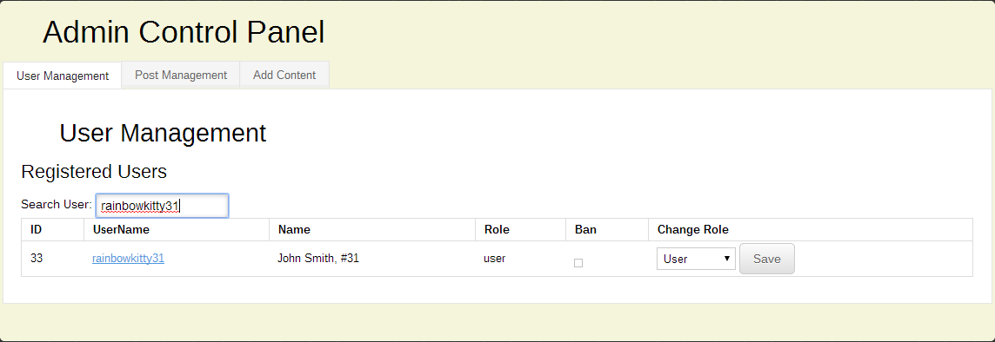
Figure 3.5

Figure 3.6 shows how an administrator can unban a user.

From the homepage:

(1) Login as an administrator
(2) From the navigation bar, hover over the administrator username
(3) Select Control Panel
(4) Select the User Management tab
(5) Select the gavel icon under Restore for the desired user

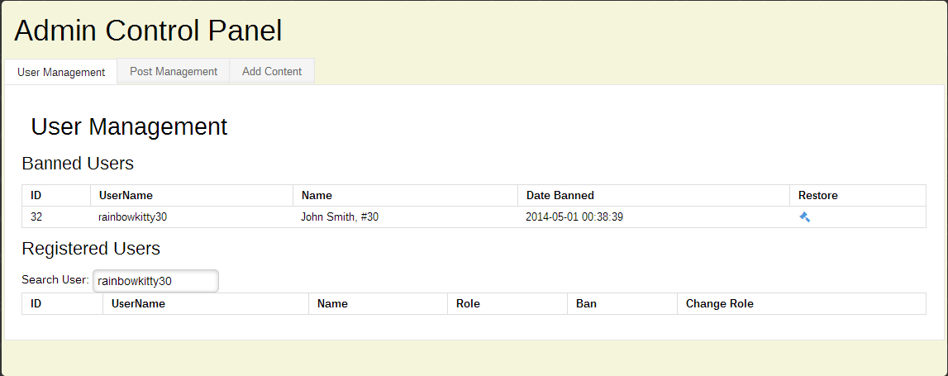
Figure 3.6

3.3.3 Removing Comments

Refer to section 3.2.1, Reviewing Comments, for comment reviewal/removal.

3.3.4 Removing Recipes

An administrator should review the content of flagged recipes (including pictures) for profanity, racism, sexism, violence, nudity, and any other reasonably offensive content, and objectively determine whether the recipe should be removed or allowed to remain. Note that digidiet should treat all of its users respectfully and equally – all users should be treated with courtesy and fairness. Figure 3.7 shows how an administrator can review and/or remove a flagged recipe.

From the homepage:

(1) Login as an administrator
(2) From the navigation bar, hover over the administrator username
(3) Select Control Panel
(4) Select the Post Management tab
(5) Select the thumbs down icon under Delete for the desired recipe to delete the recipe
(6) Select the thumbs up icon under Delete for the desired recipe to keep the recipe

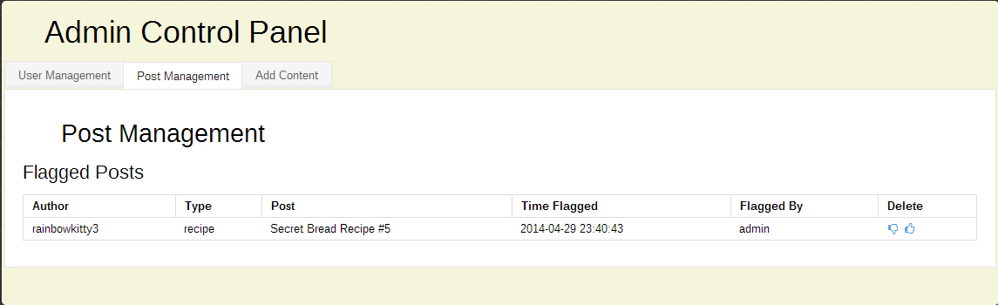
Figure 3.7

3.4 User Support

User support is provided by contacting digidietdevs@gmail.com. Contact information for user support and troubleshooting is provided on the digidiet website by clicking the Contact Us link at the bottom of any page. Figure 3.8 shows the text displayed after clicking the Contact Us link.

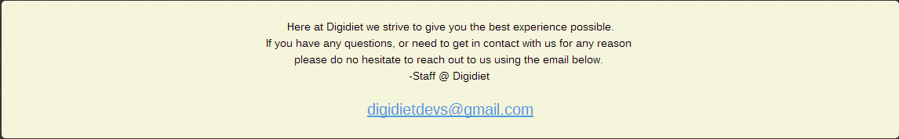
Figure 3.8

4. Troubleshooting

4.1 Dealing with Error Messages and Failures

Reviewing the stack trace for errors should lead to the culprit code, which should be easily debugged for minor errors and failures. Restarting the server(s) may resolve errors and/or failures related to network issues. Unknown errors and/or failures should be emailed to digidietdevs@gmail.com. Refer to Section 3.4, User Support, for more information.

4.2 Known Bugs and Limitations

Note: Bugs and limitations that are found, but are not included in this section, should be appended to the end of this list.

(1) Administrators can ban themselves. Normally, an administrator should be unable to ban themselves or other administrators, as this necessitates accessing the database directly or having another administrator unban them to fix the problem. If an administrator accidentally bans themselves, then another administrator should login and unban them (refer to Section 3.3.2, Banning Users, for unbanning users). If another administrator is unavailable, then the banned administrator must access the users table in the digidiet database, find the entry for the banned user (in this case, the banned administrator’s username), and edit the “deleted_at” column so that is empty (NULL).

This bug should not affect site behavior at the user level, as it is strictly an administrator bug.

(2) Notifications are marked as “read” as soon as a user navigates to another page, regardless of whether the notification was actually read. Unfortunately, there is no current work around for this bug other than to make sure users routinely check their notifications even if they think they have read them all.
Appendix A – Team Review Sign-off

All of the digidiet team members have reviewed this document and agree on its content and format. Any disagreements or concerns are addressed in the comments below.

Team
Name _________________________________________ Date ___________________

Name _________________________________________ Date ___________________

Signature ______________________________________ Date ___________________

Comments ____________________________________________________________________________________________________________________________________________

Name _________________________________________ Date ___________________

Signature ______________________________________ Date ___________________

Comments ____________________________________________________________________________________________________________________________________________

Name _________________________________________ Date ___________________

Signature ______________________________________ Date ___________________

Comments ____________________________________________________________________________________________________________________________________________

Name _________________________________________ Date ___________________

Signature ______________________________________ Date ___________________

Comments ____________________________________________________________________________________________________________________________________________

Name _________________________________________ Date ___________________

Signature ______________________________________ Date ___________________

Comments ____________________________________________________________________________________________________________________________________________
Appendix B – Document Contributions

Each digidiet team member provided screen shots and descriptions for Section 3 of this document. Section 2.2, Hardware and Software Requirements, Section 3.1, Installation, and Section 4, Troubleshooting, were collaboratively written by all team members. Each digidiet team member contributed an approximately equal amount (20%) of work to the creation of this document.

