System Design Document

Digidiet

Client

Morgan Madeira

Team 3
Connor Cook
Matt Law
Brent Mattox
Austin Murdock
Michael Neary

March 2nd, 2014

Digidiet
System Design Document

Table of Contents

Page

1. Introduction 4

  - Purpose of This Document 4
  - References 4

- System Architecture 4

2.1 Architectural Design 4
2.2 Decomposition Description 5

3. Persistent Data Design 8

3.1 Database Descriptions 8
3.2 File Descriptions

- Requirements Matrix 9

Appendix A – Agreement Between Customer and Contractor 10

Appendix B – Peer Review Sign-off 10

Appendix C – Document Contributions 10

- Introduction

1.1 Purpose of This Document

This document describes the software architecture by identifying the sub-systems of the website. This document will also outline the communication between these sub-systems and how the sub-systems are controlled.

This document will serve to guide the project developers and verify the customer of the sponsor.

1.2 References

Neary, Michael, et al. (2014). System Requirements Specification (SRS). Retrieved from https://github.com/UMBC-CMSC345/Section-2-Team-3/tree/master/Docs/SRS

Cook, Connor, et al. (2014). User Interface Design Document (UI Design Document). Retrieved from https://github.com/UMBC-CMSC345/Section-2-Team-3/tree/master/Docs/UI

Burbeck, Steve (1992). Application Programming in Smalltalk-80: How to use Model-View-Controller (MVC). Retrieved from http://st-www.cs.illinois.edu/users/smarch/st-docs/mvc.html

Ehsan, Max. "Architecture of Laravel Applications." Architecture of Laravel Applications. N.p., n.d. Web. 03 Mar. 2014. <http://laravelbook.com/laravel-architecture/>.

Otwell, Taylor. (2014) “Laravel Documentation.” Retrieved from <laravel.com/docs>.

- System Architecture

  - Architectural Design

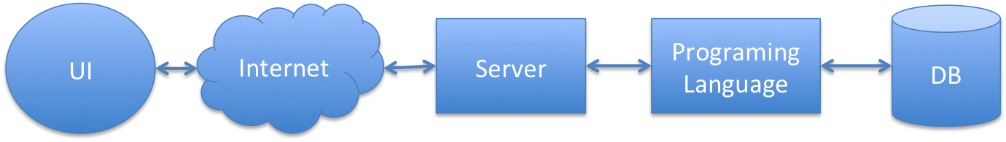
Figure 2.1 Horizontal software solution stack.

The system runs on a software solution stack consisting of an operating system, web server, database, and scripting language.
Currently the system is built on the LAMP software bundle as follows:
- Linux as the operating system
- Apache as the web server
- MySQL as the database management system
- PHP as the scripting language

The development and interaction of these components is abstracted using the Laravel framework. Users will interact with the system using a web browser user interface, which will be facilitated by the aforementioned Model-View-Controller software pattern.

2.2 Decomposition Description
Figure 2.2: A typical Model-View-Controller relationship.

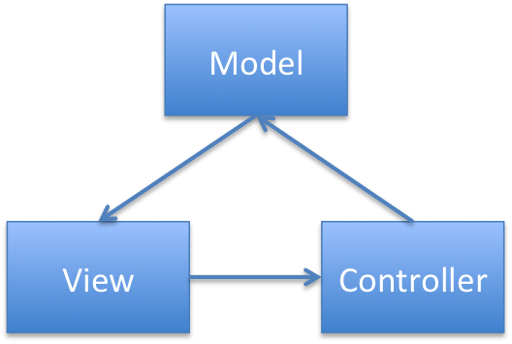
Our project will utilize a slightly altered Model-View-Controller software pattern, extended by Laravel’s capabilities as a full-stack framework. Model-View-Controller, commonly known as MVC, is a commonly used pattern for implementing web-based user-interfaces.

The MVC design pattern is made up of three components:

- The model is the domain the software encompasses- they are based on items and concepts such as a person, a post, or a product. Models both store data and enforce rules regarding its storage, ensuring constraints are properly observed. For our product, the models would include recipes, reviews, users, and comments.
- The view is the visual representation of the model that can contain additional markup to be rendered to the user’s browser. The view generates the user interface and formats the data contained in the models. While it may present varying methods of input to the user, it doesn’t handle the input itself- its work is done once the data is displayed.
- The controller facilitates the link between the view and the models. It processes input, performs actions on the model, decides what actions to take- such as whether to present a login-page or a redirect page. For example, it is the controller that examines a recipe and pulls up its comments to pass to the view, which then presents it.

In Laravel and for our project, this MVC relationship is altered slightly. To best understand these changes, we will examine a complete request in a Laravel framework (see Figure 2.3).

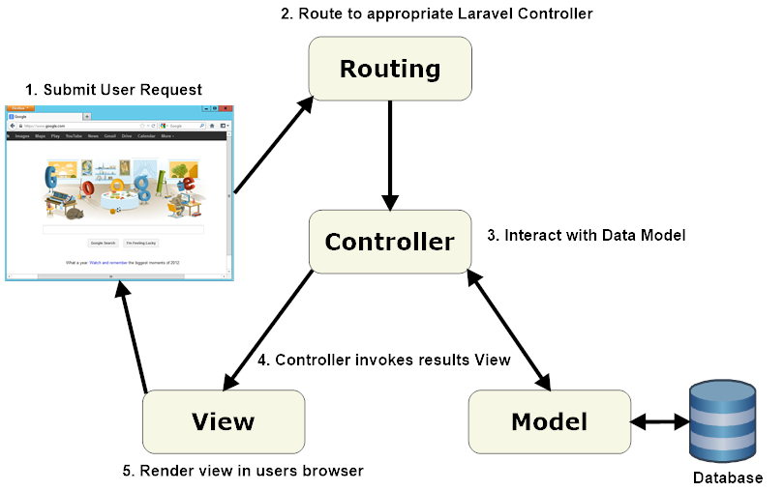
First, the browser sends a request to the application via the web server hosting it (1). Laravel’s routing engine processes the request and hands it off the appropriate controller class (2). The controller then interacts with the data models sitting on top of the database, pulling needed information as necessary (3). Once the controller invokes the model, it invokes a view containing the requested information (4) which in turn returns the complete web page to the user’s browser.
Figure 2.3: Lifecycle of a request in a Laravel application.

2.3 Routing

The routing is handled by the Laravel routing engine via a combination of controllers, RESTful resource controllers, and explicitly defined routes. The two major resource tables for users and recipes will be accessed via RESTful api's, which are defined in the api documentation attached. The api's include functionality for listing, displaying, creating, storing, editing, and destroying users and recipes. Other, more secondary resources will have more limited controllers. These include the comments, tags, and ratings for the recipes.

- Persistent Data Design

  - Database Descriptions

The system uses a MySQL database facilitated in part by multiple aspects of the Laravel framework, additionally supplemented by possible future additions such as mongodb. For now, this database utilizes Eloquent, a method for simplifying access to databases, enforcing relationships between models, and manipulating data. It is configured via the database.php config file found in /app/config/.

As such, our access to the database will be roundabout. For example, defining a database relationship for recipes could be expressed as:

class Recipe extends Eloquent
{
public function author()
{
return $this->belongsTo('Owner');
}
public function comments()
{
return $this->hasMany('Comments');
}
}

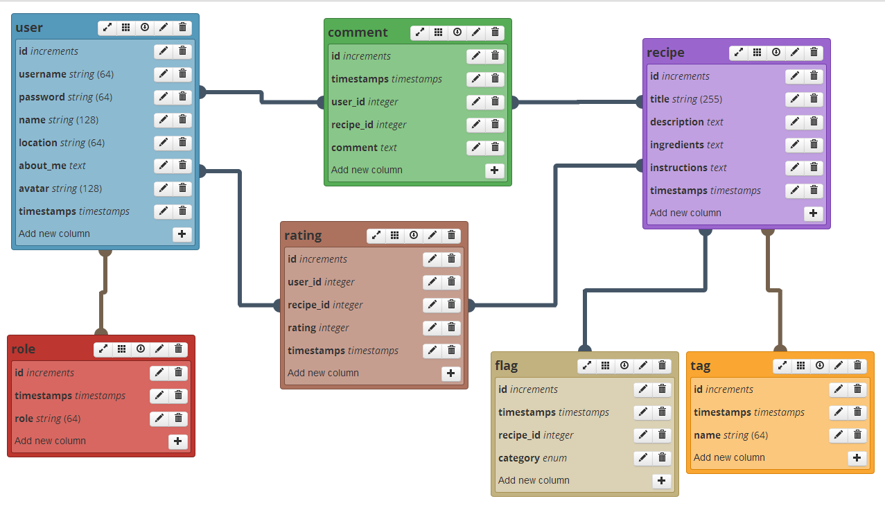

Our database currently consists of three (see below) tables. A fourth table, Comments, will be implemented at a later time. First, our Users table stores information pertaining to each user of our website. Passwords are hashed using Laravel’s Hash class, which uses Bcrypt hashing. Columns in the Users table allow users to include their name, location, a description of themselves, and an avatar, which will be displayed on their profile page and elsewhere to identify the user. An example structure of our Users table can be found in Table 3.1.

id | username | password | name | location | about_me | avatar
1 | XxFoodiexX | 2y$3$#*(( | John | Baltimore | Food lover | me.jpg
Table 3.1

Note that the password contains a “random” string of characters, computed by Laravel’s
Bcrypt hash function. Also note that two timestamp columns have been omitted from Table 3.1; these omitted columns contain date and time information about the creation and modification, respectively, of a user.

Next, our Recipes table stores information pertaining to a particular recipe. Recipes are posted by a user, and thus, that user’s id (author_id) is linked to that particular recipe. An example structure of our current Recipes table can be found in Table 3.2.

id | title | description | ingredients | instructions | author_id
250 | Peanut Butter & Jelly Sandwich | A sandwich! | bread, Pb&J | put Pb&J between bread | 1
Table 3.2

If John (XxFoodiexX) posted a recipe titled Peanut Butter & Jelly, filling in the description, ingredients, and instructions fields, then a column would appear in the Recipes table of our database that might look something like the example in Table 3.2. A unique id is given to each recipe to distinguish it from other recipes. Thus, our database can easily distinguish all Peanut Butter & Jelly Sandwich recipes by their unique id.

Note that the rating column has been omitted from Table 3.2. The rating column stores rating information for each recipe in the table, and is based on a five star rating scale. A user’s rating of a particular recipe counts only once, so a user cannot overly influence that particular recipe’s rating.

Third, our Tags table contains the search tags for a particular recipe. When a user creates a recipe, they may list comma-separated strings (called tags) in a tags field; these strings will be used when submitting search queries, to identify the particular recipe to which the tags belong. For example, the tags for John’s Peanut Butter & Jelly Sandwich recipe in Table 3.2 might be “peanut butter, jelly, sandwich.” A search for “peanut butter”, “jelly”, “sandwich” or some combination of one or more of these strings, would likely return John’s recipe titled Peanut Butter & Jelly Sandwich among the search results. An example structure of our Tags table can be found in Table 3.3.

id | name
250 | “peanut butter, jelly, sandwich”
Table 3.3

Linking the Tags table with the Recipes table will likely require a sub table, which will be designed and implemented at a later date.

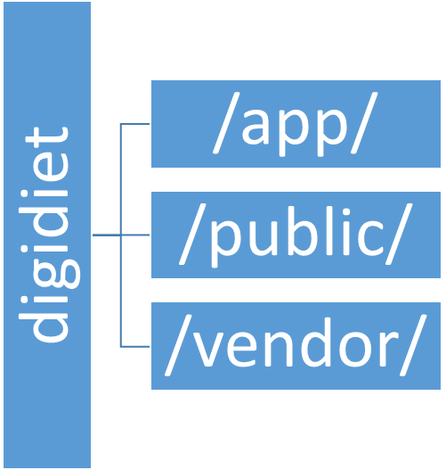
  - File Descriptions

Our project utilizes a standard Laravel file directory system. The top level folder is named after our application, working title being “digidiet”. Inside are three major folders. Chief among them is app, containing the majority of our project, including models, views, controllers, and assets. It also holds the “routes.php” file which informs the application how to handle requests.

The public is the only exposed folder in the application, most importantly containing the bootstrap “index.php” file which initializes the application itself.

Lastly, the vendor folder contains the core of Laravel, its source code, dependencies, plug-ins, and additional prepackaged functionality. For the most part, we will not be developing in this folder, just utilizing its contents.

- Requirements Matrix
# | Requirement | Components
1 | Create new account | Laravel controller passes data to User model
2 | Log onto the site | Laravel controller passes request to User model and invokes appropriate view for response from model
3 | View a profile | Laravel controller passes request to User model and invokes view to display results
4 | User will receive notifications | Laravel controller polls/receives notifcation from User model and generates/sends notification using user data
5 | Flag a comment | Laravel controller passes flag request to Recipe model and notifies moderators
6 | Comment on recipes | Laravel controller passes comment data to Recipe model and invokes view to reflect new comment
7 | Searching | Laravel controller passes search request to Recipe model and invokes view to display sorted results
8 | User statistics | Laravel controller passes request to User model and invokes view to display user statistics
9 | Upload a recipe | Laravel controller passes data to Recipe model and invokes view to display new recipe under review
10 | Rate recipes | Laravel controller passes data to Recipe and User models and invokes view to display adjusted rating
11 | Recipe review | Laravel controller passes data to Recipe model and invokes view to display new review
12 | Assigning moderators | Laravel controller passes data to the User model to classify moderators
13 | Ban user | Laravel controller passes data to User model to remove user from database
14 | Remove a Comment | Laravel controller passes data to Recipe model to remove comment

Appendix A – Agreement Between Customer and Contractor

Appendix B – Team Review Sign-off

Appendix C – Document Contributions

