System Design Document

<Website-name-here>

Client
Morgan Madeira

Team 3
Connor Cook
Matt Law
Brent Mattox
Austin Murdock
Michael Neary

March 2nd, 2014

[Put product name here]
User Interface Design Document

Table of Contents

Page

1. Introduction

  - Purpose of This Document
  - References

2. User Interface Standards

3. User Interface Walkthrough

4. Data Validation

5. Report Formats

Appendix A - Agreement Between Customer and Contractor

Appendix B – Peer Review Sign-off

Appendix C – Document Contributions

1. Introduction

1.1 Purpose of This Document

The purpose of this document is to inform the reader about how to use and navigate the website. The document will outline how pages fit together, where links go, and outline general information that will be displayed on each page.

  - References

- User Interface Standards

The top of each page will generally remain the same from page to page. The top left of the page will display two buttons/icons. These buttons allow the user to switch between the food section and the drink section of the website. Before a user is logged in a ‘login’ link will be displayed in the top right hand corner of the page. After a user has logged in, the top right hand corner will display the currently logged in user’s picture, username and a “logout’ link. Clicking on the username will take a user to their user account page. The middle of the top of the page will have a search bar.

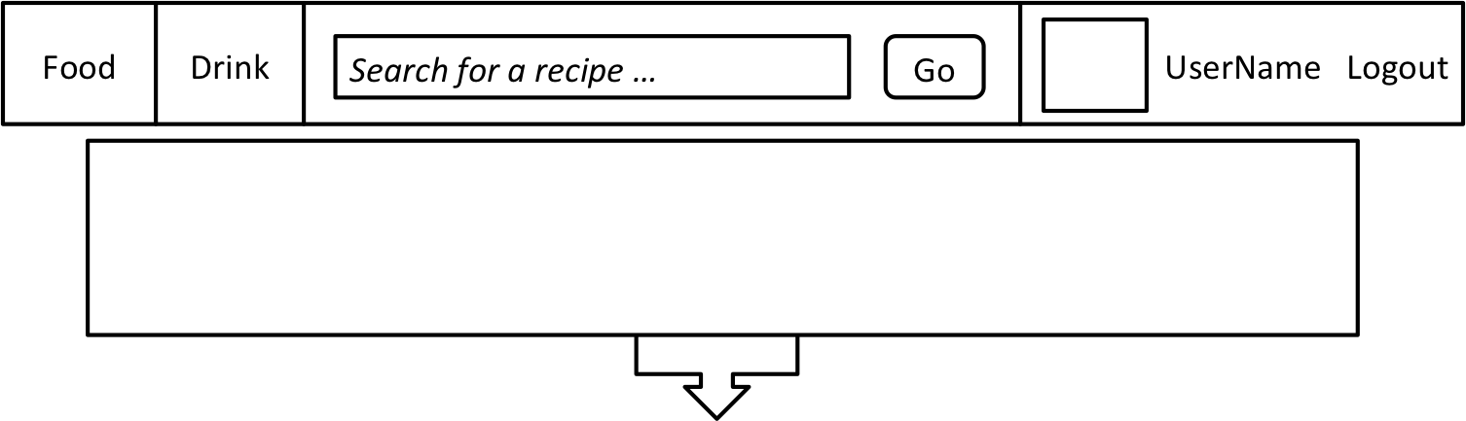

- User Interface Walkthrough

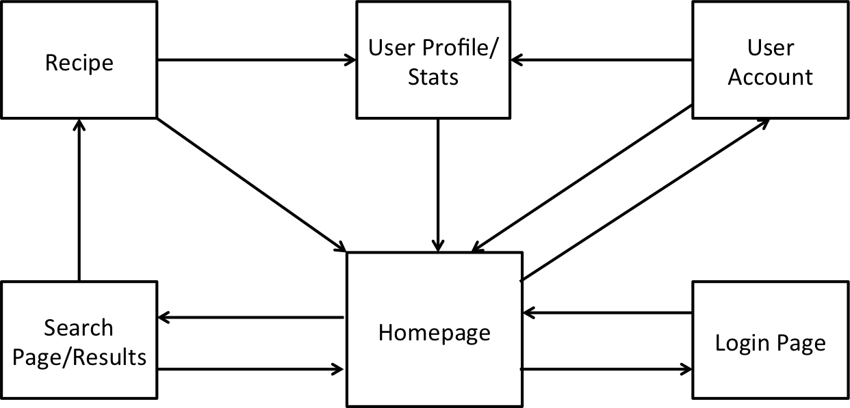

The website navigation will be centered on the homepage. The user account and search pages serve as navigation pages for additional database information.

- Data Validation

All data entered into the website excluding the user and recipe images should be (and will be restricted to ASCII text) in the format of a string. The user will be able upload an image using the file browser window.

- Report Formats

Appendix A – Agreement Between Customer and Contractor

Appendix B – Team Review Sign-off

Appendix C – Document Contributions

