DATE | COMMENT
1 November | Began the report, outlining the proposal for the system and the functional requirements. The system is a garden irrigation network with a peer-to-peer sensor and controller. I chose UDP broadcast for device discovery, which requires no central server.
3 November | Began coding the system but ran into many issues understanding what it needs to be doing.
8 November | Completed a basic version of the system with JSON messages. The sensor peer successfully broadcasts the hello message. The controller peer receives it and replies with an acknowledgement. Bidirectional JSON exchange is successful locally. Dynamic peer discovery is implemented by checking if a reply is sent before retrying. The message flow is printed for testing. Issues with the address already being in use were fixed.
9 November | Added encryption to the system with Python’s `cryptography.fernet`. The method used is a shared key. Mismatched keys are handled gracefully with exception handling. Confirmed that only peers with the same key can exchange data.
12 November | Created the README so that users know what the project is and how to work it properly. Began the testing log, showing what was tested and how the program responds successfully.
13 November | Continued the testing log.

TESTING LOG
The controller peer receives a HELLO message from the sensor and sends back an ACK response.

The sensor peer broadcasts a HELLO message and receives the controller’s ACK response.

The sensor times out when the controller is not online. This handles the joining and leaving of peers gracefully.
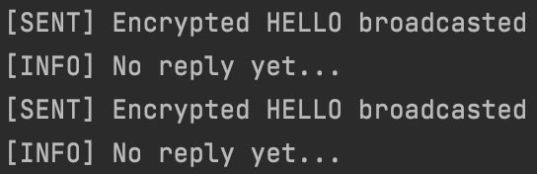

The peers communicate when the keys match.
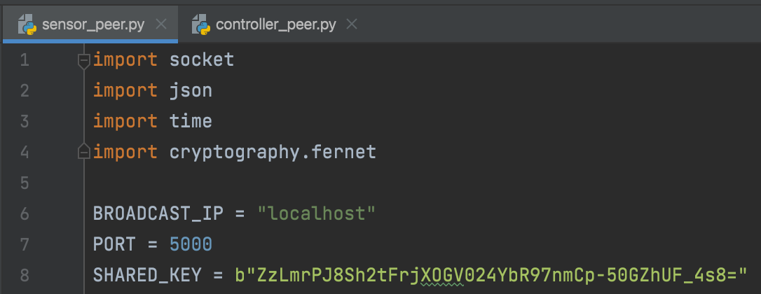
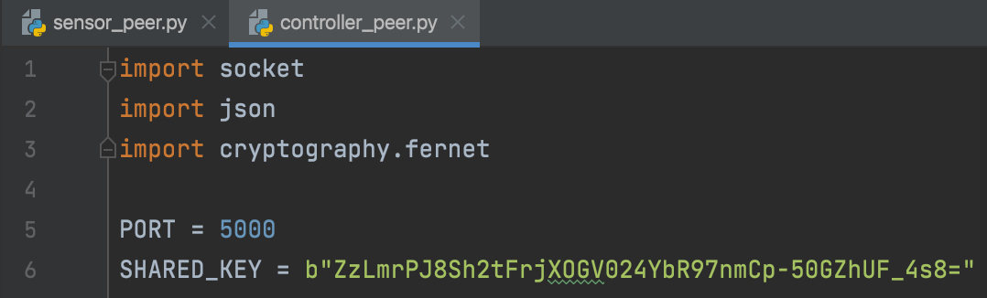

The peers cannot communicate when the keys do not match.
