Project report
COMP713
1. Project Introduction and Requirements
Project Tracker is a small distributed web/API application for tracking projects and their tasks. It demonstrates how a client communicates with a server-side component and how that component manages data, rather than being a large website or enterprise system.
The problem it addresses is keeping track of a small number of projects and the tasks under each one, without needing to install or configure a database server. Each project has a name and a status of open or closed, and each task belongs to exactly one project. A closed project cannot receive new tasks.
Main functional requirements:
- create and list projects;
- open or close a project;
- create and list tasks for a project;
- reject new tasks on a closed project;
- validate input and return clear error responses;
- persist all data between restarts.

Project option selected: Option A (client-server web/API application).
Intended users: a single user or small team who wants a lightweight, self-hosted way to track a handful of projects and tasks without setting up external infrastructure.
2. Architecture and Technology Stack
The system has three parts: a browser client, a server-side API, and a database.
- Client: plain HTML, CSS, and JavaScript pages (public/) that call the API using fetch.
- Server-side API: Node.js with TypeScript and Express 5, split into controllers, services, repositories, and middleware.
- Data persistence: SQLite accessed through better-sqlite3, stored as a single file (data/app.db).
- Testing: node:test with supertest.

TypeScript was used for the server-side code because it is the language I use most at work and am most familiar with.
Communication flow: the browser sends an HTTP request to a controller. The controller calls a service, which applies the business rules. The service calls a repository, which reads or writes SQLite. The result is sent back to the browser as JSON. Any error is caught by one error-handling middleware, which returns it as a JSON error response.
Browser (fetch)
| HTTP request (JSON body, resource URI)
v
Controller --> Service --> Repository --> SQLite
(HTTP) (rules) (SQL)
^ | |
| v |
+-- Express error middleware |
| |
v v
JSON response <--- rows mapped to plain objects

3. Implemented Functionality
- Create project (POST /projects) - Completed and tested.
- List projects (GET /projects) - Completed and tested.
- Open/close a project (PATCH /projects/:id) - Completed and tested.
- Create task on a project (POST /projects/:id/tasks) - Completed and tested.
- List tasks for a project (GET /projects/:id/tasks) - Completed and tested.
- Reject tasks on a closed project - Completed and tested.
- Input validation (blank name/title) - Completed and tested.
- Centralized error handling (404/400/409 responses) - Completed and tested.
- Edit or delete a task - Not completed.
- User authentication - Not completed.
- Pagination on list endpoints - Not completed.

This self-evaluation is based on the automated test suite (11 tests, all passing at time of writing) described in section 6, plus manual use of the web pages.
4. Communication and Distributed-System Concepts
The client and server are separate programs that only talk to each other over HTTP, using JSON (base path /api/v1). The client never touches the database directly. This is a request-response style of communication.
On the server, each request passes through a controller, a service, and a repository, each with its own job: the controller handles HTTP, the service enforces the rules (such as blocking tasks on closed projects), and the repository is the only part that talks to SQLite. Validation happens before any data is written. All errors are turned into JSON responses (400, 404, or 409) by one shared error-handling middleware. This keeps the client, the business rules, and the database as separate layers that only communicate through defined interfaces.
5. Data Design
Two persistent entities are stored in SQLite:
- projects: id (primary key), name (unique, required), status (open or closed, default open), created_at.
- tasks: id (primary key), project_id (foreign key to projects), title (required), created_at.

The relationship is one project to many tasks, enforced by the project_id foreign key and indexed for lookups. The project name is unique and the status is constrained to only 'open' or 'closed' at the database level.
6. Testing and Evidence
The system is tested with an automated suite (node:test + supertest) that runs against a real instance of the app for each test. Running npm test produces 11 tests, 11 passing, 0 failing. Representative cases covered:
- Successful operations: create a project (201), list projects (200), close a project (200), create a task on an open project (201), list tasks (200).
- Invalid input: blank project name is rejected (400, INVALID_REQUEST); blank task title is rejected (400, INVALID_REQUEST).
- Failed/rejected requests: duplicate project name (409, PROJECT_NAME_TAKEN); creating a task on a closed project (409, PROJECT_CLOSED).
- Not-found handling: closing an unknown project (404, PROJECT_NOT_FOUND); adding a task to an unknown project (404, PROJECT_NOT_FOUND).
- Persistence checks: each test creates data through the API and immediately reads it back through a list endpoint, confirming it was actually written to and read from SQLite.

The screenshots below show this in practice: the automated tests all passing in the terminal, and the application itself running in the browser, being used to view and manage projects and tasks.
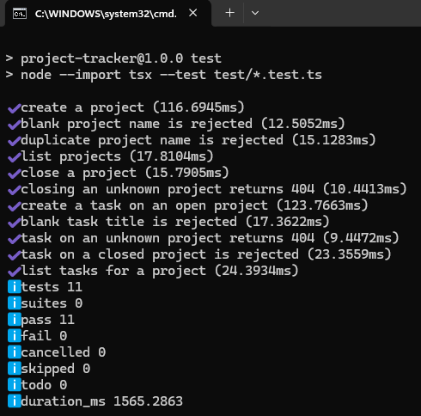
Figure 1: automated test suite running in the terminal, showing all 11 tests passing.
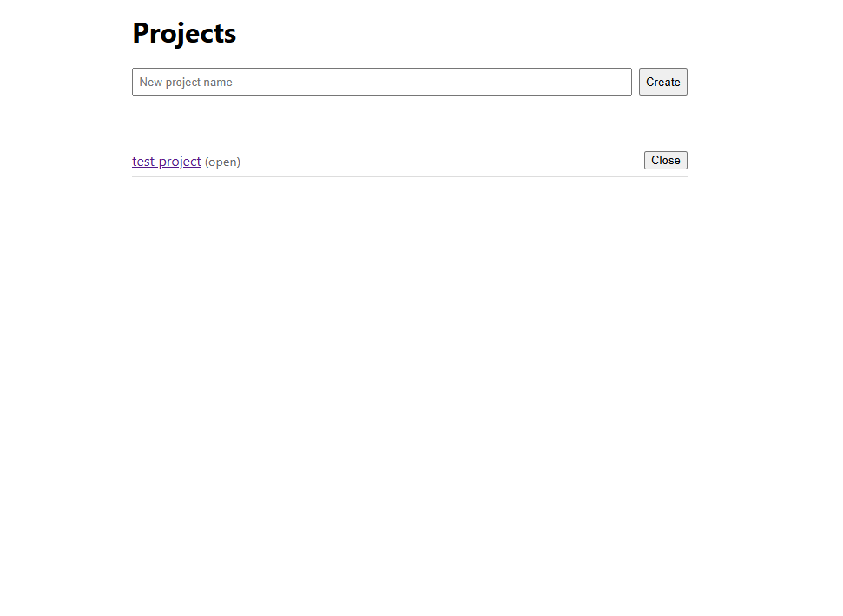
Figure 2: homepage in the browser, listing projects and allowing a project to be created or closed.
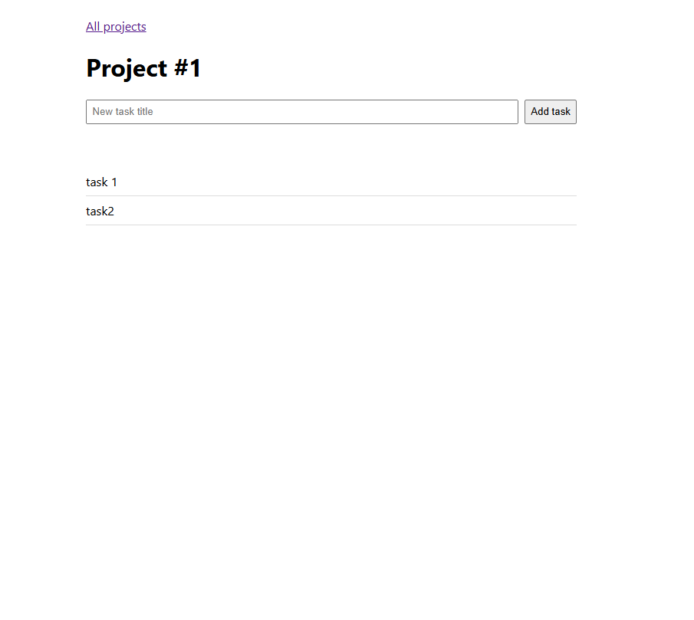
Figure 3: a project's page in the browser, showing its tasks and the option to add a new one.
7. Limitations and Possible Improvements
- No login or authentication.
- Single SQLite file; not built to scale across multiple servers.
- Tasks cannot currently be edited or deleted.
- List endpoints do not support pagination.

With more time, the next steps would be adding authentication, task editing and deletion, pagination for larger lists, and moving from a single SQLite file to a networked database if multiple server instances were needed.
8. Running Instructions
1. Install Node.js 22 or newer.
2. git clone <repository-url> and cd into the project folder.
3. Run npm install.
4. Run npm run dev (or npm run build then npm start).
5. Open http://localhost:3000 in a browser.
6. Run npm test to run the automated test suite.

