ECE 521 Assignment 2

# Work Breakdown

|  |  |
| --- | --- |
| Group Member Name | Contribution Percentage |
| Jixong Deng | 33% |
| Jeffrey Kirman | 33% |
| Connor Smith | 33% |

# 1.2 – Effect of hyperparameters

## Part 1 – Number of hidden units

The code used to see the difference in performance for different number of hidden units can be seen in **hyperparameters.py** specifically in the function *number_of_hidden_units()*. The plots showing the training error and accuracies vs iterations (per epoch) can be seen in Appendix A. The following table summarizes the results of tuning the hyperparameters:

|  |  |  |  |
| --- | --- | --- | --- |
| **# of hidden nodes** | **100** | **500** | **1000** |
| **Val. error (1 – acc)** |  |  |  |
| **Test error (1 – acc)** |  |  |  |

In summary, altering the number of hidden layers has little effect on the validation error for a single layer neural network for this dataset, but lower amount of nodes reduces computation time significantly, making it the better choice.

## Part 2 – Number of layers

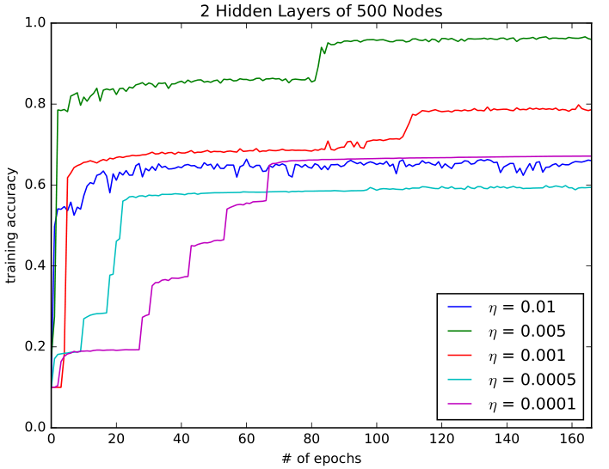

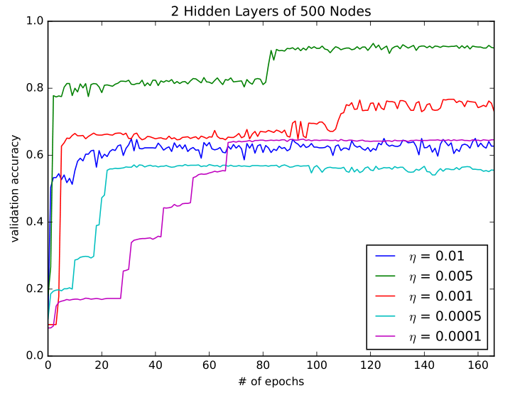

# Appendix A – Graphs

## 1.2.1:

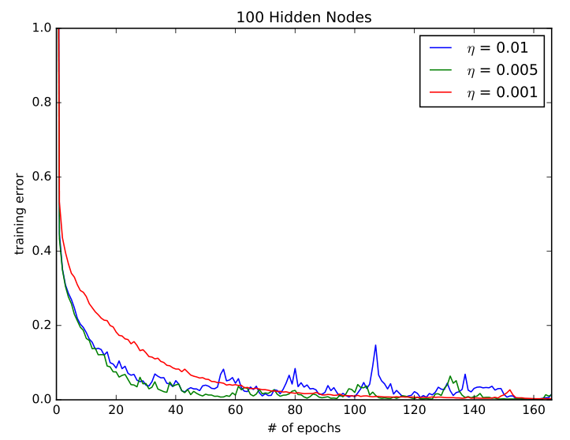

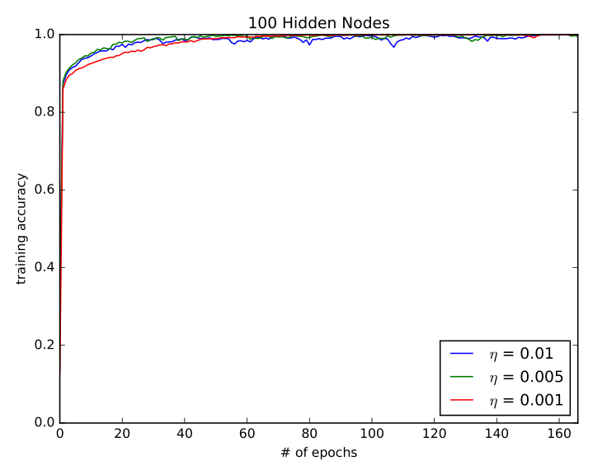

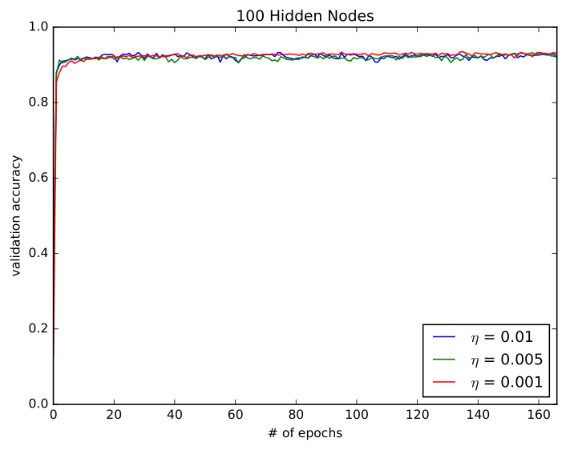

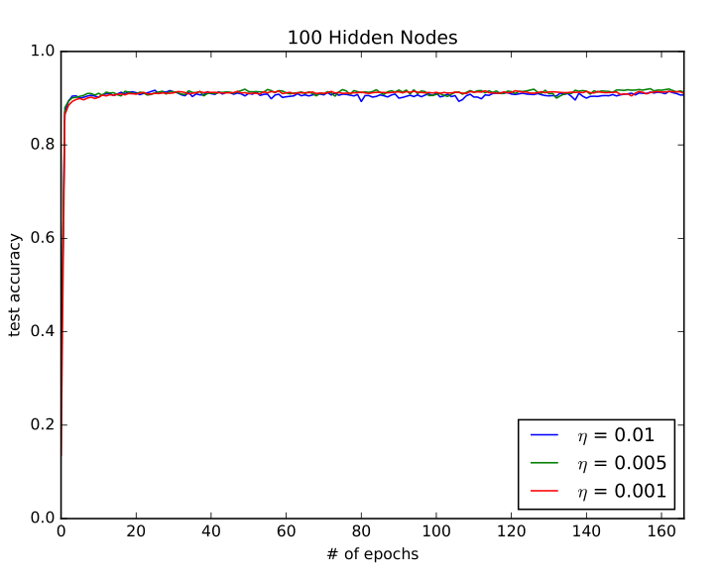

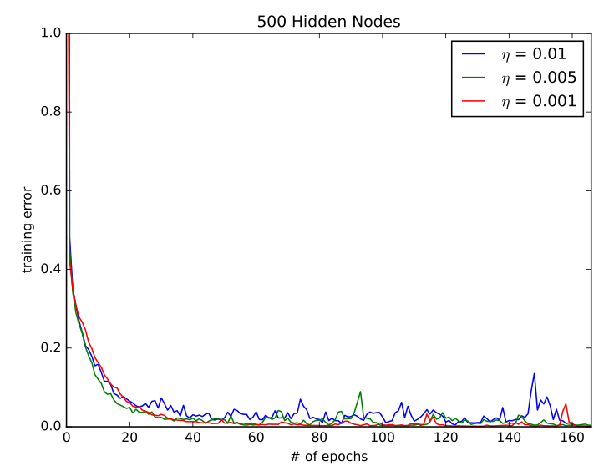

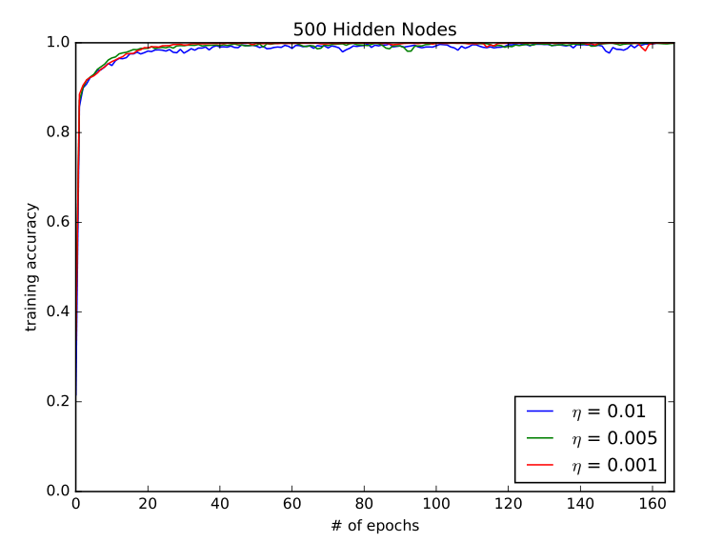

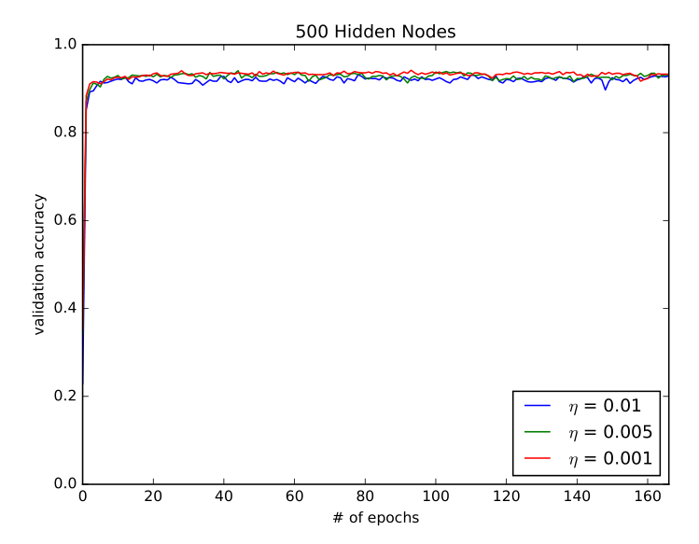

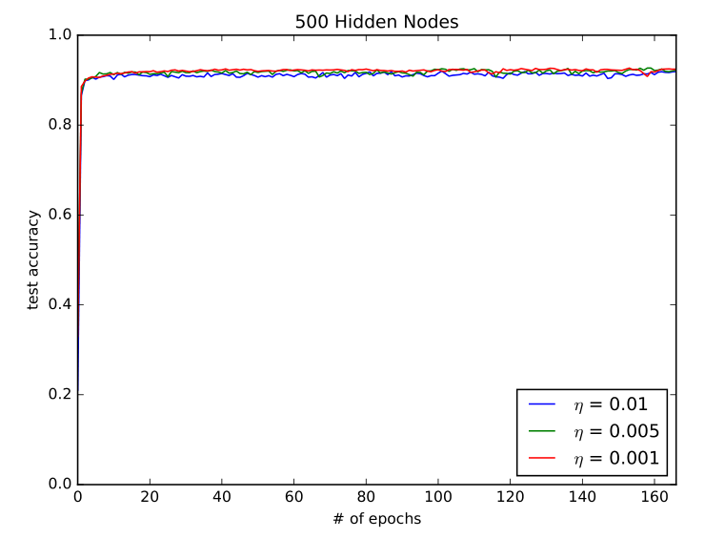

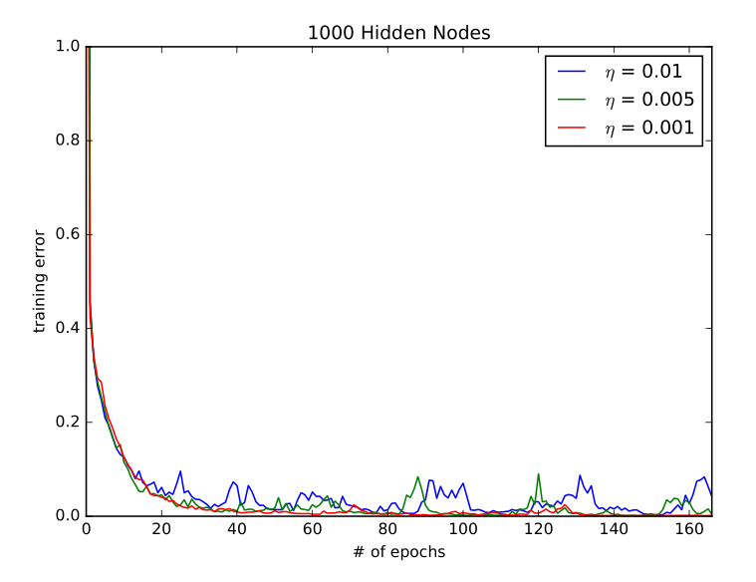

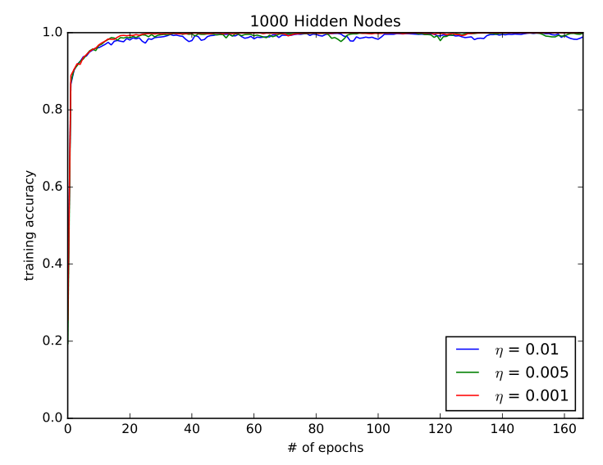

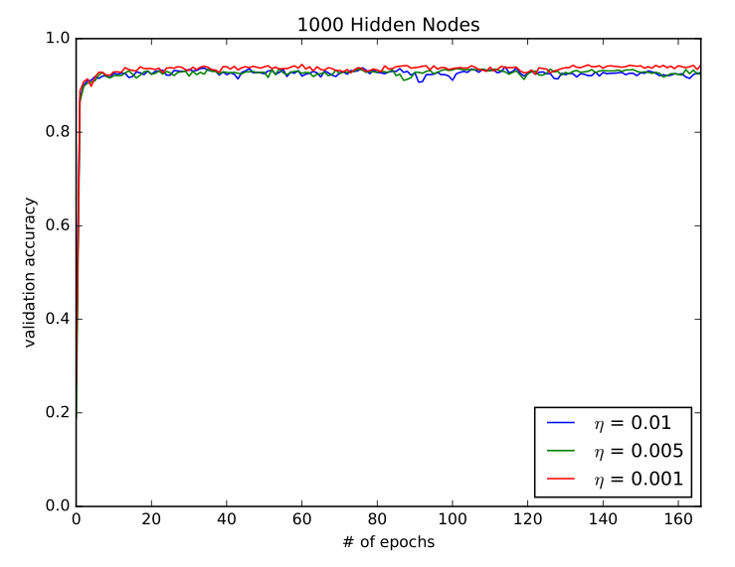

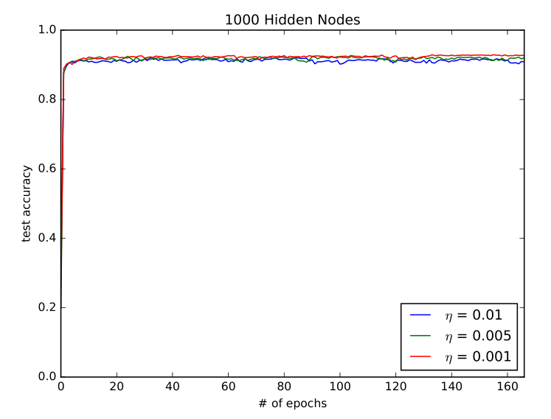

# Appendix B – Python code

## hyperparameters.py

|  |
| --- |
| import numpy as np  import tensorflow as tf  def load_notMNIST():  with np.load("notMNIST.npz") as data:  Data, Target = data["images"], data["labels"]  np.random.seed(521)  randIndx = np.arange(len(Data))  np.random.shuffle(randIndx)  Data = Data[randIndx]/255  Target = Target[randIndx]  trainData, trainTarget = Data[:15000], Target[:15000]  t = np.zeros((trainTarget.shape[0], 10))  t[np.arange(trainTarget.shape[0]), trainTarget] = 1  trainTarget = t  validData, validTarget = Data[15000:16000], Target[15000:16000]  t = np.zeros((validTarget.shape[0], 10))  t[np.arange(validTarget.shape[0]), validTarget] = 1  validTarget = t  testData, testTarget = Data[16000:], Target[16000:]  t = np.zeros((testTarget.shape[0], 10))  t[np.arange(testTarget.shape[0]), testTarget] = 1  testTarget = t  return (trainData.reshape(trainData.shape[0], -1), trainTarget, validData.reshape(validData.shape[0], -1), validTarget, testData.reshape(testData.shape[0], -1), testTarget)  def create_new_layer(input_tensor, num_hidden_units):  '''  @param input_tensor - outputs of the previous layer in the neural network, without the bias term.  @param num_hidden_units - number of hidden units to use for this new layer  '''  # Create the new layer weight matrix using Xavier initialization  input_dim = int(input_tensor.shape[-1])  initializer = tf.contrib.layers.xavier_initializer()  W_shape = [input_dim, num_hidden_units]  W = tf.get_variable("W", initializer=initializer(W_shape), dtype=tf.float32)  # todo: zero initializer?  b = tf.get_variable("b", shape=[1, num_hidden_units], dtype=tf.float32)  # MatMul the extended input tensor by the new weight matrix and add the biases  output_tensor = tf.matmul(input_tensor, W) + b  # Return this operation  return output_tensor  def number_of_hidden_units():  # Constants  B = 500  iters = 5000  learning_rates = [0.01, 0.005, 0.001]  hidden_units = [100,500,1000]  output_data = [[],[],[]]    # Load data  (trainData, trainTarget, validData, validTarget,  testData, testTarget) = load_notMNIST()    # Precalculations  num_iters_per_epoch = len(trainData)//B # number of iterations we have to do for one epoch  print("Num epochs = ",iters/num_iters_per_epoch)  inds = np.arange(trainData.shape[0])    # Set place-holders & variables  X = tf.placeholder(tf.float32, shape=(None, trainData.shape[-1]), name='X')  Y = tf.placeholder(tf.float32, shape=(None, 10), name='Y')  learning_rate = tf.placeholder(tf.float32, name='learning-rate')    for h in range(0, len(hidden_units)):  for lr in range(len(learning_rates)):  # Build graph  with tf.variable_scope("layer1_"+str(hidden_units[h])+"_"+str(lr), reuse=tf.AUTO_REUSE):  s_1 = create_new_layer(X, hidden_units[h])  x_1 = tf.nn.relu(s_1)  with tf.variable_scope("layer2_"+str(hidden_units[h])+"_"+str(lr), reuse=tf.AUTO_REUSE):  s_2 = create_new_layer(x_1, 10)  x_2 = tf.nn.softmax(s_2)    # Calculate loss & accuracy  loss = tf.reduce_mean(tf.nn.softmax_cross_entropy_with_logits(logits=s_2, labels=Y))  accuracy = tf.reduce_mean(tf.cast(tf.equal(tf.argmax(x_2, 1), tf.argmax(Y, 1)), tf.float32))    print("Number of hidden units", hidden_units[h])    with tf.Session() as sess:  with tf.variable_scope("default", reuse=tf.AUTO_REUSE):  optimizer = tf.train.AdamOptimizer(learning_rate).minimize(loss)  coord = tf.train.Coordinator()  threads = tf.train.start_queue_runners(sess=sess, coord=coord)  sess.run(tf.global_variables_initializer())  sess.run(tf.local_variables_initializer())  print("Learning rate = ",learning_rates[lr])  temp_output = []  for i in range(iters):  if (i % num_iters_per_epoch == 0):  np.random.shuffle(inds)  sess.run([optimizer], feed_dict={learning_rate: learning_rates[lr],  X: trainData[inds[B*(i%num_iters_per_epoch):B*((i+1)%num_iters_per_epoch)]],  Y: trainTarget[inds[B*(i%num_iters_per_epoch):B*((i+1)%num_iters_per_epoch)]]})  if (i % num_iters_per_epoch == 0):  t_loss, t_acc = sess.run([loss, accuracy], feed_dict={X: trainData, Y: trainTarget})  v_loss, v_acc = sess.run([loss, accuracy], feed_dict={X: validData, Y: validTarget})  test_loss, test_acc = sess.run([loss, accuracy], feed_dict={X: testData, Y: testTarget})  print("Epoch: {}, Training Loss: {}, Accuracies: [{}, {}, {}]".format(i//num_iters_per_epoch, t_loss, t_acc, v_acc, test_acc))  temp_output.append([t_loss, t_acc, v_acc, test_acc])  output_data[h].append(temp_output)    np.save('Q1-2-1.npy', output_data)  return output_data  def number_of_layers():  # Constants  B = 250  iters = 5000  learning_rates = [0.01, 0.005, 0.001, 0.0005, 0.0001]  hidden_units = [500]  output_data = [[]]    # Load data  (trainData, trainTarget, validData, validTarget,  testData, testTarget) = load_notMNIST()    # Precalculations  num_iters_per_epoch = len(trainData)//B # number of iterations we have to do for one epoch  print("Num epochs = ",iters/num_iters_per_epoch)  inds = np.arange(trainData.shape[0])    # Set place-holders & variables  X = tf.placeholder(tf.float32, shape=(None, trainData.shape[-1]), name='X')  Y = tf.placeholder(tf.float32, shape=(None, 10), name='Y')  learning_rate = tf.placeholder(tf.float32, name='learning-rate')    for h in range(0, len(hidden_units)):  for lr in range(len(learning_rates)):  # Build graph  with tf.variable_scope("layer1_"+str(hidden_units[h])+"_"+str(lr), reuse=tf.AUTO_REUSE):  s_1 = create_new_layer(X, hidden_units[h])  x_1 = tf.nn.relu(s_1)  with tf.variable_scope("layer2_"+str(hidden_units[h])+"_"+str(lr), reuse=tf.AUTO_REUSE):  s_2 = create_new_layer(x_1, hidden_units[h])  x_2 = tf.nn.softmax(s_2)  with tf.variable_scope("layer3_"+str(hidden_units[h])+"_"+str(lr), reuse=tf.AUTO_REUSE):  s_3 = create_new_layer(x_2, 10)  x_3 = tf.nn.softmax(s_3)    # Calculate loss & accuracy  loss = tf.reduce_mean(tf.nn.softmax_cross_entropy_with_logits(logits=s_3, labels=Y))  accuracy = tf.reduce_mean(tf.cast(tf.equal(tf.argmax(x_3, 1), tf.argmax(Y, 1)), tf.float32))    print("Number of hidden layers: 2, Number of hidden units", hidden_units[h])    with tf.Session() as sess:  with tf.variable_scope("default", reuse=tf.AUTO_REUSE):  optimizer = tf.train.AdamOptimizer(learning_rate).minimize(loss)  coord = tf.train.Coordinator()  threads = tf.train.start_queue_runners(sess=sess, coord=coord)  sess.run(tf.global_variables_initializer())  sess.run(tf.local_variables_initializer())  print("Learning rate = ",learning_rates[lr])  temp_output = []  for i in range(iters):  if (i % num_iters_per_epoch == 0):  np.random.shuffle(inds)  sess.run([optimizer], feed_dict={learning_rate: learning_rates[lr],  X: trainData[inds[B*(i%num_iters_per_epoch):B*((i+1)%num_iters_per_epoch)]],  Y: trainTarget[inds[B*(i%num_iters_per_epoch):B*((i+1)%num_iters_per_epoch)]]})  if (i % num_iters_per_epoch == 0):  t_loss, t_acc = sess.run([loss, accuracy], feed_dict={X: trainData, Y: trainTarget})  v_loss, v_acc = sess.run([loss, accuracy], feed_dict={X: validData, Y: validTarget})  test_loss, test_acc = sess.run([loss, accuracy], feed_dict={X: testData, Y: testTarget})  print("Epoch: {}, Training Loss: {}, Accuracies: [{}, {}, {}]".format(i//num_iters_per_epoch, t_loss, t_acc, v_acc, test_acc))  temp_output.append([t_loss, t_acc, v_acc, test_acc])  output_data[h].append(temp_output)    np.save('Q1-2-2.npy', output_data)  return output_data    #output = number_of_hidden_units()  output = number_of_layers() |