Labyrinth
PA11

by Connor Kirby and Tyler DeWitt
Overview
_________________________________________
Labyrinth is a game with the goal to traverse the maze with a ball, controlled by the tilting of the board it sits on, without falling into numerous holes on the floor.
Our version has the player running against the clock, the quicker the ball reaches the goal the higher the score. The current score gets tallied up with the total score once a run is completed. The player has three lives to rack up the highest total score he or she can. The knobs on each side of the screen turn based on your board tilt.

Extra Credit: Multiple balls in play has been implemented.
User Manuel
__________________________________
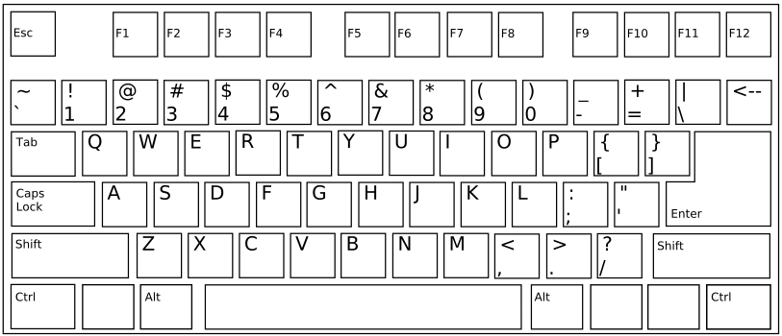
mouse | Tilts board on movement
w | Tilt board upward
a | Tilt board left
s | Tilt board downward
d | Tilt board right
n | Toggle two balls
m | Display menu
space bar | Change camera angle
esc | Exit game

User Manuel cont.
__________________________________
Gameplay

Menu

Game Over Menu

Gameplay with Two Balls

Bird's Eye Camera Angle

Reverse Bird's Eye Camera Angle

Reverse Camera Angle

Tech Manuel

Issues:
Multiple lighting types

What would have been done differently:
Multiple shaders to be switched
out during runtime
Implementation of multiple
levels
Implementation of top 10 scores
in a file

