Air Hockey
PA09

Connor Kirby
Tyler DeWitt
OVERVIEW
_______________________

This program is a recreation of the classic game Air Hockey! This game supports 1 to 2 players as opponents are pitted against each other to see who can rack up 5 goals in the shortest amount of time. Play against a friend or a computer as player 2 can drop in and out at any time in the game.

NOTE: This game has been optimized to be played in full screen.
_______________________

EXTRA CREDIT: We have implemented
- Text2D display | - Changeable puck shape (a few options) with correct physics.
- 2 Humans or Human/AI | - Toggle for AI/Player2 c

USER MANUAL
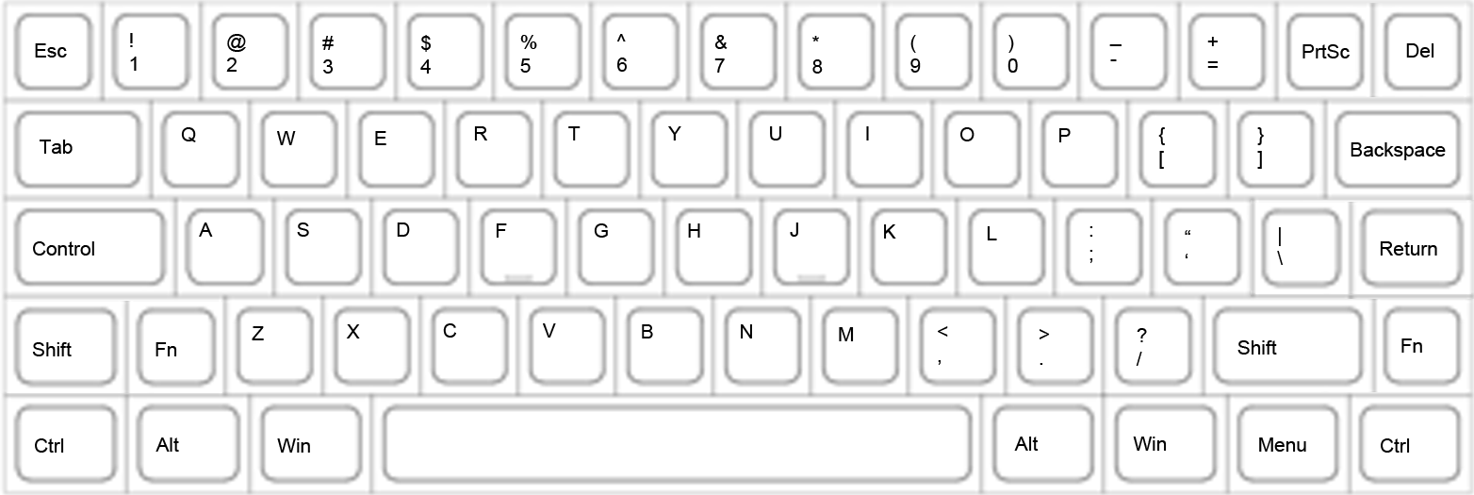
_______________________
Player 1 | Player 2
mouse = movement controls player 1 paddle  a = move the player 1 paddle to the left  d = move the player 1 paddle to the right  w = move the player 1 paddle forward  d = move the player 1 paddle backward | j = move the player 2 paddle to the left  l = move the player 2 paddle to the right  i = move the player 2 paddle forward  k = move the player 2 paddle backward

esc = exits program  n = toggles player 2 AI  m = opens menu  space bar = changes camera  angle | menu:  - resume = resumes current game  - restart = begin new game  - change shape of puck = restarts game with a new puck
TECHNICAL MANUAL
_______________________
Issues: Mouse movement could use more refinement.
Physics could feel slippery for some users.
Better gameplay mechanics if paddles did not suffer knock back from puck.
Barriers for paddles could have been implemented much cleaner and with much more efficiency.

What we would do differently:
Heavier physics
Drop down menu
More puck/paddle choices
More involvement of text
Smarter AI

