- Bizagi dispute detail
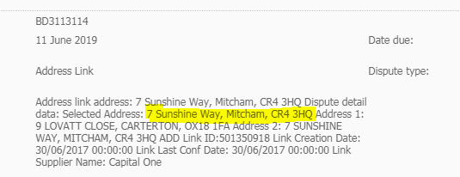
- Select disputed item in NI
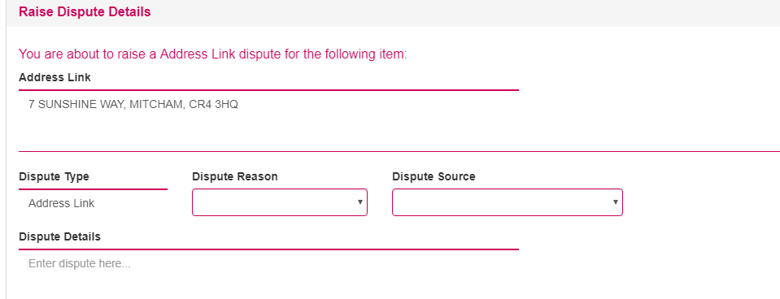
- Dispute raised (dispute this item button greyed out)
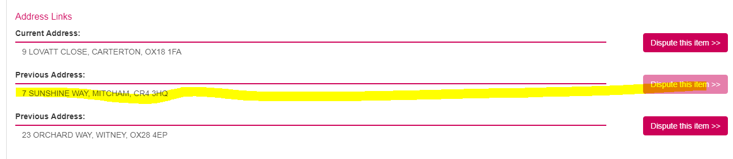

- Numero Dispute detail:
