ECEn 528

Study Guide ­ DRAM

* Read Section 2.3 of H&P

 Things to focus on

■ DRAM organization  Clarifications

■ Memory subsystems have been organized into banks for performance and capacity for decades now. As individual DRAM chips got larger, the number of banks got fewer. So, we now put banks inside the chips. It is now common to call banks outside of the chips “DRAM channels”  Answer the following questions:

* + 1. Why is it easier to increase memory capacity and bandwidth than it is to decrease memory latency?

**Moore’s Law helps capacity/bandwidth more than latency, distance limits latency, overhead hurts latency, bandwidth hurts latency**

* + 1. Why would you build a system with only parity?

**Parity only requires a single bit of overhead, and detection can be enough sometimes (if it’s possible to recreate the data)**

* Read “Memory Access Scheduling”, ISCA 2000  Things to focus on

■ Focus more on the scheduling concepts than the evaluation

 Clarifications

■ This is a fairly old paper, so the numbers for both DRAM sizes and transfer rates are a bit dated.

■ This paper introduced the concept of memory access scheduling, which is why it says that “current” memory controllers don't do it. Memory access scheduling is now very commonly used.

 Answer the following questions:

* 1. Come up with a reference stream like that in figure 1 with at least 4 references. Draw the timing diagram without access scheduling and with an “ideal” access schedule.

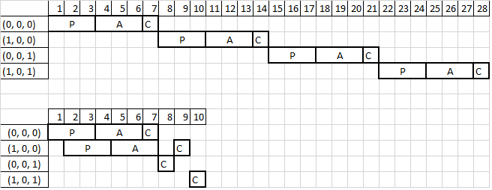

* 1. What is the difference between open and closed precharge scheduling?

**Open: a bank is only precharged if there are pending references to other rows in the bank and there are no pending references to the active row (good for significant row locality, making it likely that future references will target the same row as previous references).**

**Closed: a bank is precharged as soon as there are no more pending references to the active row (good if it is unlikely that future references will target the same row as the previous set of references).**

* 1. When is giving column access priority over row access better than giving row access priority over column access?

**Column-first scheduling reduces the latency of references to active rows.**

* 1. Why might you want a policy which looks at the number of pending references?

**Most pending would be used to allow rows to be activated that will have the highest ratio of column to row accesses, while waiting for other rows to accumulate more pending references.**

**Fewest pending would be used to minimize the time that rows with little demand remain active, allowing references to other rows in that bank to make progress sooner**

* 1. How might you improve upon any of the scheduling policies given in this paper?

**I have no earthly idea.**