Analyzing habitat use and movement using Step Selection Function:

The Corsican red deer

Savalli Hannah

Pettorelli Nathalie1, Safi Kamran2, Mondoloni Stevan3

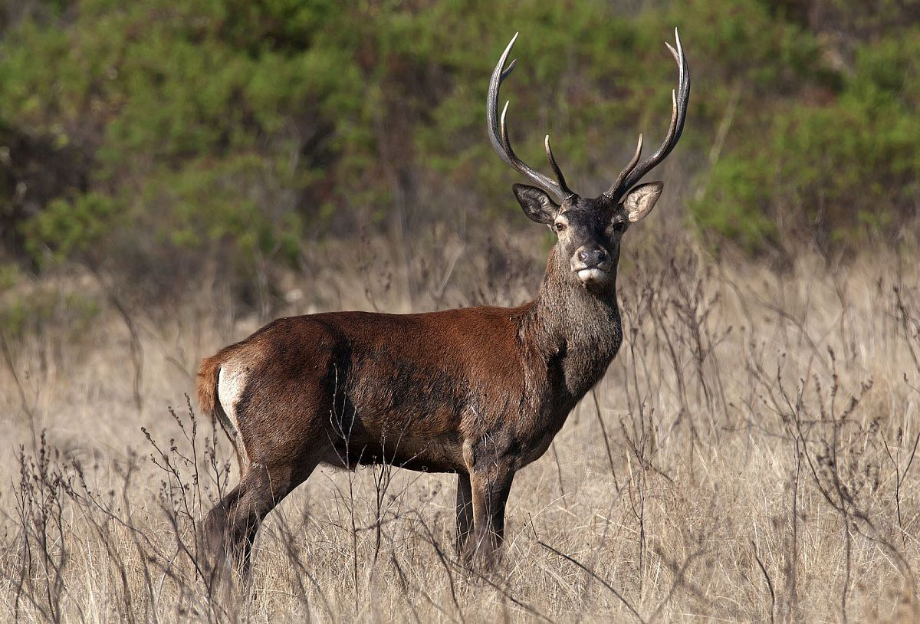

|  |
| --- |
| 1Zoological Society of London, London, United-Kingdom  2Max Planck Institute of Animal Behavior, Konstanz, Germany  3Regional Parc of Corsica, Corte, Corsica (France) |



Acknowledgments

I’d like to express sincere gratitude to Nathalie Petorelli and Kamran Safi who supported me through this internship and provided invaluable insights and guidance throughout the study. I am also grateful to Stevan Mondoloni and the staff of the Regional Parc of Corsica for their dedicated fieldwork, data collection efforts and fundings. Special thanks to Jean-Michel Gaillard who provided me a place to work when I needed it.

INTRODUCTION

Our planet is facing an imminent threat with a massive loss of biodiversity, primarily due to human activities. Human activity result in habitat destruction, pollution, overexploitation of lands and seas, rapid climate change, and disruption of ecosystem functioning by invasive species. If this disastrous loss of wildlife is a contemporary problem, it has roots in history. Between the end of the Pleistocene and the Holocene – a short period from a geological perspective – most mammals, including the largest ones, disappeared (Trouwborst & Svenning. 2022). Megafauna, whether carnivores or herbivores, is yet an essential component of biodiversity, underpinning the dynamics of ecosystems worldwide for millions of years (Svenning et al. 2022) and so megafauna extinction had profound impacts on ecosystem composition, structure and functioning (Danell et al. 2006; Ripple et al. 2015). Megaherbivores, especially, impact ecosystems through a variety of mechanisms; shaping, for example, vegetation structure and their physical environment through grazing, browsing, physical disturbances, and the dispersion of propagules and nutrients (Norman Owen-Smith 1988). Moreover, their bodies, carcasses, and excrements provide a range of specialized biotic micro-habitats for other species. The high mobility of large mammals also supports high biotic connectivity through the dispersion of many plant, fungus, and invertebrate species, affecting their colonization, distribution, and maintenance within and between landscapes (Svenning et al. 2021). It has been estimated that anthropogenic expansion, hunting, and habitat destruction have reduced megaherbivore numbers to a fraction of what they were 50,000 years ago. Their decline triggered a cascade of ecological consequences on a global scale, which have been linked to altered fire regimes, increased pressures from invasive species, and modifications of greenhouse gas regimes (Cromsigt et al. 2018). To counter this alarming trend, various approaches to nature recovery have been proposed, including ecological restoration, and more recently, rewilding (Pettorelli et al. 2019). Restoring implies returning something to its former condition or state. To achieve such thing, we have to agree on what the former state actually was and maintain the agreed state despite changing environmental conditions (Pettorelli et al. 2019). Thus, restoring need continuous human intervention to maintain the ecosystem into a particular state. In contrast, rewilding takes the changing nature of ecosystems into account and try to manage an area back to wild in the form of a self-sustaining ecosystem. It aims to reorganize and manage ecosystems processes to create an ecosystem that doesn’t require human interaction afterward (Pettorelli et al. 2017). Ecosystems processes are understood as open systems that exchange matter, energy, information, and organisms with their surroundings (Lovett et al. 2006). Therefore, knowing the actual state of our planet and the threat of climate change, projects of rewilding become more and more relevant. Rewilding offers numerous ecological, economic, and social benefits:

* **Biodiversity Enhancement**: By restoring natural habitats and reintroducing native species, rewilding increases biodiversity and supports the recovery of endangered species(**Millennium Ecosystem Assessment (MEA)** (2005)).
* **Ecosystem Services**: Healthy ecosystems provide vital services such as clean water, air purification, soil stabilization, and carbon sequestration, which are essential for human well-being and combating climate change (Tilman et al. 2014).
* **Economic Opportunities**: Rewilding can boost local economies through eco-tourism and sustainable resource use. Communities can benefit from the economic influx associated with wildlife tourism and the conservation of natural resources (Pettorelli et al., 2017).
* **Resilience to Climate Change**: Diverse and well-connected ecosystems are more resilient to climate change and environmental disturbances. Rewilding helps create robust natural systems that can better withstand and adapt to these changes (Lovett et al., 2006).

Several rewilding projects worldwide have demonstrated the potential of this approach. A good exemple would be the wolves of Yellowstone National Park, USA. The reintroduction of wolves in the 1990s has led to significant ecological changes, including the recovery of vegetation and the return of species such as beavers and songbirds. Wolves control the elk population, allowing overgrazed areas to regenerate and support a wider range of species (Ripple et al., 2015).

Both rewilding and restoration consider species translocations as interventions to fulfil their aims, particularly when considered for degraded ecosystems having experienced functionally significant local extirpations (Seddon et al. 2014). Species translocations, particularly for large species, are however not without risks and must be implemented with caution, as they can lead to conflicts with human activities such as agriculture, logging, hunting, and development. In the United States, reintroduction of a large ungulate, Elk Cervus canadensis, is strongly impacted by human activities (Wang et al. 2009). The presence of roads reduces population performance by facilitating hunter access and elk-vehicles collisions (Frair et al. 2007). On the other hand, Elk damage fences, depredate crops, and exchange diseases with livestock (Wang et al. 2009; Hegel et al. 2009). Again, in Sardinia, the reintroduction of endangered deer species Elaphus corsicanus is linked to sanitary risks as the deer are healthy carriers of Bluetongue virus. Thus, translocating deer requires particular attention to minimize sanitary risks of spreading BTV to livestock (Riga et al. 2022). In the current context, it is imperative that translocation initiatives bring positive ecological gains in both the short and long term (Svenning et al. 2016). One way to prevent increases in human-wildlife conflicts following species translocations is to mitigate risks, and identify areas likely to be colonized by introduced individuals. Such studies could be developed thanks to recent progress in positioning technology that facilitated the collection of large amounts of spatial data on animals. This has led to new opportunities to investigate resource selection by animals (Kays et al. 2015; Whittington et al. 2020), but also new challenges related to the development of proper tools for the analysis of these large amounts of information (Frair et al. 2010; Gaillard et al. 2010). Spatial data collected at such high frequency open new scenarios because they contain important information about behavior and decisions made by animals while moving through the environment (Fortin et al 2005) Studies using such fine-scale data and dealing with animal movement can be used to answer fundamental ecological questions related to species distributions and diversity (Manly et al. 2002; Fortin et al. 2005; Johnson CJ et al. 2008), home range formation (Moorcroft et al. 2006) , and can result in important management tools for identifying movement corridors (Chetkiewicz et al. 2006), key habitats (Squires et al. 2013), and responses to disturbance (Roever et al. 2010).

In this study, we aim to combine information on topography, geography, physiology and temporal analysis to highlight suitable habitats and colonization routes for reintroduced Corsican red deer (Cervus elaphus). The case of the Corsican red deer is particularly interesting for several reasons. Island fauna has been known to undergo a much higher extinction rate than continental fauna (Wood et al. 2017), and yet research on the consequences of species translocations within islands is poorly studied, with most of our knowledge being based on herbivore translocations on continents. In 1970, the Corsican deer completely disappeared from this highly topographically heterogeneous island due to illegal hunting and habitat fragmentation (vineyards); it would take more than 25 years to see them again in the island’s forests. Following this extinction, a conservation program started in order to reintroduce deer from populations in Sardinia (Mandas et al. 2008). Deer were translocated from Sardinia and raised in natural reserves in Corsica for several years before being released into the wild in 1998. The program was part of the *LIFE+, One deer, two islands* project that aimed to reintroduce deer to areas where it was previously extinct.

It is known that the behavior of deer after their reintroduction is influenced by the spatial structure of the landscape (La Morgia et al. 2011) and neighboring human activities (Zidon et al. 2009). Their habitat preference can vary with season and geographic location and is influenced by the presence of both food and cover (Borowski and Ukalska 2008; Putman & Moore 1998). What’s more, it is often people who influence deer behavior and habitat use most (Puddu et al. 2009). Furthermore, because deer are shy creatures, the availability of hiding cover becomes a crucial factor in determining habitat use by deer (Cargnelutti et al. [2002](https://nsojournals.onlinelibrary.wiley.com/doi/full/10.1002/wlb3.01049" \l "bib-0009); Dechen et al. [2013](https://nsojournals.onlinelibrary.wiley.com/doi/full/10.1002/wlb3.01049" \l "bib-0015) ). For that reason, our primary goal, is to highlight the choices made by deer regarding the landscape. Topographic variables such as landcover and elevation would give great clues on understanding and predicting habitat use after reintroductions. 1)We expect deer to spend more time in forest landcover offering shelter and food and actively avoid urban areas. 2)Furthermore, we aim to brought to light the seasonal variations in habitat use. Deer utilize various elevations seasonally, moving to higher elevations during the summer for better forage and descending to lower elevations during winter to escape deep snow and find milder condition (Dagtekin et al. 2023). It is also known that deer’s movement are governed by many other variables such as sex and location. 3)Consequently, we expect as well that their behavior differs depending on these variables.

**MATERIALS AND METHODS**

In order to show habitat use of the Corsican red deer I used 5 years of GPS data collecting and multiple environmental variables. The individuals tracked were located in 3 different regions of the island and equipped with unique GPS collar. Once collected, the data were stored on Movebank, an online database, and analyzed using R Studio v. 4.3.0.

**REINTRODUCTION PROGRAM:**

The reintroduction actions started in 1985. Several individuals were taken from Sardinia and placed in 3 enclosures in 3 different places: **Quenza**, on the southern slope of the Incudine mountain, at **Casabianda**, on the eastern plain and at Ania, in the mountainous area of **Fium’Orbu**. Those sites were chosen according to the ecological requirements of the deer (De´meautis, 1984), as well as local socio-economic and cultural constraints (Dubray, 1989 and 1990).

After a phase in captivity, the individuals were released into the wild in three localities between 1998 and 2018. They were released in groups, and individuals from the same location were released simultaneously.

* Moltifau (North area)

This site spans an area of 513 ha and is characterized by shallow and arid soils on gneiss and granite bedrocks, except in the shelf and watershed areas (cf. Appendix 1). The predominant threat to this area is the risk of fire. The landscape combines open and wooded countryside, with grasslands and maquis covering the gentler slopes and forests growing on the steeper ones (LIFE financial instrument of the European Union, 2014, 2015).

* San Petru di venacu (Central area)

The Massif du Rotondo site covers a surface of 15 295 ha and is part of the geological series known as the "Medium-grained granite of central Corsica" ((cf. Appendix 1). The area is characterized by three mountain valleys: Tavignano, Restonica, and Verghello, which offer great biological and scenic variety. The vegetation mainly consists of oaks, beeches, bushes, and scrub (LIFE financial instrument of the European Union, 2014, 2015).

* Zicavu (South area): Plateau du Coscione

This site covers an area of 11 228 ha in the Hercynian area of Corsica ((cf. Appendix 1). The mid mountainous territory is characterized by its Euro-Siberian physiognomy and features beech, fir, larch, and alder trees. The hilly and rugged landscape has numerous springs, streams, and marshes (LIFE financial instrument of the European Union, 2014, 2015).

**DATA COLLECTING:**

From all the individuals released into the wild, 19 (13 females and 6 males) were given a unique GPS collar and names to enable their localization and recognition (cf. table 1). The GPS collars provide real-time information on the animals' survival, dispersion, and habitat use. These devices have been collecting data for 5 years, between December 15th of 2015 until December 31th of 2020. Animals’ locations were recorded twice a day – at 10 a.m. and 10 p.m. for a minimum of 24 months. Data are stored on Movebank, an online database of animal tracking (Max Planck Institute of Animal Behavior). Such a database offers several advantages such as standardized data, environmental annotation easily accessible and direct use trough R (Kays et al. 2021).

Table 1: repartition of individuals in each site

|  |  |  |  |  |  |  |
| --- | --- | --- | --- | --- | --- | --- |
|  | North site | Central site | | | South site | |
| ID | Barbara (F)  Banditu (M)  Sara (F)  Roberto (M) | Dionigi(M)  Vanina (F)  Victoria (F) | Mattea (F)  Romane (M)  Sabrina (F) | Lucio (M)  Stella (F)  Lisandru (M) | Cavallara (F)  Chisaccia (F)  Latonaccia (F) | Luvana (F)  Sapara (F)  Violetta (F) |
| ∑ | 4 | 9 | | | 6 | |

To answer the first theory that deer tend to mind elevation and landcover values when moving into the environment, we need environmental information. Elevation and landcover values are respectively downloaded from the *Eurodem* and *CORINE landcover* websites. They are free to access and provide relatively recent raster file for a given area.

The elevation data have been collected in 2023 and the geographical coordinates are in seconds (longitude, latitude); based on the ETRS89 spatial reference system (EPSG:4258) (cf. Appendix 2).The landcover data have been collected in 2018 and the raster obtained from it is classified in 48 types (ordered by numbers from 1 to 48).

The variable *slope* is calculated with the following formula, using the element from the elevation Raster $Slope=\arctan\left(\frac{elevation}{distance}\right)$

Due to the presence of seasonal patterns, we separated data into summer and winter seasons and fitted independent wet and dry seasons models.

**MOVEMENT ANALYSIS**

Using QGIS I created a common GIS for all our environmental data based on the EPSG of our GPS data. Here I used the EPSG standards; precisely, the EPSG:4326 – corresponding to [WGS 84](https://en.wikipedia.org/wiki/WGS_84" \o "WGS 84) – a latitude/longitude coordinate system based on the Earth's center of mass. Uncertainty is believed to be less than 2 cm.

**CLEANING DATA**

Data were extracted directly from Movebank and cleaned using R Studio. I removed any outliers that could cause extravagant results and did the same thing for empty coordinates and duplicates. Most of the time, duplicates are caused by the same location transferred twice via different sources, one with more information than the other. In that case, I remove duplicates that are subset of others. And, naturally, empty coordinates caused by bad reception of GPSs signal or device failure, are removed as well.

**Pre-analysis work**

To deal with movement data in R, I created a Move object from the raw data. The Move package extends the spatial object SpatialPointsDataFrame by making time a mandatory component (movement = location + time). It also allows to calculate distances taking into account the curvature of the Earth and it makes sure some basic assumptions of movement are not violated (e.g. duplicated times are not allowed). Because of the properties of movement data, their analysis in R requires the use of a wide range of R packages and strict care regarding time, distance, speed, and space.

**Temporal organization of the trajectories**

Even supposedly regularly sampling devices such as GPS units often fail to be truly regular which can influence the regularity of the data obtained and need to be investigate. I checked for irregularity by taking a look at the time intervals between fixes in relation to the time of the day when the fixes were obtained. Time intervals can be obtained using the *timeLag* function, which returns a list of vectors. The option **units** control the unit at which the time lag information is displayed and is adjusted to the units that is most useful. In this case ‘hours’ is used. We then subset the **timeLagsVec** vector to only time intervals shorter than a specific hour to get a better idea of the distribution of time**.**

## Spatial organization of the track

Following the temporal characteristics of trajectories, checking speed and distance is also a very good first health check option to identify outliers and verify the plausibility of the data roughly. The exploration of both the distribution of speed and distances can make exceptionally high speeds and extremely long distances obvious, often an indication of mistakes in the data such as wrong. But beyond error checking, obtaining speed and distances are important initial measures informing about important biological aspects of the individuals ecology (Safi et al. 2013). Speed and distance ultimately form the basis of important biological questions such as dispersal ability and how barriers are likely to affect species (Tobalske et al. 2003; Alerstam et al. 2007; LaPoint et al. 2013). The distances between locations of a track can be obtained in a similar way as the time intervals using the R function *distance*. The units for distance are meters. In the same way, ground speed can easily be calculated using the function *speed*, it returns the speed in meters per second by default for an object in GCS projection. I rearranged the code to obtain a measure in meter per hour. Finally, because speeds and distances have naturally very long tails, the data needed to be transformed to run linear model. Usually log or sqrt, but if we are not sure, *boxcox* is a nice function to find a right transformation of the data.

## Turn Angles:

## In addition of distance and speed, exploring turn angles is essential as this is a key component of animal movement. Turn angles correspond to the change in direction. In most cases, we expect a uniform distribution (for example Brownian motion) or an over representation of small turning angles (for example a correlated random walk) (Bovet & Benhamou, 1988; Turchin et al.1998).

## Trajectory centered analysis

First, I looked at the characteristics of the trajectories themselves, and evaluated some methods and approaches that focus around different aspects of trajectories, such as distance, speed, turning angles and step length. Finally, I looked at ways of comparing between trajectories to evaluate first inter-individual characteristics.

**STEP SELECTION FUNCTION**

Thanks to recent progress in positioning technology, collecting massive amount of sequential spatial data became easier and more widespread. One of the new opportunities this offers are tools like Step Selection Functions. Theserelatively new models are powerful assets to study resource selection using the animals’ movement into the environment. The SSF method is derived from classic resource selection functions (RSFs) that employ a ‘used’ versus ‘available’ design to estimate species–habitat relationships (Manly et al. 2002). In this study, I used SSFs to compare environmental attributes of observed steps (the linear segment between two consecutive observations of position called ‘used’) with alternative random steps taken from the same starting point (called ‘Available’). In other words, in SSFs, the ‘used’ data give information on the landscape variables measured along each step between consecutive points. ‘Available’ data are obtained by generating random steps (drawn from the empirical distribution of step lengths and turning angles) from the start point of each used step. Landscape variables are then measured along these random steps. SSF is modeled in a conditional (a.k.a. case-controlled) logistic regression framework where each used step is paired with those that are randomly generated (Agresti 2002; Fortin et al. 2005). This framework allows for a realistic comparison between used and available (Compton et al. 2002; Fortin et al. 2005) and allows for context-dependent modeling (Zeller et al. 2014).

**STEP SELECTION FUNCTION IN R**

When working with SSF, the main package used is **amt**. This library allows us to transform the initial cleaned dataframe into an object of track_xyt supported by the model*.* Using this new data frame I inspected the samples using the function *amt::track_resample*. The track is then thinned to every 12h, with a tolerance of 3 hours. Resulting object will contain the attribute “burst_” that will assign a burst ID to all consecutive locations that are 12h (± 3h) apart, if two locations are too far apart, they are assigned two different bursts. In addition, I filtered out burst with 3 observations or more, as turning angles require at least 3 locations to be calculated. Following, I converted locations to steps. It is expected to have fewer rows in the step data frame than in the track data frame because the final position is not a complete step.

Now comes the random step creation part using the *random_steps* function. It is recommended to create at least 100 random steps for each ‘used’ (The outcome of this function creates the column *case_.* This indicator variable, is equal to *TRUE* for the used locations and *FALSE* for random locations.

The result of all the steps above is the final data frame before running the SSF model. For a better understanding I will call this type of table, SSF data-frame (cf. Appendix 3).

Next step is checking the annotated dataset for multicollinearity and use only variables not highly correlated (r < 0.6). I centered and scaled the predictors to mean zero and units of standard deviation (i.e. z-scores) to ensure comparability among predictors. The mainevent is now running the SSF. Step selection functions were estimated using the *fit_clogit* function with the amt package in R v. 4.3.0. I constructed a multilevel model with fixed effects for elevation, landcover types and slope. For an unknown reason, when integrated into the model, the season variable didn’t work. To counter this issue, I decided to take the season variable out and run each model by season separately. Seasons were determined by month: summer from June to august, fall from September to November, winter from December to February and spring from March to May.

It is important to highlight that, the SSF function is a single individual approach. Knowing that, each of the 19 individuals had to undergo the SSF function separately. Once the 19 models were created, run and checked to ensure that they work correctly, I aggregated them into one big model to analyze deer movement at the population level. We can now check impact of elevation, landcover and slope at the population level.

**RESULTS**

**Temporal organization of the data**

|  |  |  |  |
| --- | --- | --- | --- |
| a) |  | b) |  |

When inspecting irregularity, we notice that most of the time intervals between fixes are 12h and a few around 24h (cf. fig 2a). Knowing our GPS collars recorded animals’ location every 12h, this outcome is expected and reassuring. Expect the few intervals of 24h, certainly due to connection fails, our data are very steady, demonstrating regular GPS data collecting trough time (cf. fig 2b)

Fig 2: a) Distribution of time lags over the entire study. b) Distribution of time lags for hours centered at 12.0

**Spatial organization of the data**

**Distance**

Individuals travel an average distance of 331.5m in between each consecutive points. We do not observe a significant difference of travel distance between sexes (p=0.53), (cf. fig3).

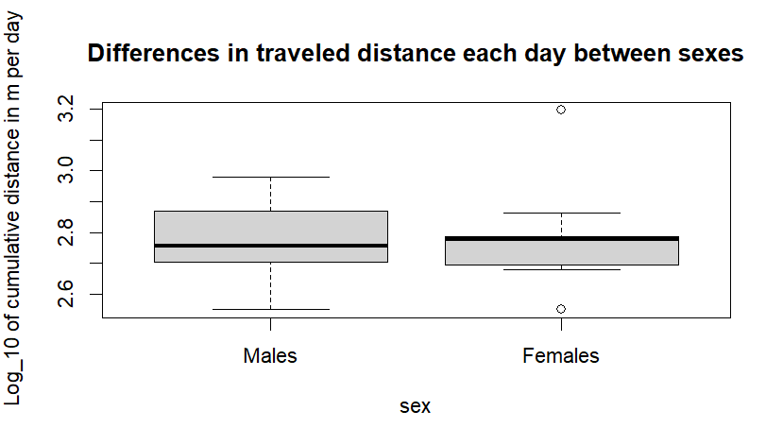

Fig 3: Comparison of track lengths using a box plot between females and males

However, we do observe a significant difference for travel distance between deers of different areas (p=0.005). Individuals in the Northern area tend to walk greater distance than Center and Southern areas (cf. fig4).

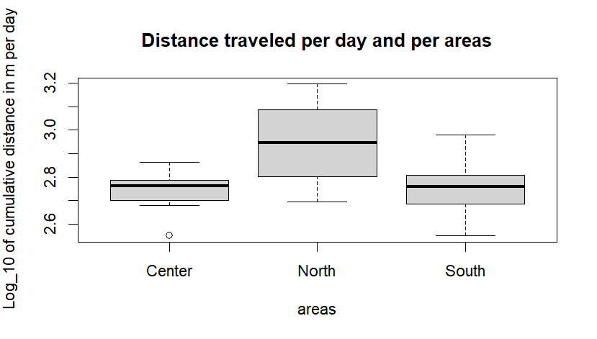

Fig 4: Comparison of track lengths using a box plot between the 3 regions studied

**Speed**

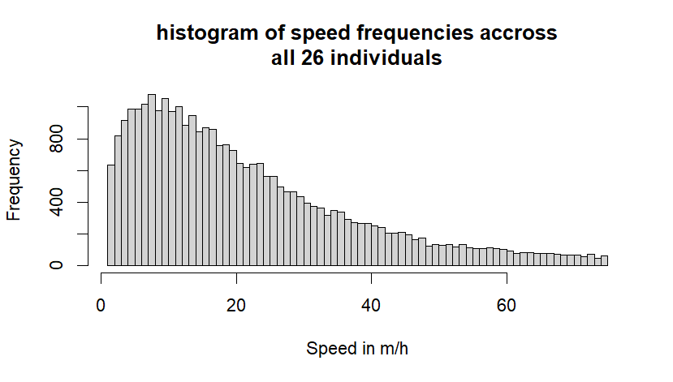The average speed through all data is 25.2m per hour (cf. fig 5). Speed values range from 0.012m/h to 720 m/h. When excluding extravagant speed values that could biased the average speed, we end up with 95% of the speed values between 1 and 75m/h. The mean speed is then slightly lower, at 21.5m/h.

Fig 5: Histogram of speed distribution over the entire study. The frequency represents independently every step of every individual.

We do not observe a significant difference for mean speed between sexes (p=0.97), (cf. fig 6). Plus, unlike the mean distance, we did not observe a difference for mean speed between areas (p_north=0.22, p_south=0.80), (cf. fig 7).

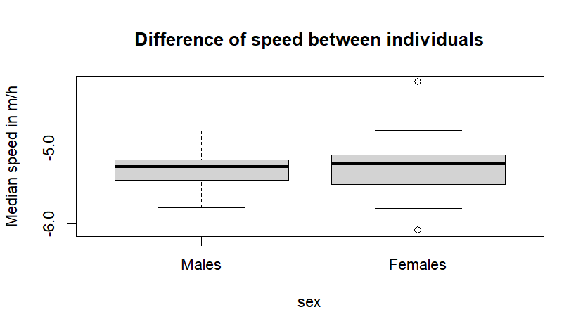

Fig 6: Comparison of median speed using a box plot between females and males

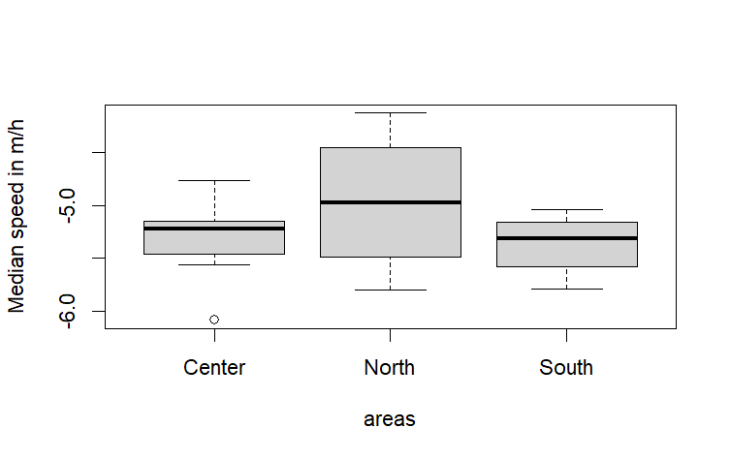

Fig 7: Comparison of median speed over the entire study using a box plot between regions

**Turning angles**

Another interesting observation is the frequency of turning angles. We see right away that high angles (180°) are the most represented ones (cf. fig 8). For most expected outcomes we should have a uniform distribution (such as Brownian movement for example), or an over-representation of small turning angles (random walk).

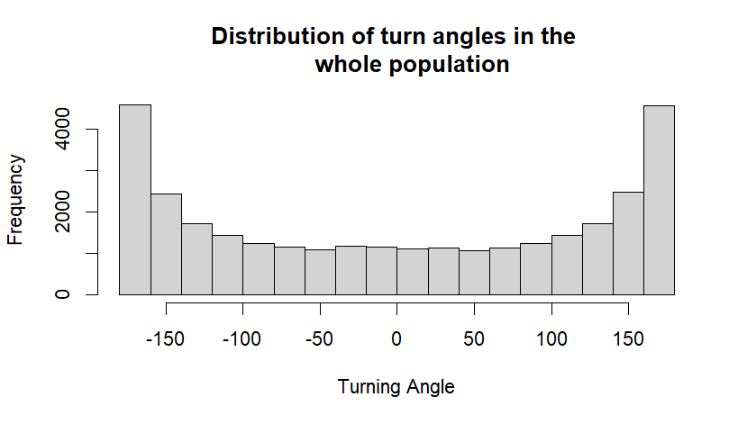

Fig 8: Turn angles distribution over the entire study

Gamma distribution will be used to fit step length and a Von Mise distribution for the turning angles.

**SSF RESULTS**

As expected, individuals strongly avoid urban areas (coef = -2.24 ± 0.26, p<2e-16) and concentrate their movement in forests and low vegetation. Even if not significant (0.03 ± 0.03, p=0.3), there is a slight preference for paths leading to forest areas. The likelihood of choosing a path with forest increases by 3.7%. The exp(coef) value for forest (1.037 ± 0.03) supports the previous result by indicating how strongly the forest landcover influences individuals' choices. When given the option to go in different directions, they are 1.037 times more likely to choose the path leading to the forest.

A surprising result is the “elevation_end” variable with a negative coef (-0.02 ± 0.009, p=0.002), meaning individuals avoid higher elevation at the end of the step. In simple words they tend to stay at the same level (or go down), rather than going up, when having the choice. Animals also show a strong preference for straighter paths (coef cos_ta = -0.69 ± 0.01, p<0.001) and avoid longer steps (coef sl_=-31.16 ± 3.81, p<0.001).

**Sex comparison**

As observed in previous studies, both males and females show a strong preference for straighter paths and short steps, with those preferences being more pronounced in females coef male =-1.87 ± 0.45, p<0.001 vs. coef female=-2.38 ± 0.31, p<0.001). Urban areas are consistently avoided by both males and females. Surprisingly, females show a slight avoidance for forest and low vegetation landcover. Males exhibit the opposite preferences. They seem pickier about elevation, with elevation coefficients being negative and significant (coef=-0.04 ± 0.01, p=0.003), while it is not significant for females (coef = -0.01 ± 0.01, p=0.12). What’s more, females show a significant avoidance of steeper slopes (coef = -0.16 ± 0.03, p<0.001), (cf. Table 2).

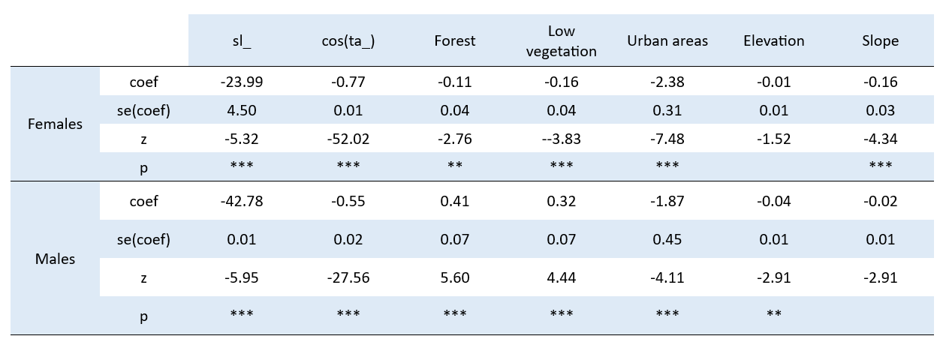

Table 2: Step Selection Function model output for sex variables

**Seasonal comparison**

In both seasons, animals exhibit a strong preference for straighter paths (cf. table 3). Urban areas are consistently avoided in both seasons, with the avoidance being more pronounced during the summer (coef winter=-1.47 ± 0.23, p<0.001 vs. coef summer=-2.68 ± 0.58, p<0.001).

Regarding step length, animals show strong avoidance of longer steps in both seasons, but this avoidance is more pronounced in summer (coef winter = -94.73 ± 8.22 vs. coef summer = -113.4 ± 8.01). The log of step length also shows a negative effect in both seasons, indicating sensitivity to step length changes (coef winter = -0.14 ± 0.01, p<0.001 vs. summer =-0.04 ± 0.01, p=0.019). Elevation has a significant impact on movement in winter (-0.05 ± 0.021, p=0.004), where higher elevations reduce the likelihood of movement. Slope shows a significant avoidance in winter, indicating animals are less likely to traverse steeper slopes (-0.23 ± 0.05, p<0.001). Forest landcover does not show a significant preference in either season (0.04 ± 0.07, p=0.53), but there is a very slight, non-significant positive effect in both (cf. table 3).

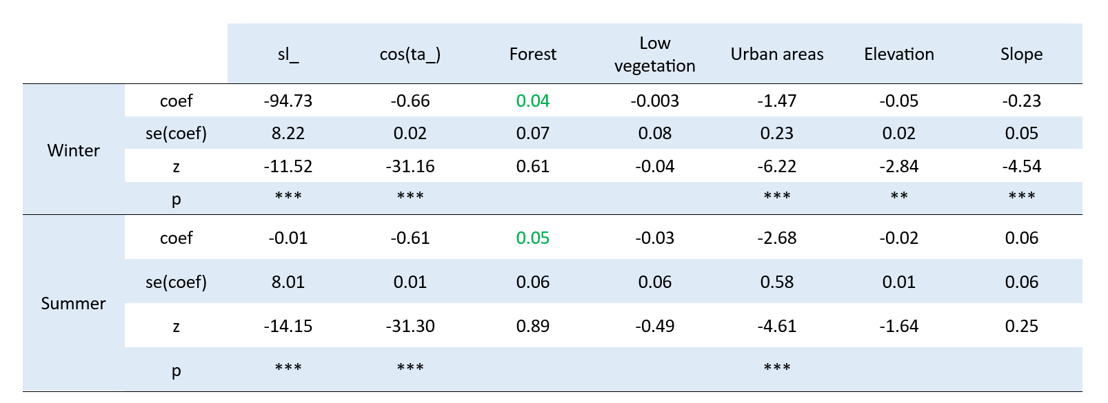

Table 3: Step Selection Function model output for seasonal variables

**Regional comparison**

All areas demonstrate a strong preference for straighter paths. Urban areas are consistently avoided across all regions, with the most extreme avoidance observed in the south. When it comes to step length, the north area shows a preference for longer steps, while both the central and south areas exhibit strong avoidance of longer steps, particularly in the central region. Regarding the log of step length, both the north and south show significant avoidance of larger steps (coef log_sl north = -0.07 ± 0.02, p<0.001 and coef log_sl south = -0.07 ± 0.01, p<0.001), whereas the central area shows a minimal effect. Elevation plays a notable role in movement, with higher elevations significantly reducing movement likelihood in the north and south, but not having a significant impact in the central area (cf. Table 4). The slope of the terrain also affects movement differently; for instance, the central and south regions show significant avoidance of steeper slopes (coef center = -0.07 ± 0.04, p=0.05 and coef south = -0.22 ± 0.04, p<0.001). In terms of landcover preferences, animals in the north show a significant positive preference for forested areas, while the central area shows a neutral effect, and the south shows a slight avoidance (cf. Table 4). For low vegetation, the north shows a significant positive preference (0.30 ± 0.13, p<0.05), the central and south areas show no significant effect.

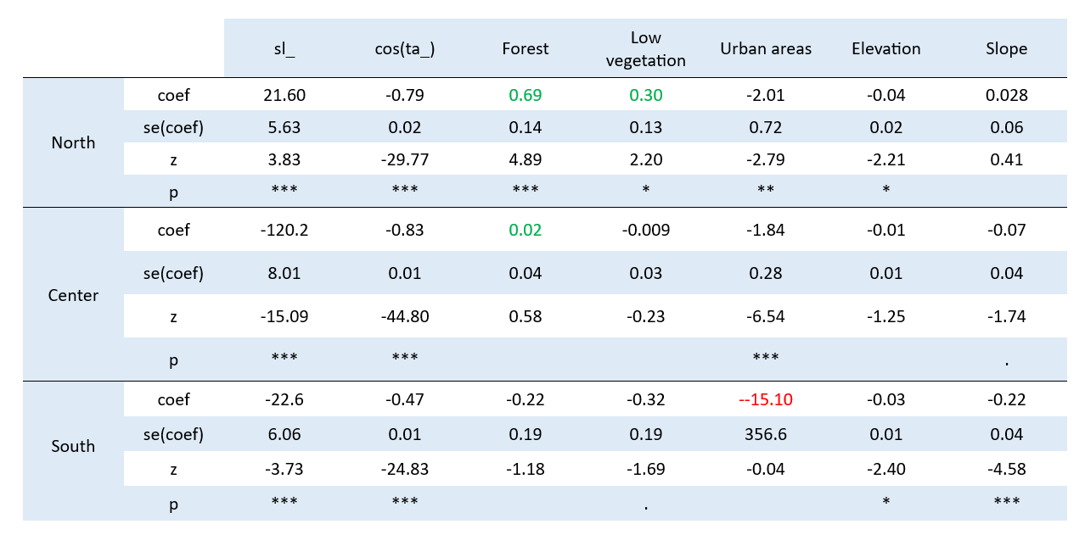Table 4: Step Selection Function model output for regional variables

**DISCUSSION**

Our study focused on understanding the movement patterns and habitat preferences of deer, particularly in relation to landcover and topography, and how these factors are influenced by season, region, and sex. The results have provided insightful observations aligning with our initial hypotheses, revealing both expected patterns and some surprising trends.

As outlined in our first hypothesis, we observe a clear avoidance of urban areas across all individuals, regions, seasons, and sexes. This aversion likely stems from the lack of cover and increased human presence in urban areas, which is consistent with previous research suggesting that human activities significantly impact deer behavior (Puddu et al. 2009; Riley et al. 2006). In contrast, forested areas appear to attract movement. This inclination towards forested paths was expected as these areas offer preferable conditions, such as shelter, food resources, and lower predation risk (Van Dyke et al. 1986). While the preference for forest is not statistically significant, the positive coefficient indicates a trend that warrants further investigation, especially considering the importance of forest habitats in conservation planning. The role of cover in habitat use may be especially important in winter, when cervids reduce their food intake and live to a remarkable extent off fat reserves (Putman, 1988).

Indeed, seasons play a big role in movement organization of red deer. Results showed significant seasonal variations in movement. During winter, deer exhibited a stronger avoidance of longer steps and higher elevations, likely due to the harsh weather conditions and the need to conserve energy (Parker et al. 1984). In contrast, summer saw a slight decrease in this avoidance, reflecting the deer's movement to higher elevations for better forage and milder temperatures (Dagtekin et al. 2023). This seasonal variation is linked to changes in resource availability, predation risk, and thermoregulatory needs (Fryxell & Sinclair, 1988).

In parallel, sex-based analysis revealed that both males and females demonstrate a strong preference for straighter paths suggesting, a tendency towards energy-efficient movement strategies (Wilson et al. 2013). However, we do notice this preference is more pronounced in females, indicating potential differences in spatial navigation and risk avoidance behaviors between sexes (Péron et al. 2017). Surprisingly, the study reveals a notable aversion to higher elevations for both sexes. This tendency to avoid ascending terrain agrees with energy expenditure and potential risks that have been explored in past studies (Wilmers, C et al. 2013; Wilson et al. 2005). Males were also more sensitive to elevation changes with significant negative coefficients. This could be due to the different foraging strategies and energy expenditure patterns between the sexes, as males might be more willing to traverse varied terrains in search of mates or resources (Putman & Moore, 1998; Nathan et al. 2008).

What’s more, findings suggest that elevation-related movement preferences are different between regions, (certainly) due to topographical and climatic differences (Wang et al. 2009). In the north, characterized by shallow, arid soils and a mix of grasslands and maquis, deer showed a preference for longer steps, possibly due to the open landscape allowing for more extensive movement. In contrast, the central area, with its diverse vegetation including oaks and beeches, saw a strong avoidance of longer steps and higher elevations, reflecting the more rugged terrain and dense vegetation. The south area, featuring a hilly landscape with streams and marshes, showed significant avoidance of urban areas and steep slopes, highlighting the impact of the complex terrain on movement efficiency (Morales et al. 2004). It can be noted that, the south shows a slight avoidance for both landcover types, suggesting that other factors, such as human disturbance or landscape fragmentation, might influence movement decisions more strongly in this region (Mysterud & Ims, 1998).

**CONCLUSION**

This study provides valuable insights regarding deer habitat use and preferences. However, several elements could be improved to be able to have convincing prediction and widen our results to other species and regions. Results, such as the avoidance of forest by female individuals, were not expected and quite suspicious. Analyzing closely the environment’s characteristic and vegetable coverage could help understand why we observed such behavior. Adding the Normalized Difference Vegetation Index (NDVI), would be of great help for future research to improve this study. Further, adding new individuals is needed as 2 out of 3 areas were studied with less than 10 individuals, which could cause unrealistic results. Finaly, in an island such as Corsica, integrating hunted sites, could help refine habitat use and movement.

In conclusion, our study presents a first approach of Corsican red deer habits after its reintroduction. We hope this may help future researchers to improve the success of reintroductions for deer but also provide a valuable framework that can be applied to other species and regions, contributing to broader conservation goals.

**REFERENCES**

1. **Agresti, A. (2002).** Categorical Data Analysis (2nd ed.). Wiley-Interscience
2. Alerstam, T., Hedenström, A., & Åkesson, S. (2007). "Long-distance migration: evolution and determinants." *Oikos*, 103(2), 247-260.
3. Borowski, Z., & Ukalska, J. (2008). The influence of habitat structure and food availability on the foraging behaviour of roe deer (Capreolus capreolus) and red deer (Cervus elaphus) in forest ecosystems*. Forest Ecology and Management*.
4. Bovet, P., & Benhamou, S. (1988). "Spatial analysis of animals’ movements using a correlated random walk model." *Journal of Theoretical Biology*, 131(4), 419-433.
5. Cagnacci F, Boitani L, Powell RA, Boyce MS (2010). Animal ecology meets GPS-based radiotelemetry: a perfect storm of opportunities and challenges. *Philos T R Soc B.*
6. **Cagnacci, F., Focardi, S., Ghisla, A., Van Moorter, B., Merrill, E. H., Gurarie, E., Heurich, M., Mysterud, A., Linnell, J. D. C., Panzacchi, M., May, R., Nygård, T., Rolandsen, C. M., & Saïd, S. (2011).**
7. Cargnelutti, B., Coulon, A., Hewison, A. J. M., Goulard, M., Angibault, J. M., & Morellet, N. (2002). Testing Global Positioning System performance for wildlife monitoring using mobile collars and known reference points. *Journal of Wildlife Management*,
8. Chetkiewicz CLB, Clair CCS, Boyce MS (2006). Corridors for conservation: integrating pattern and process. *Annu Rev Ecol Evol* S; 37:317–342.
9. **Clark, J. D., Dunn, M. R., & Reynolds, M. A. (2023). Factors affecting elk reintroduction success in the United States. *Journal of Mammalogy,***
10. **Compton, B. W., Rhymer, J. M., & McCollough, M. (2002).** Habitat selection by wood turtles (Clemmys insculpta): An application of paired logistic regression. Ecology, 83(3), 833-843.
11. Cromsigt JPGM, Te Beest M, Kerley GIH, Landman M, le Roux E, Smith FA. (2018) Trophic rewilding as a climate change mitigation strategy? *Philos Trans R Soc Lond B Biol Sci*.
12. Dagtekin, M., Soyumert, A., and Ambarlı, H. (2023). "Seasonal habitat-use patterns of large mammals in a human-dominated landscape." Journal of Mammalogy.
13. Danell, K., Bergstrom, R., Duncan, P. & Pastor, J.(2006). LargeHerbivore Ecology, Ecosystem Dynamics and Conservation.*Cambridge University Press, Cambridge*.
14. De´meautis, G. (1984). "Les Cerfs: Biologie et Écologie." Revue d'Écologie (La Terre et la Vie),
15. Dechen Quinn, A. C., Williams, D. M., & Porter, W. F. (2013). Postcapture movement rates can inform data-censoring protocols for GPS-collared animals. *Journal of Mammalogy*, 94(3), 563-570.
16. **Dubray, D. (1989).** "The Behavioural Ecology of Deer in Modified Landscapes." Journal of Wildlife Research, 33(2), 153-168.
17. **Dubray, D. (1990).** "Impact of Human Activities on Deer Habitat Use and Movement Patterns." Wildlife Conservation Review, 24(1), 45-60.
18. Evan C. Fricke *et al. (2022)* The effects of defaunation on plants’ capacity to track climate change. *Science* 375, 210-214.
19. Fortin D, Beyer HL, Boyce MS, Smith DW, Duchesne T, Mao JS. Wolves influence elk movements: behavior shapes a trophic cascade in Yellowstone National Park (2005). *Ecology.* 86:1320–1330
20. Frair JL, Fieberg J, Hebblewhite M, Cagnacci F, DeCesare NJ, Pedrotti L (2010). Resolving issues of imprecise and habitat-biased locations in ecological analyses using GPS telemetry data. *Philos T R Soc B.*
21. **Frair, J. L., Merrill, E. H., Visscher, D. R., Fortin, D., Beyer, H. L., & Morales, J. M. (2007). Thresholds in landscape connectivity and mortality risks in response to growing road networks.** Journal of Applied Ecology**, 44(4), 909-918.**
22. Fryxell, J. M., & Sinclair, A. R. E. (1988). Causes and consequences of migration by large herbivores. Trends in Ecology & Evolution, 3(9), 237-241
23. G.M.; Jones, C.G.; Turner, M.G.; Weathers, K.C. (Eds.)2005, Ecosystem Function in Heterogeneous Landscapes. *Lovett, XVIII, 489 p. 94 illus., Hardcover*
24. Gaillard JM, Hebblewhite M, Loison A, Fuller M, Powell R, Basille M, Van Moorter B (2010). Habitat-performance relationships: finding the right metric at a given spatial scale. *Philos T R Soc B*
25. **Hegel, T. M., Mysterud, A., Huettmann, F., & Stenseth, N. C. (2009). Spatial scale dependence of climate and density feedback on moose population growth rate.** Ecological Monographs**, 79(2), 299-321.**
26. Jiale Qian, Yunyan Du, Jiawei Yi, Fuyuan Liang, Sheng Huang, Xiaoyue Wang, Nan Wang, Wenna Tu, Tao Pei, Ting Ma, (2022). Regional geographical and climatic environments affect urban rainstorm perception sensitivity across China*. Sustainable Cities and Society, Volume 87.*
27. Johan T. du Toit & Nathalie Pettorelli (2019). The differences between rewilding and restoring an ecologically degraded landscape. *Journal of Appplied Ecology*.
28. Johnson CJ, Gillingham MP (2008). Sensitivity of species-distribution models to error, bias, and model design: an application to resource selection functions for woodland caribou. *Ecol Model.213*:143–155
29. Kays, R., Crofoot, M. C., Jetz, W., & Wikelski, M. (2015). Terrestrial animal tracking as an eye on life and planet. *Science*, 348(6240), aaa2478.
30. Kays, R., Davidson S., Berger M., Bohrer G, Safi K., Scharf, A., Wikelski, M. (2021). The Movebank system for studying global animal movement and demography. *Methods in Ecology and Evolution*. 13. 10.1111/2041-210X.13767.
31. La Morgia, V. (2011). Conservation of the Corsican Red Deer **Cervus elaphus corsicanus** in Sardinia and Corsica. *Proceedings of the International Congress on the Conservation of Biodiversity*, 123-132.
32. LaPoint, S., Gallery, P., Wikelski, M., & Kays, R. (2013). "Animal behavior, cost-based corridor models, and real corridors." *Landscape Ecology*, 28,1615-1630
33. LaPoint, S., Gallery, P., Wikelski, M., & Kays, R. (2015). Considering the continuum of movement behavior in habitat selection studies. Journal of Ecology, 96(5), 1202-1208.
34. Mandas L., Fleba L., Murgia A., Casula P., Secci D. (2008) - Analisi storica dell’abbondanza e della distribuzione del cervo sardo in Sardegna. VI Congresso Italiano Teriologia. *Italian Journal of Mammology.*
35. Manly BF, McDonald LL, Thomas DL, McDonald TL, Erickson WP (2002). Resource selection by animals: statistical design and analysis for field studies. Dordrecht, *The Netherlands: Kluwer Academic Publishers.*
36. Manly, B. F. J., McDonald, L. L., Thomas, D. L., McDonald, T. L., & Erickson, W. P. (2002). Resource Selection by Animals: Statistical Design and Analysis for Field Studies (2nd ed.). Springer.
37. Marucco, F., & McIntire, E. J. B. (2010). Predicting spatio-temporal recolonization of large carnivore populations and livestock depredation risk: Wolves in the French Alps. Journal of Applied Ecology, 47(4), 789-798.
38. **Millennium Ecosystem Assessment (MEA)** (2005). Ecosystems and Human Well-being: Synthesis. Island Press.
39. Moorcroft PR, Lewis MA, Crabtree RL (2006). Mechanistic home range models capture spatial patterns and dynamics of coyote territories in Yellowstone. *P Roy Soc*; 273:1651–1659.
40. Mysterud, A., & Ims, R. A. (1998). Functional Responses in Habitat Use: Availability Influences Relative Use in Trade-Off Situations. *Ecology*, *79*(4), 1435–1441.
41. Nathan, R., Getz, W. M., Revilla, E., Holyoak, M., Kadmon, R., Saltz, D., & Smouse, P. E. (2008). A movement ecology paradigm for unifying organismal movement research. Proceedings of the National Academy of Sciences of the United States of America, 105(49), 19052-19059
42. Parker, K. L., Robbins, C. T., & Hanley, T. A. (1984). Energy Expenditures for Locomotion by Mule Deer and Elk. The Journal of Wildlife Management, 48(2), 474-488
43. Péron, G., Fleming, C. H., Duriez, O., Fluhr, J., & Calabrese, J. M. (2017). The energy landscape predicts flight height and wind turbine collision hazard in three species of large soaring raptor. Journal of Applied Ecology, 54(6), 1895-1906.
44. Pettorelli N, Durant SM, du Toit JT. (2017) Rewilding: a captivating, controversial, twenty-first-century concept to address ecological degradation in a changing world. *Rewilding*. *Ecological Reviews. Cambridge University Press*
45. Puddu, G., Mariacher, S., & Apollonio, M. (2009). Human influence on the distribution and abundance of red deer (Cervus elaphus) in Italy. *Journal of Zoology.*
46. Puddu, G., Vignolia, S., & Veith, M. (2009). An introduction to the status, distribution and conservation of the genus Triturus (Amphibia: Salamandridae) in Sardinia. *Acta Herpetologica*, 4(1), 73-85.
47. Putman, R. J., & Moore, N. P. (1998). Impact of deer in lowland Britain on agriculture, forestry and conservation habitats. ***Mammal Review,* 28**(4), 141-164.
48. Putman, R. J., & Moore, N. P. (1998). Impact of deer in lowland Britain on agriculture, forestry and conservation habitats. Mammal Review, 28(4), 141-164.
49. [R. Norman Owen-Smith](https://www.google.fr/search?hl=fr&tbo=p&tbm=bks&q=inauthor:%22R.+Norman+Owen-Smith%22&source=gbs_metadata_r&cad=6) (1988). Megaherbivores: The Influence of Very Large Body Size on Ecology. *[Cambridge Studies in Ecology](https://www.google.fr/search?hl=fr&tbo=p&tbm=bks&q=bibliogroup:%22Cambridge+Studies+in+Ecology%22&source=gbs_metadata_r&cad=6)*. Cambridge University Press.
50. Riga, F.; Mandas, L.; Putzu, N.; Murgia, A (2022). Reintroductions of the Corsican Red Deer (Cervus elaphus corsicanus): Conservation Projects and Sanitary Risk. *Animals*, 12, 980.
51. Riley, S. P. D., Sauvajot, R. M., Fuller, T. K., York, E. C., Kamradt, D. A., Bromley, C., & Wayne, R. K. (2003). Effects of urbanization and habitat fragmentation on bobcats and coyotes in southern California. *Conservation Biology*, 17(2), 566-576.
52. Ripple WJ, Newsome TM, Wolf C, Dirzo R, Everatt KT, Galetti M, Hayward MW, Kerley GI, Levi T, Lindsey PA, Macdonald DW, Malhi Y, Painter LE, Sandom CJ, Terborgh J, Van Valkenburgh B. (2015). Collapse of the world's largest herbivores. Sci Adv.
53. Roever CL, Boyce MS, Stenhouse GB (2010). Grizzly bear movements relative to roads: application of step selection functions. *Ecography*; 33:1113–1122.
54. **Safi, K., Pettorelli, N., Brooks, T. M., Butchart, S. H., Kark, S., Rudel, T. K., & McNeely, J.A. (2013).** "Understanding global patterns of mammalian functional and phylogenetic diversity." Philosophical Transactions of the Royal Society B: Biological Sciences,
55. Schick, R.S., Loarie, S.R., Colchero, F., Best, B.D., Boustany, A., Conde, D.A., Halpin, P.N., Joppa, L.N., McClellan, C.M. and Clark, J.S. (2008), Understanding movement data and movement processes: current and emerging directions. *Ecology Letters,* 11: 1338-1350
56. Seddon, P. J., Griffiths, C. J., Soorae, P. S., & Armstrong, D. P. (2014). Reversing defaunation: Restoring species in a changing world. ***Science***, 345(6195), 406-412
57. Squires JR, DeCesare NJ, Olson LE, Kolbe JA, Hebblewhite M, Parks SA (2013). Combining resource selection and movement behavior to predict corridors for Canada lynx at their southern range periphery. Biol *Conserv.* 157:187–195
58. Svenning, J.-C., Pedersen, P. B. M., Donlan, C. J., Ejrnæs, R., Faurby, S., Galetti, M., Hansen, D. M., Sandel, B., Sandom, C. J., Terborgh, J. W., & Vera, F. W. M. (2016). Science for a wilder Anthropocene: Synthesis and future directions for trophic rewilding research. Proceedings of the National Academy of Sciences of the United States of America
59. **Tilman, D., Isbell, F., & Cowles, J. M.** (2014). Biodiversity and ecosystem functioning. Annual Review of Ecology, Evolution, and Systematics, 45, 471-493.
60. Tobalske, B. W., Hedrick, T. L., Dial, K. P., & Biewener, A. A. (2003). "Comparative power curves in bird flight." *Nature*, 421(6921), 363-366.
61. Tomkiewicz SM, Fuller MR, Kie JG, Bates KK (2010). Global positioning system and associated technologies in animal behaviour and ecological research. *Philos T R Soc B.*;
62. Trepel, J., le Roux, E., Abraham, A.J. *et al* (2024)*.* Meta-analysis shows that wild large herbivores shape ecosystem properties and promote spatial heterogeneity. *Nat Ecol Evol* 8, 705–716.
63. Trouwborst, A., & Svenning, J.-C. (2022). Megafauna restoration as a legal obligation: International biodiversity law and the rehabilitation of large mammals in Europe. *Review of European, Comparative & International Environmental Law*, *31*(2), 182-198
64. Turchin, P. (1998). "Quantitative Analysis of Movement: Measuring and Modeling Population Redistribution in Animals and Plants." *Sinauer Associates Inc.*
65. Van Dyke, F. G., Brocke, R. H., & Shaw, H. G. (1986). Use of Road Track Counts as Indices of Mountain Lion Presence. The Journal of Wildlife Management, 50(1), 102-109
66. Whittington, J., St. Clair, C. C., & Mercer, G. (2020). The utility of remote sensing for wildlife ecology: a review of terrestrial applications. *Remote Sensing in Ecology and Conservation*, 6(4), 421-437.
67. Wilmers, C. C., Nickel, B., Bryce, C. M., Smith, J. A., Wheat, R. E., & Yovovich, V. (2013). The golden age of bio-logging: how animal-borne sensors are advancing the frontiers of ecology. Ecology, 94(8), 1748-1761.
68. Wilmers, C. C., Smith, J. A., Nickel, B., Mason, R., Keller, L., & Williams, T. (2013). Energetics and fear of humans constrain the spatial ecology of pumas. *Proceedings of the National Academy of Sciences,* 110(32), 13057-13062
69. Wilson, R. P., Grundy, E., Massy, R., Soltis, J., Tysse, B., Holton, M. D., ... & Halsey, L. G. (2013). Turn costs change the value of animal search paths. Ecology Letters, 16(9), 1145-1150.
70. Wilson, R. P., Pütz, K., Peters, G., Culik, B. M., Bannasch, R., Reins, T., & Zimmer, I. (2005). Movement patterns of foraging marine predators: diving, searching and prey encounter. Antarctic Science, 7(2), 148-154.
71. Wood, J. R., Wilmshurst, J. M., Worthy, T. H., & Rawlence, N. J. (2017). Island extinctions: processes, patterns, and potential for ecosystem restoration. Environmental Conservation, 44(4), 348-358.
72. **Zeller, K. A., McGarigal, K., & Whiteley, A. R. (2014).** Estimating landscape resistance to movement: a review. Landscape Ecology, 27(6), 777-797.
73. Zidon, R., Saltz, D., & Shore, L. S. (2009). Behavioral changes, stress, and survival following reintroduction of Persian fallow deer (Dama mesopotamica). Behavioral Ecology, 22(2), 236-243.

**APPENDIX**

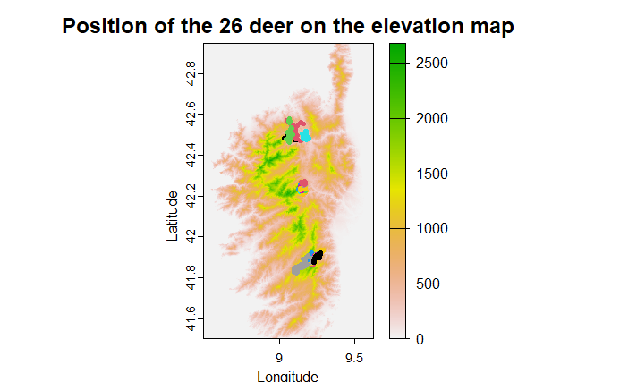

Appendix 1: Map of Corsica with position of the individuals and the elevation scale in m.

Appendix 2: DEM specification

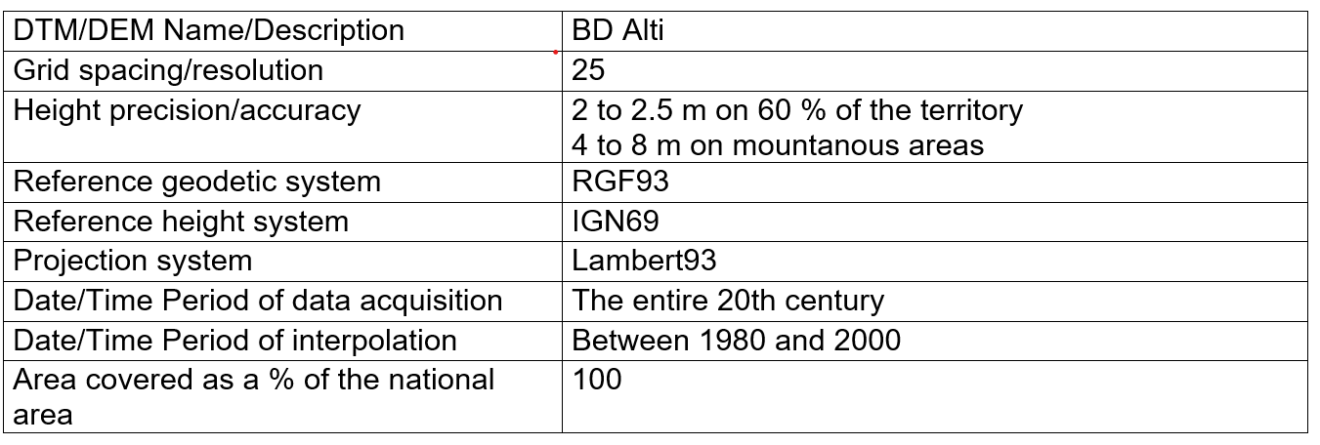

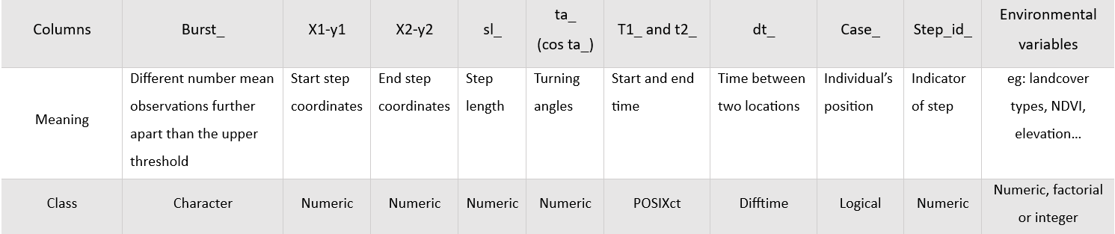Appendix 3: Table summarizing the SSF dataframe

**SUMMARY**

This study investigates the habitat use and movement patterns of reintroduced Corsican red deer (Cervus elaphus) in relation to landcover, topography, season, region, and sex. Utilizing recent advancements in positioning technology, we employed Step Selection Functions (SSFs) to analyze environmental attributes of deer movement. SSFs compare observed steps with randomly generated alternative steps, enabling a detailed examination of habitat preferences. The study revealed that deer consistently avoid urban areas, favor forested regions, and exhibit significant seasonal and sex-based variations in movement. Winter movements were constrained by energy conservation needs, while summer movements reflected a search for better forage. Our methodology involved transforming spatial data into track objects, resampling, and generating random steps for SSF analysis. This approach highlights the importance of considering various environmental and individual factors in conservation planning and rewilding efforts.

**Résumé**

Cette étude examine l'utilisation de l'habitat et les schémas de déplacement des cerfs rouges corses réintroduits (Cervus elaphus) en relation avec la couverture terrestre, la topographie, la saison, la région et le sexe. En utilisant les avancées récentes en technologie de positionnement, nous avons employé les fonctions de sélection de pas (SSF) pour analyser les attributs environnementaux des déplacements des cerfs. L'étude a révélé que les cerfs évitent systématiquement les zones urbaines, préfèrent les régions forestières et montrent des variations significatives dans leurs déplacements en fonction des saisons et du sexe. Les mouvements hivernaux étaient limités par la nécessité de conserver l'énergie, tandis que les mouvements estivaux reflétaient une recherche de meilleure nourriture. Notre méthodologie impliquait la transformation des données spatiales en objets de suivi, le rééchantillonnage et la génération de pas aléatoires pour l'analyse SSF. Cette approche met en lumière l'importance de prendre en compte divers facteurs environnementaux et individuels dans la planification de la conservation et les efforts de réensauvagement.

**Key words**: cervus elaphus, Step Selection Function, movement, habitat use.