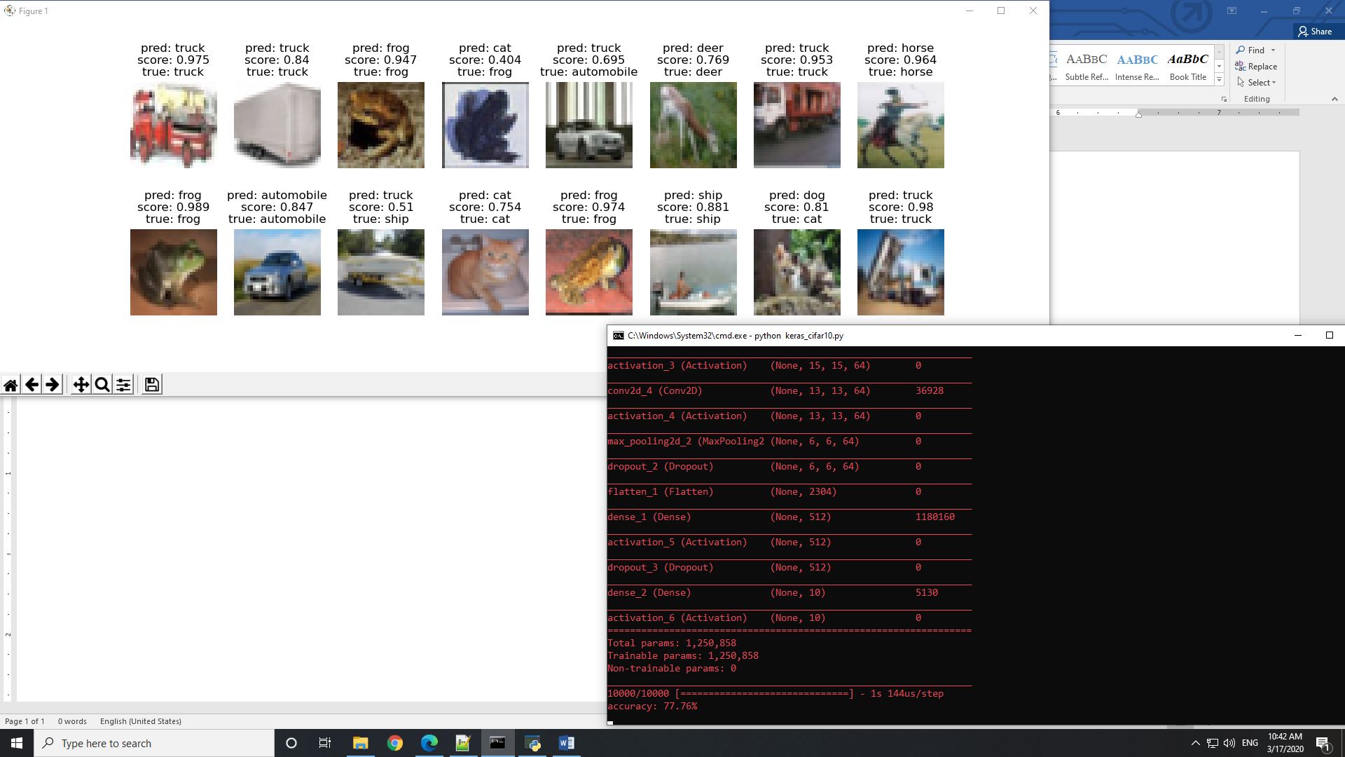

Batch = 64

Epoch = 10

Model : C2

Accuracy: 77.76 on testset

Accuracy: Under 35 on random set