Determining Suitable Habitats for the White Rhino in South Africa Using ArcGIS Techniques

Connor Payne
Western University
December 8, 2023

Introduction
With the rising climate change crisis, planet Earth is losing some of its most beloved species. This is partially due to habitat loss in dry or humid regions of the planet as well as various species being pushed out of their natural range due to human disturbance and urbanization. With hundreds of thousands of new humans born into the world each day, there is a growing need for rapid residential development strategies to be put in place. Unfortunately, these sites are typically located in areas ‘not in use’ and are therefore seen as a suitable location. This is not the case, as many species reside in those ‘unclaimed’ areas that are eventually forced out of their natural habitats. In the case of Africa, more particularly South Africa, land development is used for agricultural practices rather than large infrastructure construction. Agriculture is the most important and primary income-generating industry for the majority of Africa, as there is an abundance of land that can be converted into crop fields. Once again, this drives local animal species out of the area, forcing them to relocate and potentially encounter new dangers and threats to their survival.
This project focuses on the poaching threat of a particular species, the African White Rhino, due to habitat loss and increased constraints on their typical living arrangements. As I conducted my research and consulted data, I decided to focus primarily on the northeastern portion of South Africa. This area of Africa has no shortage of protected nature reserves and national park systems whose entire operation is the protection of land and the species that reside inside them. Unfortunately, there is a very real and ongoing poaching threat to the South African rhino and other species in these protected spaces. My goal for this project is to seek out areas that are within a certain radius of previous poaching threats and reports, as well as ensure they are located inside one of these protected spaces.
The act of poaching has been exploited by criminals for centuries, dating back to the initial colonization of the African continent roughly around the 14th century. The driving force behind why poachers take part in this illegal practice is the lucrative monetary incentive received through the illegal black-market trade. They primarily target megafauna, which is another term for larger and heavier animals, such as elephants and rhinos, for their ivory tusks, and often kill these animals solely for the sought-after material. The growing issue with poaching is that there is a depleted supply of ivory, as a large majority of the white rhino populations have been diminished since they escaped extinction in the early 1900s (Elephanatics, 2023). Currently, there are roughly 16,000 white rhino species left in Africa, with the majority remaining in South Africa, where my project is focused (Save The Rhino, 2021). With a shrinking population, the ivory trade market grows in demand, resulting in ivory prices soaring, leading to more poaching interfering with the species' daily lives. This trend will continue and will affirm their extinction if protective conservation strategies are not implemented. My project will attempt to aid this conflict and allow others to visualize where the White Rhino species can live with little to no fear of potential poaching threats.
Study Area
The White Rhino is a species that is very particular in deciding its ideal ecosystem and environment. According to the World Wildlife Fund, the White Rhino currently resides in only four African countries, which include Kenya, Namibia, Zimbabwe, and South Africa. If you observe Figure 1, we can interpret the drastic difference in the species' overall range of habitat suitability. This change can be explained by climate change altering the environmental composition south of the Sahara Desert. The species is then forced to relocate to a more familiar and suitable ecosystem, leaving them vulnerable to new and existing threats, such as poaching. For my project, I decided to focus on South Africa, primarily the northeastern part of the country that is home to various nature reserves along with the nation's largest and most popular park, Kruger National Park. Figure 2 displays the large variety of different types of protected spaces, ranging from marine, wilderness, and forest areas, as well as several national parks and catchment regions. This map expresses the need for increased amounts of protected space to further protect a variety of species, such as the White Rhino. Figure 3 demonstrates a visual representation of my chosen study area along with a comparison between South Africa’s protected spaces and biomes with previously reported poaching hotspots. The majority of these hotspots are located near or inside Kruger National Park, making it an ideal location to conduct my analysis.
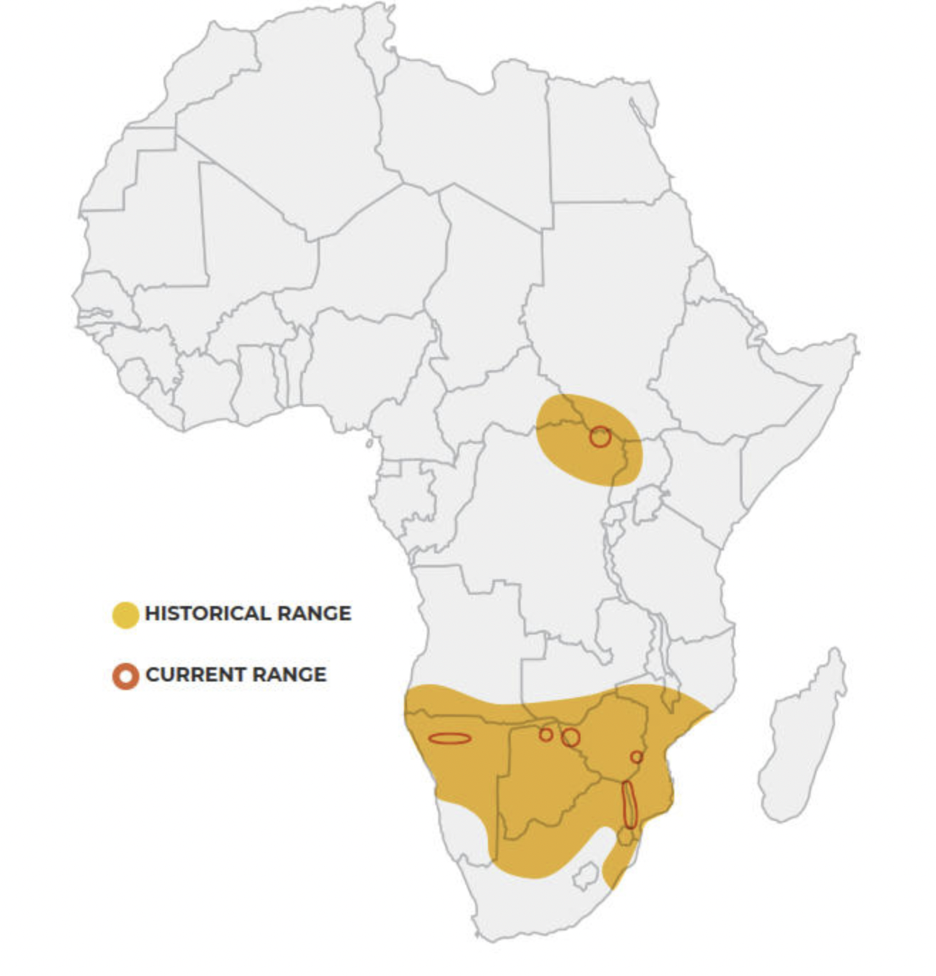
Figure 1: White Rhino Historical and Current Range - World Wildlife Fund. (n.d.). White rhino. WWF. https://www.worldwildlife.org/species/white-rhino#:~:text=The%20majority%20(98.8%25)%20of,Kwazulu%2DNatal%2C%20South%20Africa.

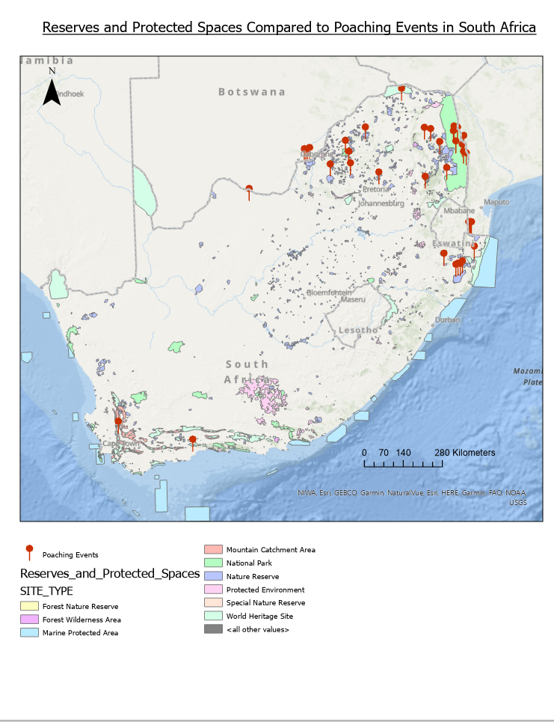
Figure 2: Current Reserves and Protected Spaces Compared to Poaching Events in South Africa

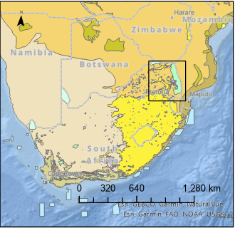

Figure 3: Study Area (Northeastern South Africa)

Data Description
To conduct my analysis, it was important to study accurate and fairly recent data that could be interpreted to provide insight into the white rhino’s habitat location. For this project, it was beneficial to prioritize data using mainly vector-based information and data systems. Vectors refer to a form of spatial data that the viewer can easily visualize. They consist primarily of polygons, points, or lines, which can be manipulated and converted into more detailed analyses. They are typically displayed as coordinate matches that create these geographic points, which often form shapefiles, which are the heart and soul of a map (Romeijn, H & D, J, 2021). Vector data was selected primarily in the form of shapefiles allowing the analysis to commence appropriately and efficiently without over-complicating the process. There are many locations in which one can access these datasets for their own project analyses. Some of these include local open data sources, ESRI, and governmental GIS hubs. The vector datasets were gathered from the ArcGIS Hub which is a cloud platform system in which creators and researchers can upload their findings and datasets which other users can access. From this website, several datasets were downloaded and utilized. The first is called ‘GMM South Africa Rhino Poaching Locations’ which generated hotspots of previous locations where rhinos had been poached in South Africa. This was beneficial to the analysis, as it generated an understanding of areas to avoid. The next data set was titled ‘Africa Biomes’ which displayed the various biomes in Africa, which could then single out the certain biomes that the White Rhino species typically reside in. The final dataset that was gathered from ArcGIS Hub was a road systems network titled ‘South Africa Roads’ that displayed the many interlinking roads and pathways surrounding the protected spaces. It was important for data to be collected locally near the study site and discovered the South African Forest, Fisheries, & Environment GIS database, which had plenty of suitable and useful tools and datasets that could be applied to the analysis. While searching through the website, a dataset was found called ‘SAPAD: SA Protected Area’ that displayed the many protected nature reserves and national parks inside South Africa. This was more than ideal for the project analysis, as it gave a framework to base where these suitable habitats for the White Rhino are situated. For the final data source, data from a previous GEO3222 ‘Lab 2’ assignment were borrowed including the Major Roads and Rivers layers to polish off the visual aspect of my project and ensure that the habitat is near water.
Problems and Limitations
While creating this project analysis, there were very few issues that would have hindered or stunted the progression of the analysis. One potential issue that may change the outcome of the final result is the fact that the ‘Rhino Poaching Locations dataset was created and published in 2017. In the year 2023, there has been a 6-year gap in which more poaching threats and hotspots will most definitely turn up. While searching for data, the goal was to locate a more recent dataset; however, the one from 2017 was the best available. This dataset was too useful not to use and therefore potentially missing key information from the past 7 years. Recently updated data from the South African region could provide an accurate representation of suitable habitats for the white rhino species. Overall, there were very few problems that needed to be overcome and conquered, barring any software bugs and malfunctions that slowed down the process briefly. Luckily, these issues were simple to troubleshoot, and with the help of those around with greater knowledge of the ArcGIS software, the malfunctions were tackled with ease.

Conversions of the Data
When using or conducting analyses on ArcGIS, it is very important to ensure that all the datasets and layers are under the same geographic reference system. Failing to do so can lead to potential skewness, errors, and distortions in your final map product. For the project, only three layers needed to be converted to fit the other datasets. The ‘Rhino Poaching Locations’, Africa Biomes', and the ‘South African Environmental Observation Network layers were all georeferenced under NAD 1983. While this georeferenced system is one of the most used in the GIS industry, conversions were needed on these datasets to fit the African landscape properly. Once converted, those layers matched the Major Roads and Rivers layers from the Lab 2 assignment using the ‘Africa Albers Equal Area Conic reference system. This process was relatively straightforward using the ‘Define Projection’ tool in ArcGIS. This allowed the possibility to insert the correct projection geographic reference system to ensure the data lined up spatially and gave us the best possible analysis as part of the final result.
Methodology
Once all the data needed to incorporate into the final project was downloaded and converted to the appropriate geographic reference system, it was time to begin conducting the analysis. Firstly, the ‘clip’ tool in ArcGIS, was used as an almost cookie cutter, in which you can select specific areas of the data set or shapefile that you want to use. Considering the layer being focused on was made up of ‘lines’, specification was needed in the ‘Clip Features’ input tab. This tool is very useful as it shrinks down your dataset, allowing you to efficiently visualize and interpret the results within your specified study area or site. For the analysis, the ‘clip tool’ was ran on the ‘MajorRoads’ layer to get an understanding of possible areas of conflict for the White Rhino and human drivers within my study area. Considering South Africa is one of Africa’s largest countries in land area, shrinking down the ‘MajorRoads’ layer allowed me to preserve usage space and increase the processing time for the ArcGIS software.
In the next step of the procedure, it was beneficial to utilize ArcGIS ‘Buffer Analysis tool for the final project. The buffer tool is used in this software as a means of creating a set circular diameter around a polygon or point. The distance between the centre and the outskirts can be modified to fit your project criteria. For my project, a buffer analysis was conducted for the ‘Major Roads’ layer to ensure a safe distance from potential threats and accidents originating from human interaction and vehicle collisions. Some thought went into how large of a distance would be believed suitable to ensure possible protection if the White Rhino species wandered too far and finally landed on roughly 3 kilometres. South Africa is one of the largest and busiest countries in Africa, so it is important to ensure road safety for both the white rhino species and local humans.
Similarly, another buffer analysis was completed, instead using the ‘GMM Africa Rhino Poaching Locations’ layer to determine a safe distance away from previous casualties and current hotspots to limit the potential of the poaching events from increasing. A distance of 12 kilometres was decided as the buffer from the centre of the hotspot and expanded outward.After completing the buffer and clip analyses, the Africa Biomes dataset was next as well as the South African Environmental Observation Network (SAEON) to determine the suitable biomes that white rhinos typically reside in when seeking a potential habitat. From this point, everything was needed to analyze and insert the potential sites on the map. Figure 4 represents the created Model Builder output of my analysis of suitable habitat locations for the White Rhino and its overall results.

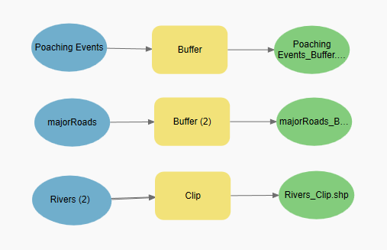

Figure 4: Model Builder Input and Output

Data Analysis
As stated at the beginning of my report, a pre-analysis of the datasets was conducted and laid out on a map, to decide the best area in which I wanted to conduct my study. Focus was shifted to the northeastern part of South Africa, combining a variety of national parks and nature reserves, which can be further evaluated with ease. It was beneficial to the project to have the study area near Kruger National Park, as it’s the largest and a common hunting ground for the White Rhino.
As displayed in Figure 5, there appears to be a large percentage of the poaching threats occurring within the Kruger National Park (Large Green Polygon) boundary. This raises the question of what is being done as well as what else can be done to ensure these protected spaces offer protection from human threats and interactions.

Figure 5: Map Detailing the Poaching Clusters in Northeastern South Africa
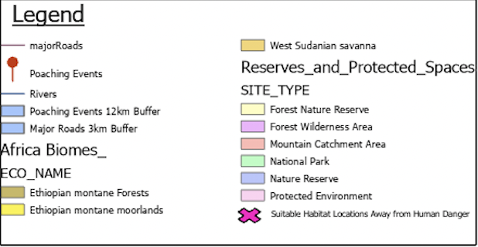
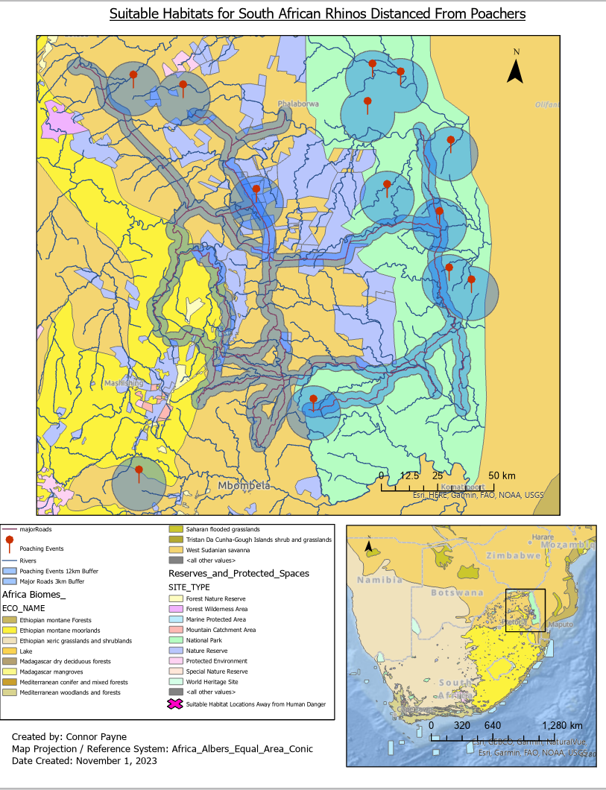

The White Rhino species can survive up to 5 days without water, therefore forcing me to place these suitable habitat locations within the range of a river system (Australian Rhino Project, 2023). Rhinos are not the most mobile species in the animal kingdom; thus, it takes them longer to traverse farther distances, increasing the need for rivers to be within walking distance. There needed to be placements of the locations outside of the buffer zones to optimize the safe environment while they stopped for a drink. Oftentimes, poachers will set up camp near streams and wait for animal species to approach the water, where they become a stationary target and easy for the poachers to attack. Therefore, being further away from the poaching hotspots will be beneficial to the species overall health and safety. The pin symbol in Figure 4 represents the previous poaching location hotspots dating up until 2017, combined with the 12km buffer analysis that was created earlier. We can consider the area inside these hotspots as the “danger zone," further eliminating it from being a potentially suitable habitat location.
Further examining Figure 5, we can observe the African biomes inside my study area of choice, which include the Ethiopian Montane Forests and Moorlands and the West Sudanian Savanna. These biomes differ slightly, even though they are generally in the same region. The Ethiopian Montane Forest consists of an elevated landscape with plenty of vegetation ranging from grasslands to various types of shrubbery. The Montane Moorlands are a little different in that there is not much vegetation, minus the odd section of short in-stature trees with regions of elevated topography. This is due to the dry climate, which creates difficult circumstances for vegetation to thrive in such a harsh environment. These elevated biomes create great cover for poachers, allowing them to see the open landscape of the moorlands and track species such as the White Rhino. The West Sudanian Savanna is the optimal location for the White Rhino species as it has loads of vegetation in the form of long grass and shrubs. There are a variety of access routes to get to the various river systems across this biome environment, making it easy for slower and larger animals to access these bodies of water. Overall, this biome is relatively flat with slight inclines in the form of hills; however, once again, this low-lying land creates potential hazards due to poaching. The long grassland vegetation provides more of a protective camouflage than most biomes in the South African regions, making it a popular destination for a variety of mixed species. After conducting the analysis, it was decided that it was time to place markers on the believed suitable habitat locations that could exist based on the variety of stipulations placed on this analysis.
Results
After conducting this approach, confidence grew in the selection of potential habitats for the White Rhino species and the belief that it will help enable their species' conservation in the future. Figure 6 displays the finished product. The 𝗫 represents the suitable habitat locations for the White Rhino based on the analysis. Two markers were placed inside the nature reserve (purple polygon) bordering various main river systems as well as being near Kruger National Park, where most law enforcement and conservation authorities are located. A third marker was placed directly inside Kruger National Park on the southern portion of the park, far away from the poaching hotspots, in an area that has not seen many threats. This location is in the centre of half a dozen river systems in which the White Rhino can access drinking water safely. A fourth marker was placed outside of any protected spaces, as judging by the hotspots, poachers seem to target the reserves and protected spaces even if there is increased protection in some of the areas. The issue becomes that the protected space is too large for law enforcement to monitor 24/7, thus resulting in poachers slipping through and attacking various species. Those four placed markers are situated inside the West Sudanian Savanna biome, which, as stated previously, is the optimal biome for the White Rhino. The final marker was placed was on the west side of my study area,
Figure 6: Suitable Habitats for South African Rhinos Amidst the Poaching Crisis
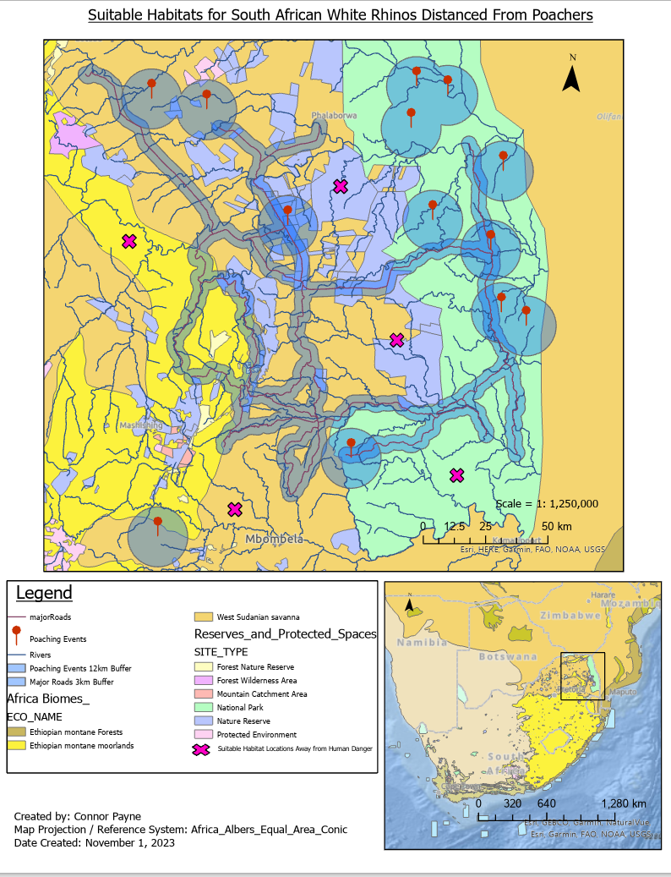
inside the Ethiopian Montane Moorlands, while also bordering the Moorland Forest. It was believed that this location would be suitable for the White Rhino due to it being farther from poaching hotspots than any other of the markers placed, as well as being in a vegetation-filled environment with plenty of cover from potential threats.

Discussion
Most of the markers were placed inside already-protected areas and reserves due to their increased law enforcement and general monitoring techniques that allow for increased safety rather than the species being on its own in the unmarked territory. The larger protected areas, such as Kruger National Park, contain militarized trained personnel whose sole task is to protect the park and the species inside of it. The effort that is involved in protecting these areas and various megafauna species, such as the White Rhino, is because ivory is one of the most expensive and precious items in the illegal trade market. This frequently results in elephants and rhinos being targeted the most. The “World Animal Foundation estimates that the illicit poaching trade brings in close to $23 billion annually worldwide (WAF, 2023)]. Regarding its impact on the South African rhino population, we can see annual minor losses, which suggests that further efforts are being made to prevent the extinction of the larger megafauna species. Further effort is required to flatten the curve, such as by turning open land into protected spaces and firmly enforcing the rules and penalties for unlawful poaching to discourage others from engaging in harmful activity. Poaching not only depletes animal species' populations and range, but it also disrupts the ecosystem and environment through the food chain. A lack of herbivores in the African biomes can result in an influx of vegetation, leading to overgrowth, which limits the production of other plant and animal species. Researchers can more accurately determine the locations of these poaching hotspots and generate a greater concentration and placement of military presence with the further collection of data.

Conclusion
In conclusion, the overall goal of my final project was to create a basic framework for the conservation of the White Rhino species and develop potential habitat sites that are both suitable and safe from human harm. Conservation and park organizations can use this information to continue monitoring and tracking the habits and trends of the White Rhino to ensure that the species does not become extinct in the near future. The development of new monitoring systems and technologies such as drones, helicopters, and night-vision technology are used to track poachers, as they often strike at night when it is virtually pitch black. The continued support from South African locals and veterans of the country’s military, combined with conservation strategies and techniques, can help ensure a protected environment for the White Rhino and other endangered species in the South African region.

References
Poaching statistics & facts that will shatter your heart!. WAF. (2023, November 18). https://worldanimalfoundation.org/advocate/poaching-statistics/
Poaching. Elephanatics. (2023, February 10). https://elephanatics.org/african-elephants/conservation/#:~:text=A%20brief%20history%20of%20the,perhaps%20about%201%2C000%20years%20ago.
Rhino species - rhinocerotidae. All about rhinos - The Australian Rhino Project. (2023). https://www.theaustralianrhinoproject.org/index.php/rhino-info/species
Rhino species: Learn: Save the rhino international. Save The Rhino. (2021, July 22). https://www.savetherhino.org/rhino-info/rhino-species/
Romeijn, H., & D, J. (2021, March 4). Raster and vector data in GIS. Spatial Vision. https://spatialvision.com.au/blog-raster-and-vector-data-in-gis/#:~:text=Vector%20data%20is%20what%20most,physical%20location%20in%20the%20world.
World Wildlife Fund. (n.d.). White rhino. WWF. https://www.worldwildlife.org/species/white-rhino#:~:text=The%20majority%20(98.8%25)%20of,Kwazulu%2DNatal%2C%20South%20Africa.

Data Sources
Forestry, Fisheries & the Environment. “SAPAD: SA Protected Areas” [Shapefile] [Scale Unknown]. South Africa, 2023.

National Geospatial-Intelligence Agency. “GMM South Africa Poaching Locations” [Shapefile] [Scale Unknown]. Virginia, United States, 2017.

Regional Centre for Mapping of Resource for Development. “Africa Biomes Dataset” [Shapefile] [Scale Unknown]. Nairobi, Kenya, 2023.

South African Environmental Observation Network (SAEON). “South African Rivers” [Shapefile] [Scale Unknown]. South Africa, 2021.

