Theater API
– REST communication protocol –
– Developed on Python –

For running locally assume defaultURL = http://localhost:PORTNUMBER/
(refer to .flaskenv for port number, default = 5000)

Delivered API supports the following calls:

1) GET - defaultURL:
Will return welcome message “ Welcome to Theater Cyprus”

2) GET - defaultURL/movies:
Will return all available movies
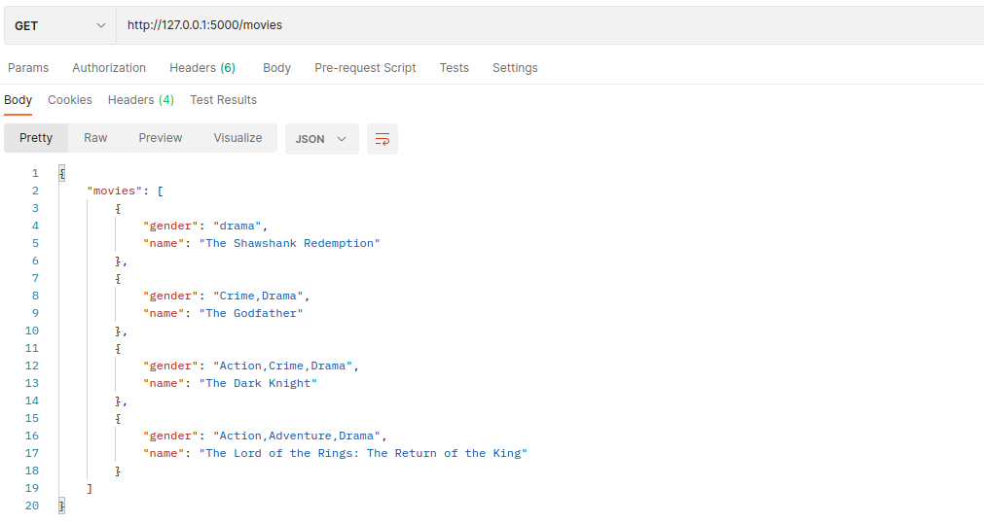

3) GET - defaultURL/movies/<movie_id>:
Will return selected movie based on entered ID alongside the theaters it is shown

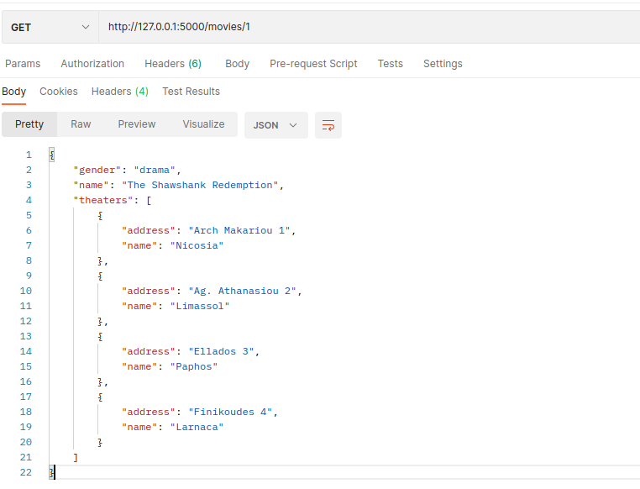

4) GET - defaultURL/movies/<movie_id>/<theater_id>:
Upon selecting movie and theater, will redirect to /reservations/<movie_id>/<theater_id> and will reveal:
a) Ticket availability
b) Seat availability
c) Selected movie and details
d) Selected theater and details

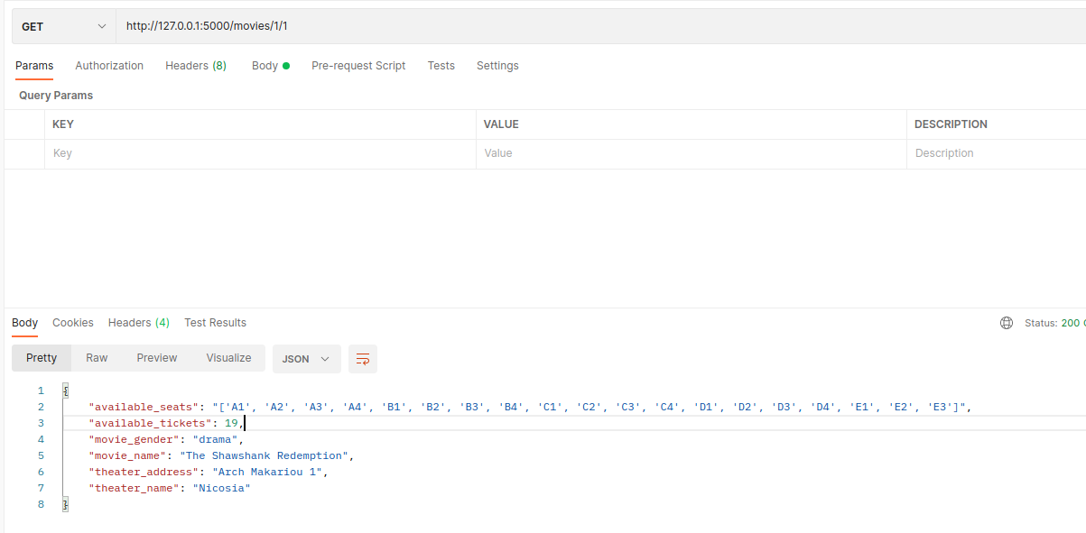

5) GET - defaultURL/theaters:
Will return all available theaters

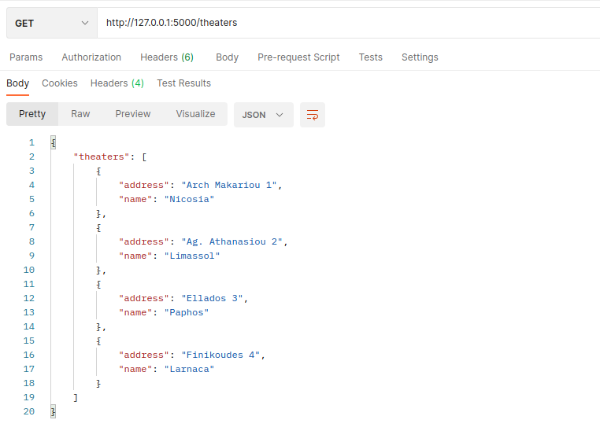

6) GET - defaultURL/theaters/<theater_id>:
Will return selected theater based on entered ID

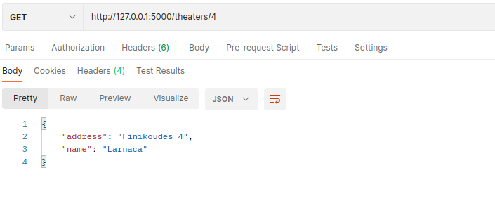

7) GET - defaultURL/reservations/delete_booking/xxx:
Will ask you to append your booking ID to delete booking

8) DELETE - defaultURL/reservations/delete_booking/<reservation_id>:
Will delete all reservation arrangements under the specific reservation ID

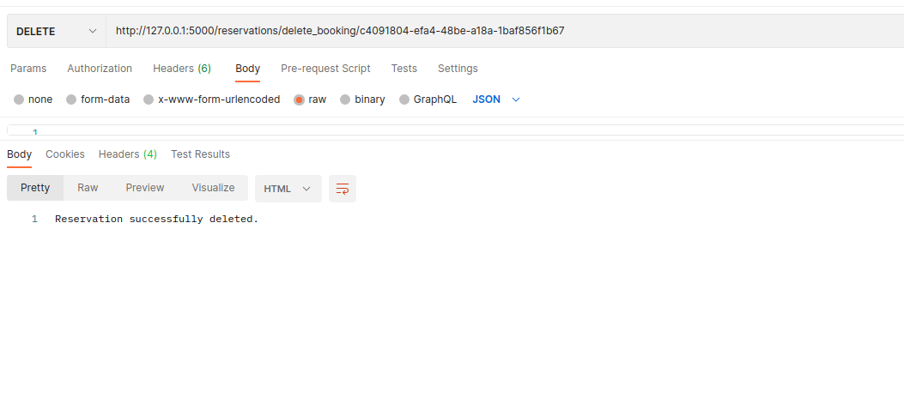

9) POST - defaultURL/reservations/<movie_id>/<theater_id>:
When using POST it expects a JSON input with selected seats. Max input 20 seats assuming completely empty theater.

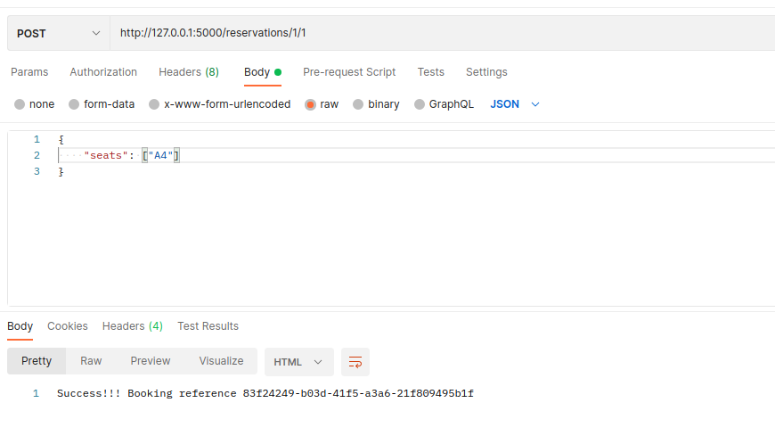
Possible responds to this call:
a) If seat selection valid, will receive a successful message alongside booking ID
b) If invalid seat selection will receive “Invalid seat selection” message alongside the current available seats (reserved seat, invalid seat number, duplicate seat selection)
c) If 0 seats selected will receive “Cannot book less than 1 seat” message
d) Empty or no JSON will receive a 500 code
