Project Plan
  - Modular Power Electronics & Current Control for the Geec
Student | Conor Farrell
Supervisor | Dr Maeve Duffy
Co-Assessor
Revision | 1

Scope Statement
The scope of this project will include:
- Evaluation of Current Power Electronics on the Geec
- Evaluation of Brushless versus Brushed Motor
- Simulation & Design of Power Electronics Board
- Design of Power Control Board
- Verification of safe functionality & implementation on the Geec

Stakeholders
Stakeholder | Power | Interest | Concerns
Supervisor  (Owner) | High | High | On time & achieve milestones/outputs  Timely Solutions to project issues  Regular Reports, safe and reliable implementation of deliverables
Co-Assessor | Medium | Low | Achieve Deliverables
Student(me) | High | High | Technical feasibility, meeting project scope and deadlines, producing results
Geec Team | Medium | High
SEM Organiser | High | High | Design is compliant with the rules as written by SEMD
Technical Officers | Medium | Medium | Safe use of lab equipment
EEE Department | High | Medium | Compliance with academic standards, successful project outcome
Geec Driver | Medium | High | System needs to be responsive and fail safe for driver safety

Contents
1 Scope Statement 1
2 Stakeholders 1
3 Deliverables 3
3.1 Fixed Deliverables 3
3.2 Interim Deliverables 3
4 Work Breakdown Structure 3
4.1 WP1: Background Research and Evaluation of Existing System 3
4.1.1 Task 1: BLDC Evaluation 3
4.1.2 Investigate the Current Power Electronics Design 3
4.1.3 Research different methods of control, power etc. 3
4.2 WP2: Power Electronics Design 3
4.2.1 Task 1: Power Stage Circuit Simulation 3
4.2.2 Task 2: Power Electronics Part Selection 3
4.2.3 Task 3: Schematic Design 4
4.2.4 Task 4: Layout Design 4
4.3 WP3: Control Electronics Design 4
4.3.1 Task 1: Control Scheme Comparison 4
4.3.2 Task 2: Hardware Control Simulation 4
4.3.3 Task 3: Control Electronics Schematic 4
4.3.4 Task 4: Control Electronics Layout 4
4.4 WP4: Electrical Verification 4
Deliverable: Verify the functionality of both the power electronics board and the power controller board. 4
4.4.1 Open Loop Power Electronic Testing 4
4.4.2 Power Controller Testing 4
4.4.3 Closed Loop Motor Control 5
4.4.4 Verification on Mini Dynamometer 5
4.5 WP5: Implementation on the Geec 5
4.5.1 Integrate Power Electronics into the Geec 5
4.5.2 Run new Power Electronic on the Dynamometer 5
4.5.3 Complete a Track Test 5
5 Work Schedule 6
6 Risk Register 7
7 Communication Strategy 8

Deliverables

Fixed Deliverables
- Project Plan
- Progress Report & Presentation
- Project Dissemination ( Word Document + PPT document)
- Bench Demonstration
- Final Project Report

Interim Deliverables
- Hardware Simulation
- Control Simulation
- Power Electronics Schematic and Layout
- Power Controller Schematic and Layout

Work Breakdown Structure

WP1: Background Research and Evaluation of Existing System
Deliverable: This Work Package should allow for an informed decision on the benefits and drawbacks of the current power electronics and the required direction forward for the Geec.

Task 1: BLDC Evaluation
- Rory Egan’s thesis last year investigated the use of a BLDC motor, suggesting that there is much greater performance to be achieved using BLDC.
- Investigate high efficiency BLDC motors in the 100-1000W range.
- Compare using existing data and manufacturer specifications the energy requirements.

Investigate the Current Power Electronics Design
- Evaluate the parts and layout of the current power electronics.
- Identify the capabilities and limitations involved in the current design.
- Simulate the current design.

Research different methods of control, power etc.
- Investigate the newer power MOSFETs, Gate Drivers, HEMTs and sensors.
- Investigate different control strategies, open loop, hardware vs software closed loop.
- Investigate connectors separate solutions.

WP2: Power Electronics Design
Deliverable: Power Electronics board with gate driver, Power MOSFETs, Current Sensors, Bulk Capacitors and non-isolated

Task 1: Power Stage Circuit Simulation
- Create an accurate simulation of the new power electronics.
- Determine the power consumption during switching events.
- Evaluate current ripple due to different switching frequencies

Task 2: Power Electronics Part Selection
- Select and Simulate other electrical parts. Current sensors, voltage sensors, combinations of capacitors (electrolytic, ceramic, Film, MLCC).
- Create a block diagram and of parts on each board.
- Estimate Power Consumption for idle and active states.

Task 3: Schematic Design
- Create part library in Altium with easy-to-understand symbols
- Create a 1- or 2-page schematic showcasing all components keeping all components that are functionally close to each other.
- Use SMD devices 0805 or greater in size.

Task 4: Layout Design
- Import schematic into PCB designer.
- Design 4-layer board keeping a large ground plane and minimising loop areas in switch nodes. Have separate ground planes for high resolution analogue signals vs power plane
- Order and assemble multiple boards.

WP3: Control Electronics Design
Deliverable: Power Controller board able to interface directly with the power electronics board. Containing micro-controller, hardware signal conditioning, DCDC converters, signal isolation.

Task 1: Control Scheme Comparison
Evaluate different control schemes: Open Loop, Closed Loop in hardware, software and hybrid approach.

Task 2: Hardware Control Simulation
- Simulate the chosen control scheme using a simplified power stage
- Simulate the hardware sensors and controllers

Task 3: Control Electronics Schematic
- Design a 1- or 2-page schematic with all components divided into functional block areas.
- Integrate isolation, DCDC conversion and signal conditioning.
- Use standard and reliable connectors to the power electronics board. Integrate extra connectors to integrate a DAQ board or other communication protocols

Task 4: Control Electronics Layout
- Import schematic into PCB designer
- Design 2-layer board creating a large and continuous ground plane where possible.
- Add mounting holes and order PCBs to be assembled in Galway.

WP4: Electrical Verification

Deliverable: Verify the functionality of both the power electronics board and the power controller board.

Open Loop Power Electronic Testing
- Verify bridge functionality behaves as per simulations
- The Power Electronics board can be tested open loop to verify functionality and characterise the device
- Determine maximum specifications, voltage, PWM % current etc.

Power Controller Testing
- Verify the functionality of the hardware/software controller
- Determine isolation efficacy, response speed for current controller.

Closed Loop Motor Control
- Connect the power electronics board to the power controller
- Run an Arduino script connecting the throttle and running an unloaded motor.
- Use a very low maximum current and use an oscilloscope to see the current limiting.

Verification on Mini Dynamometer
- In combination with Seán Cotter’s mini dynamometer project verify functionality with different current limits on different loads
- Identify stall torques and currents and use the current limiting to meet the limits.

WP5: Implementation on the Geec
Deliverable: Power Electronics system integrated into the Geec capable of racing at SEM

Integrate Power Electronics into the Geec
- Create all necessary connections for the new power electronics board
- Add connections to the steering wheel and DAQ.

Run new Power Electronic on the Dynamometer
- Complete a safe test of the new power electronics on the Dynamometer and compare the results with existing dynamometer data
- Run a variety of torques and current limits

Complete a Track Test
- Complete a track test in Dangan or another location and run a full race as per SEM rules.
- Complete a simulated technical inspection of the electrical system based on

Work Schedule
The work schedule for the project is being managed alongside the other team members in YouTrack, details of completed work will be kept in tasks and subtasks at https://thegeec.youtrack.cloud/gantt-charts/210-1 Below is a screenshot of the Gannt Chart for the above project
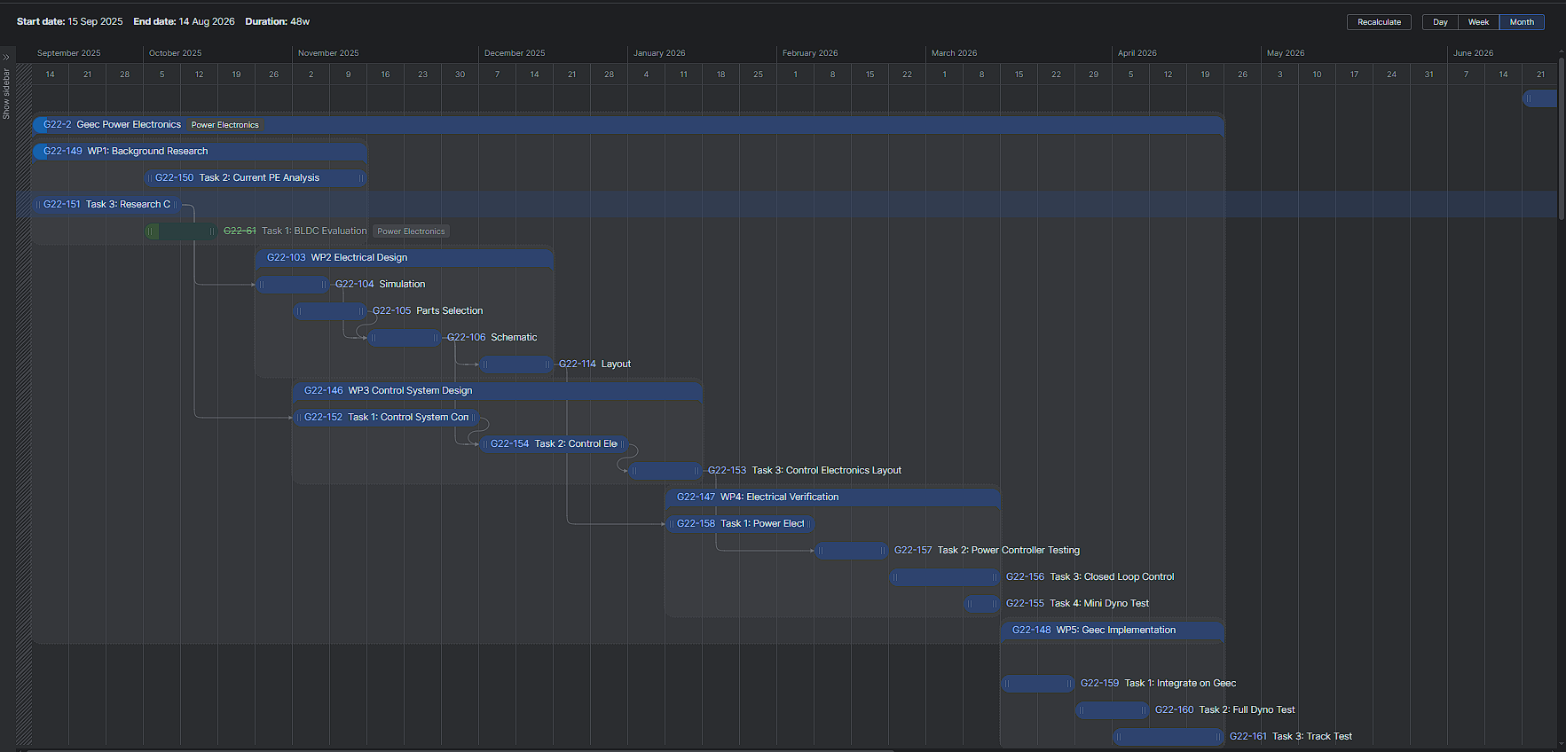

Risk Register
The project will be coordinated with respect to existing Geec SOPs and RAs, necessary SOPs and RAs will be updated as required:
Title | Severity | Likelihood | Overall Risk
Battery Charging
Power Electronics Testing | Low | Low | Low
Testing On Dynamometer | Medium | Low | Medium
Testing on Mini-Dynamometer | Medium | Low | Medium
Track Testing | Medium | Low | Medium
Manual Tools | Low | Low | Low
Power Tools | Medium | Low | Medium
All Risk assessments are available in the Geec lab (ENG-G011) and on the Geec SharePoint.

Communication Strategy
Name | Recipient | Frequency | Medium | Contents
Supervisor Meetings | Supervisor | Weekly (Monday) | In Person | Discuss actions of the previous week and next week
Leads Meeting | Teams Leads and Lecturers | Weekly (Tuesday) | In Person | Major Events on the team
YouTrack Tasks | Supervisor and Team | As work is Completed | YouTrack | Technical Details on work done
Progress Report | Supervisor and Co-Assessor | Once (deliverable) | In Person | PowerPoint and Report
Poster | All Stakeholder | Once (deliverable) | Public Event | Project Achievements
Bench Demo | Supervisor and Co-Assessor | Once (deliverable) | In Person | Demonstration of Technical Achievements
Final Report | Supervisor and Co-Assessor | Once (deliverable) | Document | In depth details on Technical Work

