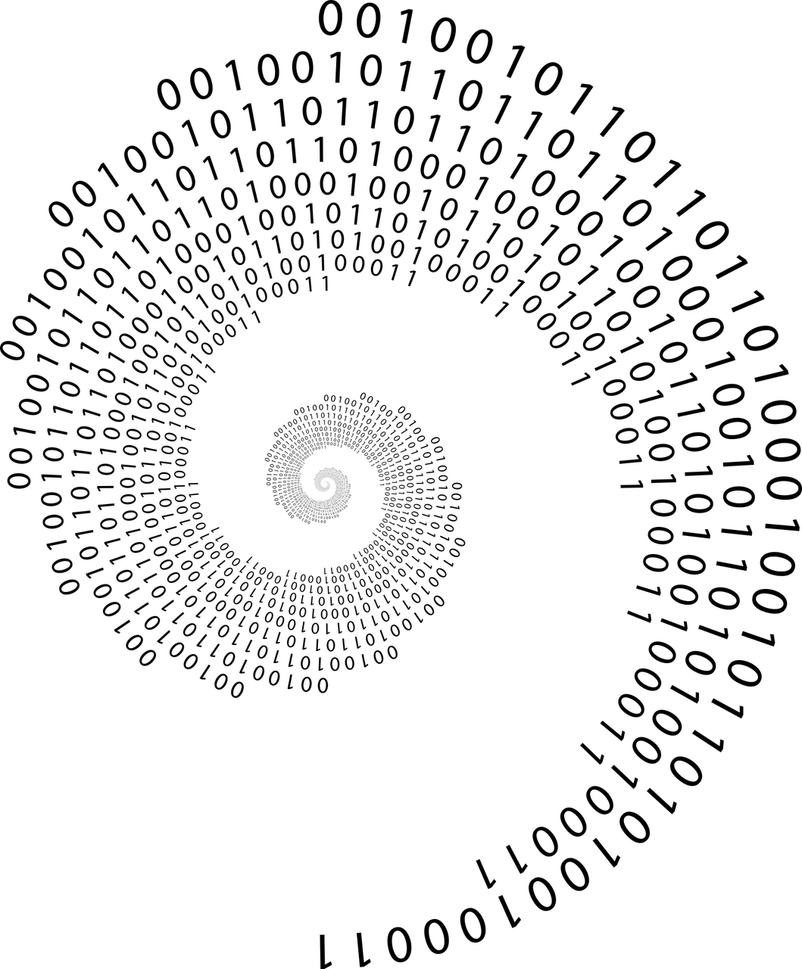
Sorting Algorithms Benchmarks
Report by Conor Dowdall
https://github.com/conor-dowdall/sorting-algorithms-benchmarks

Image by Gordon Johnson on Pixabay
Table of Contents
Introduction 3
Sorting Algorithms Overview 3
Time-and-Space Complexity 4
In-Place Sorting 4
Stable Sorting 5
Comparator Functions 5
5
Comparison-Based vs. Non-Comparison-Based Sorts 6
Five Sorting Algorithms 7
1) Bubble Sort 7
The First Iteration 7
The Second Iteration 9
Further Iterations 9
2) Selection Sort 10
The First Iteration 10
The Second Iteration 10
Further Iterations 11
3) Insertion Sort 12
The First Iteration 12
The Second Iteration 13
The Third Iteration 13
Further Iterations 14
4) Quicksort 15
5) Counting Sort 18
Implementation and Benchmarking 22
Effect of Sample Size on the Mean Times 22
Sorting-Time Histograms 22
Mean-Sorting-Time Plots 25
CPU Usage 26
Final Results 26
Developing the Software 28

Introduction
For this project, I wrote an application to benchmark the time-based performance of five sorting algorithms:
- Bubble Sort
- Selection Sort
- Insertion Sort
- Quicksort
- Counting Sort
The results of my measurements are discussed, and a discussion on the space-based complexity is included. The benchmarking software, which can be found in the sortingAlgorithmsBenchmarks directory accompanying this report, was written in Java and run on my home-PC, which has the following specifications:
Operating System | Kubuntu 23.10
Kernel Version | 6.5.0-27-lowlatency (64-bit)
Graphics Platform | X11
Processors | 4 × Intel® Core™ i5-4460 CPU @ 3.20GHz
Memory | 15.5 GiB of RAM
Graphics Processor | Mesa Intel® HD Graphics 4600
OpenJDK Version | "17.0.10" 2024-01-16
The plots and histograms included in this report were produced using a MATLAB / GNU Octave script, which can be found in the benchmarksPlots.m file accompanying this report. This script reads data from files produced in the benchmarking software, and stored in the data directory inside the Java project directory.

Sorting Algorithms Overview
In computer science, a sorting algorithm is an algorithm that puts elements of a list into an order [https://en.wikipedia.org/wiki/Sorting_algorithm]. For this project, arrays of integers were sorted in numerical order. Each sorting algorithm has its own strengths and weaknesses, and selecting the right one can significantly impact the efficiency and effectiveness of a program. Understanding the concepts outlined below, such as time complexity, and in-place sorting, allows developers to choose the most appropriate sorting algorithm for a given task, based on factors such as the size of the dataset, memory constraints, stability requirements, and performance considerations.

Time-and-Space Complexity
Big O notation is commonly used when discussing the time-based, and space-based requirements of a sorting algorithm as the input size grows, and is so called because it represents the order of the function that the algorithm uses. The order of a mathematical function is the highest power represented in input of the function. For example, the functions
- y = x² + x + 1
- y = x³ + x² + x + 1
have orders of 2 and 3 respectively, so these could be represented in big O notation as
- O(n²)
- O(n³)
Some sorting algorithms can be more, or less, efficient, depending on the input supplied, so omega notation is sometimes used to describe the best-case for an algorithm, and is represented using the Greek letter, omega: Ω(n).
Time complexity refers to the amount of time it takes for an algorithm to complete as a function of the size of the input data; whereas space complexity refers to the amount of memory, or space, required by an algorithm to complete. See Table 1 for a breakdown of the time-and-space complexities of the five algorithms chosen for this project.
 | Time |  |  | Space
Algorithm | Best (Ω) | Average | Worst | Worst | Stable
Bubble Sort | Ω(n) | O(n²) | O(n²) | O(1) | Yes
Selection Sort | Ω(n²) | O(n²) | O(n²) | O(1) | No*
Insertion Sort | Ω(n) | O(n²) | O(n²) | O(1) | Yes
Quicksort | Ω(n log n) | O(n log n) | O(n²) | O(n) | No*
Counting Sort | Ω(n + k) | O(n + k) | O(n + k) | O(n + k) | Yes
Table 1: Summary of a selection of sorting algorithms’ time and space complexities
* stable variations exist

In-Place Sorting
In-place sorting algorithms are those that rearrange the elements within the array without requiring extra memory space. This is particularly advantageous for sorting large datasets where memory efficiency is critical. Examples of in-place sorting algorithms include bubble sort, selection sort, and insertion sort. Quicksort is usually considered in this category, although it usually needs O(log² n) of additional space. Other algorithms needing only O(log n) of additional space are usually considered to be in-place algorithms [https://en.wikipedia.org/wiki/In-place_algorithm].

Stable Sorting
A sorting algorithm is stable if it preserves the relative order of equal elements in the sorted output. Stability is essential in situations where the original order of elements carries significance, for example if patients arriving at a hospital were arranged by seriousness-priority rankings, it would still be necessary to see people with the same seriousness-priority ranking, in the order they arrived. Algorithms like bubble sort, insertion sort, and counting sort are stable. Selection sort and quicksort are not inherently stable, but can be modified to be stable.

Comparator Functions
Comparator functions are used in a programming language, to define custom comparison rules for sorting elements. They allow sorting algorithms to be flexible and adaptable to different data types and sorting criteria. Implementations of comparator functions in the Java language to arrange a list of integers in ascending order; and to arrange a list of strings in ascending order, according to length, are shown in Figure 1 and Figure 2 [https://www.geeksforgeeks.org/sort-an-array-in-java-using-comparator/].

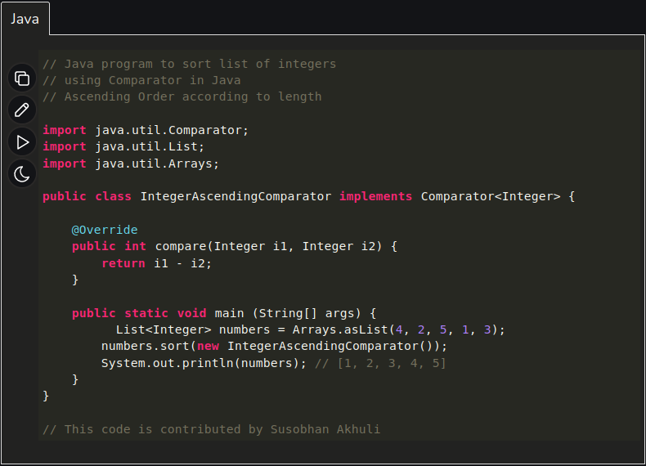Figure 1: Java code to sort a list of integers in ascending order.

Comparison-Based vs. Non-Comparison-Based Sorts
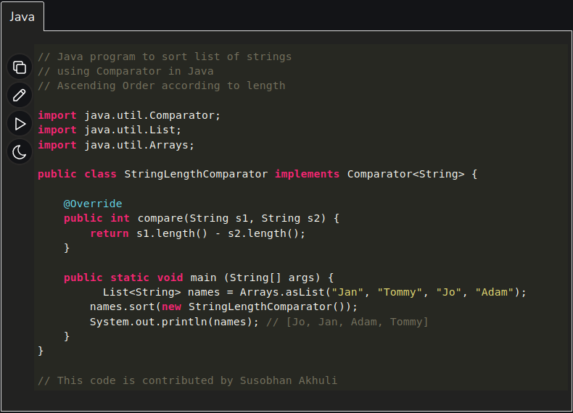Figure 2: Java code to sort a list of strings in ascending order, according to length.
Sorting algorithms can be categorised based on whether they rely on comparing elements directly or use alternative techniques. Comparison-based sorting algorithms, like bubble sort, compare elements pairwise to determine their order. Non-comparison-based sorting algorithms, like counting sort, exploit specific properties of the input data to sort elements without direct comparisons, often leading to improved performance in certain scenarios.
Counting sort, for example, creates a bucket for each value and keeps a counter in each bucket. Each time a value is encountered in the input collection, the appropriate counter is incremented. Because the counting sort algorithm creates a bucket for each value, an imposing restriction is that the maximum value in the input array is known beforehand. Once every value is inserted into the bucket, you just go through the count array and print them out depending upon their frequency [https://www.java67.com/2017/06/counting-sort-in-java-example.html].

Five Sorting Algorithms

1) Bubble Sort
Bubble sort is a stable sorting algorithm that works by iterating over a list, comparing adjacent elements, and swapping them if necessary (based on the comparator function used). Multiple iterations over the list are required to fully sort the list, and it is not particularly suitable for real-world usage on large datasets.
- Time: in the worst case, an iteration over the entire list is done for each list-element, resulting in a time complexity of O(n²).
- Space: lists are sorted in place, so the space complexity is O(1).
Let’s examine its operation by sorting a list of integers in ascending order. For the example, I will use the integers in my student number: 10024983.

The First Iteration
Start with the list: 1, 0, 0, 2, 4, 9, 8, 3.
1 | 0 | 0 | 2 | 4 | 9 | 8 | 3

Starting at the first element, we go through the list, comparing elements. This will be the first iteration through the list.
Compare the first two elements: 1 and 0. We are sorting in ascending order, so if the former is greater than the latter, we swap their positions. In this case, 1 is greater than 0, so we do a swap.
1 | 0 | 0 | 2 | 4 | 9 | 8 | 3
1 > 0 => swap
0 | 1 | 0 | 2 | 4 | 9 | 8 | 3

We the move on to the second and third elements of the new list: 1 and 0. Since 1 is greater than 0, we swap again.

0 | 1 | 0 | 2 | 4 | 9 | 8 | 3
 | 1 > 0 => swap
0 | 0 | 1 | 2 | 4 | 9 | 8 | 3

Next, we compare the third and fourth elements of the new list, swapping if needed, and the process continues until we have checked the last two elements of the list.
0 | 0 | 1 | 2 | 4 | 9 | 8 | 3
 |  | 1 < 2 => no swap
0 | 0 | 1 | 2 | 4 | 9 | 8 | 3

0 | 0 | 1 | 2 | 4 | 9 | 8 | 3
 |  |  | 2 < 4 => no swap
0 | 0 | 1 | 2 | 4 | 9 | 8 | 3

0 | 0 | 1 | 2 | 4 | 9 | 8 | 3
 |  |  |  | 4 < 9 => no swap
0 | 0 | 1 | 2 | 4 | 9 | 8 | 3

0 | 0 | 1 | 2 | 4 | 9 | 8 | 3
 |  |  |  |  | 9 > 8 => swap
0 | 0 | 1 | 2 | 4 | 8 | 9 | 3

0 | 0 | 1 | 2 | 4 | 8 | 9 | 3
 |  |  |  |  |  | 9 > 3 => swap
0 | 0 | 1 | 2 | 4 | 8 | 3 | 9

As can be seen, the list is not yet fully sorted, so further iterations are needed. However, the last element in the list will indeed be the largest integer.
0 | 0 | 1 | 2 | 4 | 8 | 3 | 9

The Second Iteration
During the second iteration, we don’t need to go all the way to the end, because the first iteration moved the largest integer to the end of the list already. Below is a quick run through of the second iteration.
0 | 0 | 1 | 2 | 4 | 8 | 3 | 9
0 | 0 | 1 | 2 | 4 | 8 | 3 | 9
0 | 0 | 1 | 2 | 4 | 8 | 3 | 9
0 | 0 | 1 | 2 | 4 | 8 | 3 | 9
0 | 0 | 1 | 2 | 4 | 8 | 3 | 9
0 | 0 | 1 | 2 | 4 | 3 | 8 | 9

Now, the last two integers are in the correct places. The process then continues iterating through third, fourth, etc. iterations, ending at one position less each time, until the list is sorted.
0 | 0 | 1 | 2 | 4 | 3 | 8 | 9

Further Iterations
Further iterations will “bubble” the larger numbers to the end of the list and result in a fully sorted list: 0, 0, 1, 2, 3, 4, 8, 9.
0 | 0 | 1 | 2 | 3 | 4 | 8 | 9

2) Selection Sort
Selection sort is an unstable sorting algorithm (with stable variations) that sorts a list by dividing the list into a sorted part and an unsorted part, then repeatedly finding the minimum element (assuming an ascending sorting order) from the unsorted part and putting it at the beginning of the unsorted part. It is quite inefficient and should only be considered for real-world usage when space complexity is a consideration.
- Time: each iteration finds the minimum (assuming ascending order) in the entire unsorted part of the list, which results in a time complexity of O(n²).
- Space: lists are sorted in place, so the space complexity is O(1).
Let’s examine its operation by sorting a list of integers in ascending order. For the example, I will use the integers in my student number: 10024983.

The First Iteration
Start with the list: 1, 0, 0, 2, 4, 9, 8, 3.
1 | 0 | 0 | 2 | 4 | 9 | 8 | 3

Starting at the first element, we go through the list, and find the minimum value: 0. This will be the first iteration through the list.
1 | 0 | 0 | 2 | 4 | 9 | 8 | 3
 | min.

Since this is the first iteration, we swap the found minimum element with the first element.
0 | 1 | 0 | 2 | 4 | 9 | 8 | 3
swapped | swapped

The first element in the list is now in the correct position, so we move on to the next iterations.

The Second Iteration
Beginning from the second element in the list (because the first one is already properly sorted), we again find the minimum, and swap it with the second element.
0 | 1 | 0 | 2 | 4 | 9 | 8 | 3
 |  | min.

0 | 0 | 1 | 2 | 4 | 9 | 8 | 3
 | swapped | swapped

Further Iterations
Further iteration find the new minimum, and swap it with the first element in the unsorted part of the list. Below is a quick run through of these iterations.
0 | 0 | 1 | 2 | 4 | 9 | 8 | 3
0 | 0 | 1 | 2 | 4 | 9 | 8 | 3
0 | 0 | 1 | 2 | 3 | 9 | 8 | 4
0 | 0 | 1 | 2 | 3 | 4 | 8 | 9
0 | 0 | 1 | 2 | 3 | 4 | 8 | 9

The final result is the sorted list: 0, 0, 1, 2, 3, 4, 8, 9.

3) Insertion Sort
Insertion sort is a stable sorting algorithm that works by taking one element from the “unsorted portion” of the list and inserting it into its correct position in the “sorted portion” of the list. It is more efficient than bubble sort and selection sort, but still inefficient on large datasets.
- Time: each iteration traverses the entire unsorted part of the list, which results in a time complexity of O(n²).
- Space: lists are sorted in place, so the space complexity is O(1).
Let’s examine its operation by sorting a list of integers in ascending order. For the example, I will use the integers in my student number: 10024983.

The First Iteration
Start with the list: 1, 0, 0, 2, 4, 9, 8, 3.
1 | 0 | 0 | 2 | 4 | 9 | 8 | 3

We store the second element as a key value and compare with the first element, which is in the “sorted portion”. The first element is greater than the key value, so we copy its value to the element ahead of it. We then find that we are at the beginning of the list, so we copy the key value into the first element.
1 | 0 | 0 | 2 | 4 | 9 | 8 | 3
 | key = 0
1 | 0 | 0 | 2 | 4 | 9 | 8 | 3
copy
1 | 1 | 0 | 2 | 4 | 9 | 8 | 3
key
0 | 1 | 0 | 2 | 4 | 9 | 8 | 3

Now, the first two elements comprise what we will call the “sorted portion” of the list. The rest of the list is the “unsorted portion”.

The Second Iteration
We store the third element as a key value and compare with the second element, which is in the “sorted portion”. The second element is greater than the key value, so we copy its value to the element ahead of it. We then compare the key value with the first element. They are in the correct order, so we copy the key into the element ahead of the first element (the second element) and terminate because there is no need to check any further into the “sorted portion” of the list.
0 | 1 | 0 | 2 | 4 | 9 | 8 | 3
 |  | key = 0
0 | 1 | 0 | 2 | 4 | 9 | 8 | 3
 | copy
0 | 1 | 1 | 2 | 4 | 9 | 8 | 3
key
0 | 0 | 1 | 2 | 4 | 9 | 8 | 3

Now, the first three elements are sorted.

The Third Iteration
We keep iterating in this manner, next choosing the fourth element, and putting it into its correct position in the “sorted portion” of the list. The algorithm can stop when it compares the key to element three, because the third element is less than the key value. We know we can stop here because the third element is in the “sorted portion” of the list, and all previous elements are lesser in value. Following the algorithm’s steps, we copy the key value to the element ahead of the third element (the fourth element).
0 | 0 | 1 | 2 | 4 | 9 | 8 | 3
 |  |  | key = 2
0 | 0 | 1 | 2 | 4 | 9 | 8 | 3
 |  | key
0 | 0 | 1 | 2 | 4 | 9 | 8 | 3

Further Iterations
Below is a quick run through of the rest of the iterations.
0 | 0 | 1 | 2 | 4 | 9 | 8 | 3
 |  |  |  | key = 4
0 | 0 | 1 | 2 | 4 | 9 | 8 | 3
 |  |  | key
0 | 0 | 1 | 2 | 4 | 9 | 8 | 3

0 | 0 | 1 | 2 | 4 | 9 | 8 | 3
 |  |  |  |  | key = 9
0 | 0 | 1 | 2 | 4 | 9 | 8 | 3
 |  |  |  | key
0 | 0 | 1 | 2 | 4 | 9 | 8 | 3

0 | 0 | 1 | 2 | 4 | 9 | 8 | 3
 |  |  |  |  |  | key = 8
0 | 0 | 1 | 2 | 4 | 9 | 8 | 3
 |  |  |  |  | copy
0 | 0 | 1 | 2 | 4 | 9 | 9 | 3
 |  |  |  | key
0 | 0 | 1 | 2 | 4 | 8 | 9 | 3

0 | 0 | 1 | 2 | 4 | 8 | 9 | 3
 |  |  |  |  |  |  | key = 3
0 | 0 | 1 | 2 | 4 | 8 | 9 | 3
 |  |  |  |  |  | copy
0 | 0 | 1 | 2 | 4 | 8 | 9 | 9
 |  |  |  |  | copy
0 | 0 | 1 | 2 | 4 | 8 | 8 | 9
 |  |  |  | copy
0 | 0 | 1 | 2 | 4 | 4 | 8 | 9
 |  |  | key
0 | 0 | 1 | 2 | 3 | 4 | 8 | 9

The final result is the sorted list: 0, 0, 1, 2, 3, 4, 8, 9.

4) Quicksort
Quicksort is an unstable sorting algorithm (with stable variations) that divides a list into two sublists based on a comparison with a “pivot” element.
- Time: On average, quicksort has a time complexity of O(n log n), however in the worst-case scenario it has O(n²).
- Space: Carefully implemented optimisations can be used to make it O(log n) in space complexity, however it ordinarily has O(n).
Let’s examine its operation by sorting a list of integers in ascending order. For the example, I will use the integers in my student number: 10024983.
Start with the list: 1, 0, 0, 2, 4, 9, 8, 3.
1 | 0 | 0 | 2 | 4 | 9 | 8 | 3

Choose a pivot element. There are different strategies for choosing a pivot – a common one is to select the last element, which we will do here. Then, we do a process called “partitioning”, where we rearrange the elements in the list so that all elements smaller than the pivot come before it, and all elements greater than the pivot come after it. We mark the, theoretical, −1th element with a * and, iterating over the list, if the current element is less than the pivot, we move the * forward element, and swap the current element with the * element. This functionally does nothing, in the demonstrations below, but is used in different scenarios. Finally, we move the * forward by one element, swap that element with the pivot element, and label the position of the * as the partition index (index_{p}). The element at index_{p} is now in the correct position in the list. This is partitioning.

 | 1 | 0 | 0 | 2 | 4 | 9 | 8 | 3
 |  |  |  |  |  |  |  | pivot
* | 1 | 0 | 0 | 2 | 4 | 9 | 8 | 3
 | 1 < 3?
 | 1* | 0 | 0 | 2 | 4 | 9 | 8 | 3
 |  | 0 < 3?
 | 1 | 0* | 0 | 2 | 4 | 9 | 8 | 3
 |  |  | 0 < 3?
 | 1 | 0 | 0* | 2 | 4 | 9 | 8 | 3
 |  |  |  | 2 < 3?
 | 1 | 0 | 0 | 2* | 4 | 9 | 8 | 3
 |  |  |  |  | 4 < 3?
 | 1 | 0 | 0 | 2* | 4 | 9 | 8 | 3
 |  |  |  |  |  | 9 < 3?
 | 1 | 0 | 0 | 2* | 4 | 9 | 8 | 3
 |  |  |  |  |  |  | 8 < 3?
 | 1 | 0 | 0 | 2* | 4 | 9 | 8 | 3
 |  |  |  | *
 | 1 | 0 | 0 | 2 | 4* | 9 | 8 | 3
 |  |  |  |  | swap |  |  | swap
 | 1 | 0 | 0 | 2 | 3 | 9 | 8 | 4
 |  |  |  |  | index_{p}
 | 1 | 0 | 0 | 2 | 3 | 9 | 8 | 4

We now partition the sub-list to the left of index_{p}, and the sub-list to the right of index_{p}. For this demonstration, we will only partition the sub-list to the right.

 | 9 | 8 | 4
 |  |  | pivot
* | 9 | 8 | 4
 | 9 < 4?
* | 9 | 8 | 4
 |  | 8 < 4?
* | 9 | 8 | 4
*
 | 9* | 8 | 4
 | swap |  | swap
 | 4 | 8 | 9
 | index_{p}
 | 4 | 8 | 9

Now, because the partition index is at the beginning of the list, we stop partitioning. As can be seen, this sub-list is now fully sorted.

The same approach is taken for the other sub-list, and, if necessary, that is divided into further left-and-right sub-lists which are partitioned, resulting in a fully sorted list of integers.

5) Counting Sort
Counting sort is a stable, non-comparison-based sorting algorithm, that sorts a list of elements by counting the frequency of each distinct element in the list and then calculating where each element should be placed in the output, sorted list.
- Time: O(n + k), where k is the range of the non-negative key values.
- Space: Worst case O(n + k).
Let’s examine its operation by sorting a list of integers in ascending order. For the example, I will use the integers in my student number: 10024983.
Start with the list: 1, 0, 0, 2, 4, 9, 8, 3.
1 | 0 | 0 | 2 | 4 | 9 | 8 | 3

First, find the maximum value in the list: 9.
Original List
1 | 0 | 0 | 2 | 4 | 9 | 8 | 3
 |  |  |  |  | max.

Then, create a new list, which we will call the “counting list”, with one more element than the value of the maximum, and fill it with zeroes. This will be like a histogram of the input elements. In this case the “counting list” will be of size ten.

Counting List
i = 0 | i = 1 | i = 2 | i = 3 | i = 4 | i = 5 | i = 6 | i = 7 | i = 8 | i = 9
0 | 0 | 0 | 0 | 0 | 0 | 0 | 0 | 0 | 0

Next, use the values in the original list as the index values for the “counting list” (index values start from 0, as opposed to position values, which start at one). For each occurrence of a value in the original list, increment the element at the index equal to that value in the “counting list”, by one. One occurs once, in out example, so the “counting list” will be incremented by one at index one. Zero occurs twice, so the “counting list” will be incremented by two at index zero.

Counting List
i = 0 | i = 1 | i = 2 | i = 3 | i = 4 | i = 5 | i = 6 | i = 7 | i = 8 | i = 9
2 | 1 | 1 | 1 | 1 | 0 | 0 | 0 | 1 | 1

Starting at index 1 (position 2), we go through each element in this “counting list” and add the value at the previous index to it (which gets updated as we move through the list). The “counting list” values are now, essentially, the position values for the output, sorted list, of the input-list elements, where their values are taken as indexes of the “counting list”.

Counting List
i = 0 | i = 1 | i = 2 | i = 3 | i = 4 | i = 5 | i = 6 | i = 7 | i = 8 | i = 9
2 | 3 | 4 | 5 | 6 | 6 | 6 | 6 | 7 | 8

Lastly, we create a new, empty list, of the same length as the original list (i.e. 8), which will be the sorted list.

Using value of the last element in the original list (value = 3), as the index of the “counting list” (value = 5), we subtract one (value = 4) and use that value as the index of the (to-be) sorted list to store the value of the last element in the original list (value = 3). This element is in its correct position. We then decrement, by one, the “counting list” value, at the index equal to the value we are dealing with (i.e. 3) to handle duplicate elements correctly.

Original List Value = 3

Sorted List
i = 0 | i = 1 | i = 2 | i = 3 | i = 4 | i = 5 | i = 6 | i = 7
 |  |  |  | 3

Counting List
i = 0 | i = 1 | i = 2 | i = 3 | i = 4 | i = 5 | i = 6 | i = 7 | i = 8 | i = 9
2 | 3 | 4 | 5–1 = 4 | 6 | 6 | 6 | 6 | 7 | 8

Using the previous element as the “last element”, we move through the values in the original list, repeating the most recent step, until we reach the first element in the original list.

Original List Value = 8

Sorted List
i = 0 | i = 1 | i = 2 | i = 3 | i = 4 | i = 5 | i = 6 | i = 7
 |  |  |  | 3 |  | 8

Counting List
i = 0 | i = 1 | i = 2 | i = 3 | i = 4 | i = 5 | i = 6 | i = 7 | i = 8 | i = 9
2 | 3 | 4 | 4 | 6 | 6 | 6 | 6 | 7–1 = 6 | 8

Original List Value = 9

Sorted List
i = 0 | i = 1 | i = 2 | i = 3 | i = 4 | i = 5 | i = 6 | i = 7
 |  |  |  | 3 |  | 8 | 9

Counting List
i = 0 | i = 1 | i = 2 | i = 3 | i = 4 | i = 5 | i = 6 | i = 7 | i = 8 | i = 9
2 | 3 | 4 | 4 | 6 | 6 | 6 | 6 | 6 | 8–1 = 7

Original List Value = 4

Sorted List
i = 0 | i = 1 | i = 2 | i = 3 | i = 4 | i = 5 | i = 6 | i = 7
 |  |  |  | 3 | 4 | 8 | 9

Counting List
i = 0 | i = 1 | i = 2 | i = 3 | i = 4 | i = 5 | i = 6 | i = 7 | i = 8 | i = 9
2 | 3 | 4 | 4 | 6–1 = 5 | 6 | 6 | 6 | 6 | 7

Original List Value = 2

Sorted List
i = 0 | i = 1 | i = 2 | i = 3 | i = 4 | i = 5 | i = 6 | i = 7
 |  |  | 2 | 3 | 4 | 8 | 9

Counting List
i = 0 | i = 1 | i = 2 | i = 3 | i = 4 | i = 5 | i = 6 | i = 7 | i = 8 | i = 9
2 | 3 | 4–1 = 3 | 4 | 5 | 6 | 6 | 6 | 6 | 7
Original List Value = 0

Sorted List
i = 0 | i = 1 | i = 2 | i = 3 | i = 4 | i = 5 | i = 6 | i = 7
 | 0 |  | 2 | 3 | 4 | 8 | 9

Counting List
i = 0 | i = 1 | i = 2 | i = 3 | i = 4 | i = 5 | i = 6 | i = 7 | i = 8 | i = 9
2–1 = 1 | 3 | 3 | 4 | 5 | 6 | 6 | 6 | 6 | 7

Original List Value = 0

Sorted List
i = 0 | i = 1 | i = 2 | i = 3 | i = 4 | i = 5 | i = 6 | i = 7
0 | 0 |  | 2 | 3 | 4 | 8 | 9

Counting List
i = 0 | i = 1 | i = 2 | i = 3 | i = 4 | i = 5 | i = 6 | i = 7 | i = 8 | i = 9
1–1 = 0 | 3 | 3 | 4 | 5 | 6 | 6 | 6 | 6 | 7

Original List Value = 1

Sorted List
i = 0 | i = 1 | i = 2 | i = 3 | i = 4 | i = 5 | i = 6 | i = 7
0 | 0 | 1 | 2 | 3 | 4 | 8 | 9

Counting List
i = 0 | i = 1 | i = 2 | i = 3 | i = 4 | i = 5 | i = 6 | i = 7 | i = 8 | i = 9
0 | 3–1 = 2 | 3 | 4 | 5 | 6 | 6 | 6 | 6 | 7

Original List Finished
The sorted list is now complete and can be returned to the user as a sorted version of the original list.

Sorted List
i = 0 | i = 1 | i = 2 | i = 3 | i = 4 | i = 5 | i = 6 | i = 7
0 | 0 | 1 | 2 | 3 | 4 | 8 | 9

Implementation and Benchmarking

Effect of Sample Size on the Mean Times
The specification for this project suggests:
The running time (in milliseconds) for each algorithm should be measured 10 times, and the average of the 10 runs for each algorithm…
I wanted to investigate the effect of various sample sizes (repetitions of the sorting-time measurement) on the value of the mean. I outputted the each sorting-time measurement, in nano-seconds, for an input-array size of 1000 elements, to a space-separated file in the data directory in the Java project directory, sortingAlgorithmsBenchmarks, for each algorithm. The files were named:
- data/BubbleSortTimes.csv
- data/CountingSortTimes.csv
- data/InsertionSortTimes.csv
- data/QuickSortTimes.csv
- data/SelectionSortTimes.csv
I also outputted a space-separated file, in tabular form, of the input-array sizes; the mean sorting-times in nano-seconds; and the standard deviations on the means; for each sorting algorithm, to a file called:
- data/data_ns.csv
These files could then be read by a MATLAB / GNU Octave script called:
- benchmarksPlots.m
located in the main directory of this project submission. This script goes into the data directory inside the Java project directory, sortingAlgorithmsBenchmarks, and outputs histograms of the individual sorting times, in milli-seconds; and plots of the mean sorting-times, in milli-seconds, for different input-array sizes; for each sorting algorithm, storing the plots in JPEG format in the images directory of the main project directory.
In general, the average sorting-times were quite consistent for repetition sample-sizes of 10; 100; 1000; 10,000; and 100,000, and some discussion of the data is presented below. An entirely new random integer array, with values between 0 and 1000, was generated for each sample’s run, rather than using the same array, to ensure a better estimation of the average time and to avoid the possibility random edge-cases, that work for-or-against each algorithm.

Sorting-Time Histograms
The histograms and plots can be found below in Figure 3 to Figure 8. As can be seen in Figure 3, ten repetitions does not form anything close to a normal distribution., while in Figure 4, it is beginning to look more normal. It is noteworthy that the data is actually closer to a Poisson distribution, as is further evident in Figure 5, which would require slightly different mathematics to find the expected value of the data. However, for this project, a simple average, assuming a normal distribution suffices. Figure 5 reveals some abnormalities in some of the sorting algorithms, in particular bubble sort, where a second, smaller spike is noticeable. This implies a more complex discussion on the expected time could be necessary for bubble sort. Some of the other algorithms show hints at secondary bumps too.
Figure 6, with 100,000 repetitions, shows a highly abnormal bump for bubble sort. I re-ran the algorithm with the same repetitions to check if this was repeatable, but Figure 7 and Figure 8 show a more stable-looking, singe bump.
Using visual inspection, I decided that 10,000 repetitions looked close to a normal distribution, so I used that for my final run, discussed in the Final Results section.

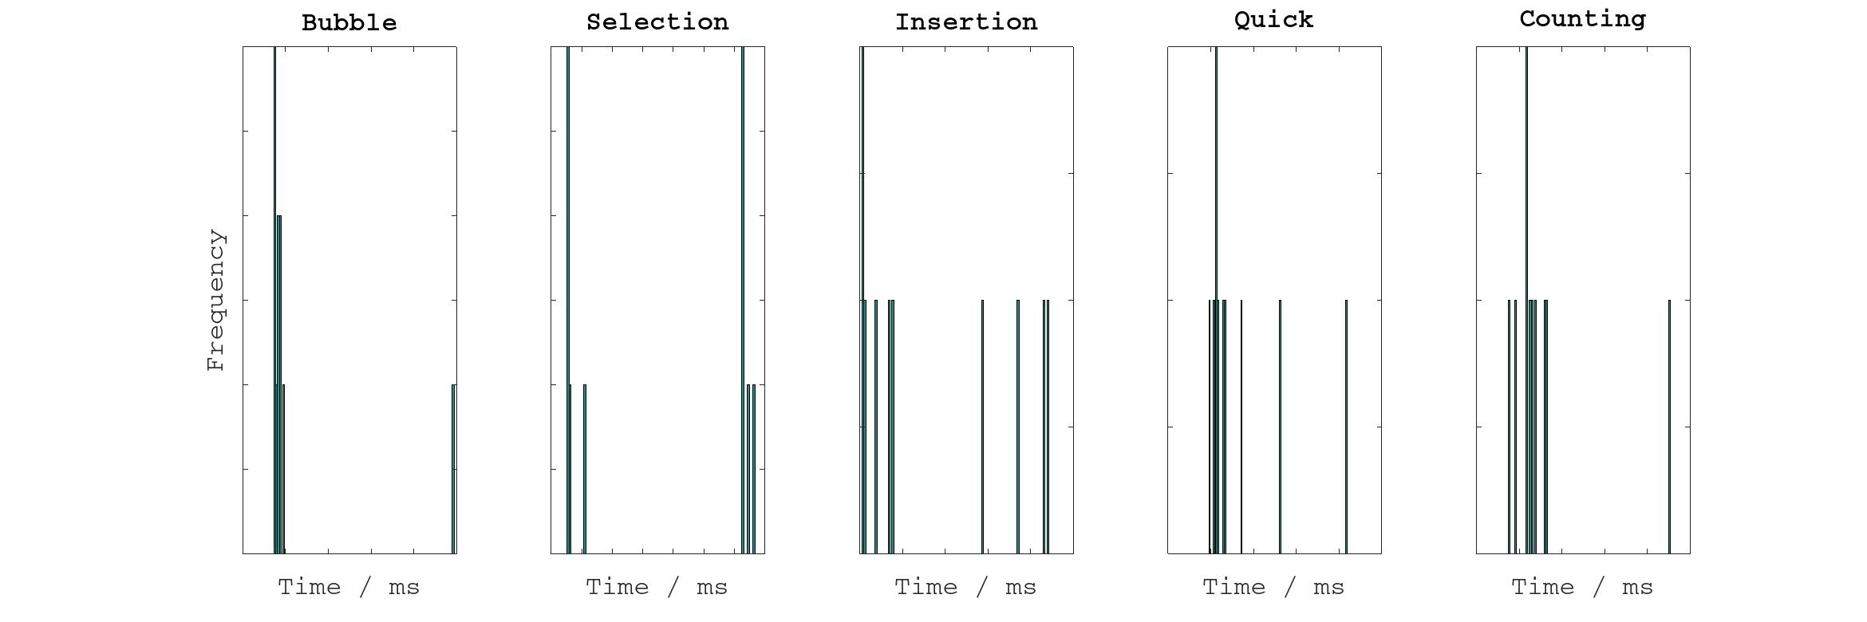Figure 3: Histograms of sorting times using 10 repetitions on 1000-element input arrays.

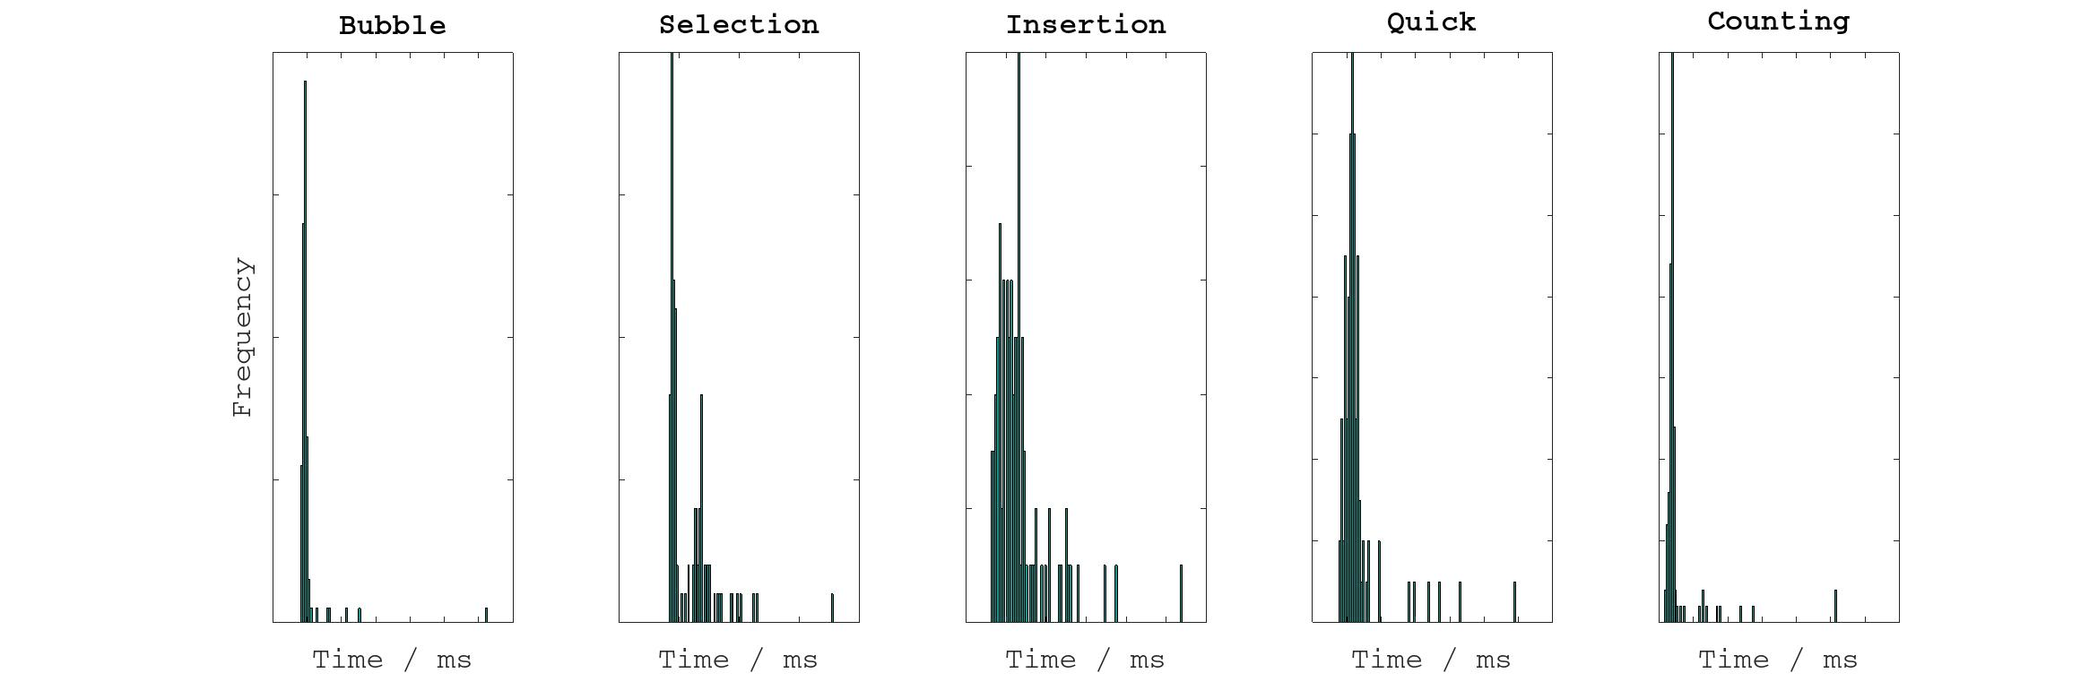Figure 4: Histograms of sorting times using 100 repetitions on 1000-element input arrays.

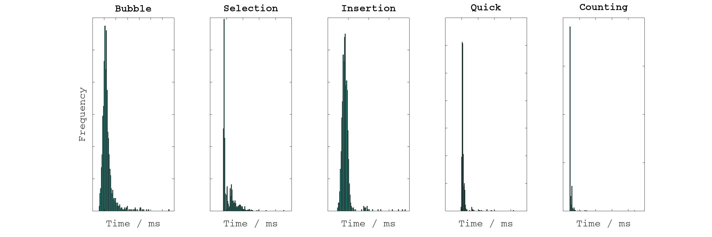Figure 5: Histograms of sorting times using 1000 repetitions on 1000-element input arrays.

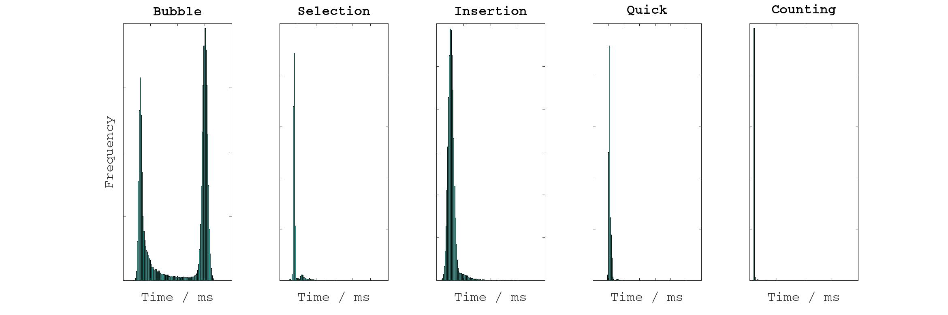Figure 6: Histograms of sorting times using 100,000 repetitions on 1000-element input arrays.

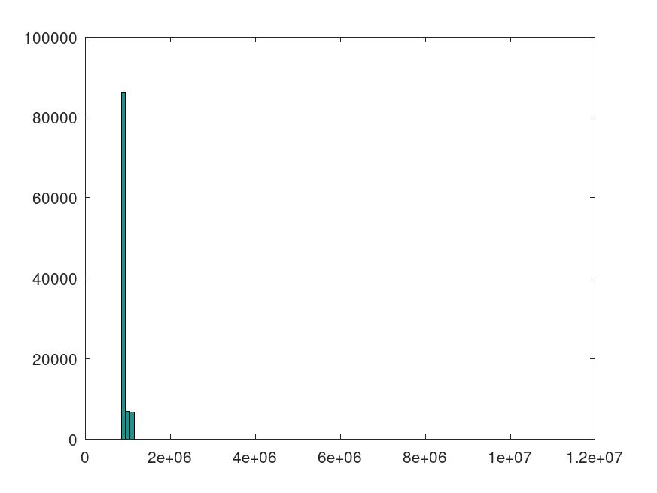Figure 7: Histogram of re-run of bubble sort sorting times using 100,000 repetitions on 1000-element input arrays.
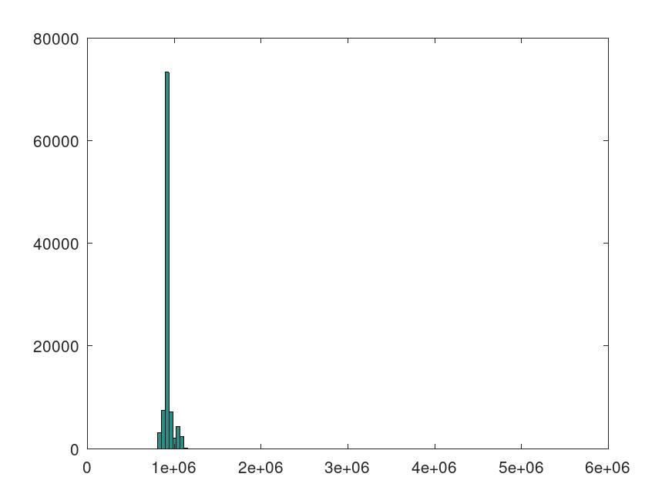Figure 8: Histogram of re-run of bubble sort sorting times using 100,000 repetitions on 1000-element input arrays.

Mean-Sorting-Time Plots
Figure 9 to Figure 13 show the mean times to sort various-sized inputs for each algorithm. The standard deviation for each mean is shown in the error bars, and is there as a visual indicator of the spread of the data. In particular with bubble sort, this standard deviation gets bigger as the input array size increases. Figure 9 shows some inconsistencies at lower input sizes, using 10 repetitions. However, the data is relatively consistent at different repetition sample sizes.
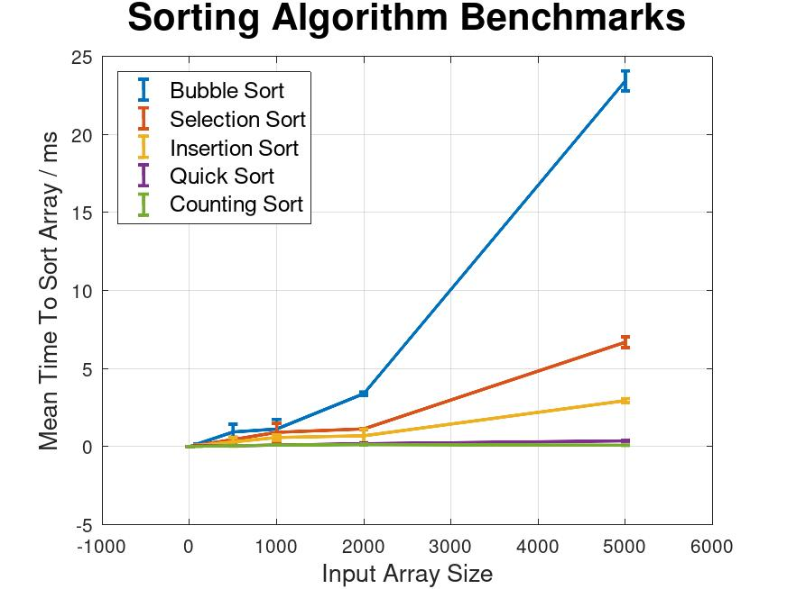Figure 9: Plots of mean sorting times using 10 repetitions on different input-array sizes.
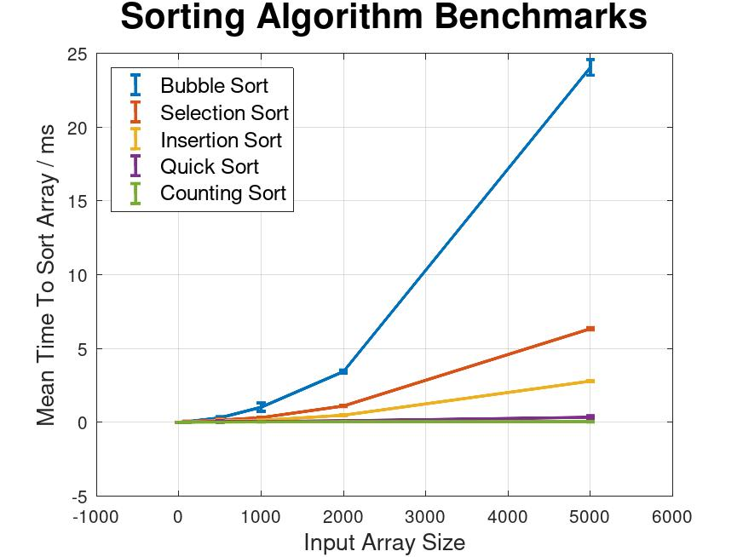Figure 10: Plots of mean sorting times using 100 repetitions on different input-array sizes.
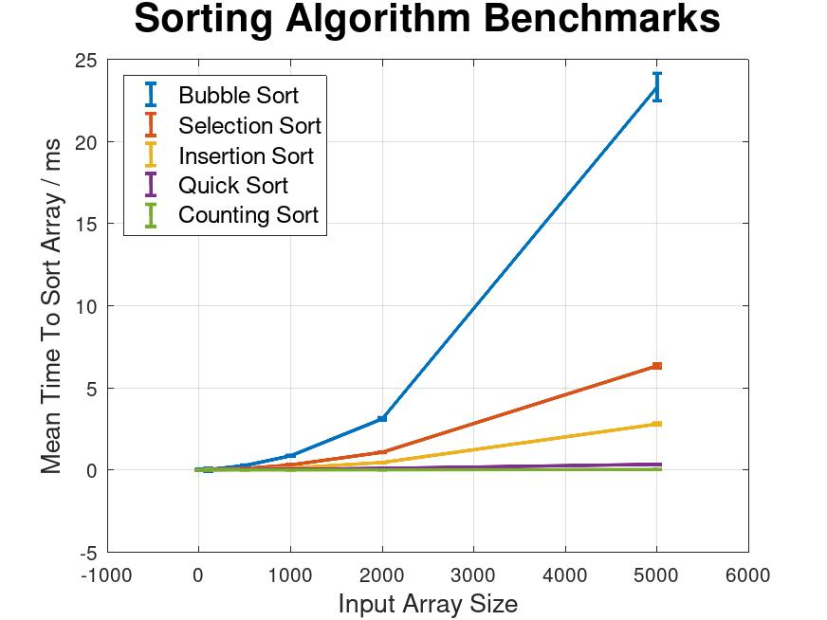Figure 11: Plots of mean sorting times using 1000 repetitions on different input-array sizes.
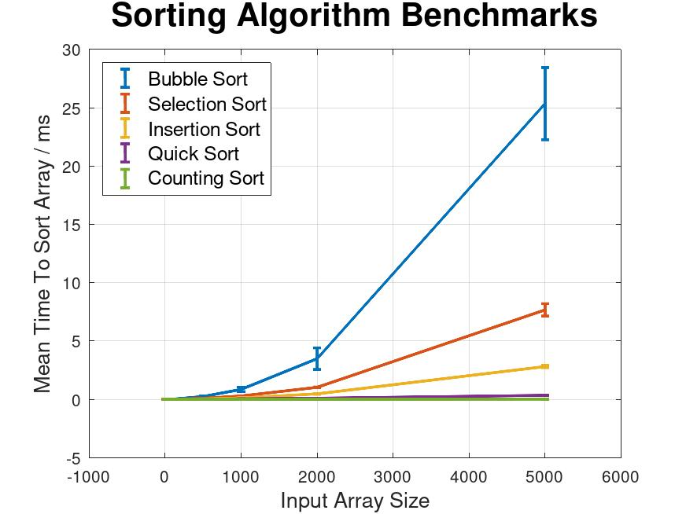Figure 12: Plots of mean sorting times using 10,000 repetitions on different input-array sizes.
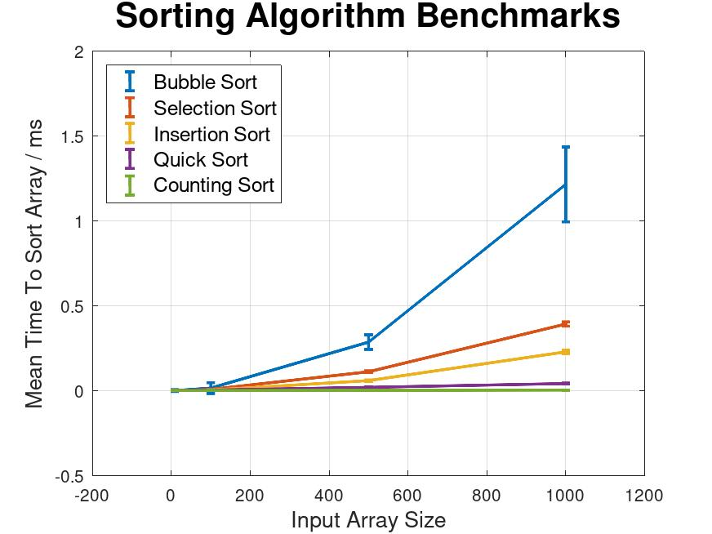Figure 13: Plots of mean sorting times using 100,000 repetitions on different input-array sizes (only up to size=1000, in this case).

CPU Usage
Figure 14 and Figure 15 show screenshots of the CPU usage on the computer during the execution of the benchmarking software.
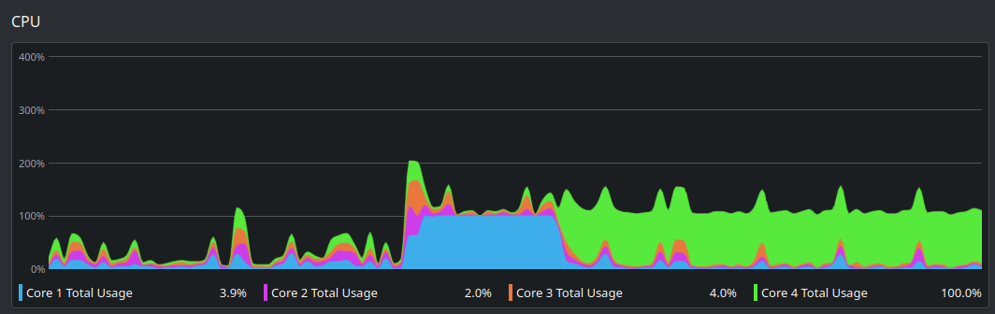Figure 14: CPU cores usage during sorting.
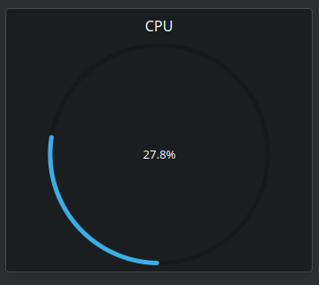Figure 15: Total CPU usage during sorting.
Core 4 can be seen in Figure 14 to be 100% used, when the software was running, where the other cores are barely being used at all. Core 1 appears to have been to 100% used at first, and then the system swapped over to core 4 at 100%. The total CPU usage in Figure 15, shows only approximately ¼ of the computer’s abilities being used. This implies that some multi-threading optimisations could be considered to speed up the code execution.

Final Results
Figure 16 shows a screenshot of the output of the software into the terminal. The same data is neatly presented in Table 2. This was done by importing the space-separated table data file, which was output from the benchmarking software, into LibreOffice Calc’s spreadsheet software, and tweaking some of the visual-presentation settings. These data are shown as plots in Figure 18 and Figure 19.
Histograms of the sorting times for each algorithm are presented in Figure 17, and these times are averaged and presented, in a plot, versus input-array size in Figure 18 and Figure 19.
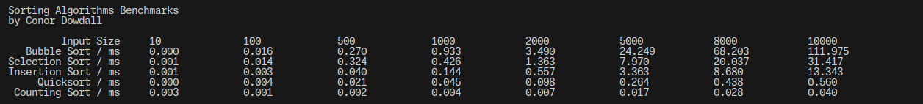Figure 16: Screenshot of the terminal output from the benchmarking software.

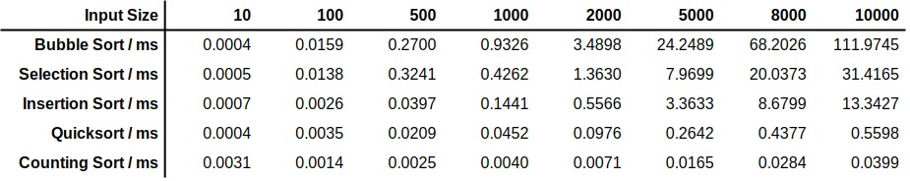Table 2: Mean sorting times using 10,000 repetitions on different input-array sizes.
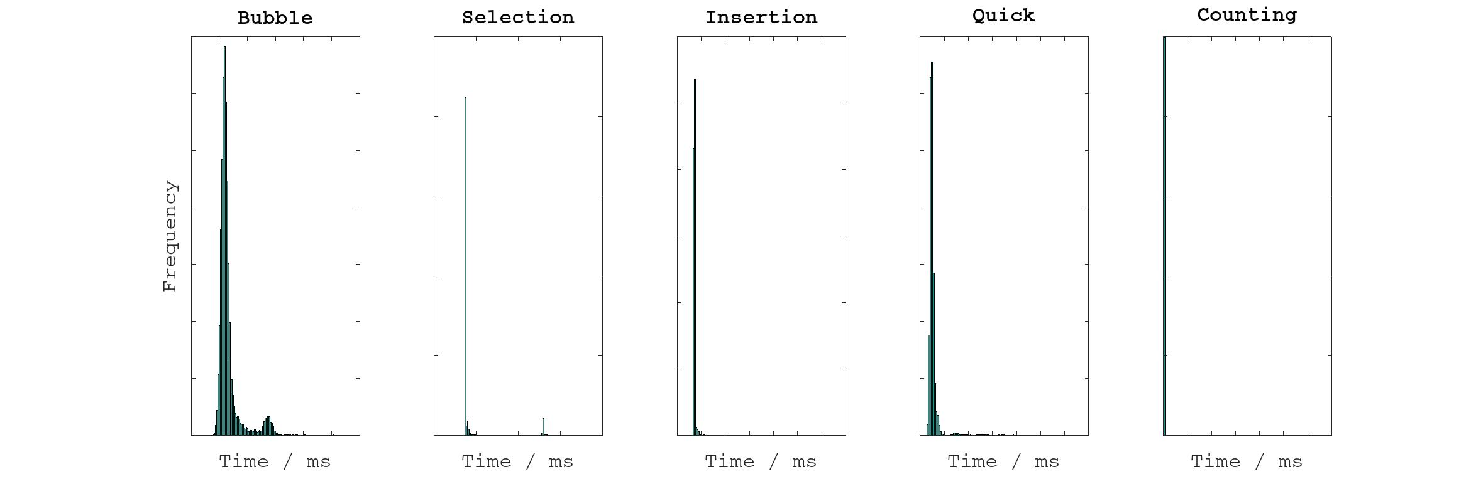Figure 17: Histograms of sorting times using 10,000 repetitions on 1000-element input arrays.
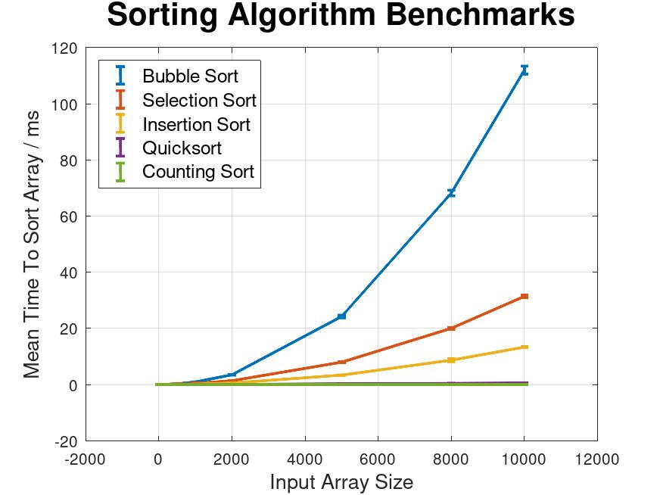Figure 18: Plots of mean sorting times using 10,000 repetitions on different input-array sizes.
From Figure 18, bubble sort, selection sort, and insertion sort, each display the quadratic tendencies of their respective algorithms, with average time complexities of O(n²) (see Table 1), although bubble sort clearly has the largest quadratic coefficient. The advantage of selecting a non-quadratic time complexity is quite clear when the O(n log n) of quicksort and the O(n + k) of counting sort are observed in this plot. This advantage was evident too, when watching the terminal output, waiting for the software to finish! O(n log n) and O(n + k) time complexities appear very similar in Figure 18; however in Figure 19, produced with benchmarksPlots_alt.m, the difference is more obvious. For very-large datasets, in real-world scenarios, this difference could be crucial.

Developing the Software
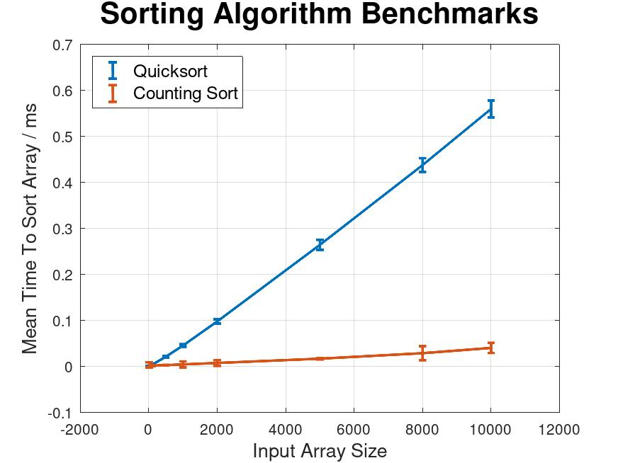Figure 19: Plots of mean sorting times for quicksort and counting sort using 10,000 repetitions on different input-array sizes.
The software, written in Java, is organised into packages, according to functionality. There are three classes implemented in conordowdall.util:
- Array.java
- BenchmarkSorter.java
- File.java
and the five sorting algorithm classes are implemented in conordowdall.sorters.
The Array utility class has many convenient methods to, for example, get a random array, write an array to a file or to the console, and find the mean of an array of numbers.
The File utility class has, for example, a method to delete a file if it already exists – useful for re-running the software without having to delete the previous files (because the Array class’s print methods append data to files).
Each sorting algorithm class implements a Sorter interface and has a name and a sort method. When the main method is executed in App.java, the five sorting algorithm classes are added to a list of Sorters, and this list is iterated over in a for loop, calling the benchmark method in the BenchmarkSorter utility class, which calls the sort method on the passed-in Sorter. This makes the code quite extensible, and new sorters can easily be added to the list.
A neat separation of concerns is observed, and this hopefully makes the code more readable, and reusable.
All the code is commented in the Javadoc style which, if your IDE supports it, allows descriptions of methods to be displayed when hovered over, showing a brief summary of its purpose, and a description of all the input-and-return values.
The implementation of the sorting algorithms are all taken from https://www.geeksforgeeks.org. However, each algorithm was thoroughly inspected, understood, and commented. The implementations were examined in detail to generate the list-sorting diagrams in the Five Sorting Algorithms section, which highly-accurately reflect the code-based solution.

