



ISBC

**Web Development**

(COMP11008)

Project Report

By:

ILUNGA WA LUNDA Ariel

B00382810

Submission: 10/04/2020

# Contents

Contents 1

Introduction 2

Project handling 2

Requirement collection 2

Design 2

Implementation 3

Server setup 3

Database design and implementation 3

UI design 4

PHP and MySQL 6

Planning 6

Tests & Evaluation 6

# Introduction

In the professional world, each project undertaken at a given place or organization is accompanied by a project report detailing all the specifics of the undertaken project. The project definition, the project discussing, the approach used to conduct the project, the challenges faced, the project scheduling and assessment are the main elements found therein. In that same way, this project report is written to explore how we replied to each of the technical criteria for creating and delivering the public with a website for cinema accessories. This report demonstrates in depth how we addressed issues relating to HTML, CSS, JavaScript and AJAX to design and make the website more attractive and interactive, and how we addressed the back-end user with PHP and MySQL. It also demonstrates the scheduling carried to execute the project according to tasks and deadlines. At the end of the project an evaluation is given.

# Project handling

To meet each project's technical requirements, we broken down the work into different tasks:

* Requirement collection
* Design
* Implementation (server setup, DB Design, UI)
* Testing
* Documentation

## Requirement collection

The project-brief provides the specifications for this project to be implemented. The project's purpose is to provide the public with a five-page website (home page, about-us page, product, registration and administration page) and to create all related brands. Our work consisted of following the requirements given and meeting them in the best possible way using the latest technology. Find [here](project-brief.pdf) further details on the project requirements.

## Design

We began the project with the graphic creation of every web page, as it was up to us to create everything. This phase was taken to ease the next steps by getting a global understanding of the website's appearance. Figure 1 below shows the site pages primitively designed.

This step facilitated the implementation of the user interface (UI) design by avoiding iteration or several code modifications during the implementation. A design with Adobe XD wire framework followed it. The given https link <https://xd.adobe.com/view/f33bd5c9-b14d-4eca-494d-d1f2e5318107-850a/> leads to the prototype website created using Adobe XD.

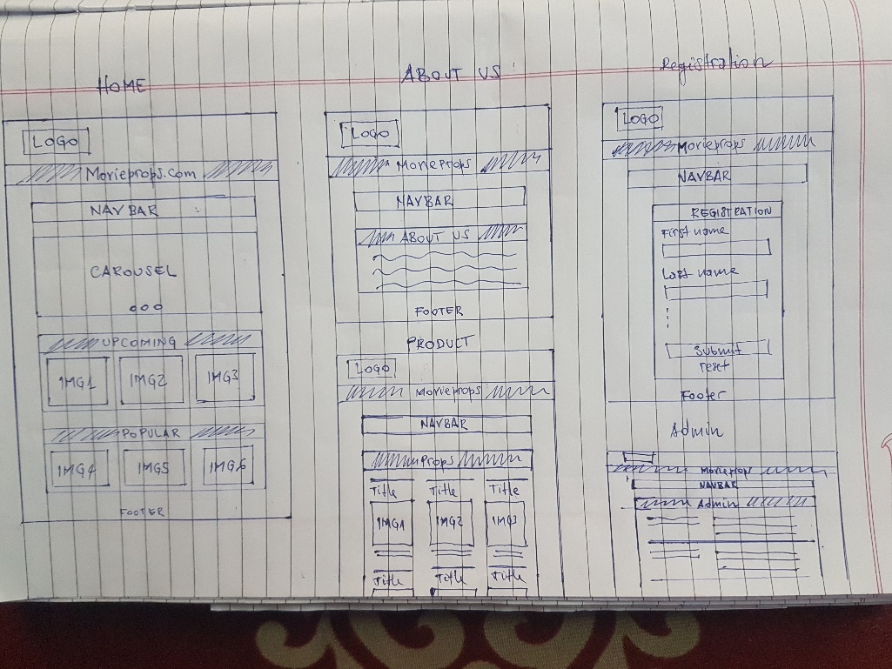

Figure 1: website wireframe

## Implementation

This is the main step in creating the website. This step was aimed at coding and transforming all previous designs into a real website. According to the requirements of the project, we needed to implement a server, a user interface and a database. Therefore, we have divided the work into four sub-steps:

* Server setup
* Database design
* UI design and Logo design
* Database connection (PHP and MySQL)

### Server setup

Before entering the implementation of the project, we downloaded and installed the server necessary to develop and test the website. We used for this purpose the XAMPP server which is an apache distribution containing MariaDB, PHP and Perl. This software is available free for different operating systems (OS) at <https://www.apachefriends.org/index.html>.

### Database design and implementation

Part of our website is database-based. In accordance with the requirements, the website should allow users or customers to register their interest on the website and allow the administrator to see these interests; a database must be implemented in order to answer the question. We have defined the name of the database, the tables and the columns in the tables according to what users will have to register as shown in Table 1 below.

Table 1: database design

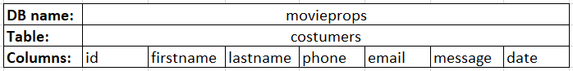

We implemented the database directly using the given XAMPP user interface accessible from the link: <http://localhost/phpmyadmin/>.

### UI design

#### The user interface design involved the following technologies: HTML5, CSS3 and JavaScript. To implement these technologies, we used the sublime text editor as an integrated development environment (IDE). This software is available for Windows OS at: <https://www.sublimetext.com>.

#### HTML5

We have created five pages that all contain HTML5 code to display images, text, buttons, record fields, menu bar, etc. W3C standard compliant. We have checked each of our five HTML files (for each of the five pages) in W3C Markup Validation Service available at <https://validator.w3.org/>. The following table 2 presents the test results of each page:

Table 2: W3C HTML page tests results

|  |  |  |
| --- | --- | --- |
| **Page** | **File** | **Error** |
| Home page | home.html | **No errors or warnings to show.** |
| About-us | about.html | **No errors or warnings to show.** |
| Product | product.html | **No errors or warnings to show.** |
| Registration | registration.php | **Three errors or warnings to show** |
| Administration | admin.php | **Eight errors or warnings to show** |

#### Errors on the registration and administration pages are due to the presence (integration) of PHP code in the HTML5 and JavaScript code.

#### CSS3

We used CSS3 to stylize and professionalize the appearance of all pages on the website. We did this process with a CSS sheet that we integrated into all the pages of the website (external CSS). In addition, we also used inline CSS to directly style certain HTML tags. We also tested the CSS file in W3C Markup Validation Service available at <https://validator.w3.org/>. The following table 3 shows the test result:

Table 3: W3C CSS page test results

|  |  |  |
| --- | --- | --- |
| **Page** | **File** | **Error** |
| External CSS file | style.css | **No errors or warnings to show.** |

#### JAVASCRIPT

We have integrated JavaScript to improve the end user experience on the website and to display the logo using HTML5 Canvas. The interactive components added to the website using JavaScript are:

* Carousel: available only on home page.
* Windows alert: Upon successful registration, this window pops to ensure the efficiency of the process.
* Required HTML input: Check the completion on the Registration page of the required input fields.
* Scroll-To-Top button: This button can be used on all pages except the About-Us page. This button allows the user to go back to the top of the page, without scrolling.
* Reset button: A button JavaScript that clears all fields of the form.

The following Figure 2 provides an overview of the JavaScript applications embedded on the website.

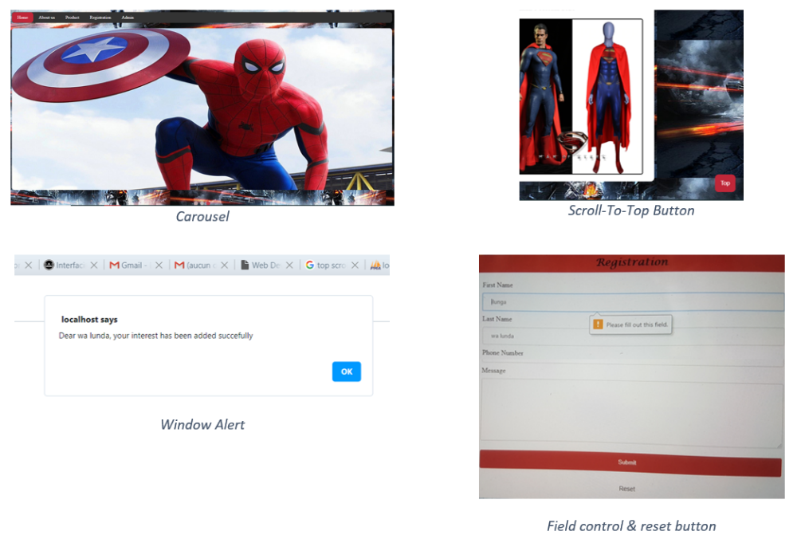

Figure 2: JavaScript applications

#### HTML5 Canvas

We used HTML5 Canvas and JavaScript to put the logo on the Website. We first designed the logo using Microsoft World, then inserted with the Canvas-image script (drawImage) the image created on the web. The logo is visible on all pages of the site. Figure 3 below shows the logo image.



Figure 3: logo image

### PHP and MySQL

We have used PHP and MySQL as needed to insert and extract data from the database. We used the PHP Data Object (PDO) method to create the website-database connection. We used the "INSERT" SQL query to record clients 'interests from the registration page and the "SELECT" SQL query to retrieve and show those interests on the admin page. To do this, we built an external file "datatabase.php" in which we placed the link configuration code and merged this file with the keyword "require" into the registration.php (registration page) and admin.php (administration page) file.

# Planning

|  |  |  |
| --- | --- | --- |
| No | Tasks | Deadline |
| 1 | Requirement collection | 28th Jan 2020 |
| 2 | Design | 11th Feb 2020 |
| 3 | Implementation |  |
|  | Server setup | 18th Feb 2020 |
|  | Database design | 18th Feb 2020 |
|  | UI implementation | 3rd March 2020 |
|  | Database connection | 3rd March 2020 |
| 4 | Testing | 6th March 2020 |
| 5 | Documentation | 17th March 2020 |

# Tests & Evaluation

We carried out the last tests after having implemented almost all the concepts that were required to us. We tested the site on different screen sizes and the display is good on all of them. All the technological concepts implemented on the website work well.

The project does not cover all the technological aspects of the requirement, AJAX and the web services were not implemented.