THE TREATMENT OF THE THROTTLING EFFECT IN INCOMPRESSIBLE 1D FLOW SOLVERS

Conor Fleming and Gary Clark

Atkins, UK

ABSTRACT

This paper is concerned with the throttling effect of a tunnel fire and its treatment in 1D flow solvers. The primary mechanisms through which a fire increases the aerodynamic resistance of a tunnel are explained. These mechanisms are due to the expansion of heated air and hence are inherently captured by compressible flow solvers. However several widely-used tunnel flow solvers make an assumption of incompressibility and therefore require corrections to model fires. The appropriate corrections, originally derived for mine ventilation applications, are presented here. Guidance is offered on the appropriate use of the throttling model in one commercial incompressible flow solver, with validation against a compressible flow solution.

©2016. This manuscript version is made available under the CC-BY-NC-ND 4.0 license http://creativecommons.org/licenses/by-nc-nd/4.0/

KEYWORDS

## Fire throttling effect, tunnel fire, incompressible flow solver, longitudinal ventilation system.

INTRODUCTION

When a fire occurs in a uni-directional tunnel with a longitudinal ventilation system, the ventilation system is typically designed to direct combustion products towards the exit portal, away from trapped vehicles. This aids self-rescue of tunnel users and intervention by the fire service on the upstream side (see figure 1).

Smoke control is achieved by generating a longitudinal air flow exceeding a certain velocity. This ‘critical velocity’ is a function of the heat release rate of the fire, the tunnel geometry and gradient (Thomas, 1968; Kennedy et al, 1996). In generating an airflow above critical velocity, the ventilation system must overcome several sources of aerodynamic resistance, e.g. vehicle drag, wall friction, area changes, buoyancy and wind. The ventilation system capacity influences other aspects of tunnel design, including power supply, plant room space, and potentially the tunnel diameter.

Figure 1: Illustration showing smoke being controlled by a longitudinal ventilation system

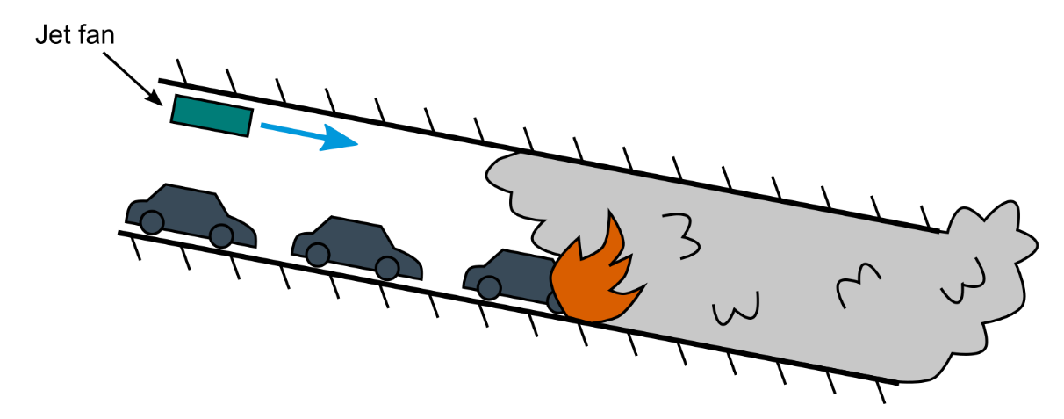

Some sources of aerodynamic resistance are temperature-dependent, and cause the overall tunnel resistance to increase with the heat release rate of a fire. This ‘throttling effect’ is essentially due to the expansion of heated air and combustion products downstream of the fire. Several numerical flow solvers used in tunnel ventilation system design are based on an assumption of constant air density, e.g. Subway Environment Simulation 4.1 (US Department of Transportation, 2001) and IDA Tunnel 1.1 (EQUA Simulation AB, 2014), and hence do not inherently capture the mechanisms of the throttling effect. The corrections that these incompressible flow solvers require are presented in this paper.

One of the throttling corrections in IDA Tunnel is inadequate, depending on a user-defined coefficient for which the developer provides limited guidance. This paper introduces a method for calculating this throttling coefficient, and demonstrates its effectiveness by comparison with a compressible flow solution, where the flow-throttling mechanisms are inherently captured.

MECHANISMS OF THE THROTTLING EFFECT

Hwang and Chaiken (1978) identified the two primary mechanisms of the throttling effect in their investigation into the interaction of fires and ventilation flow rate in mine shafts.

Wall friction and local losses

The first mechanism is due to elevated wall friction and local energy losses (e.g. at the tunnel portal) downstream of the fire. The pressure drop associated with such losses, $Δp$, is a function of density, $ρ$, and velocity, $u$,

|  |  |  |
| --- | --- | --- |
|  | $$Δp =K\frac{1}{2}ρu^{2}$$ | (1) |

where $K$ is an empirical coefficient for the element in question. For wall friction losses, $K=fL/D$, where $L$ is the length of the section, $D$ is the hydraulic diameter and $f$ is the Darcy friction factor. At elevated temperatures, e.g. downstream of the fire, the density reduces and velocity increases. The pressure loss increases overall due to the dominance of the velocity-squared term.

This increase in aerodynamic resistance can be modelled in an incompressible flow solver by applying the Ideal Gas Law (and adopting its assumptions of a perfect gas) to express the density and velocity at a location downstream of the fire in terms of the flow conditions upstream of the fire and the local absolute temperature,

|  |  |  |
| --- | --- | --- |
|  | $$ρ_{h}=ρ_{c}\frac{T_{c}}{T_{h}}$$ | (2) |
|  | $$u_{h}=u_{c}\frac{T_{h}}{T_{c}}$$ | (3) |

where $T$ is temperature and the subscripts ‘c’ and ‘h’ indicate upstream (cold) and downstream (hot) locations. Equations 1 – 3 are combined to yield the corrected pressure loss term,

|  |  |  |
| --- | --- | --- |
|  | $$Δp =K\frac{1}{2}ρ_{c}u_{c}^{2}\frac{T_{h}}{T_{c}}$$ | (4) |

Momentum change

The second throttling mechanism is due to the increase in the momentum of the flow as it passes through the fire. The flow expands in the downstream direction as it is heated, and hence presents an equivalent resistance to the oncoming flow upstream.

Figure 2: The momentum change is calculated across the control volume marked by the broken red line.

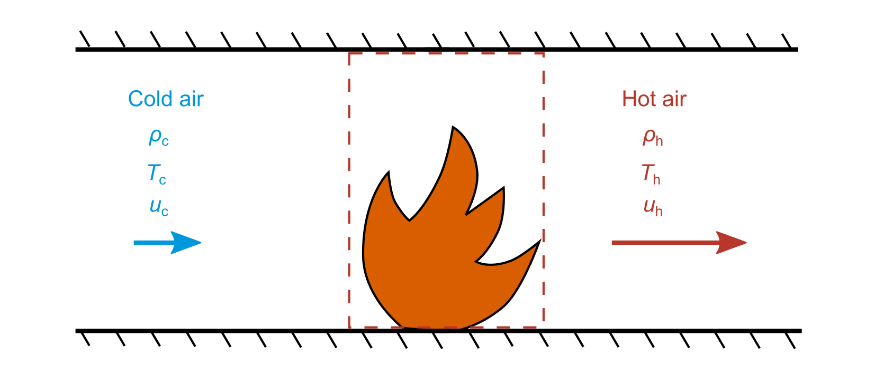

This resistance can be calculated by balancing momentum in a one-dimensional control volume containing the fire, as shown in figure 2 (Hwang and Chaiken, 1978). Neglecting wall friction, the net force on the boundaries of the control volume is equal to the change in momentum,

|  |  |  |  |
| --- | --- | --- | --- |
|  | $$F_{fire}=\dot{m}\left(u_{c}-u_{h}\right)$$ |  | |
|  | $$=ρ_{c}u_{c}A_{t}\left(u_{c}-u_{h}\right)$$ | | (5) |

where $\dot{m}$ is the mass flow rate and $A_{t}$ is the cross-sectional area of the tunnel. The downstream velocity can be expressed in terms of the upstream velocity and the ratio of absolute temperatures by substituting equation 3 to yield the pressure drop across the fire,

|  |  |  |
| --- | --- | --- |
|  | $$Δp_{fire}=\frac{F_{fire}}{A_{t}}=ρ_{c}u_{c}^{2}\left(1-\frac{T_{h}}{T_{c}}\right)$$ | (6) |

Note that for a temperature increase (e.g. $\frac{T_{h}}{T_{c}}>1$) the pressure change will be negative and hence will resist the oncoming flow.

THE THROTTLING EFFECT IN IDA TUNNEL 1.1

While IDA Tunnel incorporates the temperature correction for wall friction and local losses described above (equation 4), it features a simplified model of the pressure drop across the fire. The pressure change is assumed to be proportional to the heat release rate, $Q$,

|  |  |  |
| --- | --- | --- |
|  | $$Δp_{fire}=C_{fire}Q$$ | (7) |

where $C_{fire}$ is a user-defined fire pressure drop coefficient. However the developer does not provide guidance on the value of this coefficient.

We have determined an appropriate value for the fire pressure drop coefficient by noting that a fire is represented in one-dimensional flow solvers as a simple heat source,

|  |  |  |
| --- | --- | --- |
|  | $$Q=\dot{m}c_{p}ΔT$$ | (8) |

where $c_{p}$ is the specific heat capacity of air at constant pressure. Equations 6 – 8 can be combined to yield an analytical expression for the fire pressure drop coefficient,

|  |  |  |
| --- | --- | --- |
|  | $$C_{fire}=\frac{{10}^{6}u_{c}}{c_{p}A_{t}T_{c}}$$ | (9) |

where the factor of ${10}^{6}$ converts the units from Pa W-1 to Pa MW-1 as required by the solver.

While it may be acceptable to assume a constant specific heat capacity, the upstream velocity is not known *a priori* and hence the following iterative approach is necessary:

1. Obtain an initial prediction of upstream flow velocity using IDA Tunnel with Pa MW-1.

2. Solve equation 9 for an improved estimate of .

3. Obtain a refined flow prediction using the new value of $C_{fire}$ in IDA Tunnel.

4. Repeat steps 2 and 3 until $C_{fire}$ converges to within an acceptable tolerance.

This process has been found to converge well across a range of tunnel fire scenarios, generally requiring four or five iterations. The simulation time for a tunnel fire simulation in IDA Tunnel ranges from several seconds to a couple of minutes, and hence the additional effort associated with this iterative approach is acceptable for most practical engineering applications.

DEMONSTRATION OF MOMENTUM CHANGE MODEL

This method for predicting the pressure drop at the fire in IDA Tunnel is now demonstrated by comparing flow predictions with results from the compressible flow solver ThermoTun. A compressible flow solver inherently captures the density changes and the corresponding momentum change at the fire site, and hence provides a suitable reference solution.

Verification of tunnel resistance and jet fan models

Prior to simulating a tunnel fire, a simple scenario featuring a single jet fan in an otherwise empty tunnel is considered in order to verify the models for wall friction, local losses and jet fans in both solvers. A jet fan is modelled as a momentum source which introduces the following thrust,

|  |  |  |
| --- | --- | --- |
|  | $$F_{j}=η{\dot{m}}_{j}\left(u_{j}-u_{t}\right)$$ |  |
|  | $$=ηρu_{j}A_{j}\left(u_{j}-u_{t}\right)$$ | (10) |

where $η$ is the efficiency of momentum transfer, the subscripts ‘j’ and ‘t’ correspond to the jet fan and the tunnel respectively (EQUA Simulation AB, 2014). The pressure rise in the tunnel due to the jet fan is $Δp_{j}=F_{j}/A_{t}$. Note that the jet fan thrust is applied at a point in IDA Tunnel, whereas it must be distributed over a finite length in ThermoTun for numerical stability.

A perfectly-efficient jet fan ($η=1$) of cross-sectional area m2 and jet velocity m s-1 is installed 100 m from the entry portal of a 1 km long tunnel as shown in figure 3. The tunnel is level, with a cross-sectional area of m2 and hydraulic diameter of $D=7$ m. The Darcy friction factor is $f=0.02$, the entry loss factor is $K_{entry}=0.6$ and the exit loss factor is $K_{exit}=1$. The ambient temperature is 10°C and the absolute pressure is 101325 Pa.

Figure 3: Dimensions of the verification case for tunnel resistance and jet fan models

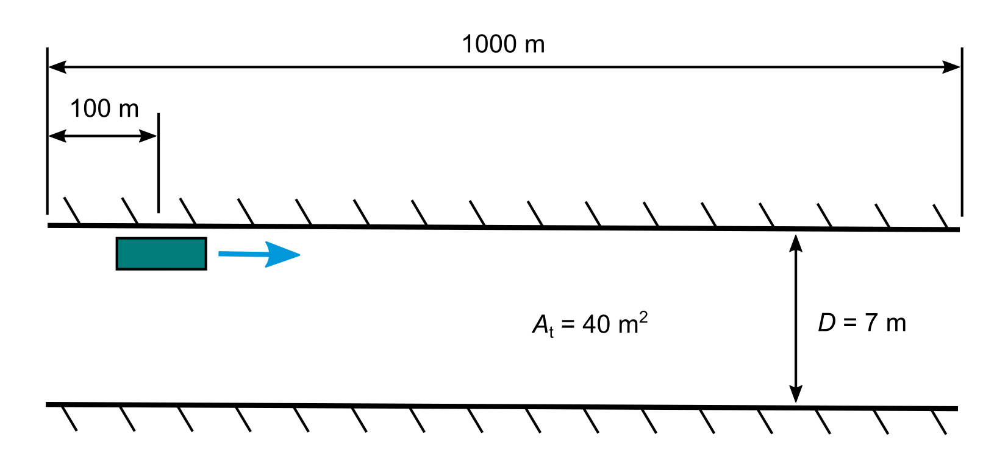

The flow solvers are found to agree well, with IDA Tunnel predicting a flow velocity of 3.005 m s-1 and ThermoTun predicting a velocity of 3.018 m s-1. Predictions of the static pressure profile along the tunnel length, $x$, are shown in figure 4. The pressure gradient is due to wall friction and the pressure rise at $x=100$ m is caused by the jet fan (this is applied over a 5 m distance in ThermoTun).

Figure 4: Predictions of the static pressure profile for the verification case

## ../fig/simple%20tunnel/pressure%20light%20bg.png

Predictions of the pressure change at the fire

A fire is now introduced in the region between 200 m and 208 m from the entry portal as shown in figure 5. The convective heat release rate is 20 MW, representing a truck fire. Thermal radiation from the fire to the tunnel walls is neglected for simplicity. The specific heat capacity is J kg-1 K-1.

Adiabatic (perfectly-insulating) walls are prescribed in both solvers to eliminate differences due to their respective wall heat transfer models. While this measure allows direct comparison of the fire pressure drop, it will result in over-prediction of downstream wall friction and local losses as the air is not allowed to transfer heat to the walls. All other simulation conditions are consistent with the preceding verification case.

Figure 5: Illustration of the tunnel fire scenario

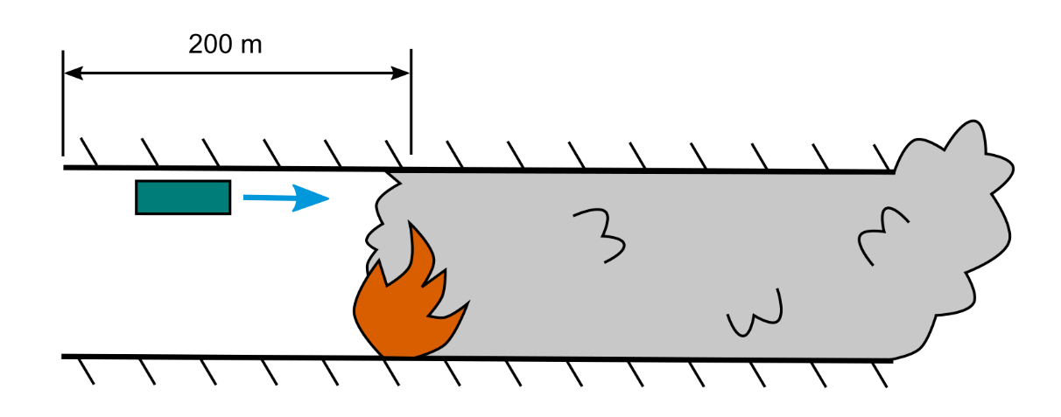

Two cases are simulated using IDA Tunnel. In the first case a fire pressure drop coefficient of Pa MW-1 is applied, and hence the momentum change at the fire is not captured. In the second case, $C_{fire}$ is calculated using the new method described above. A reference solution is produced using ThermoTun, which is a compressible flow solver and hence inherently captures the momentum change.

The first throttling mechanism is highlighted by the ‘IDA: $C_{fire}=0$’ case in figure 6. The increased pressure gradient downstream of the fire (figure 6a) is due to the elevated wall friction, which in turn is due to the increased downstream velocity (figure 6b) and temperature (figure 6c).

The second throttling mechanism is demonstrated by the ‘IDA: new method’ and ‘ThermoTun’ cases. In figure 6a, a sharp pressure drop occurs at the site of the fire ( $x=200$ m) due to the increase in fluid momentum, consistent with equation 6. Under-prediction of this throttling mechanism leads to over-prediction of velocity, as indicated by the ‘IDA: $C_{fire}=0$’ case in figure 6b, and could result in an under-sized ventilation system.

The new method for defining $C_{fire}$ in IDA Tunnel results in a fire pressure drop prediction which is nearly identical to the ThermoTun case, visible at $x=200$ m in figure 6a. Good agreement is also observed in predictions of pressure, velocity and temperature profiles along the tunnel by both solvers. The small wave in the ThermoTun pressure profile just downstream of the fire (figure 6a) is believed to be due to a numerical instability, which may be due to the relatively short length of the fire.

The effect of the adiabatic wall boundary condition is evident in the constant velocity and temperature downstream of the fire. In reality, the temperature would decay exponentially as heat escapes through the walls, and the velocity would reduce correspondingly as the flow contracts (i.e. as density recovers).

Figure 6: Predictions of (a) pressure, (b) velocity and (c) temperature for the tunnel fire scenario

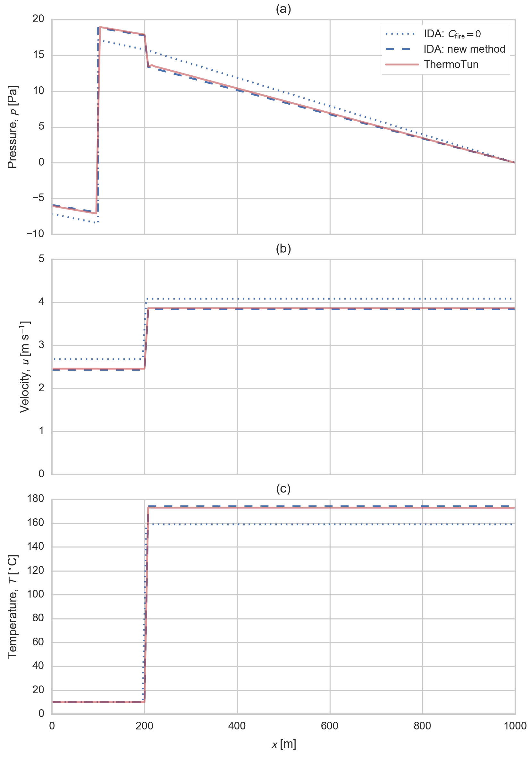

CONCLUSION

A longitudinal tunnel ventilation system is designed to control smoke by generating an airflow exceeding the critical velocity, while overcoming the aerodynamic resistance of the tunnel. A fire increases the aerodynamic resistance of a tunnel through multiple mechanisms, collectively known as the throttling effect. The increase in velocity downstream of the fire leads to elevated wall friction and local losses, and the momentum change which occurs across the fire causes a corresponding resistance to the upstream flow.

The corrections required by one-dimensional incompressible flow solvers to capture these throttling mechanisms have been presented. The flow solver IDA Tunnel 1.1 features a simplistic model of the pressure drop at the fire, which is controlled by a user-defined coefficient for which no guidance is available. A new method for determining this coefficient based on the momentum change which occurs across the fire is presented. The effectiveness of this method is demonstrated by comparison with a compressible flow solution, which inherently captures the momentum change at the fire.

ACKNOWLEDGEMENT

The ThermoTun simulation results were provided by Thomas Wicht of HBI Haerter, Switzerland.

REFERENCES

EQUA Simulation AB (2014) *IDA Tunnel 1.1*. http://www.equa.se/en/tunnel/ida-tunnel/overview

Hwang CC, Chaiken RF (1978) *Effect of duct fire on the ventilation velocity.* US Bureau of Mines Report of Investigations 8311, http://hdl.handle.net/2027/mdp.39015078483404

Kennedy WD, Gonzales JA, Sanchez JG (1996) *Derivation and application of the SES critical velocity equations.* ASHRAE Trans: Research 102(2):40–4

Thomas, PH (1968) *The movement of smoke in horizontal passages against an air flow.* Fire Research Note 723, Fire Research Station, UK, http://www.iafss.org/publications/frn/723/-1/view/frn_723.pdf

U.S. Department of Transportation (2001) *SES Version 4.1 User’s Manual*. National Technical Information Service, Springfield, Virginia 22161.