**Mobile App Development**

**Corona SDK/LUA**

**Menus Application**

**Cafe Libre**

**by**

**Conor Gilmer**

**(D12127567)**

**Lecturer: Alan Grace**

**WebElevate 2.1**

**Digitial Skills Academy**

**Dublin Institute of Technology**



**Background**

I chose to base the application on a Coffee shop which sold food, it is a brochure app showing what is available at the shop.

I chose the name Cafe Libre (since the DSA is based in the Liberties) the color scheme for the basic logo was Green and Red from the Italian flag, also since it was October and inspired by oktoberfest i chose that the cafe should also serve German Food and Snacks.

The app is to be created using the Corona SDK platform.

**Overview**

The app is a menu drive brochure type app with 4 sections, Home, Products, About and Contact. The Home page is the landing page with the options to navigate to the three other sections. The About page contain details about the Cafe, and the Contact page contains the contact details of the app.

The Main functionality is the Products page which breaks up the products into four categories, Coffees, Teas, Biscuits, and Food, this is a page with four icons with these categories of products.

When a product category is selected the user has a list view of the products available, and can scroll down and select an individual page to see further information about the product.

At any time the four main menu sections are visible on each page, the category of products have a Back button to navigate back to the Products menu, each individual product item will have a back button to navigate back to the category from which it was selected.

**Programs**

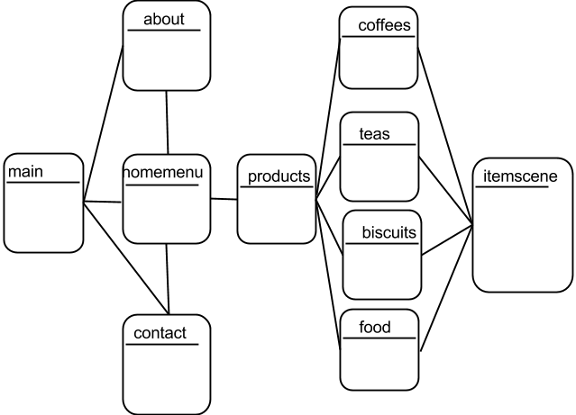

Main.lua

the main program invokes the first scene homemenu – it also creates the segmented widget which contains the top menu bar which features on all pages

homemenu.lua

is the main landing page which gives the user three options of Products, about and contact pages.

about.lua

Forms an about Cafe Libre page, with some text, also the logo is on the bottom of the page.

contact.lua

Forms a contact us screen with the address, contact numbers and social media addresses, also a screenshot of a map which when clicked will navigate you to a google maps page on a browser. The phone number and email address i have made tap-able so they should invoke the mail client and phone call - however i am only able to test this on the emulator as my smartphone has an old chip which the corona sdk doesnt work on.

products.lua

lists the four categories available

biscults.lua

uses a list view of the biscuits when clicked will open an item view (using itemscene.lua of the product based on the parameters passed has a back button to the products page available.

coffees.lua

uses a list view of the coffees when clicked will open an item view (using itemscene.lua) of the product based on the parameters passed has a back button to the products page available.

teas.lua

uses a list view of the teas available when clicked will open an item view (using itemscene.lua) of the product based on the parameters passed has a back button to the products page available

food.lua

uses a list view of the food/snacks (in this case german and austrian food) when clicked will open an item view (using itemscene.lua) of the product based on the parameters passed has a back button to the products page available

itemscene.lua

this forms the individual product page, with an image of the product and some text as well as price and country of origin of the product.

**Resources**

Images for the products are stored in directrories for each of the categories. Other images are stored in the assets directory

**Conclusion**

The app could be made more customisable and updateble by having the contents populated by database rather than hard coded in the categories individual pages. More pictures could be available and the content made look more dynamic.

**Colophon**

Corona SDK used

Lua Language [www.lua.org](http://www.lua.org/)

Images edited using [www.gimp.org](http://www.gimp.org/)

Coordinates obtained using [www.freegeocoder.org](http://www.freegeocoder.org/)

Editors used using [www.vim.org](http://www.vim.org/)

IDE ZeroBane used