IT Tallaght
Social Media Analysis
Analysing a Twitter Network

Conor Griffin X00111602
11/23/2017

Contents
Analysing a Twitter Network 2
Intentions and Expectations 2
Analysing the Data Set 2
Visualising the data 4
Fine Tuning 6
Conclusions 12

Conor Griffin
X00111602

Analysing a Twitter Network
I began this assignment by importing a twitter network using NodeXL import feature. I imported the network using NodeXL to import tweets with the hash tag #CODWWII. The hash tag is from a new game that was only recently released on Xbox last month called Call Of Duty World War II. I bought the game and after playing it a lot I then went onto twitter to see what other users thought of the game. I used the hash tag #CODWWII and was returned with a massive data set of tweets on the game.

Intentions and Expectations
My Intentions in this assessment are to gain a better understanding of how to analyse a twitter network, to gain a better skillset using NodeXL to analyse a dataset, also to see how analysing a network can make future decisions. I am a big fan of the game call of duty so I think it will be interesting to see what other people are saying about the new game world war II.
I expect to gain an understanding of analysing data, twitter networks and know how using my visualisations I could then make future decidsions on the network. I expect to see how this data could be used by the company call of duty and see is there any benefit in analysing twitter data.

Analysing the Data Set
This type of data would fall under gaming data category and this was the type of data I intended to analyse. The network provided had 2054 nodes and 2534 edges. Some of the main characteristics consisted of over 2 million tweets, 20 million followers, 50 thousand favourites; I was able to gather this data using the In-Degree of the top 50 accounts with the highest amount of references.
I began by analysing the tweets and looking for some patterns in the data. I noticed that some of the egos in the networks were twitter accounts with massive amounts of followers such as YouTube, Xbox, codww2intel, ign and other big egos. There is a pattern in the more followers an account has then the higher number of connections to that network and also there is a pattern in most accounts with high amount of followers usually don’t follow many other accounts.
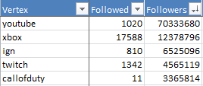
There were also some examples of accounts that were the ego in a network but had only a small number of followers such as “k_carius” with only 162 followers.
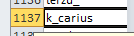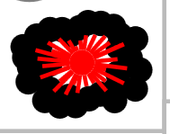
This may be due to the fact that k_carius has a lot of mentions by other accounts giving it a high In_Degree.
Also the account cdiscount has the highest in-degree of 152 due to the fact that it gets the most references from other accounts. This user doesn’t have the most followers but does have the highest In-Degree and this could be due to their tweet with #CODWWII is the most popular and has the most references.
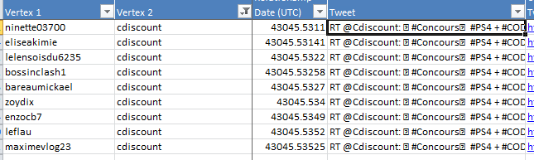
Another interesting fact in analysing the data set is that there are no isolates. Each vertex has at least 1 in-degree or 1 out-degree meaning that each individual in the network is referred to or refers to at least one other individual, i.e. the whole network is connected.
I also found that not all accounts with high followers had a high betweenness centrality, some of the accounts in the top 20 had an extremely low betweenness centrality such as xbox with 0.00 meaning that xbox is not uniquely connected to users in different groups.
This was also the case for a lot of individuals with huge amount of followers but a low betweenness centrality.

Visualising the data
I started organising the network by grouping the network, I chose the “Group by Cluster Algorithm,” and calculated graph metrics using the graph metrics button on NodeXL.
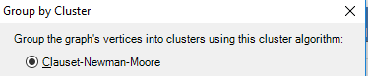
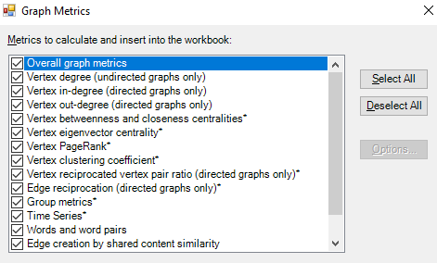
After that I chose the Fruchterman-Reingold network and clicked show graph. The graph was grouped but quite hard to read or identify anything in it. I edited the layout options by grouping each network in their own box to see which node and connection belonged to a box. I got a total of 162 groups I also tried moving all the smaller boxes to the bottom of the graph pane and although this filtered out a lot of the smaller networks that were hard to read it also jumbled up a lot of the larger network up.
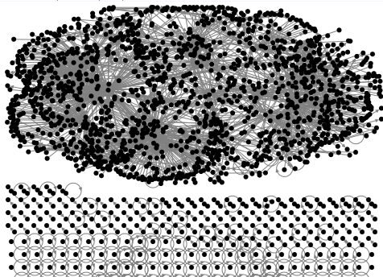
I left the graph grouped by boxes. I also used bundled edges on the graph, this made it easier to see what edges were connected and grouped to each other.
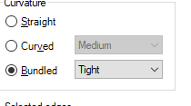
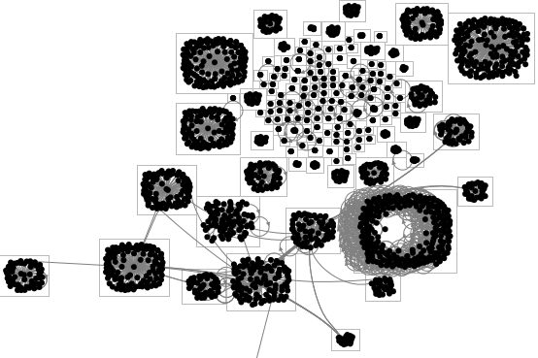
The groups were sorted using the groups functionality so I can see what groups are large, small and how many nodes and connections exist in that network.
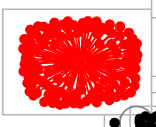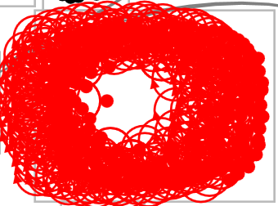
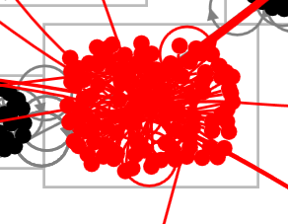

Fine Tuning
I then began fine tuning the graph because it was still very unclear and hard to identify egos and user information. I went into the group options tab and grouped the colours of each group by the colour specified on the group vertices worksheet. This made the graph easier to look at and read.
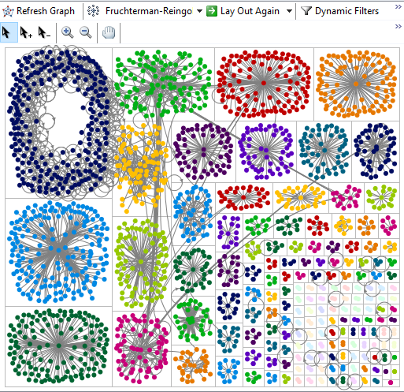
To identify the nodes with the highest In-Degree and the ego in a network I used the vertex name on the top 10 labels in the vertices worksheet, this made it easier to identify the nodes on the graph that are the ego in each network.
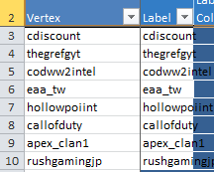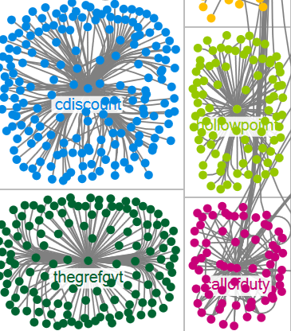
An even better way to do identify the ego was to use there twitter image as the shape on the node. Using the image gave a graph a more real life feel and allowed me to easily identify the ego in the network.
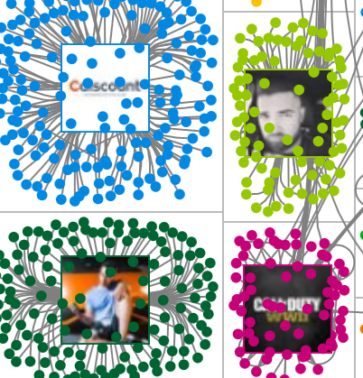
I wanted to see what users have a high betweenness centrality and are uniquely connected to other groups, to do this I used the autofill columns to fine tune the search. First I sorted the dataset in the betweenness centrality column from largest to smallest, I could then see the vertexes with the largest betweenness centrality.
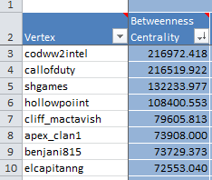
To visualise this data I used the autofill columns to fill in the graph. I used auto fill for vertex color, shape, size and opacity. This made it a lot easier to identify the nodes with a high betweenness centrality and tha are uniquely connected to other groups. I also used the dynamic filters to filter out data that has a low betweenness centrality making it even clearer identifying the data I wanted to see.
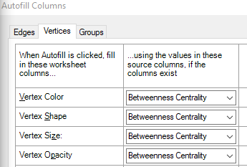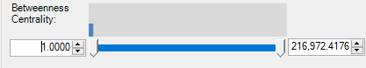

Graph presenting nodes with high betweenness centrality
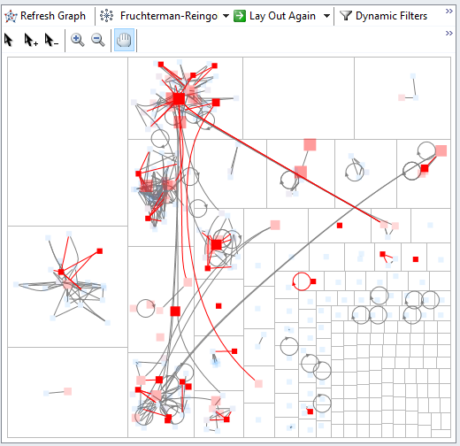
I was able to identify from the graph that group 4 has the most nodes with a high betweeness centrality so I labelled the group with that title.
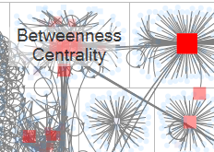
Most of the users in this group are gamers and are all connected through there tweet about the game but are also uniquely connected to other groups. There tweets mostly consisted of info on the launch of the game which I find interesting.

I wanted to identify the nodes in the network that do the most referring to other nodes i.e. have the highest out-degree. I thought this would be important to also identify nodes that might not be the most important in terms of referral but important in terms of they are referring to other nodes and keeping the network central as well as dispersed to other networks. To do this I organised the dataset by out-degree and was able to see the nodes that had the highest out-degree.
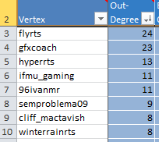
I then used autofill columns to sort the visualisation. I wanted to see what nodes were most central to see what nodes are nearest to all other individual nodes in the network, I also wanted to ignore outliers as I am not interested in them, I chose closeness centrality for vertex size to see central nodes. I then coloured the nodes based on there in-degree as I wanted to differentiate between the nodes that were referred to vs the nodes doing the referral. Finally I filtered the opacity based on the out-degree as I wanted to only show the nodes that were most central and did most of the referring. I also edited some of the advanced options in the autofill columns to get a clearer picture of the visualisation I was looking to achieve.
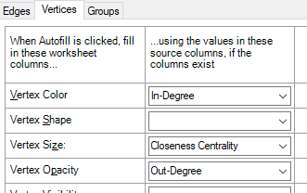
This left me with a graph where I could identify the nodes that were doing the most referring in there tweets.

Graph presenting nodes with high Out-Degree
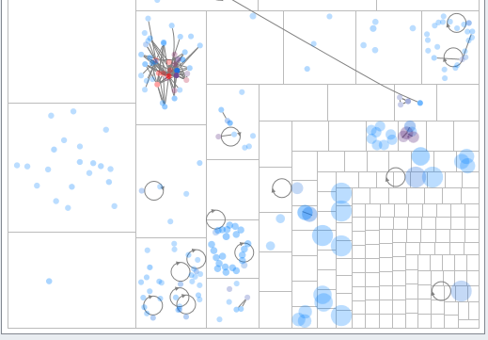
I was able to see that group 5 had the highest out-degree, I labelled that group with that title.
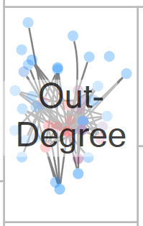

Conclusions
I learned many things from this network; I feel I have gained a better understanding of analysing a twitter network. I also feel that my knowledge of using NodeXL has greatly increased. From the network itself I was able to analyse the data and see what individuals had the most followers, were referred to the most and what nodes were doing the most mentions. I was also able to identify the nodes that were most central and the nodes that had the highest degree and shared friends with each other. The visualisations I created presented me with many subgroups and different clusters and this made it easier to identify what they mean. Some su groups were those with little betweenness centrality and others with a high betweenness centrality. From completing this assignment I am now confident in using NodeXL to analyse twitter networks.

