# Profile Website for Colin Ritman

For this assignment I created a single page profile website for Colin Ritman. The structure and design choices of this site and the development processes I completed are outlined in this written report

## Task 1 – Self Evaluation

Here are the various tasks I completed to evaluate my current developer skills.

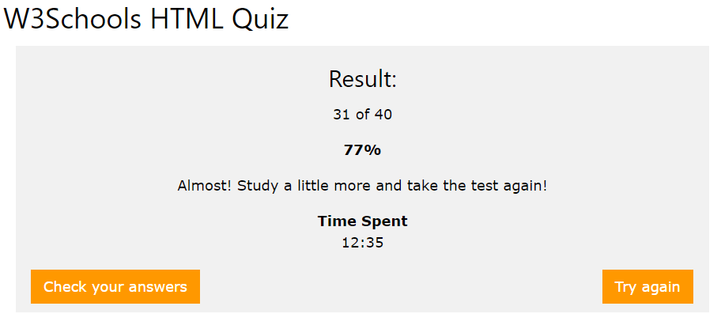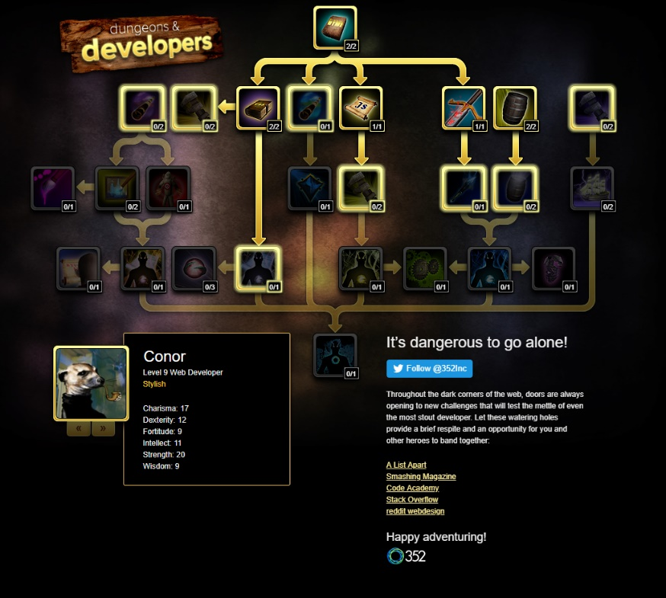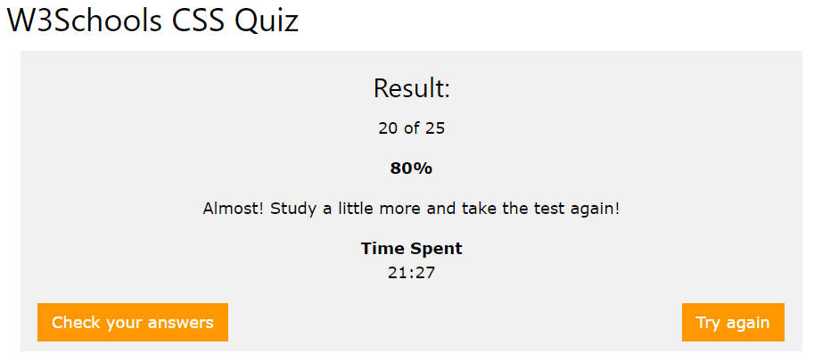Dungeons & Developers Quiz

CSS Diner

## C:\Users\ch17811\Pictures\Capture.PNGTask 2 – Requirements capture

### Information Inspiration

With this task I read through the brief to fully understand the user requirements. With this I searched for webpages which displayed similar info for inspiration. Here they are with my thoughts about each of them, with bullet points for what inspiration I took:

#### [**http://hugo.fyi/**](http://hugo.fyi/)

As a single page, the screen shot shown here does not do justice for Hugo Peters’ personal site. As a game programmer his site is very well suited to the project for Colin and his required profile page.

* I was able to take inspiration for how he has structured the site in its relevant sections.
  + Additionally, I have taken inspiration for how his prior work and projects have been displayed in the second section.

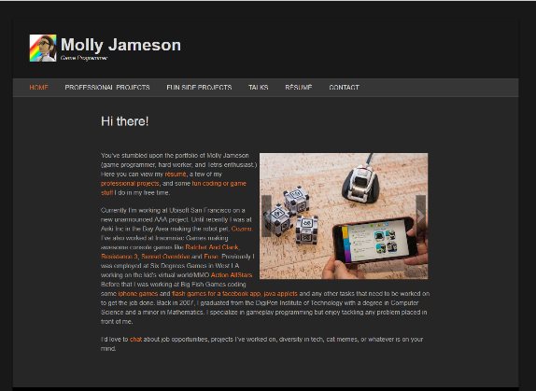

#### [**http://www.mollyjameson.com/**](http://www.mollyjameson.com/)

With Molly’s portfolio page, this site is clear and has an appealing colour scheme. It features all the items I would like to know more about as a user.

* A very clear layout; not cluttered with many titles to navigate through.
* The rotating photos allows for multiple snapshots of a project.
* Colour scheme continues throughout for links and contrasts very clearly with orange on grey!

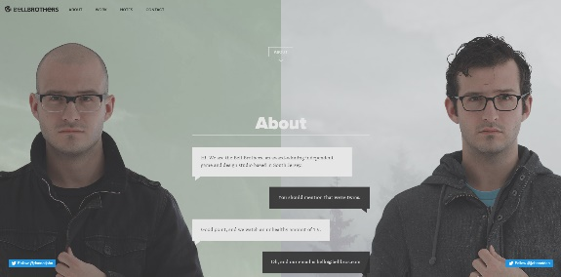

#### [**http://bellbros.com/**](http://bellbros.com/)

This site is quite different and has some amazing transitions and all with scrolling actions! Again the screen shot here does not do it justice, you should definitely have a look at it with the link above (or [***here***](http://bellbros.com/) :) ).

* This site may be for displaying a different type of information as a web development groups page, however I quite like the design and continuous flow of the site!

Additional sites that I looked at, but did not draw much inspiration from, include

<https://carolinedussuel.com/> & <http://jen.lu/> . I did not take much from these sites as it would be very ambitious to complete something like this, especially for Jen Lu’s site!

### Site structure

With all this inspiration I was able to draw up a structure specification to the site. This has been outlined as the following

* A single navigation bar to the top which remains with the user as they scroll down
* The menu items are clickable which will navigate to the relevant section as necessary and smooth scroll is enabled.
* Image examples from projects should be shown in first part.
* The menu bar should have clear distinct sections – 5 to match the criteria for the assignment.
* Should feature a variety of colour photos
* Have a distinct colour scheme throughout.

### Considering users

To understand the users which may be using Colin’s site I constructed user profiles, user stories ad user journeys for three *potential* users. With this brainstorming and considering users. I was able to use this thoroughly with the next task (3rd task) for the creation of the prototype page.

#### Freddie O’ Ryan

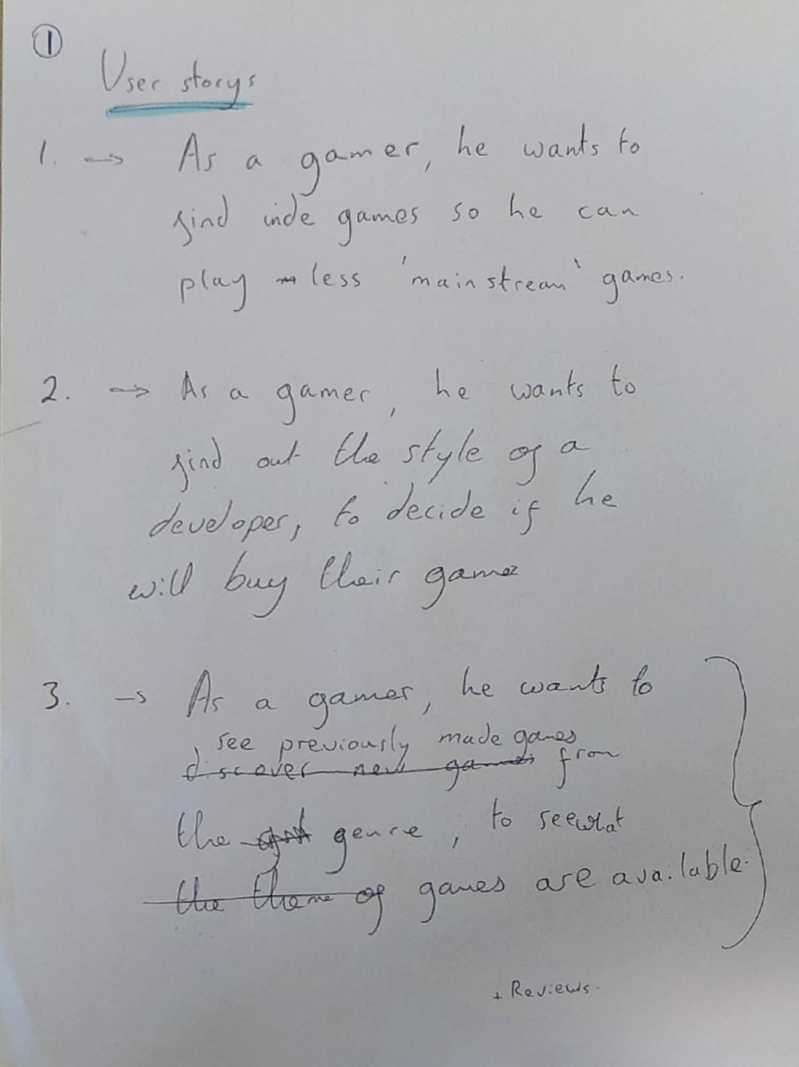

#### Amy McLennan Patrick Gallagher

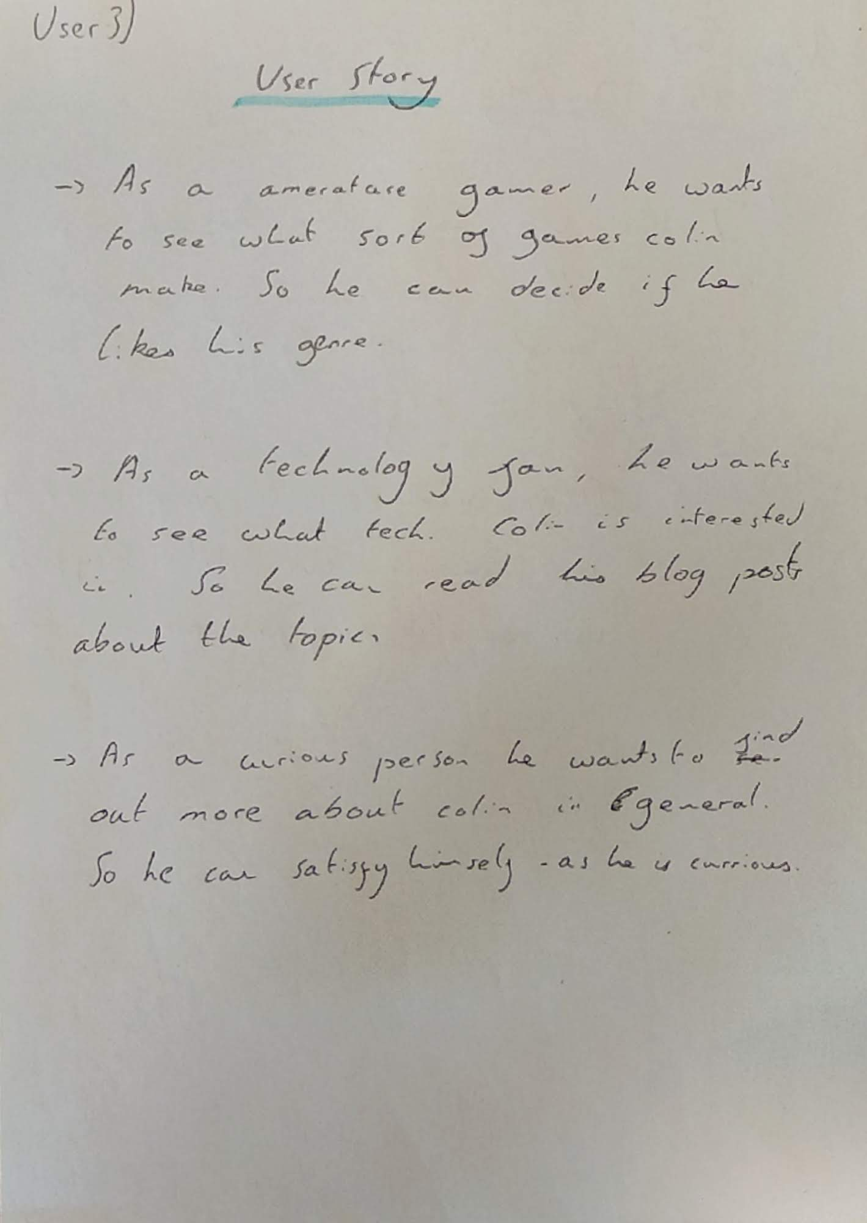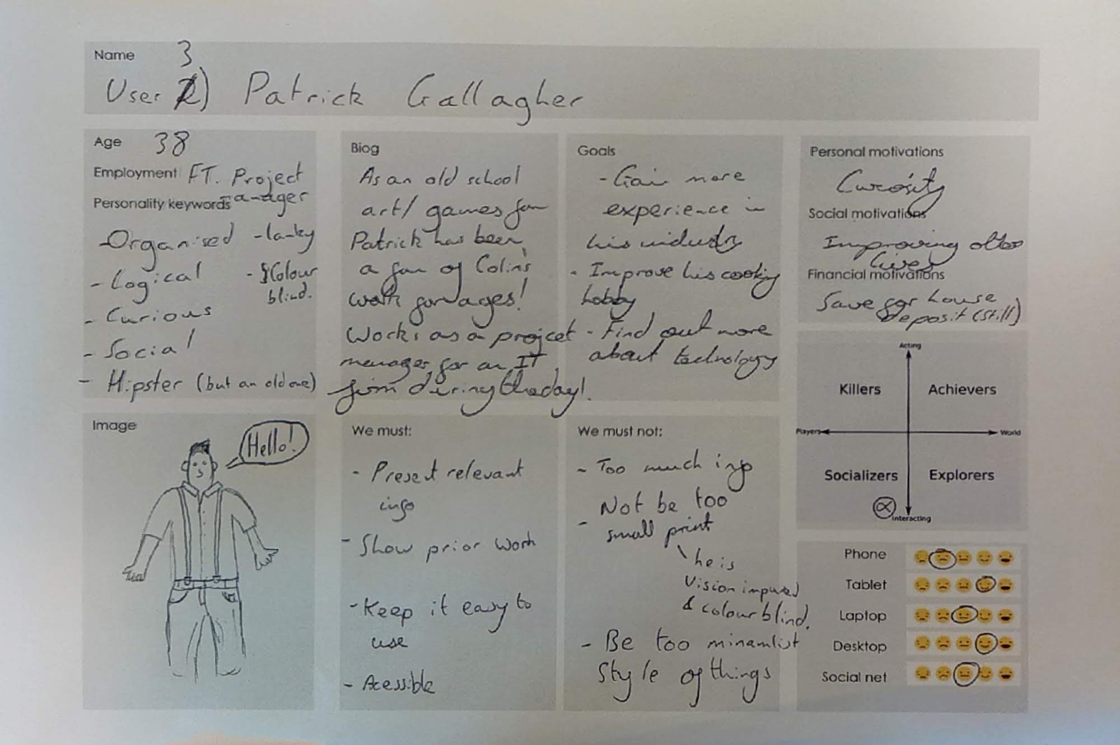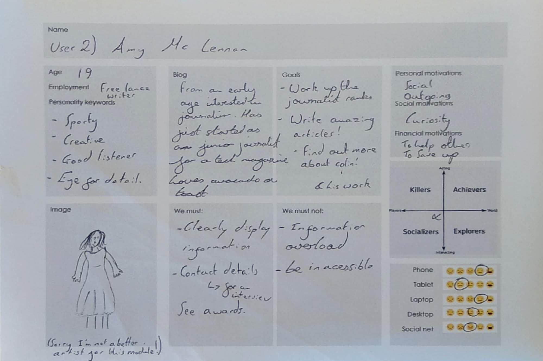

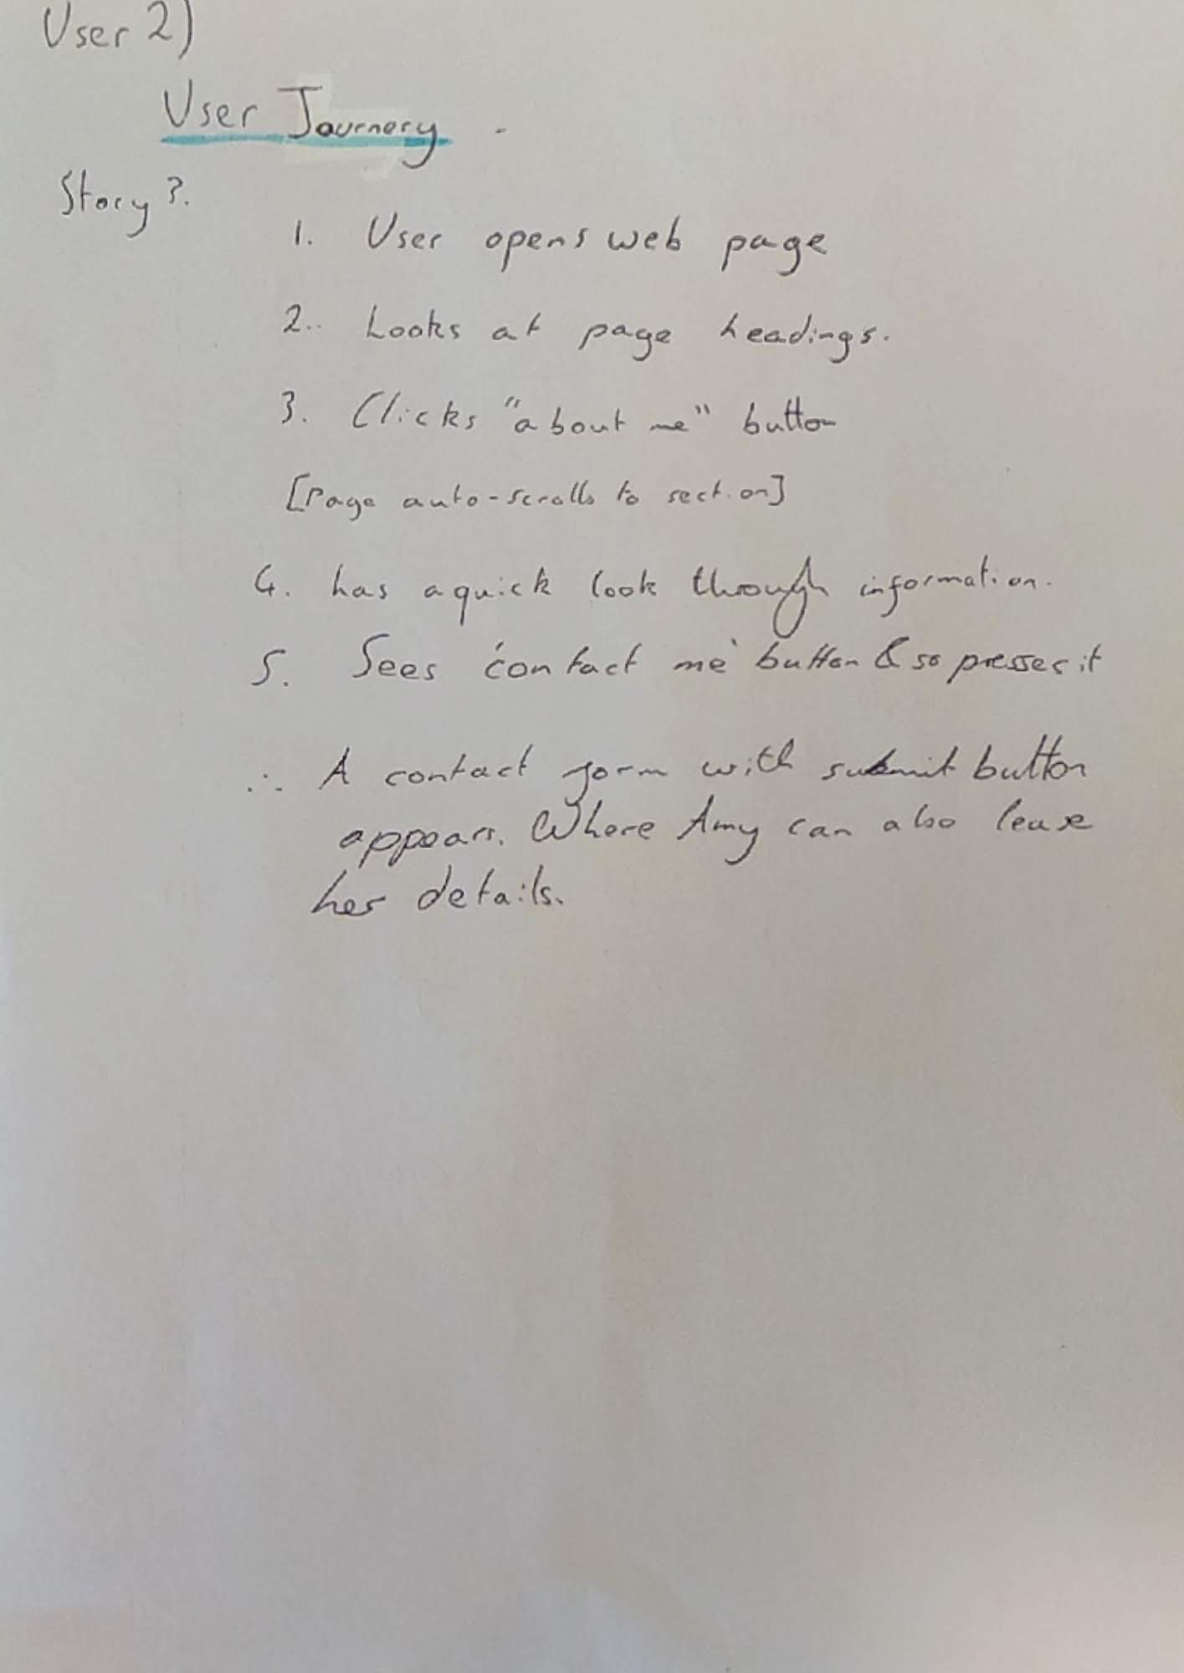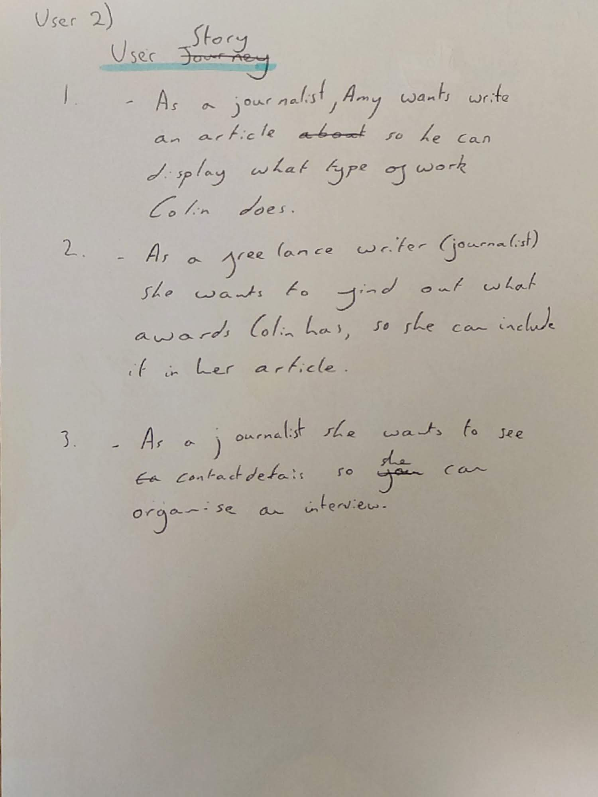

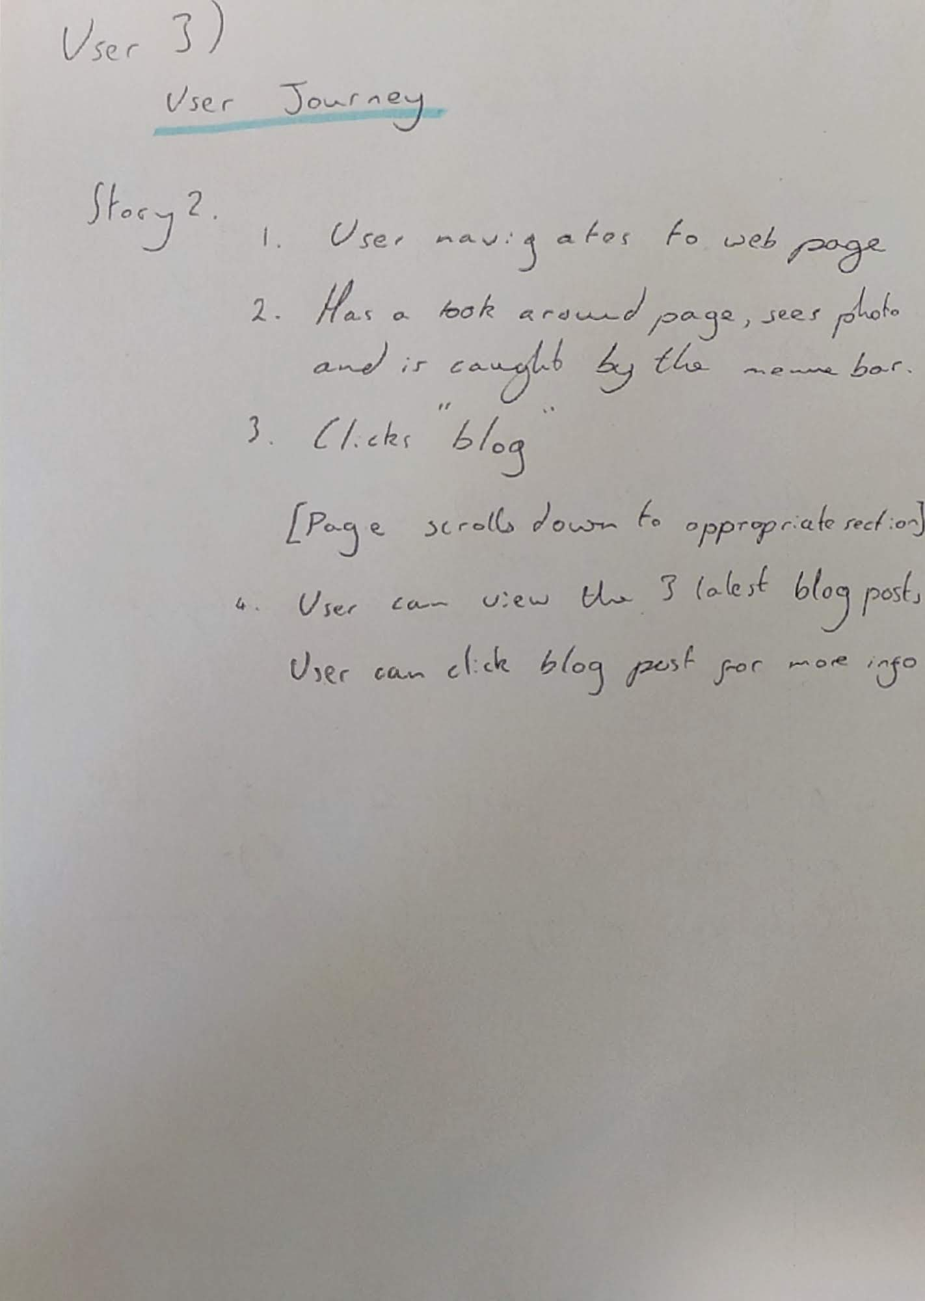

## Task 3 – Initial Webpage Design

### Design Inspiration

Now that I have a specification, I have been able to build upon what I found in the previous tasks with regards to inspiration. With this week’s task I have been able to find some sites which offer design inspiration. Here they are with my thoughts about each of them, with bullet points for what inspiration for design that I took:

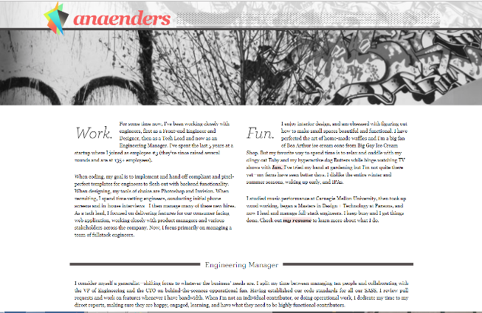

#### [**http://anaenders.com/**](http://anaenders.com/)

Another personal website which has given me great design inspiration. With clear design to the various sections have taken inspiration from the site

* I quite like the pronounced ‘Work’ & ‘Fun’ titles to each section for this site initial site.
* The line separators from each section to section keep the structure very clear.

#### [**https://www.devonstank.com/**](https://www.devonstank.com/)

This single scrolling site for a web developer has a really nice style and design to it. Again as a single page site, the screen shot does not do the site justice.

* The clear cut header menu is very nice design! As on hover the section I am interested in clicking is highlighted – good emphasis.
* The selections below are well structured with icons that I think are well designed!

#### [**http://hugo.fyi/**](http://hugo.fyi/)

Back to this single page which I visited in task two. As a game programmer his site is very well suited to the project for Colin and his required profile page for displaying information. But it also has some very nice design elements

* For navigation the site is structured well with very clear menu options
  + Additionally, I have taken inspiration for the design of how his prior work & projects have been displayed in the second section.

### Initial design

With the compiled research for inspiration for showing both information and design inspiration, I have been able to complete an initial website design as a mock up for what is to be formed. This outlines the

look & feel for the site, navigation, layout, colours imagery, fonts and more. Please see below as I outline my first and then second design ideas which show my design choices through the annotations.

#### Version 1

Aesthetics and Design –

A simple one page site. Featuring the 5 distinct sections with an idea of featuring a time line for the education and experience sections.

This drawing was completed in pencil and so does not feature colours. It is relatively simple as it was built upon in the second version - Featured on the next page

However with this version I was thinking of a dark blue colour scheme with light blue accent colours – taking the following colour pallet:

Layout –

5 Distinct sections which incorporate text relevant to the section,

Additional section to show latest tweet.

This design was not taken further as it does not look the most appealing. Additionally, the latest tweet was deemed to not be a very relevant item.

Navigation –

A single set of menus together as clickable links. Clickable links have been denoted by purple here.

#### Version 2

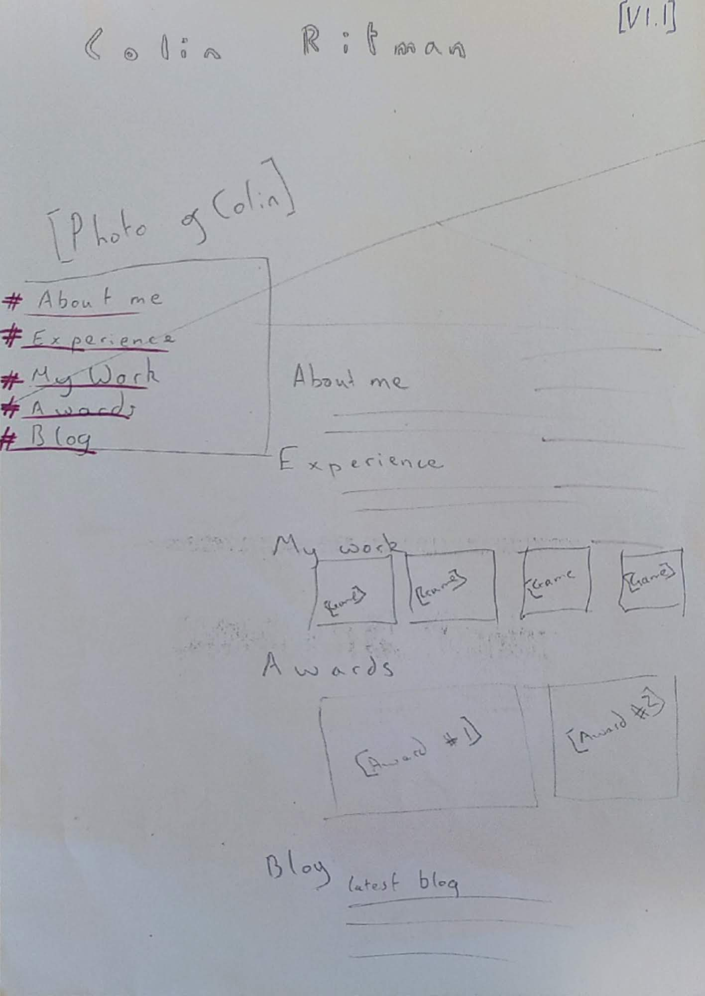This is the version which I took forward to develop further.

*For fonts intended to be used, please see to next page of this document!*

A distinct title and background splash phot. Which remains still as the lower half of the page passes over this with scrolling

**Aesthetics and Design –**

Continuing from the initial first design this will be a simple one-page site. Featuring the 5 distinct sections with an idea of featuring a time line for the experience section.

Within the “my work” section, a range of titles that Collin has recently worked on will be featured here. Where on hover added text appears about each game. This feature may appear with the redesign of the CSS!

This drawing was completed in pencil and so does not feature colours. With this will be using a very dark blue colour scheme with light blue accent colours – taking the colour pallet shown here.

**Layout –**

(Similar to the first version) This site features a single scrollable page where anchor tags have been used to navigate to the relevant sections.

This design now features photos for the various pieces of work completed by Colin with additional photos for the current project Collin is completing – *Nohzdyve*.

**Navigation** –

With this version I moved to a reduced sized navigation pane which featured the five sections required. However, I changed one section from ‘my work’ to ‘my projects’ to properly reflect what this section would be about.

## Task 4 – CSS Based Webpage

Show initial page and outline with graphics file format used

Font types

Annotations about colours

Navigation

Show credits

## Task 5 – Website Review

Complete screen shot,

Calculate values

Modify layout

Complete survey

## Task 6 – Website redesign

Show comparison and add on for specifics

Following Fitts law

Make suggestions on what I can do

Refer to new CSS file

DONE 😊

<https://www.w3schools.com/howto/howto_css_timeline.asp>

<https://www.w3schools.com/howto/tryit.asp?filename=tryhow_css_timeline>