Information management II
SQL Project
Conor Loftus
18326036

Application Description
For this project I decided to do a model of the structure of the data within the National Basketball Association or NBA for short. The NBA is an American men’s professional basketball league composed of 30 teams each playing roughly 70 games during the regular season so capturing all the data generated from each individual player and game each year requires a well-structured database.
The following tables represent the real-world semantics and attributes of different entities of the NBA:
The Player table contains 10 attributes:
player_id | Unique identifier for a player in the league
firstname | Players first name
lastname | Players last name
height | The height of the player in metres
weight | The weight of the player
position | The position the player plays
dob | The date of birth of the player
team_id | A foreign key of the team this player plays for
start_date | The date the player began playing for their current team
end_date | The date the player is contracted to stop playing for their current team

The Team table contains 3 attributes:
team_id | Unique identifier for a team in the league
team_name | The name of the team
location | The state the team is set up in (e.g. California or Florida)

The Game table contains 7 attributes:
game_id | Unique identifier for an individual game that happened
venue_id | A foreign key of the id of the venue the game was played in
date | The date the game was played on
hometeam_id | A foreign key of the id for the team that was the home team in this game
awayteam_id | A foreign key of the id for the team that was the away team in this game
hometeam_score | The number of points scored by the home team
awayteam_score | The number of points scored by the away team

The Performance table contains 8 attributes:
player_id | First part of a composite key for the performance of a specific player
game_id | Second part of a composite key of the game this player performed in
points | The number of points scored by this player
rebounds | The number of rebounds this player had
assists | The number of assists this player had
steals | The number of steals this player had
blocks | The number of blocks this player had
mins_played | The number of minutes played in this game by this player

The Coach table contains 7 attributes:
firstname | First part of a composite key of the first name of a coach for the team
lastname | Second part of a composite key of the last name of a coach on the team
dob | The birthdate of this coach
coaching_role | The role of this coach e.g. Head coach or Shooting coach etc
team_id | The id of the team this coach works for
start_date | The start date this coach began working with this team
end_date | The date this coach is contracted to stop coaching this team

The Venue table contains 6 attributes:
venue_id | A unique identifier for a venue that games are played in
venue_name | The name of the venue
city | The city the venue is built in
state | The state the venue is built in
capacity | The number of people the venue can hold
year_built | The year the venue was built

The Venue_Owner table contains 2 attributes:
team_id | A primary and foreign key of a unique identifier for a team
venue_id | A primary and foreign key of an identifier for a venue

In addition to the assumptions listed above, I have made the following assumptions when making this model:
- Teams can own at least one or more venues, one of which is considered their home venue
- All numeric values like weight and height are measured using the metric system.
- A team can only exist if it has players and coaches and actively playing games in the league
- Each player included in the Players table must be on a team but they do not have to compete in games

Entity Relationship Diagram
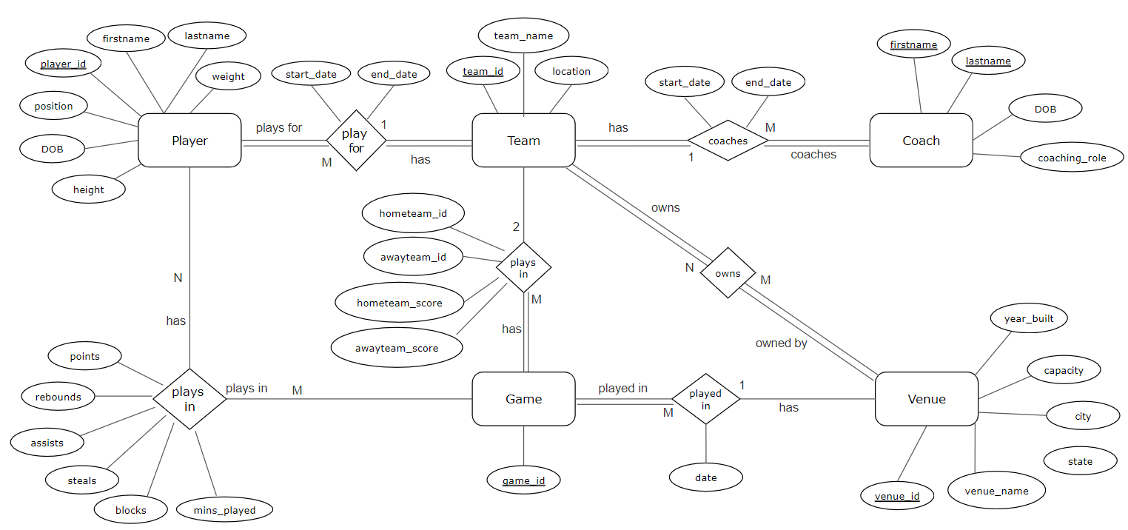

Relational Schema
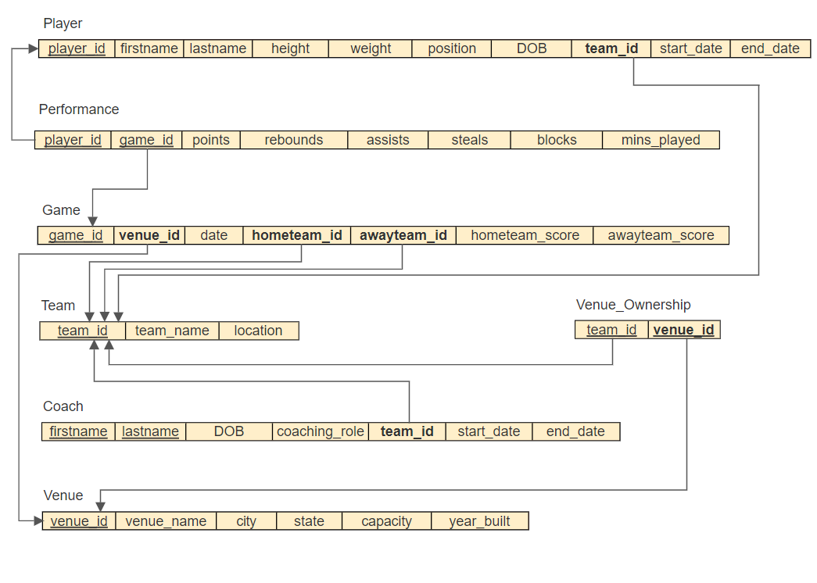

Functional Dependency Diagram

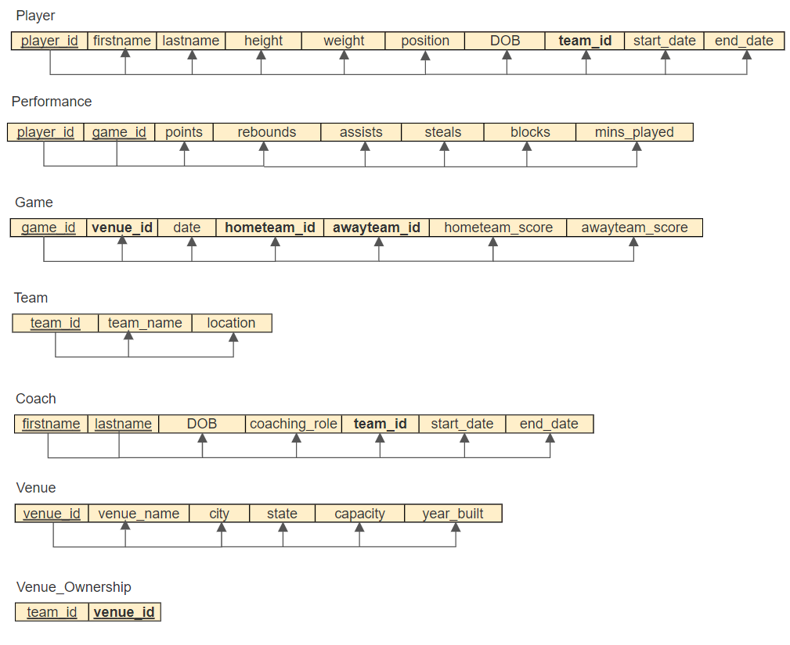

The underlined attributes are considered to be primary keys for their respective tables and so will typically have unique values so that individual records in the database can be retrieved.
The attributes that are in bold are foreign keys for other tables in the database.

Normalisation
After creating drafts of the entity relationship and functional dependency diagrams, I began to check if any normalisation could be carried out on the relation tables. This is key in the database design process to avoid abnormalities when inserting or deleting values in the database tables. It also ensures the tables will be structured in such a way that they cannot contain redundant data. The rules for normalisation are called normal forms:

First Normal Form:
A relation is in first normal form if the domain of each attribute contains only atomic values and the value of each attribute contains only a single value from that domain.
All relations in this example were found to be in first normal form.

Second Normal Form:
A relation is in second normal form if in addition to satisfying the criteria for first normal form, every non-key attribute is functionally dependent on the entire primary key.
All relations above were found to comply with the rules of second normal form as all non-key attributes are functionally dependent on the entire primary key (or the primary keys of a composite key).

Third Normal Form:
A relation is in third normal form if in addition to satisfying the criteria for second normal form, no non-key attributes are transitively dependent upon the primary key.
After some modifications to the relational data I was able to achieve third normal form. This means that for each of the relational tables above, every attribute was functionally dependent only upon the primary key for the table. Knowing a non-key attribute which is the determinant of the primary key can’t be used as the determinant for other columns in that relation.

Boyce Codd Normal Form:
A relation is in Boyce Codd normal form if all the attributes in a relation should be dependent on the key, the while key and nothing but the key.
All relations were found to comply with the rules of Boyce Codd normal form.

Integrity Constraints
The relational model describes integrity constraints. Three types of integrity constraints considered part of the relational model are:
Key, Entity integrity and Referential integrity
The DBMS must enforce these constraints and when creating databases, the user must ensure that SQL operations do not violate any of these constraints
Key Constraints
Key constraints specify that there may not be any duplicate entries in key attributes. Keys are used to uniquely identify a tuple or record. This is typically handles by the DBMS when the user defines an attribute of a table as the key by labelling it with the ‘primary key’ constraint. In the database I created every table has key constraints enabled to ensure that each tuple can be uniquely identified.
Entity Integrity Constraints
Entity constraints are specified on individual relations, one such constraint is that none of the primary keys may be null. When designing the database, I ensured that when creating tables, the DBMS ensures that the primary key cannot be null, so the database retains its entity integrity.
Referential Integrity Constraints
Referential integrity constraints are specified between two relations: they maintain consistency among tuples in the two relations.
A tuple in one relation that refers to another relation, must refer to an existing tuple in that relation. A foreign key formally specifies a referential integrity constraint between two relations and when dealing with this the user has to be careful with their SQL operations and define when foreign keys may or may not be null. As an example, from my database design, the team the coach works for is represented as a four-digit integer called ‘team_id’ which cannot be null, as a coach must have a team which was a design decision. This ‘team_id’ is also a foreign key for the ‘team’ table. As a result, the team_id for the coach table cannot be null as it must reference an existing team_id in the team table. This means that we can only insert a coach into the coach table as long as the coach is linked to an existing team in the team table.

Semantic Constraints
Semantic constraints are vital to ensure the integrity of the database and avoid the accidental corruption of information. These constraints can be defined when creating the tables in the database and in the form of checks, triggers, and assertions.
In the majority of my tables, attributes have been given the NOT NULL constraint if they have been deemed important and this means that at insertion time these values must be defined.
I also used check constraints in numerous tables to ensure that numeric values such as the number of points scored, or the number of assists players got wasn’t less than 0.
For my semantic constraints I decided to implement a trigger for players who were inserted without a first or last name. Rather than leave that attribute of the table blank or null, the trigger forces that attribute to update its value to ‘noname’.
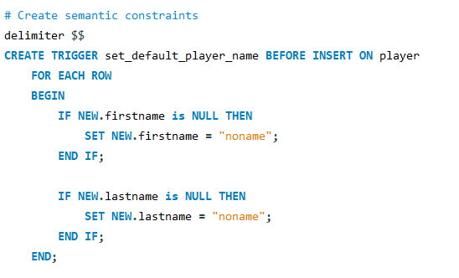

Security
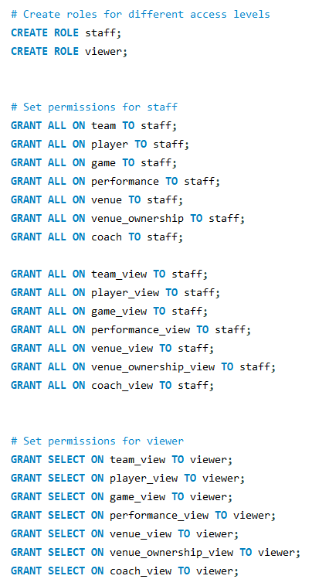
Security constraints are concerned with deliberate corruption of data in the database. We can ensure database security using security policies and access control.
For security reasons I have implemented separate views for each table. These views offer the possibility of hiding information from public users without admin permissions.
The staff role allows users with this permission to access both the main tables and the views of these tables and can perform all actions on these tables such as the insert, update and delete commands.
The viewer role can only access the views of these tables and are limited to performing SELECT queries on these tables.

Appendix
