Conor Loftus Lynch
Student number - 18326036
Biography of Terry A. DAvis An influential Software Engineer

Background
Terry Andrew Davis was an American programmer who created and designed the operating system TempleOS from scratch with his own customised version of C which later on became known as HolyC. The development of such an application was excessively complex for one person to work on as he had to develop his own programming language, editor, compiler, and kernel. The successful creation of his own OS has led to him being called “the smartest programmer that’s ever lived” by his followers online.

Early Life
Terry A. Davis was born on December 15th, 1969 in West Allis, Wisconsin to a family of eight. When Terry was a child he was put in a gifted school where he had regular access to an Apple II computer and is sourced as being the start for his interest in computing. From there he adopted the commodore 64 and with his natural talent was able to teach himself Assembly Language in the early 80’s.
After achieving a SAT score of 1440, he continued to program throughout high school and eventually enrolled at Arizona State University where he got an Undergraduate and Masters degree in electrical engineering in 1994.
While studying for his undergrad, Terry was employed by Ticketmaster from 1990 to 1994 where he initially worked on VAX machines but later moved to the research department from 1994 onwards where he built barcode readers and power supplies.
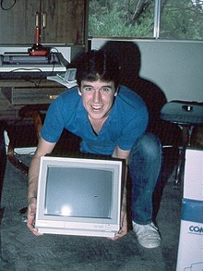
In 1996 Terry began experiencing regular manic episodes and suffered from delusions of aliens and paranoia of government agents following him. He often described people dressed in suits following him and was worried that these people were spying on him. This led Terry to forming conspiracy theories about the American government and how they were concerned with him and the software he was developing.
One episode that Terry mentioned to his followers entailed him driving 100’s miles south with no direction in mind and was simply following the car’s radios “instructions” which was commanding Terry on what to do. He was later picked up by a police officer who found the vehicle pulled over in the middle of the desert in Texas with the car in pieces after he took it apart searching for tracking devices.
In 1997 after these events Terry was diagnosed with bipolar disorder and later declared a schizophrenic which gave him time to work from home on his own interests. Using credit cards and loans Terry began building homemade CNC machines and designed his own 3 – axis milling machine along with its own custom software that allowed the user to design and do 3D modelling on their home pc which was advanced software for its time.
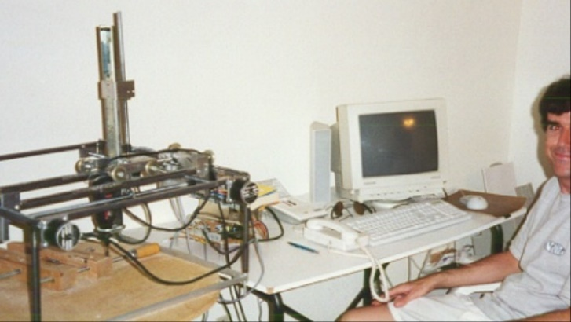

LoseThos Operating System
In October 2008 Terry created a subreddit on Reddit where he would make posts about his project on developing the OS as an entertainment platform and had no plan for this to be a competitor with other popular OS’s like windows or OSX.
This OS was written in a customised version of C which was later named HolyC. It was completely written from scratch and had over 100,000 lines of code. The OS built from scratch allowed Terry to create a clean break from the past and “innovate” as LoseThos had no compatibility with any other software written. This OS was quite dated for 2008 as it had to be run on a resolution of 640x480 with only 16 colours.
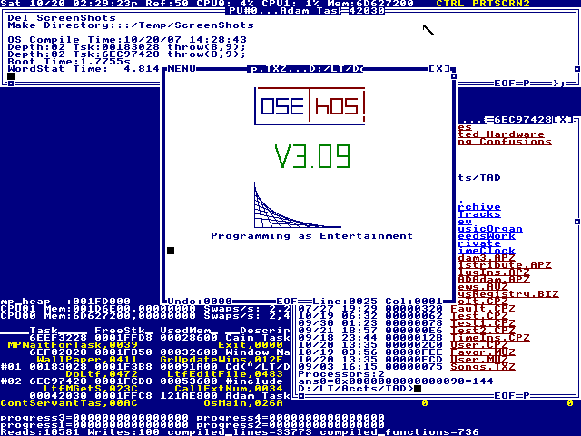
LoseThos was also limited in the sense that it didn’t have any ability to connect to the internet. This was a purposeful decision by Terry as the OS was at risk to basic malware and viruses which meant that anything developed with this OS couldn’t be shared.
Although the OS was questioned for its usefulness its recognised that this was an achievement in the sense that a single person was able to developer their own operating system from scratch and can be compared to as a person building a skyscraper alone.
Around this time Terry began making YouTube videos for the first time showing off LoseThos and its functionality as well as providing user guides and overviews.

Sparrow OS
In September 2012 Terry released a new OS called Sparrow and created new social media accounts to promote it. The following year it was rebranded as TempleOS. The OS was similar to the Commodore 64, DESQview and other early DOS-based interfaces.
Terry released a large number of support documents for this project as well as adding many more games and features than LoseThos. Davis claimed that he was in direct communication with God and was told to build a successor to LoseThos. As such, references to Biblical tropes are ubiquitous in the OS. He also created a YouTube channel and created videos demonstrating the features of this new OS and it was from this point on Terry began to grow in popularity online. It was also on this platform that his fans were able to watch his mental health deteriorate.
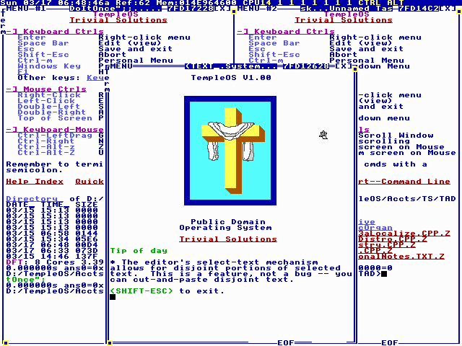
(What TempleOS looked like)

Death
During his last few months, Davis struggled with homelessness and incarceration and had stopped taking his medication as he thought it limited his creativity. Fans made attempts to help him, but they were all refused.
On August 11 2018, Terry was struck by a train while walking alongside the railroad tracks in Oregon. Investigators determined that his death was suicidal.

References
- https://en.wikipedia.org/wiki/Terry_A._Davis#Recognition,_controversy_and_following
- https://en.wikipedia.org/wiki/TempleOS
- https://thenewstack.io/the-troubled-legacy-of-terry-davis-gods-lonely-programmer/
- https://www.vice.com/en/article/wnj43x/gods-lonely-programmer

