• Contract address: 0xCE5CaCc061E0946D89a6BD6BD556216800Cf1009
• Contract creator: 0x432C641eaf473F923199e1AeBc70f75FC9F050c3
EtherScanURL: https://sepolia.etherscan.io/address/0xCE5CaCc061E0946D89a6BD6BD556216800Cf1009

Ticket bought hash: 0xd89d7b49f41a5c504ba6101735319afda67218a9379848275ee7e2101daae9f1

Upload your side of the ai conversation-development process,
Describe how to compile project+how everything works+diagram ie in mermaid

Bitcoin – transactional – pov unspent transactions
Ethereum- account based
Last piece of project- introduce concept of payable:
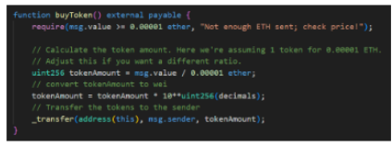

3 Wallets
• Wallet 1 — Contract Creator (this is your existing MetaMask wallet, so you may already have it)
Wallet Address: 0x432C641eaf473F923199e1AeBc70f75FC9F050c3
Private Key
Keystore file:
private key: 5277abf2f3ca1ab43ec5d88635f9aba39863dbe5ed98dc7a81259d8c0387ca07
password: HarryPotter123

• Wallet 2 — Ticket Purchaser
Wallet Address: 0x5BcFFDDA3742584789D504FBE299579E1121E79A
Private Key: 0x14e364e1f7b2ec4fb694555008f05239995d7d30fa29d5a42209131fae843fa3
Keystore password (whatever you typed when creating it): HarryPotter123
Keystore file (downloaded JSON): ~BCProject/TicketPurchaserKS
• Wallet 3 — Vendor / Doorman
Wallet Address: 0x1044544d313C8145B5e6b02C5fB9b25C6DAaeAAe
Private Key: 0x672254df01e5e3e252577c39a736abdcd97473fef00df87ea88d59bda315cd01
Keystore password (whatever you typed when creating it): HarryPotter123
Keystore file (downloaded JSON):BCProject/VendorKS

Secret recovery phrase for Wallet1:
winner fix trumpet tongue absorb jeans siege flame fall isolate bar ensure

