EAA Ca2

Conor O’Neill – X00110726



Operating System Used

The operating System that I used to conduct the tests was the CNTLM Fedora image that we were given in college for this module. The VM was configured to only use a single core as outlined in the CA description document. The memory of the machine was 4098 MB of base memory, as shown below in the image.

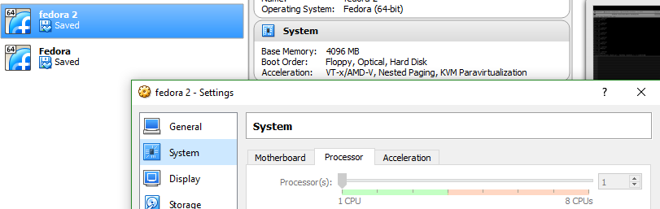

Ui Vs N Graph

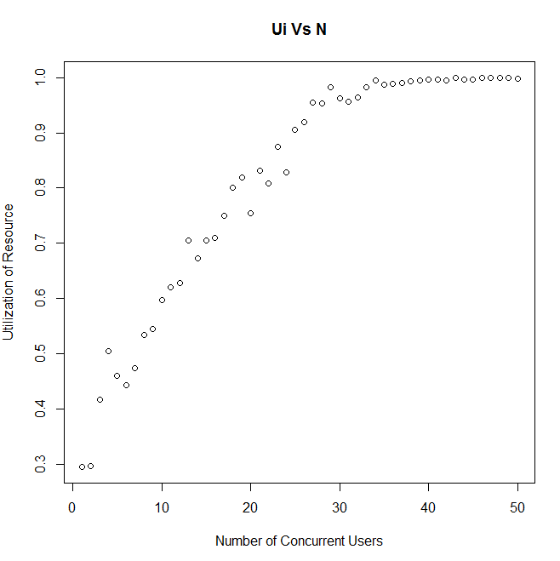



This graph shows the utilization of the resource as the number of users increases. The utilization grows consistently until it hits 1, as the number of users increases. This is because 1 is the maximum utilization you can have on a resource. We know this because of the general properties that 0<= Ui =<1 .

X0 Vs N Graph

