Bargain bin

Usability Report

BSHCE4 - Usability

Conor Prunty – 13102311

Kevin Clarke - 13101722

Table of Contents

Executive Summary 3

Stakeholder Matrix 4

Data Gathering 4

Focus Group Introduction 11

Expectations Setting 12

Initial Interactive Exercise 12

User Groups 15

Users Trading Items/Services Overview 15

Personas 16

Scenarios 17

Scenario 1 – a user is using the site as a professional picker 17

Scenario 2 – initiating a trade on a listing 17

Task Analysis 18

Task 1 18

Task 2 18

Requirements 18

Use Case Diagram 18

Functional 19

Non-Functional 19

Performance 19

Scalability 19

Availability 20

Usability 20

Security 20

References 21

# Executive Summary

This report details the process our team followed during the gathering of requirements for our application *BargainBin.com*. *BargainBin* is a web application targeted at the niche market of unwanted household goods and clutter, and the micro economy that these items create. The application is intended to act as a portal that allows registered users to create online listings in order to trade unwanted goods in exchange for other goods or services. For example, a user of *BargainBin* may have just completed a Spring clean and discovered forgotten items such as rollerblades, which they can then attempt to barter on the application in exchange for music lessons, fishing equipment or other desired experiences and items.

*BargainBin* facilitates these exchanges by allowing users to register and create a profile. Once their profile is created they have the ability to create a listing that describes their unwanted item, the approx. value, and the type of items/experiences they would be interested in bartering for.

We have determined the main stakeholders of the *BargainBin* application fall into one of several categories.

* The average Irish household will be our main stakeholder. The large majority of people that completed our survey stated that they have at some point received an unwanted gift or made an ill-advised spur of the moment purchase that later found its way into a storage space never to be seen again. This demographic also indicated that they would welcome the opportunity to get rid of these unwanted items in exchange for items and services that they currently desired.
* Avid “pickers” (people who trade brick a brack for a living) - these users make up a smaller set of stakeholders, but while their individual user numbers will be smaller, they are much more likely to have a large volume of transactions and be active members of the application. These users will contribute to the micro economy that this barter system will create and enrich the user experience.
* Skilled craftsmen/instructors – These users will likely play a key role in the success of the *BargainBin* application because they have a readily available supply of skills and experiences which have inherent value that they may wish to barter.

## Stakeholder Matrix

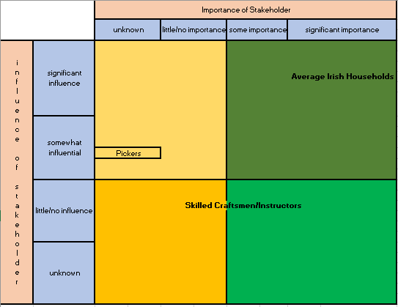

# Data Gathering

The first data gathering technique that we used was a questionnaire. We felt that keeping it short and to the point would provide for more useful information. Some questions were created with a comment box for further feedback. We also have learnt from our experience; that users like to give their opinion, and some questions don’t always give a full explanation with the specified answer choices.

The questions we posed are:

* Do you have unwanted items lying around at home?
* Would you be willing to use an online application in order to trade with others?
* Would you be happy to receive goods instead of a monetary gain for any unwanted items?
* Would you rather use a website or a mobile application for trading unwanted goods?
* How confident do you feel that a trading application is safe, and that you would receive the goods as advertised; when responding to an ad?
* Our application will validate each and every person who wishes to advertise. Would this change your answer from the previous question?
* Would feedback from past users influence whether you use an application or not?
* Have you ever used a similar application in order to trade unwanted items? If yes, please describe any positive and negative aspects you experienced.
* How often do you think you might use a trading application?
* Please provide any features or ideas you would like to see on a trading application.

The responses provided some excellent feedback, and gave us valuable insight into how we should create the application. Not only that, the responses were overwhelmingly in favour of having such an application, and confirmed the demand for the application.

Q1: *Do you have unwanted items lying around at home?*

This question was a resounding ‘yes’ answer, which first and foremost, showed us that this type of application could be a success and used by the public.

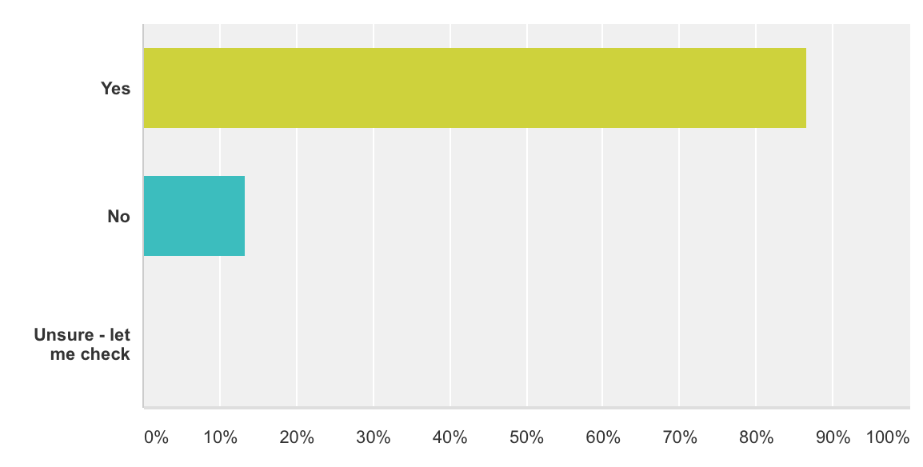

Q2: *Would you be willing to use an online application in order to trade with others?*

Another very important question, as not everyone uses online applications. As the application will all be online, another big ‘yes’ answer was very important to this question.

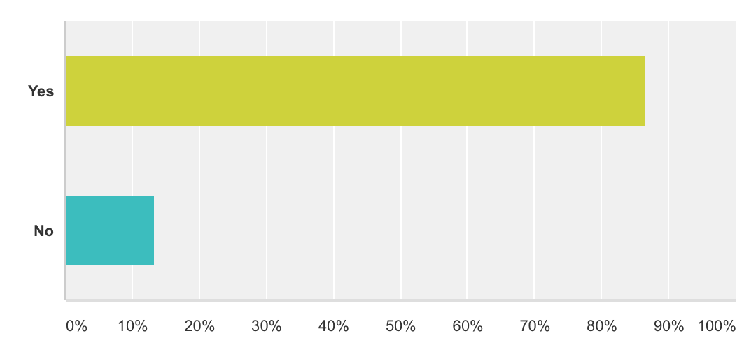

Q3: *Would you be happy to receive goods instead of monetary gain for any unwanted items?*

We were really hoping for a higher ‘yes’ answer, but at least it’s one and a half times higher than the ‘no’ responses. We thought this might question might not give an overwhelming ‘yes’ answer, so we put a comments section on this to see why a specific answer was chosen.

Some of the ‘no’ comments were:

* *“I want to get rid of clutter, not replace it”*
* *“Don’t want more clutter”*

But there were also positive comments, such as:

* *“One man’s trash is another man’s treasure”*
* *“Yep – I don’t think I’d get much money if I tried to sell some of my stuff!”*

This gave us an indication that people are afraid that they’ll just end up with more junk, in place of junk they already have. We hope that we can use this to our advantage and ensure that the application is broken down into different sections, to cater for all different user’s needs, and try match what people are looking for. We’re hoping this avoids the main issue that this question has indicated.

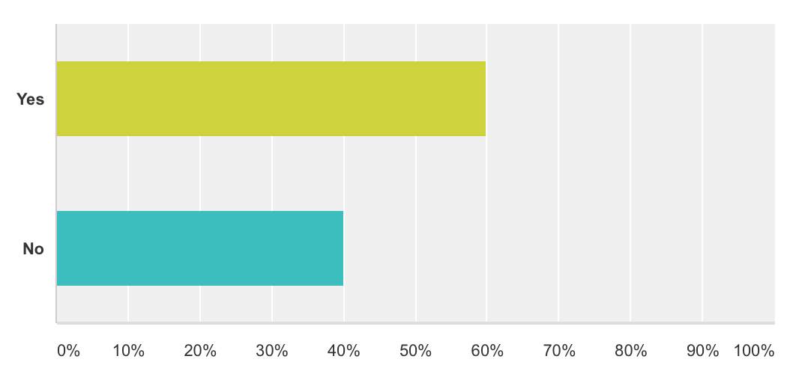

Q4: *Would you rather use a website or a mobile application for trading unwanted goods?*

It seems the majority of people would like both a website, and a mobile application – with mobile application being more popular than a website. I thought this might be the result here as the online market is definitely turning towards mobile applications over using a website on a desktop PC.

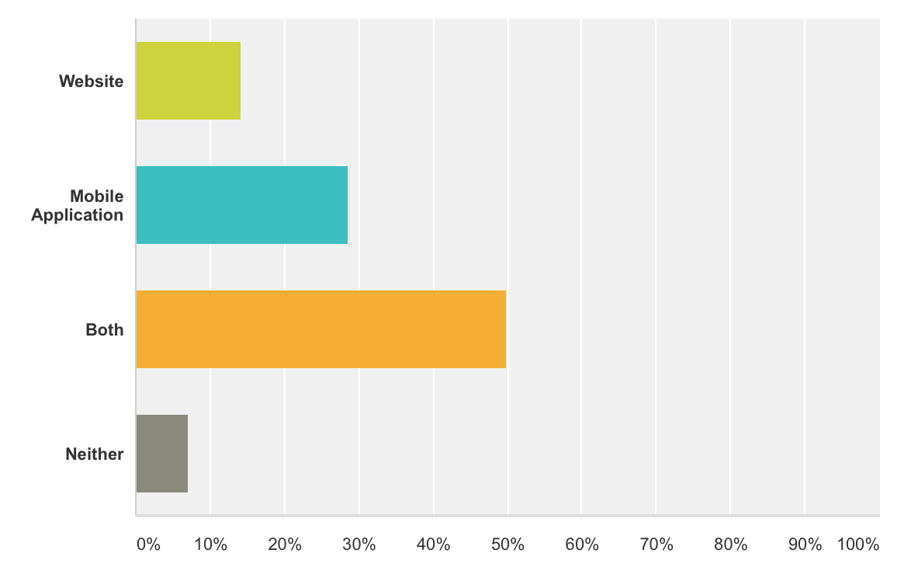

Q5: *How confident do you feel that a trading application is safe, and that you would receive the goods as advertised, when responding to an ad?*

This question we felt was very important, as security is a major issue for anyone who does shopping online. When the questionnaire was issued, we had no idea how people would respond. From 15 responses, 3 of our choices came out even. And the most positive news was, that nobody picked the lowest answer. This deliberately led us to our next question.

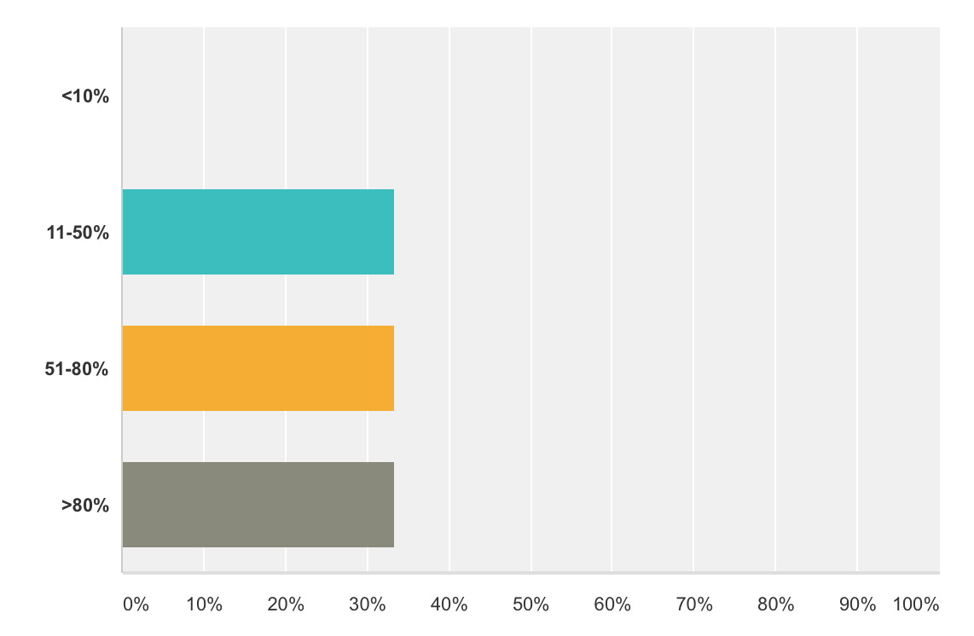

Q6: *Our application will validate each and every person who wishes to advertise. Would this change your answer from the previous question?*

As mentioned previously, security is a very important aspect of any online application. The results below make for good reading, when combined with the results of the previous question. As one third of respondents in question 5 said ‘>80%’, and the same percentage answered ‘no’ to this question, therefore, barring any anomaly, the two-thirds who answered between 11 and 80% would answer higher (not guaranteed, but most likely), and the one third who answered >80% had nowhere higher to change their answer to and would have answered ‘no’. Although the question didn’t specify asking would they answer a higher percentage, it is how it was meant to be interpreted.

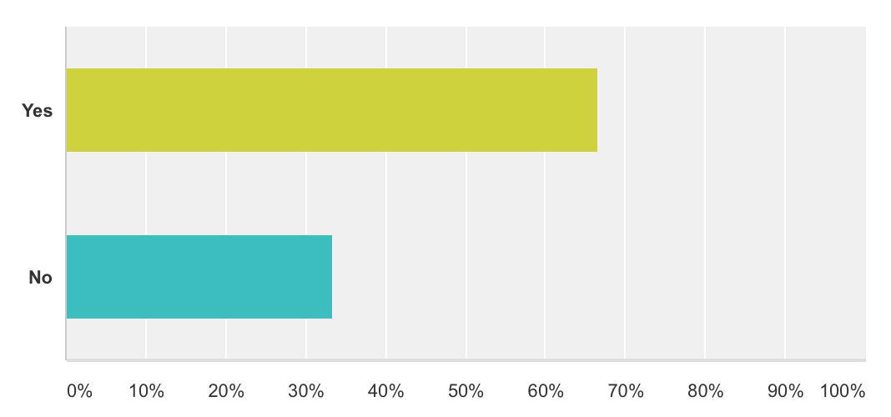

Q7: *Would feedback from past users influence whether you use a site or not?*

Again, the results may not be surprising, but it was important to capture the response, just in case. As we fully expected, the vast majority of the public do believe that customer feedback is important regarding future application usage.

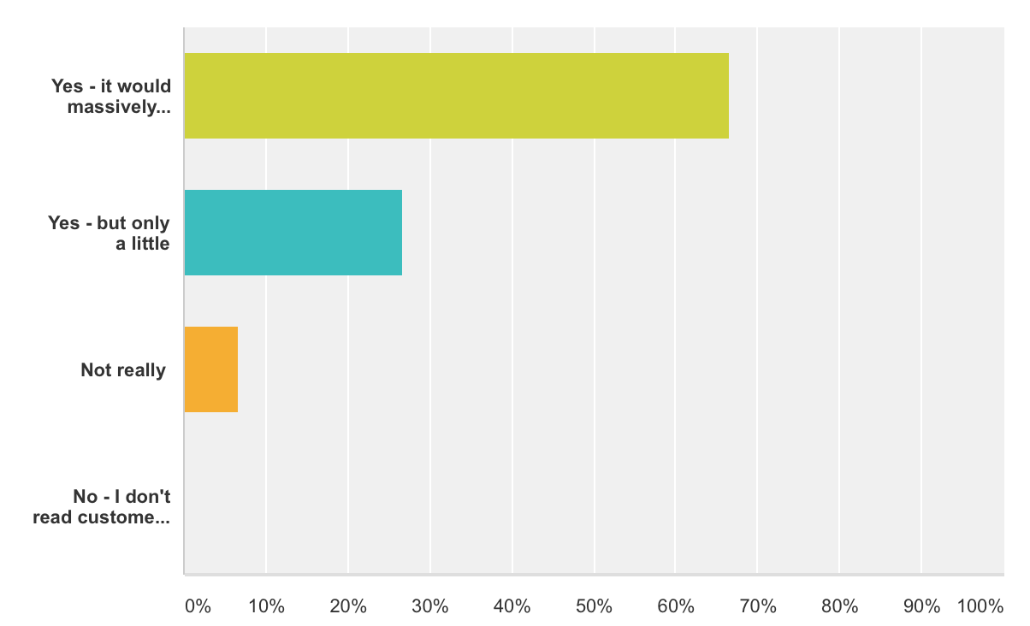

Q8: *Have you ever used a similar application in order to trade unwanted items? If yes, please describe any positive and negative aspects you experienced.*

A whopping 85% of people have never used a trading application in the past! This is great news for us, considering how much of a positive response we got for questions one and two. It does look like we may have found a potential gap in the market.

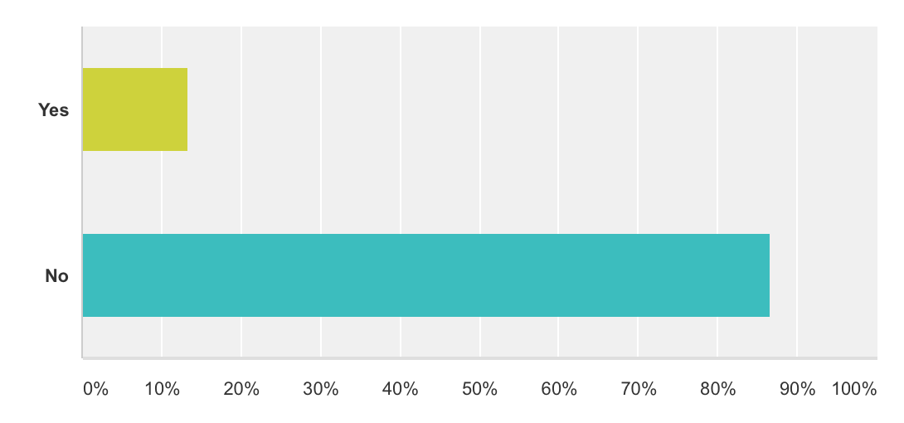

Q9: *How often do you think you might use a trading application?*

From five options available, only two actually received a response. The leader was ‘as often as required’, with the only other option chosen was ‘rarely’. This makes sense though, as once you get rid of your unwanted items, you wouldn’t revisit the application for probably a while. This is acceptable though, judging by the results received from how many people have unwanted junk lying around, as there would be big numbers visiting the application.

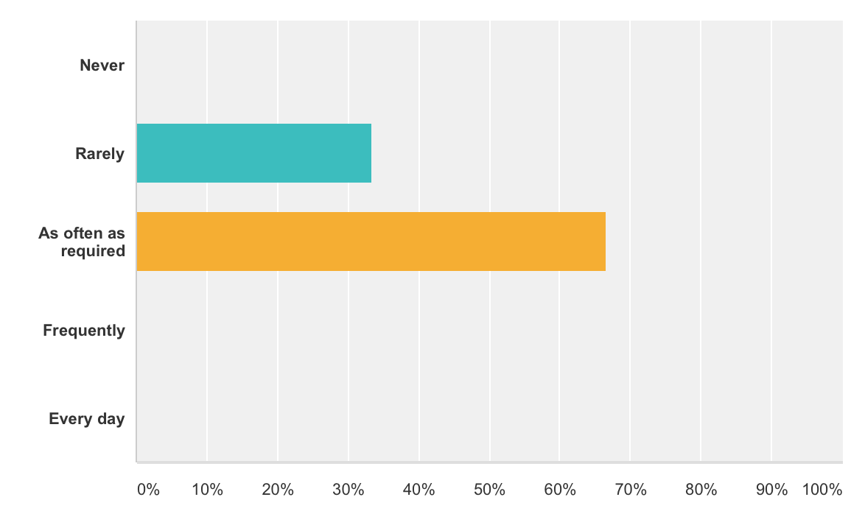

Q10: *Please provide any features or ideas you would like to see on a trading application.*

Some ideas given in the free text box were:

* I would like it to be easy to use - and get responses quickly when sending requests.
* Camera access functionality.
* Bulk items - trade items in groups

Our second technique used for data gathering was the form of focus groups.

Focus groups are small number of people (usually between 4 and 15, but typically 8) brought together with a moderator to focus on a specific product or topic ("Which Of Your Friends Needs To Learn This Term?").

We followed a specific technique for the focus group in order to gain some meaningful results. The steps we used were:

-Introduction

-Set expectations

-Initial interactive exercise

-All other questions

-Closing

Each step has its own purpose and helps the members of the focus groups to relax and understand what is going on.

## Focus Group Introduction

We got 9 participants for the focus group; a number we were happy with. We didn’t want a *forced* environment, such as a school type setting, but rather somewhere where people would feel relaxed. We chose a lobby of a popular hotel chain, which we felt was public enough that people could relax and enjoy the setting, and therefore give us more realistic results.

We introduced ourselves, and explained why we were doing this. We also had to explain that, as everyone is in the same room with each other, that there is not a 100% guarantee of confidentiality.

## Expectations Setting

The next step was to explain what is going on, and what will be happening. This was a short 5-minute chat just to say what was going to happen next, and in turn over the course of the meeting. Everyone seemed happy to engage, but we didn’t know at this stage how it would turn out.

## Initial Interactive Exercise

The first plan was just to get the group to interact with each other, by using a fun group exercise. The one we chose was a simple brainstorming session. The idea was to get the group to just throw out ideas of what type of functionality they would like to see on a trading application. We got some good ideas to take away and just as important, we got the group to get comfortable with each other so they could work well together on the later questions.

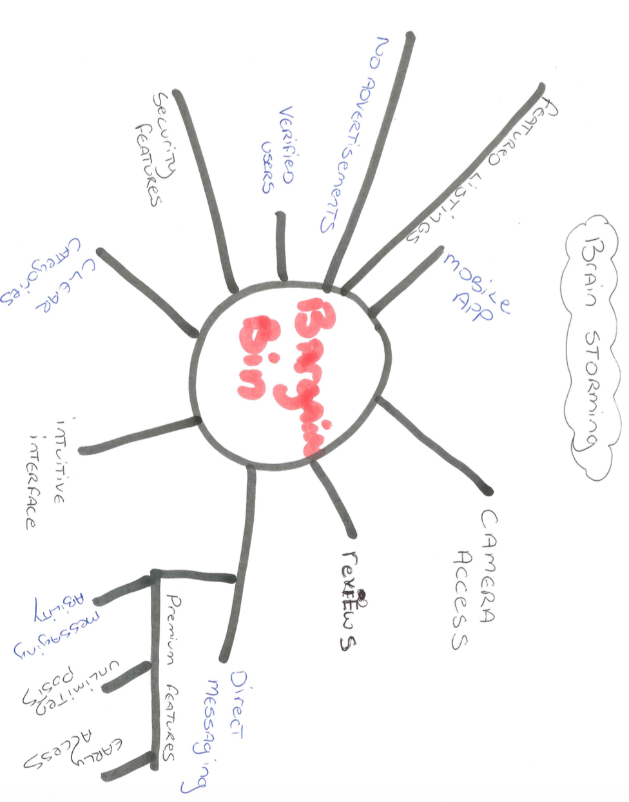

As you can see, many ideas were thought of such as: no ads, clear categories, camera access, direct messaging and many others.

Once this quick session was done, we gave the group a short break, then handed out a list of questions to everyone.

The questions we had were:

* What would make you come back to a trading application?
* Is there any other functionality or features you now can think of after the brainstorming session?
* How would you like to contact the sellers?
* Would you be willing to pay for such an application? And if not, would you be happy with advertisements?
* What kind of unwanted goods have you lying around at home?
* Would like to be able to receive alerts for specific categories?
* What are the pros and cons for mobile vs desktop versions?
* How important is a comments section, and would you use it?
* If you like the application, would you recommend it to a friend?
* What type of categories would you like to see?

Each sheet handed out had the questions in a different order as we’ve researched into this and people give different answers depending on where in a list a question is posed. We felt this was the fairest way to gain proper responses. Randomising the question order means that the influence is no longer subject to this ordering bias (times?).

The main outcome of the questions are as follows:

8 out of 9 people said they would not be happy to pay for the application, which would mean we would need most likely some sort of advertising in order to make financial gain. However, 66% said they would not mind if there was some form of advertising, which is helpful.

The majority of people chose between email, text message and direct message (on the application itself), with email coming out slightly on top at 32%. This was for us to decide what users of the application would have to provide us with upon registering.

The users were also very positive in the application having a comments or feedback section. This rated highly on how they would return to the application, and even if they would visit in the first place. This is one section that we will definitely implements, and take some time over getting it right and user-friendly.

We also wanted the users to decide what type of categories would be most applicable for such an application. We allowed the users to choose as many options as they liked, and you can see from the chart below which were the most popular.

Most people selected using the mobile application, as they are always on the go. This was somewhat expected as everyone these uses some sort of mobile device. The users also chose email alerts for specific categories when new goods are advertised, as they can also receive this on their devices.

We thanked all the users for their valuable feedback and answers to our questions. We told them that we wouldn’t differentiate who gave what answer (even if we knew), and that it was all just used for us for the initial stages of developing our application. We felt this focus group was definitely a worthwhile session as it gave us excellent knowledge on what the public would like to see.

# User Groups

We have identified 3 main user groups as we have progressed through the requirements gathering of BargainBin.

* Users trading items.
* Users trading services
* Admin

For the purpose of this usability study we will focus primarily on users wishing to trade products, and users wishing to trade services. These two user groups represent a very important part of the BargainBin application and will be vital to its success. Due to the similarity in requirements between both user groups, this report will set-out the features and functionalities of both groups while highlighting the one key differentiator.

## Users Trading Items/Services Overview

In this usability study we will narrow our focus onto the key attributes and functional elements of the user group “Users trading items” & “Users trading services”. Both groups of users will carry out the following steps while using BargainBin.

User Sign Up Process

* User registration and profile set-up – Name, Profile Image, Product/Service Description, List of Items or Services they would be willing to accept.

Uploading Images/Videos

* Both user groups will have the ability to upload images and a short video to assist drawing attention to their listing. – Image/Video Title, Image/Video File.

Social Media Sharing

* Both groups of users will share their listing on social media outlets – Facebook, Pinterest, Twitter, Instagram.

The key difference between the two user groups will be how they advertise their listing depending on whether they are listing an item or a service.

* Users listing a service will need to provide a great description, video/image, and service reviews. In addition, because as service has a potentially unlimited quantity they need to detail availability, and will likely need to highlight any awards or standout features that set-them apart.
* Users listing a product have an easier time because most users will not need a very detailed explanation of a product as they will be aware of many commonly listed items already. (musical instruments, sporting goods etc.)
* Our aim is to provide these user groups with a rewarding and pleasant experience that will keep them returning regularly to our application.

# Personas

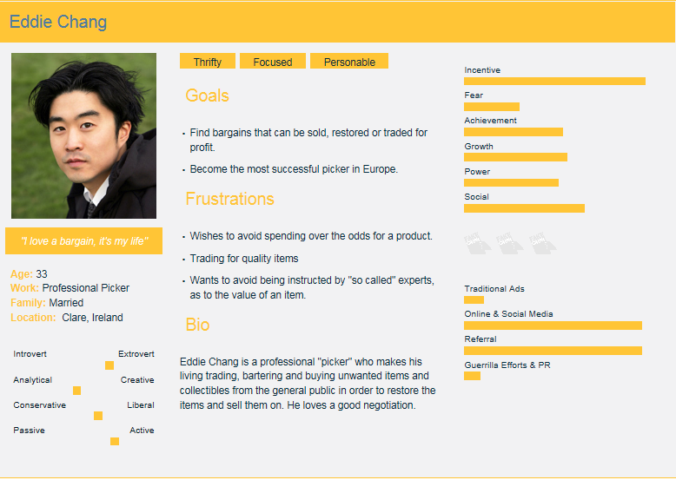

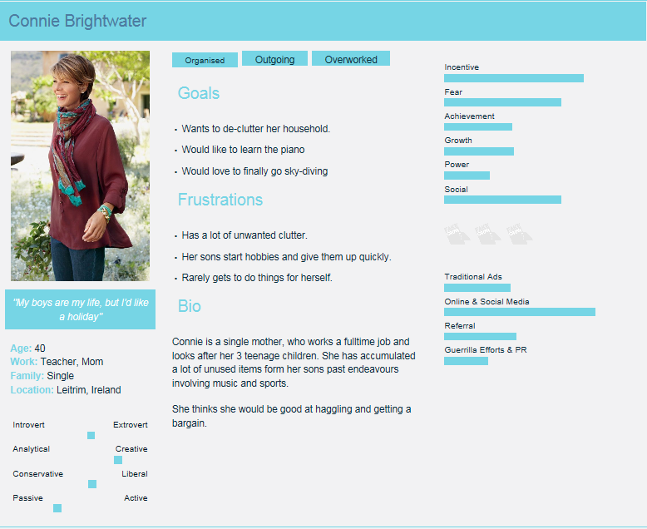

# Scenarios

## Scenario 1 – a user is using the site as a professional picker

It’s 5pm Friday evening and Eddie intends to log-into *BargainBin* and upload his 5 newest listings in order to gain more views from users logging in at the weekend. He logs into the application and begins creating his listings. He has prepared professional images of each product and needs to load them into the application. He wishes to be made aware of any offers by receiving an alert on his phone.

## Scenario 2 – initiating a trade on a listing

Connie a single mother of 3 has come home from work and decides to browse the *BargainBin* application. She opens the application and browses they latest listings. She finds a listing that is offering an item she desires. In addition, the seller has specified he is interested in trading for original movie posters which Connie has several of. She initiates contact with the seller and negotiates a trade which is executed in the application.

# Task Analysis

## Task 1

* 0. Create listings
* 1. Log into the application.
* 2. Start a new listing.
  + 2.1 Enter a product/service description.
  + 2.2 Upload an image/video.
  + 2.3 Enter a list of desired items in return.
* 3. Enter the desired method of contact.
* 4. Log out of the application.

## Task 2

* 0. Initiate a trade
* 1. Log into the application.
* 2. Browse the latest listings.
* 2.1 Filter by category and date.
* 3. Select a listing to bid on.
* 3.1 Initiate contact with the seller.
* 3.2 Agree on the terms of the trade.
* 4. Execute Trade

# Requirements

## Use Case Diagram

## 

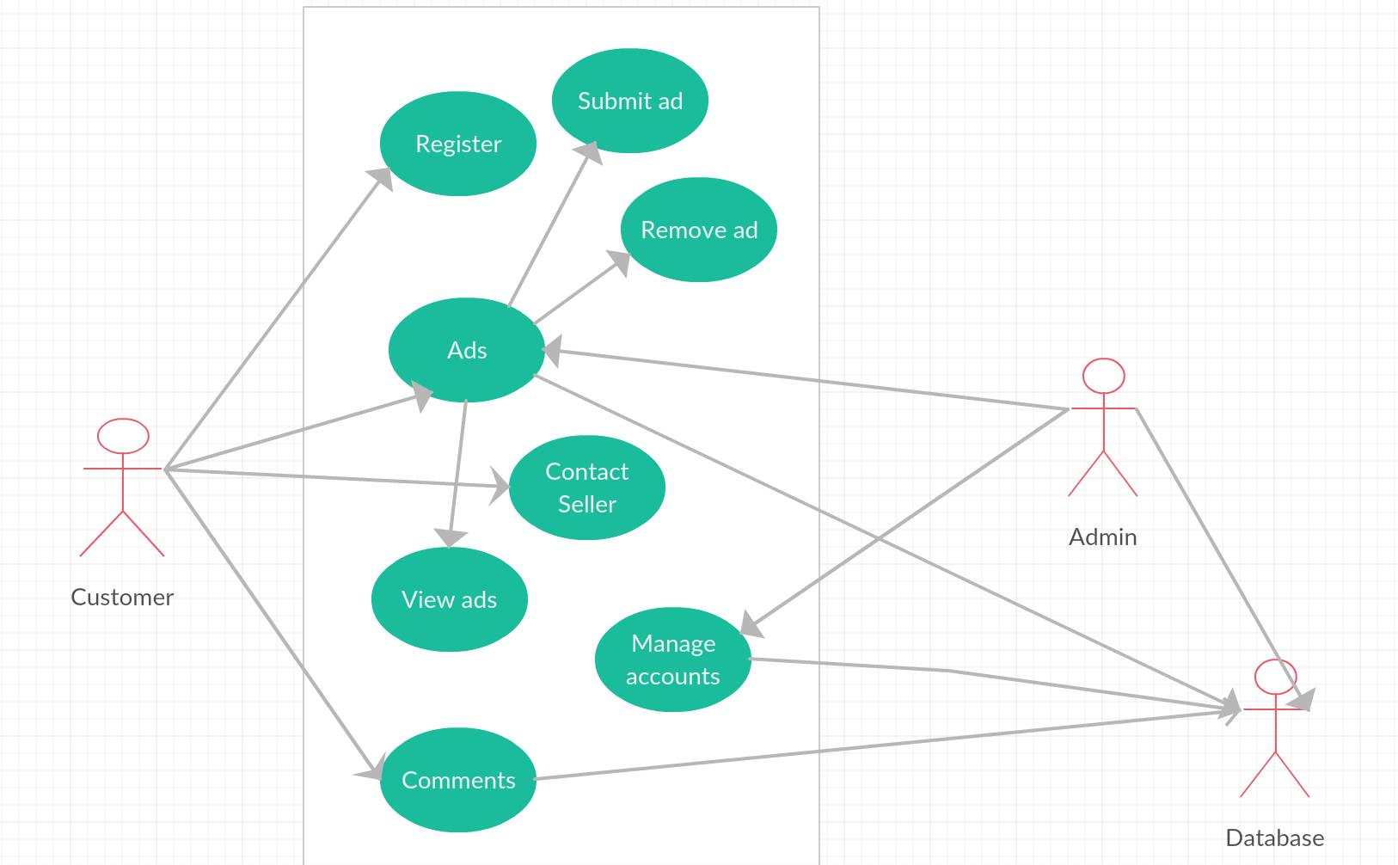

## Functional

Following on from the use case diagram, we developed our list of functional requirements. Each requirement is important in its own right, and also as part of the application as a whole. Our main functional requirements are as follows:

* Allow a user to register using a valid email address. Email was chosen as the highest percentage for how users wish contact to be initiated.
* Accept listing input from a logged in user and post this information to the database, where it can be retrieved and displayed to all users.
* Display an error message to the user in the event that something goes wrong and their posting is unsuccessful. This ties in with some of our non-functional requirements; performance and usability.
* Users that are logged in with a valid account can create trade listings on the site.
* Display all listings currently stored in the database, and allow the user to filter which listings are displayed by selecting from a number of criteria such as location, value and category.
* Users who have successfully logged in should be able to manage any listings that have been created under their account. This includes deleting listings that are no longer relevant.
* Users can leave reviews and provide feedback and comments.
* Users can use the camera feature on the application and upload pictures or videos along with their listing.
* Users can contact other sellers.

## Non-Functional

We felt that non-functional requirements are just as important as the functional requirements. We put a lot of thought into what non-functional requirements we require and we’ve broken down them as follows:

### Performance

The performance of any application is very important. We want the application to be able to handle multiple users all doing different transactions (registering, creating ads, viewing ads, contacting others, leaving feedback), without any lag or delays.

### Scalability

We are expecting the number of users to be small initially, but we will keep in mind that once it gathers momentum, there will be many users and scalability will have to be implemented from the start to save any potential issues further down the line.

### Availability

Another important aspect is the availability of the application. This goes for any application, but without high availability, we don’t feel any application would remain in existence. In the online world, the ideal availability is known as the six 9s (99.9999%). This is the target. This means on average the application would be unavailable for only 31.6 seconds a year.

### Usability

Usability is the extent to which a product can be used by specified users to achieve specified goals with effectiveness, efficiency and satisfaction in a specified context of use ("Usabilitynet: Definition Of Usability"). This is important to keep the customer satisfied and will aid in not only gaining users, but getting users to return. Having a good look-and-feel to the application, combined with an easy to use interface, will massively help gain and keep our future user base.

### Security

This leaves us with what we feel is our most important non-functional requirement; security. Following the results of our data gathering, the users of the application are hugely dependent on security and any flaws with it would nearly instantly discourage a future return. We will work hard on ensuring the security is of the highest standard.

# References

times?, Should. "Should I Randomize Survey Questions If A Respondent Will Fill In Identically

Structured Forms Multiple Times?". *Stats.stackexchange.com*. N.p., 2017. Web. 2 Mar. 2017.

"Usabilitynet: Definition Of Usability". *Usabilitynet.org*. N.p., 2017. Web. 9 Mar. 2017.

"Which Of Your Friends Needs To Learn This Term?". *BusinessDictionary.com*. N.p., 2017. Web. 7 Mar. 2017.