Bargain bin

Usability Report

BSHCE4 - Usability

Conor Prunty – 13102311

Kevin Clarke - 13101722

Table of Contents

Introduction 3

Prototyping 3

Low-fidelity prototype 3

Wireframe 1 3

Wireframe 2 3

Wireframe 3 4

High-fidelity prototype 4

Testing 6

5 participant’s minimum 7

Testing techniques employed 7

Five second test 7

Trunk test 8

Think Aloud 9

Video / Screen recording – only 1 required 9

Heuristic Evaluation 9

Individual Evaluations 11

H1 – Visibility of System status 11

H2 – Match between System and the Real World 11

H3 – User Control and Freedom 12

H4 – Consistency and Standards 12

H5 -Error Prevention 12

Patterns 13

Conclusion 13

References 13

# Introduction

Here, we are introducing our testing plan and implementation for *BargainBin*. We will display low and high-fidelity prototypes to give different ideas of how the application will look. We applied many different testing techniques in order to get the maximum value from our testing, and will ensure that the application is stable and works as intended.

# Prototyping

Prototyping is very important for any project design. While skipping prototyping might save some time during design, that surplus can be lost many times over in development (Designshack.net, 2017). A saying I heard recently comes to mind; ‘A user interface is like a joke. If you have to explain it, it’s not that good’. While this was said as an attempt at humour, I feel it is very appropriate when designing the front-end.

There are many benefits to a good prototype. For example, simple design issues might suddenly become apparent and this saves time and money if fixed now, rather than further down the line where the cost to do so increases exponentially as the project timeline elapses. Another major benefit is that the customer can visualise what you are proposing, instead of them just telling you what they want. This is a key point as it nearly always leads to change as the customer has a different picture in their head of what they actually want. Again, this can save time and money if resolved in the prototyping phase. Another advantage, albeit not as important, is that the prototype can be used with regards to training, before the final solution is delivered. This can save the end-users time, although this is not always possible.

## Low-fidelity prototype

### Wireframe 1

The first page we felt needed to have a wireframe was the homepage. This is the first point of contact a user has with *BargainBin* once they are logged in, and acts as the central hub for the entire application. We have attempted to keep the design as clean as possible in order to prevent users from becoming confused. The Homepage contains links to social media and also displays the *BargainBin* twitter feed. The homepage also contains the links to our main features such as Search Ads, Create Ads, and User Profile.

We have also prototyped a standard navigation bar that will provide a continuous feel for users as they navigate around the application.

### Wireframe 2

The second wireframe outlines the general concept behind the applications “Create advert” functionality. The main feature of this page is a detailed form which gathers the details of the goods that the seller wishes to barter. The same navigation bar style is continued onto this page along with the applications branding such as Logo, and slogan.

### Wireframe 3

The third and final wireframe we have created deals with the display of all the active ads on the site and the various details that will be displayed to the user. In particular, the wireframe displays all of the details that were passed into the form field on the previous page. There is also the ability for an interested party to contact the seller in order to initiate a trade. Yet again the same navigation bar style is continued on this page in order to provide continuity to the user experience.

## High-fidelity prototype

We created a high-fidelity prototype using some excellent online software on Axure. The idea was to give the users a more realistic idea of what the application will look like once complete. We did, however, stress that this is not the be-all and end-all, and it is *not* considered the actual final product.

We showed the users a number of different pages, and asked for their feedback.

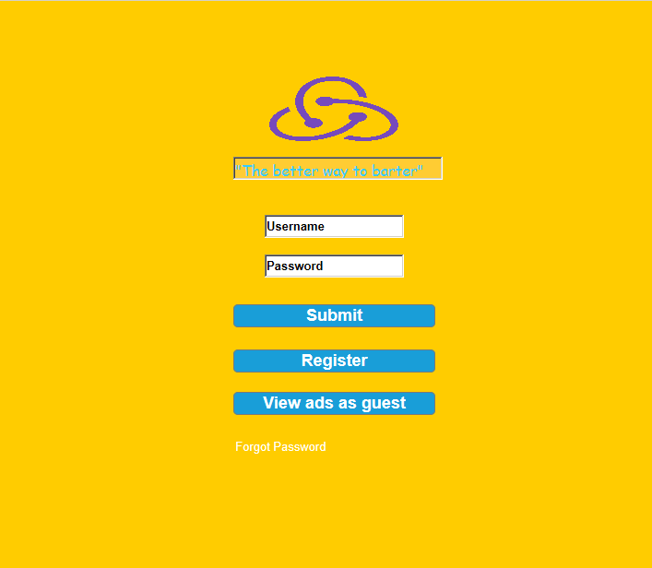

Figure - Login

Here we can show what the initial login page will look like. The users were very happy with this, as they felt it was simple and to the point, and included the logo and slogan quite nicely on the page. The only negative feedback was the colour, but they just wanted a more faded orange-like colour as the overall background.

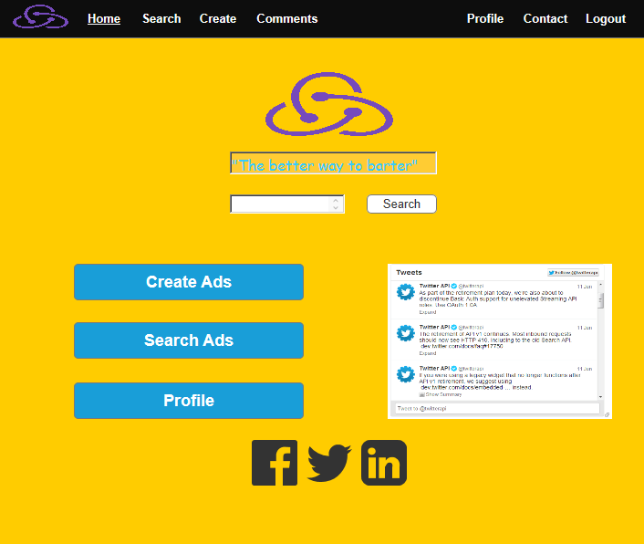

Figure - Main Menu

The Main Menu was also received with positive feedback. It incorporated everything the users wanted, yet still didn’t look too clunky or crammed. The navigation bar was received well also, and they did ask could something similar be put on the login page. We said that users shouldn’t be able to navigate around the site until they are logged in, but we will work with them for an alternative idea.

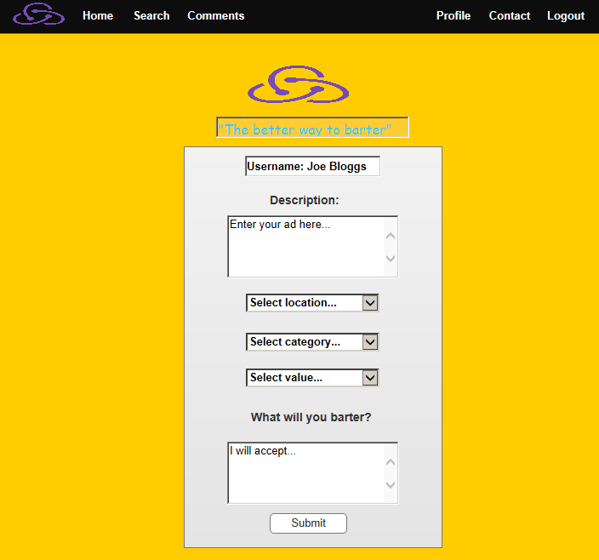

Figure – Search

The users were, I’d say, averagely happy with the search page. We tried to keep it simple but include all the fields required. They are not sure of what else is required on the page, but they expressed an interest in adding maybe a side column or some more information. They asked for a standard colour for the search box, but actually on display they wish for it to be changed slightly to fit in more with the background colour scheme. This type of feedback proves how effective prototyping can be. In addition, they were again happy with the navigation bar, and the fact the logo and slogan are displayed.

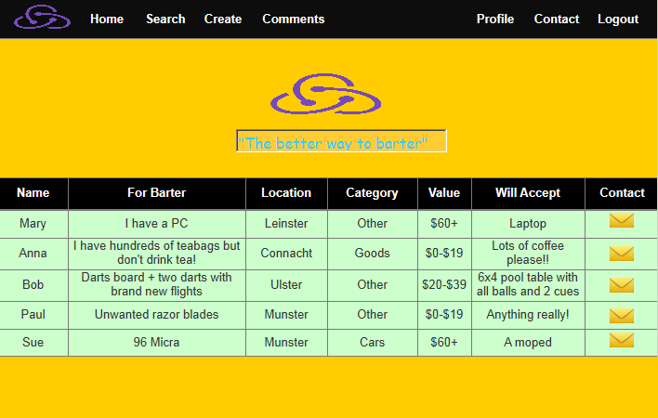

Figure - The Ads

This page was definitely received warmly. The table format was liked, along with the clickable envelope icon for contacting the seller. In fact, there wasn’t any negative feedback on this page.

The last page we showed them was the contact page – but as it was almost identical to the ‘search’ page, the feedback was basically the same.

We took on board all of the feedback – both positive and negative – and will work closely with the users to ensure that everyone is happy before we start the design phase.

# Testing

Testing is crucial to the success of any project. There are many different types of testing; functional testing, regression testing, GUI testing, usability testing and end-to-end testing to name but a few. Testing is necessary in order to provide the facilities to the customers like the delivery of high quality product or software application which requires lower maintenance cost and hence results into more accurate, consistent and reliable results (Level et al.).

Here, we are going to focus on three different usability techniques of testing – five-second test, trunk test and think aloud test.

## 5 participant’s minimum

We carefully selected just five individuals to perform usability testing on our application. The amount of testers was carefully chosen as the probability of a user encountering an error during testing is 31%, according to Jeff Sauro of MeasuringU, testing just 5 users would turn up 85% of the problems in an interface (testing and Ellie Martin).

Each tester was purposely chosen:

* Martin, an 18-year-old from Cavan who is about to move to Dublin for college. He does not have much money so wishes to trade some of his junk lying around for college materials.
* Debbie, a 41-year-old recent divorcee who wishes to get rid of a lot of her ex-husband’s items and trade them for something she can use
* Eddie, an expert in the field of trading who makes a living out of trading items and repairing them to a sellable standard
* Josephine, a young mother of three who wishes to trade some old items for newer ones to give them as gifts to her children
* Anne, a general internet user who was purely chosen as an outsider without a 100% specific interest in trading, but who could potentially give a different viewpoint

Once all users were gathered together, a little introduction of what was going to happen was provided. The users were informed that the whole process was to be informal, but that they weren’t allowed ask us questions as it would defeat the purpose. We made them feel as comfortable as possible, and discussed how any ideas they may come up with could be implemented into the application, but all information would be treated confidentially, and as anonymous as possible. They were all also informed that we would present them the tasks, and answer any questions before the task started, where possible.

## Testing techniques employed

### Five second test

The first test carried out was the ‘five second test’. This is a usability testing method in which the participant is exposed to an image of a webpage for five seconds. The image is then removed and the participant is asked questions about what they remember seeing on the page ("5 Second Test").

We presented the homepage to the user (after you were logged in), counted to five, and then closed the image. We posed four questions to the users and gave them a few minutes to respond.

* What does the site do?
* What did you like or dislike about the design?
* What stuck out the most on the page?
* Any other general observations?

The results were interesting. Out of the five participants, only two could work out in the short timeframe what the application was supposed to do. This provided us with valuable information for the implementation phase, as we need to make it as obvious as possible what the application does, as time is a key element for people when first visiting; the first 10 seconds of the page visit are critical for users' decision to stay or leave ("How Long Do Users Stay On Web Pages?").

The users liked the fact that the application had a simple layout, with big buttons (“create, search and can’t remember the other one”) for navigating around the application. The navigation bar along the top of the page was also liked, and “it looks like it’s easy to move about the site”. There were two main dislikes; “the colour scheme is a bit funny” and “what does the site do?”. Again, this helps us in how we will make the user interface look when the design is being progressed.

Generally, the results showed that four different things stuck out on the page: Tweets, Simple Layout, Large Buttons and Heading. Four out of the five users said the tweets section, and the heading, were what stuck out. Three users said there was a simple layout, and two noticed the large buttons.

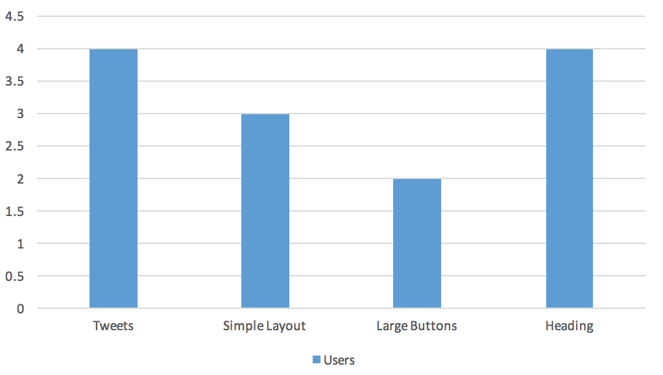

Figure - Page Standouts

There wasn’t a great deal of feedback for the general observations question. What we took from it was that the users would like to use the application for themselves (which obviously isn’t part of the five second test), so we will probably remove this question if we run this particular test again.

### Trunk test

The next test we asked the users to participate in, was the trunk test. A trunk test is a test for how well a website does in terms of navigation ("Digital Imaging And Web Design -- An MIT Half-Course -- Resources"). Five questions were posed to the users:

1. What site is this?
2. What page am I on?
3. What are the main sections?
4. What navigations do I have?
5. Where am I overall?

These questions were given, on two different parts of the application – the main menu, and the ads page.

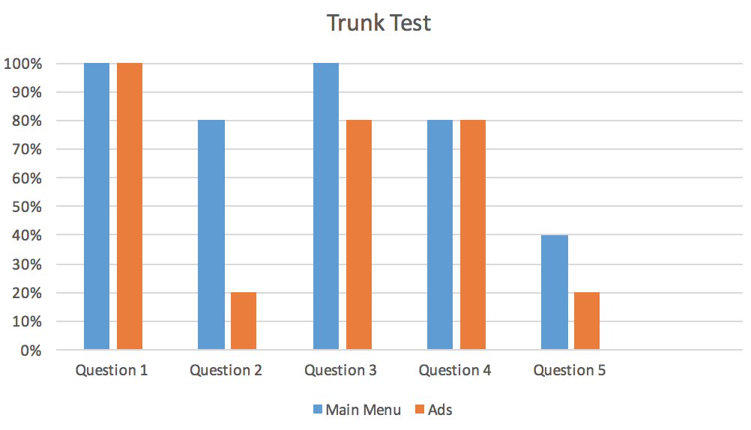

Figure - Trunk Test

The results showed that every user knew what site they were on (thanks largely to the heading), and almost every user knew what the main sections were from the page they were on. These were the two big positives from the trunk test.

Question two showed that the users knew which page they were on when they were viewing the main menu, but there seemed to be little indication of the page when viewing the ads section.

The navigation question was also scored very highly – 80% of the users could quickly see what navigations were available to them, on both pages.

The worst score came with question five; “Where am I overall?”. The users could largely not find a ‘you are here’ notice, or anything along those lines.

Overall, this helped us to point out what parts require more work, and I think we will re-conduct this same test, on different parts of the application, at some point in the near future.

### Think Aloud

#### Video / Screen recording – only 1 required

# Heuristic Evaluation

A heuristic evaluation is a usability inspection method for computer software that helps to identify usability problems in the user interface design (Uxness.in, 2017). Generally regarded as the most popular method for achieving such evaluation, is ‘Jakob Nielsen’s 10 general principles for interaction design’.

To carry out this Heuristic evaluation we collected a group of 3 potential users and applied the principles set out by Nieslen and Molich. We had each of the three group members inspect the applications interface and critiqued the application against the guidelines described below.

We then gathered this final list of issues and ranked each of the errors according to severity, using the Neilsen rating scale of 0 – 4.

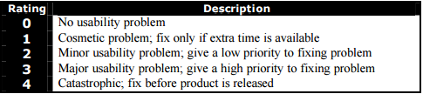

Figure - Neilsen Rating Scale

The heuristic evaluation that was carried out for the *BargainBin* application used the most up to date version of Nielsen’s list of Heuristics. Below is a detailed list of the guidelines we used.

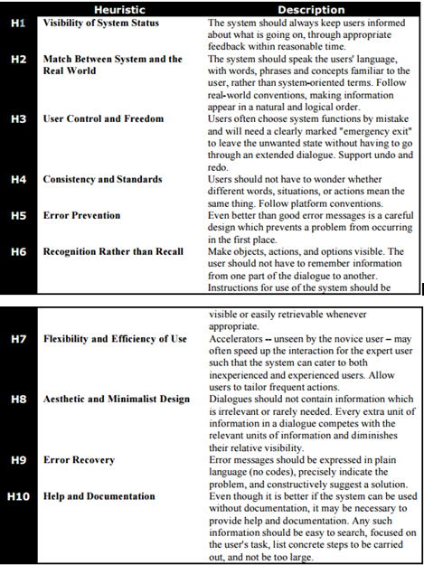

Figure - Heuristic Guidelines

Currently the *BargainBin* application acts as a resource for users who wish to trade unwanted goods and services in exchange for goods or services they wish to receive in exchange. The site is currently organised with a homepage that acts as the focal point for the main functionality of the application, which provides the users with 3 main points of interaction. Firstly, there is the ability to create a advert, then a user is able to view a list of all of the advertisements and filter by criteria such as location, price and category, and lastly users can edit their profiles.

## Individual Evaluations

We had each member of the group carry out an independent viewing and analysis of the *BargainBin* application. We organised the evaluation is such a manner so as to initially orient the users to the general layout of the site and then invited them to go through the site a second time paying a particular attention to the various sections and their details. During the analysis, the various group members compared the application elements to our list of guidelines. We then asked each user to rate the severity of the flaws they encountered 0-4.

Below is a detailed breakdown of the results produced by each group member.

*Users*: Karl Wagon, Melony Stamper, Lola Smith.

### H1 – Visibility of System status

Karl Wagon

* I found that I didn’t get lost while using the application and was well informed throughout the experience.

Melony Stamper

* Overall the application was easy to find my way around but I was a little bit confused as to what page I was on sometimes because the links didn’t highlight on each page to indicate which was an active link. I would rate this issue as 2 (minor usability problem).

Lola Smith

* I found the system always kept me informed and I didn’t get confused when using the application.

### H2 – Match between System and the Real World

Karl Wagon

* The application confused me with some of the term on the form for creating an advert. It was a little bit unclear as to what type of content I was supposed to put in the description. I would rate this issue as 2 (minor usability problem).

Melony Stamper

* I found the application to be very straightforward and all of the language was familiar to me. Processes such as the registration were very clear and followed a defined process.

Lola Smith

* I had difficulty following the advert creation form because some of the language was a little bit confusing and vague. I would rate this issue as 2 (minor usability problem).

### H3 – User Control and Freedom

Karl Wagon

* The application also displayed a consistent navigation bar which allowed me to navigate backwards as and when required.

Melony Stamper

* I found the *BargainBin* application to be easy to navigate and didn’t restrict me from navigating away from pages when required.

Lola Smith

* I didn’t have any problem undoing any unwanted actions and found the whole application to be very forgiving.

### H4 – Consistency and Standards

Karl Wagon

* *BargainBin* is very consistent and I found this to be one of its biggest positives. The navigation bar is very consistent.

Melony Stamper

* I felt *BargainBin* was really standardised and every page of the site will familiar. In particular, the consistency when using the applications navigation was great.

Lola Smith

* I didn’t come across any major issues, but when I navigated to the contact us page I felt that the form fields on that age were different and didn’t match the rest of the applications look and feel. I would rate this issue as 1 (Cosmetic Problem).

### H5 -Error Prevention

Karl Wagon

* When I was inputting an advert on the *BargainBin* application, I noticed that it did a good job of validating the form fields and not letting me submit the data unless it matched the specified criteria.

Melony Stamper

* While navigating round the *BargainBin* application I didn’t encounter any errors so I believe they have done a god job implementing error prevention.

Lola Smith

* When I attempted to use the contact form I received an error where it wouldn’t let me submit the form, but I didn’t receive any kind of explanation and I found this to be very frustrating. I would rate this issue as 3 (Major Usability problem).

# Patterns

# Conclusion

# References

"5 Second Test". *Useful Usability*. N.p., 2017. Web. 28 Mar. 2017.

Designshack.net. (2017). *How & Why Prototypes Are Mandatory for Good Design | Design Shack*. [online] Available at: https://designshack.net/articles/graphics/how-why-prototypes-are-mandatory-for-good-design/ [Accessed 28 Mar. 2017].

"Digital Imaging And Web Design -- An MIT Half-Course -- Resources". *Instruct.uwo.ca*. N.p., 2017. Web. 28 Mar. 2017.

"How Long Do Users Stay On Web Pages?". *Nngroup.com*. N.p., 2017. Web. 28 Mar. 2017.

Level, ISTQB et al. "Why Is Software Testing Necessary?". *Istqbexamcertification.com*. N.p., 2017. Web. 28 Mar. 2017.

testing, Why, and Design Entrepreneur Ellie Martin. "Why 5 Is The Magic Number For UX Usability Testing - Invision Blog". *InVision Blog*. N.p., 2017. Web. 28 Mar. 2017.

Uxness.in. (2017). 10 Heuristic Principles – Jakob Nielsen’s (Usability Heuristics). [online] Available at: http://www.uxness.in/2015/02/10-heuristic-principles-jakob-nielsens.html [Accessed 13 Feb. 2017].