Short 13-1 Add a video
In this exercise, you’ll add a video to the article in a speaker’s page. When you’re done, the page should look like the one shown below. Estimated time: 5-10 minutes.
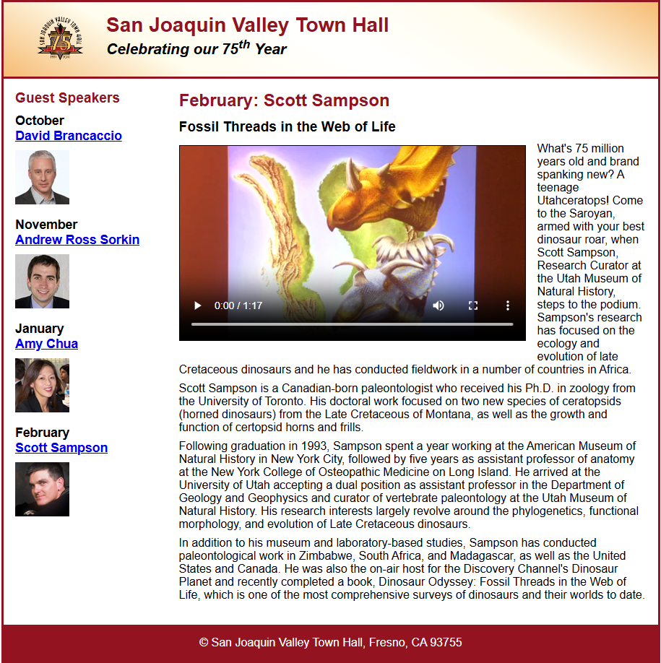
- Open the HTML and CSS files that follow and display the page in a browser:

short_exercises\ch13\index.html
short_exercises\ch13\styles\main.css
- Replace the <img> element in the article with a <video> element that plays the sampson.mp4 file in the media folder. Be sure to display controls that let you play the file. Use the image from the <img> element as the poster for the video.
- Adjust the CSS so the video floats to the left like the image did.
- Use <source> elements so the <video> element has three possible source files in this sequence: sampson.webm, sampson.ogv, sampson.mp4.

