Short 8-1 Add a media query

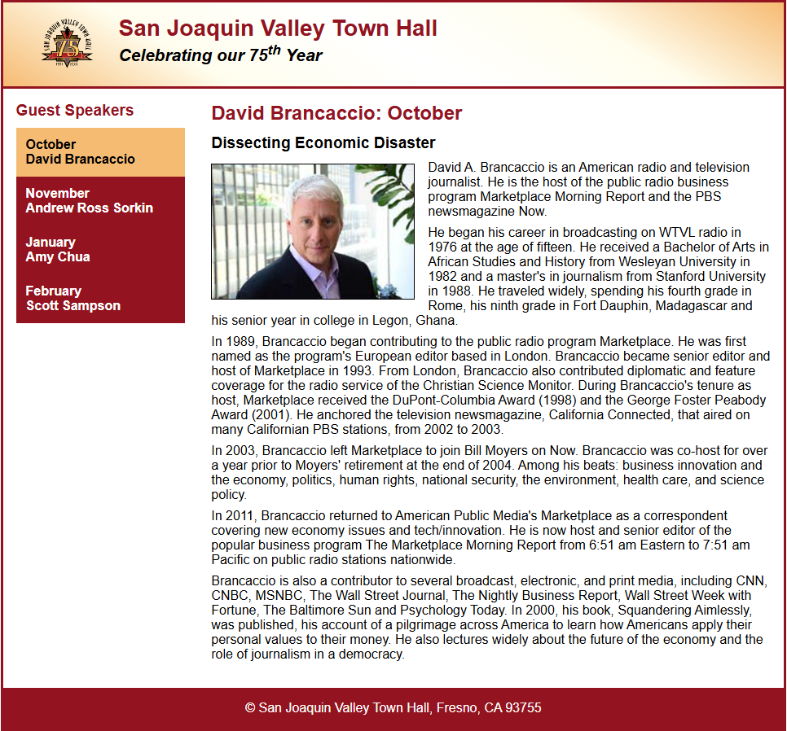
In this exercise, you’ll add a media query for large screens and adjust the main CSS to use mobile-first design. When you’re done, the page should look as shown below on large and small screens. Estimated time: 10 to 15 minutes.

- Open the HTML and CSS files that follow and display the page in a browser:

short_exercises\ch08a\index.html
short_exercises\ch08a\styles\main.css
- Note that the HTML file already includes a <meta> element that sets the width property for the viewport to the device width and the initial zoom factor to 1.
- Code a media query for the screen media type that has a minimum width of 768 pixels.
- Move the styles that set the order and flex-basis of the section and aside to the media query. In addition, add a style to the media query that sets the flex direction of the <main> element to row.
- Make the main.css file mobile first by updating the style rule for the <main> element to set the flex direction to column and to remove the order and flex basis declarations for the section and aside.
- Open the Developer Tools in Chrome, narrow the web page until the second heading in the header displays below the image, and make a note of the width of the page when that happens.
- Create a media query that has a minimum width of the value you noted in the previous step.
- Update the CSS for small screens so it doesn’t display the second heading in the header. Then, in the media query you created in the previous step, display the second heading in the header.
- Test the page at different widths and adjust the formatting as needed.

