Short 8-3 Use a container query

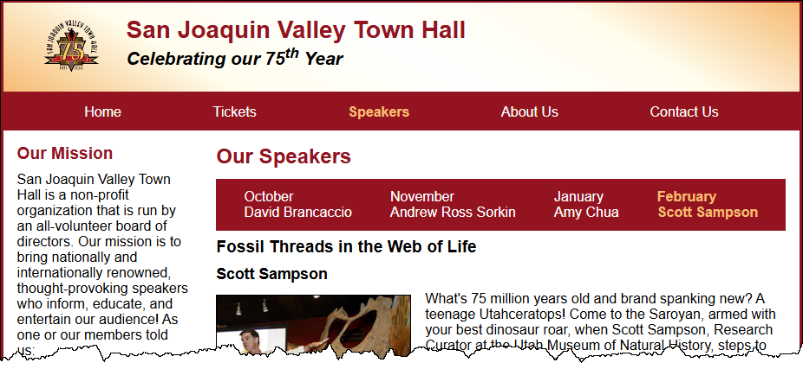
In this exercise, you’ll use a container query to create a responsive navigation menu that’s based on the width of the element that contains it, rather than the width of the viewport. That way, you can use the same CSS code for menus that are in containers of different widths, like the pages shown below. Estimated time: 20 to 30 minutes.

- Open the HTML and CSS files that follow and display the page in a browser:

short_exercises\ch08c\index.html
short_exercises\ch08c\styles\main.css
- In the HTML file, add a checkbox and label to both <nav> elements assigned to the navbar class. Later, you can select both check boxes like this:

input[type="checkbox"] {...}
- Make sure the for attribute of each label has the same value as the id attribute of the associated checkbox, and that each label is assigned to the menu-btn class.
- Define the navbar class as a container. This defines both of the <nav> elements as containers.
- Create a container query with a minimum width of the 560 pixels.
- Update the CSS for small screens to
- hide the navigation menu and display a menu button with a hamburger symbol
- display the navigation menu as a drop-down when the user clicks the menu button and change the menu button to display the close symbol
- display a right triangle for any menu item that has a submenu
- display the submenu to the right of the menu item when the mouse hovers over the menu item
- Update the container query for larger containers to:
- display the navigation menu horizontally and hide the menu button
- display a down triangle for any menu item that has a submenu
- display the submenu below the menu item when the mouse hovers over the menu item
- make sure the menu displays horizontally if the menu button checkbox is checked
- Use positioning to make sure the drop-down menus display on top of the main content of the page.
- Test the page at different widths and adjust the formatting as needed so the page looks as shown above.

