Short 11-1 Enhance a table
In this exercise, you’ll enhance a table by adding more data and modifying the formatting. When you’re done, the tables should look like the ones shown below. Estimated time: 20 to 30 minutes.
The table on a wide screen:
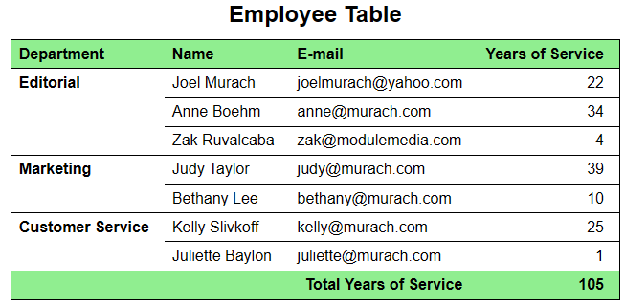
The table on a narrow screen:
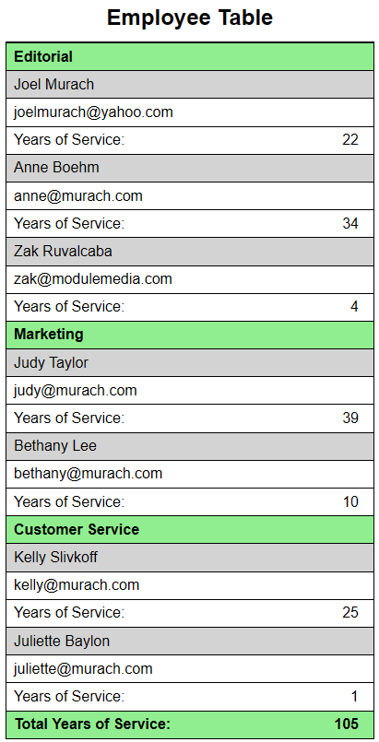
- Open this HTML file:

short_exercises\ch11\index.html
Note that this HTML file uses embedded CSS in the head section to format the table.
- Run the HTML file. It should display a table that contains some data.
- Update the HTML so the table has a caption and the same data shown in the first table above.
- Update the CSS so it formats the table so it looks like the first table shown above.
- Add a media query for when the screen width is less than 640px.
- In the media query, add styles that make the table look like the second table above. To align a ::before pseudo-element with the left side of the cell, you can set its display property to block.

