Short 12-1 Create a form
In this exercise, you’ll complete a form so it looks as shown below. Estimated time: 20-30 minutes.
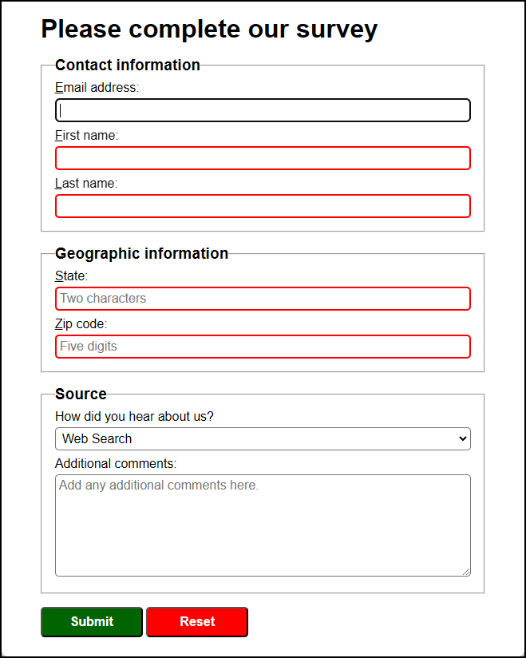
- Open the HTML and CSS files that follow and display the page in a browser:

short_exercises\ch12\index.html
short_exercises\ch12\styles\main.css
- Add the “Contact information” group. The controls in this group should have a red border when invalid and a green border when valid. They should also provide an access key for each field. The browser should set the focus on the first control in this group when the page loads.
- Add the “Geographic information” group. The controls in this group should have a red border when invalid and a green border when valid and should use regular expressions to validate the entries. The State field should accept a two character state abbreviation and the Zip code field should accept a five digit zip code.
- Add the Source group. This group should contain a drop-down list and a text area.
- Add two buttons at the bottom of the page. Each of these buttons should use a base class and a class specific to their function to style the buttons. The button styling should include a hover effect.
- Adjust any other formatting as needed so the page looks like the one above.
- Test the form with invalid and valid data.

