Short 9-1 Add contact links to a page
In this exercise, you’ll update the Contact Us page to contain a list of links. When you’re done, the page should look as shown below. Estimated time: 5 to 10 minutes.
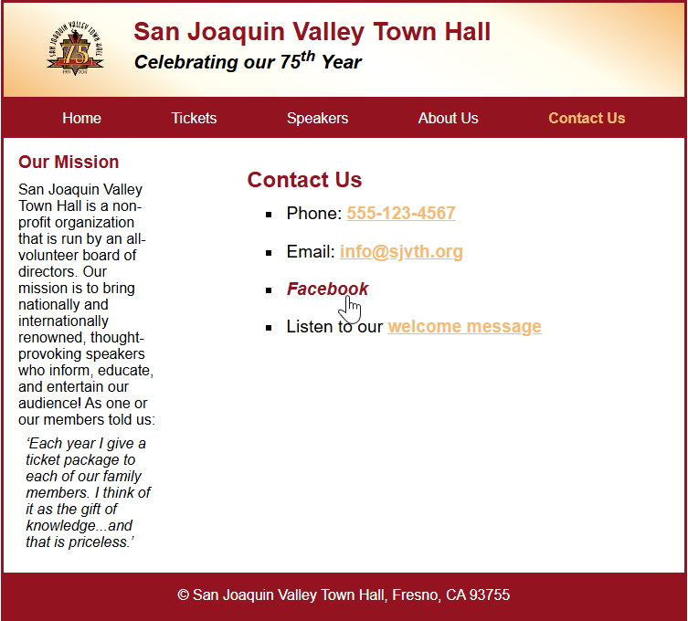
- Open the HTML and CSS files that follow and display the page in a browser:

short_exercises\ch09\contact.html
short_exercises\ch09\styles\main.css
- In the HTML, add an unordered list with four list items.
- For the first list item, add a phone link to a phone number.
- For the second list item, add an email link to an email address.
- For the third list item, add a link to a Facebook page that opens in a new tab. The link should use an absolute URL like this one:

https://www.facebook.com
- For the fourth list item, add a link this MP3 file: media/welcome.mp3.
- Use CSS to format the unordered list so it uses square bullets and is indented.
- Add vertical space between the list items and horizontal space between the list item text and the bullet.
- Format the links so they use the primary color and have no text decoration when the mouse hovers over them or they have the focus. Otherwise, they should use the accent color and be underlined.
- Adjust any other formatting as needed so the page looks like the one above.

