Solas Attendance Tracker
Update summary
Prepared: 23 August 2026
Production site: https://app.solaswellbeing.org.uk/
1. At a glance
This update focuses on making everyday tasks clearer and faster for staff, and giving managers richer statistics they can share.
- Clearer navigation with labelled menus (Attendance, People, Admin).
- Redesigned attendance screen for recording who came to which service.
- Improved people list and person records.
- Much stronger Stats area - summary cards, charts, demographics, and PDF/CSV export.
- Easier service list search and a clearer merge-duplicate-people flow.
- Polished login and password reset experience.
2. Finding your way around
The top bar now shows clear labels for Attendance and People. Administrators open Admin to reach Services, Stats, and Merge people - instead of relying on small icons alone.
Open the app: https://app.solaswellbeing.org.uk/
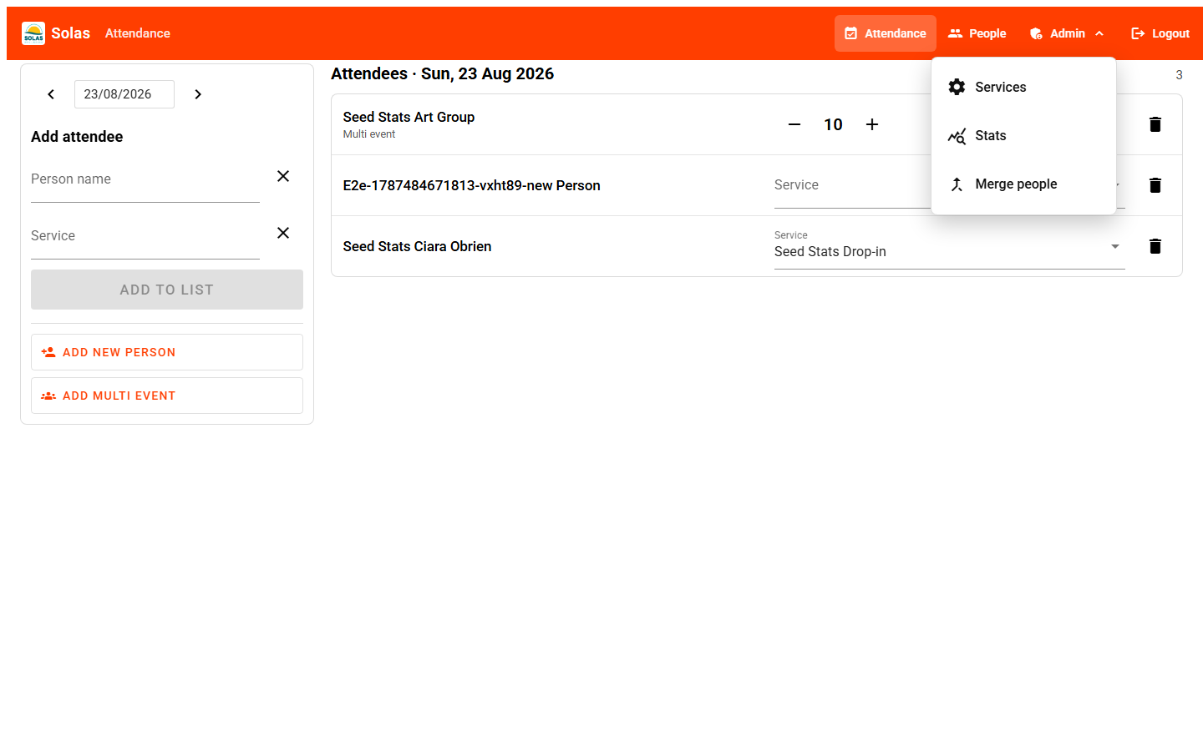

Figure 1 - Top navigation with the Admin menu open (Services, Stats, Merge people).
3. Attendance
The attendance screen has been rebuilt so staff can pick a date, search for a person and service, and add them to the day's list. Multi-event (group) counts use simple plus/minus controls. Rows can be removed with the bin icon. On-screen messages confirm when something has been saved or changed.
Attendance page: https://app.solaswellbeing.org.uk/attendance
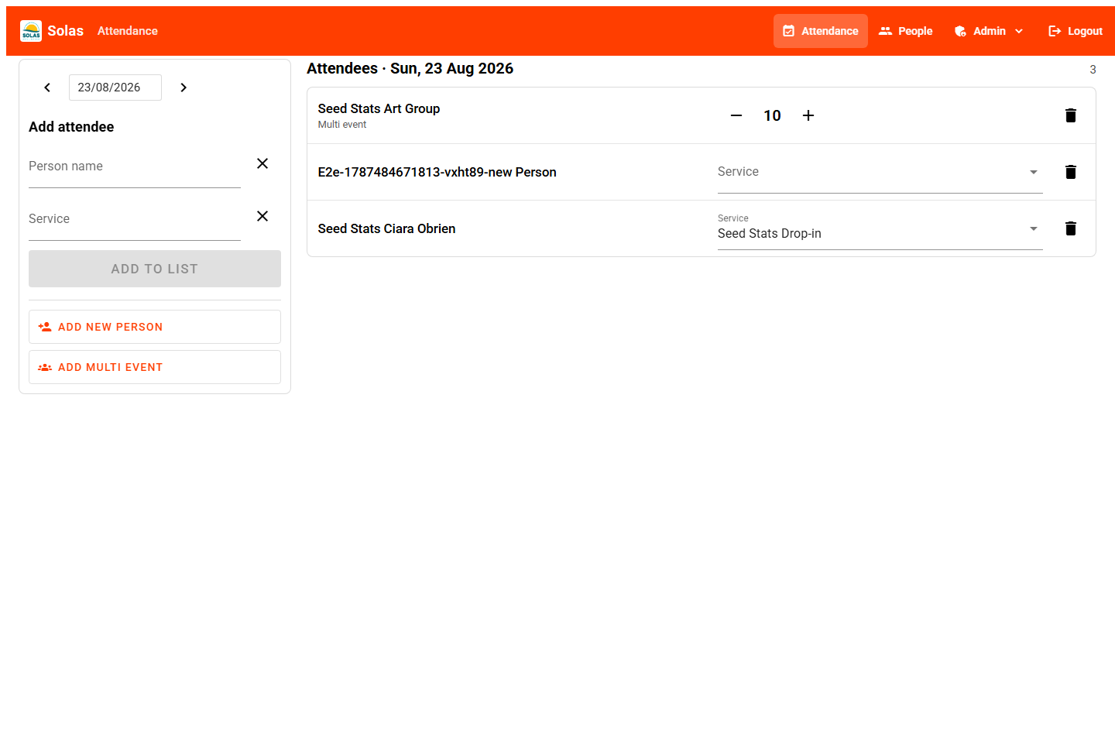

Figure 2 - Attendance: add attendees on the left; today's list on the right.
4. People
The people list is easier to scan, with search, a clear Add person button, and actions to edit, view history, or delete a record. Deletion also removes that person's attendance history - staff are asked to confirm first.
Person forms are organised into clearer sections (including client agreement and acupuncture-related health flags such as epilepsy and pacemaker where relevant).
People page: https://app.solaswellbeing.org.uk/people
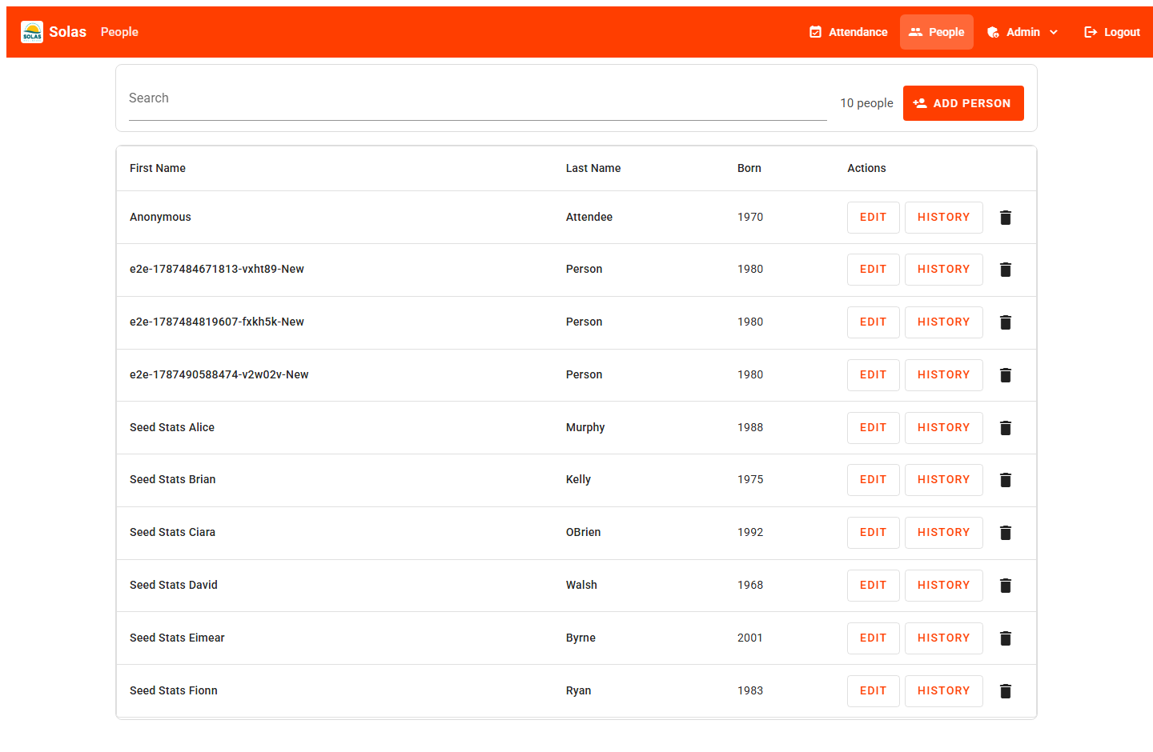

Figure 3 - People list with search, add, edit, history, and delete.
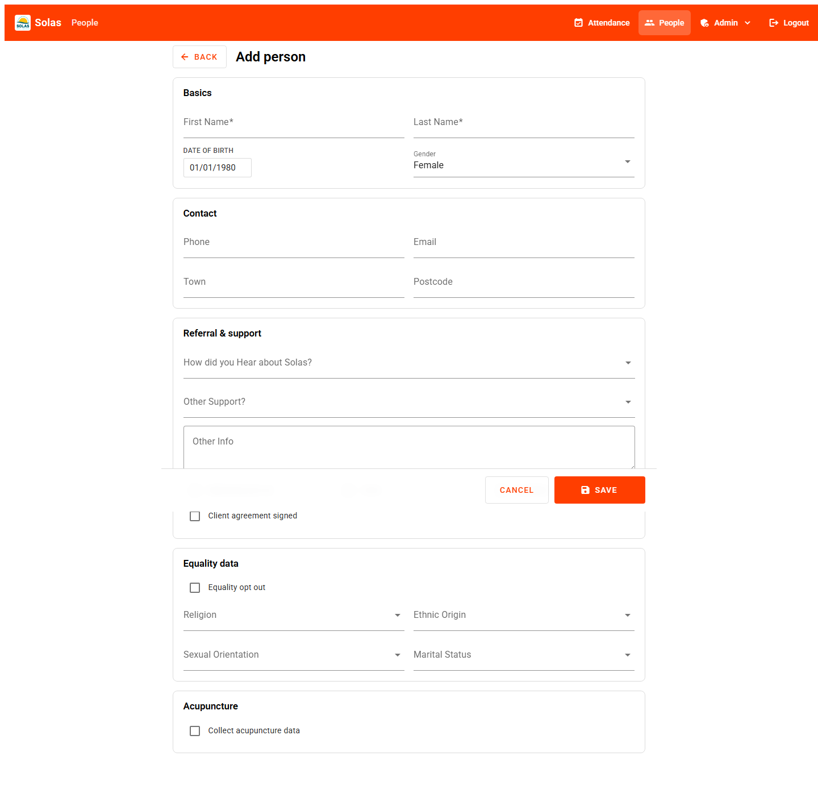

Figure 4 - Person record form.
5. Statistics and reporting
The Stats area is the biggest reporting upgrade. Choose a From / To date range, then review:
- Summary cards - unique people, total sessions, most popular service.
- Charts - sessions by service and by month.
- Tables - breakdown by service and by person (with drill-down detail pages).
- Who attended - age bands, gender, town, carers, disability, marketing preferences.
- Referral and support - how people were referred and other support noted.
Exports: Export people (CSV), Export attendance (CSV), and Export PDF. The PDF option lets you choose which sections to include before printing or saving as a PDF - useful for board packs and funder reports.
Stats page (admin): https://app.solaswellbeing.org.uk/admin/stats
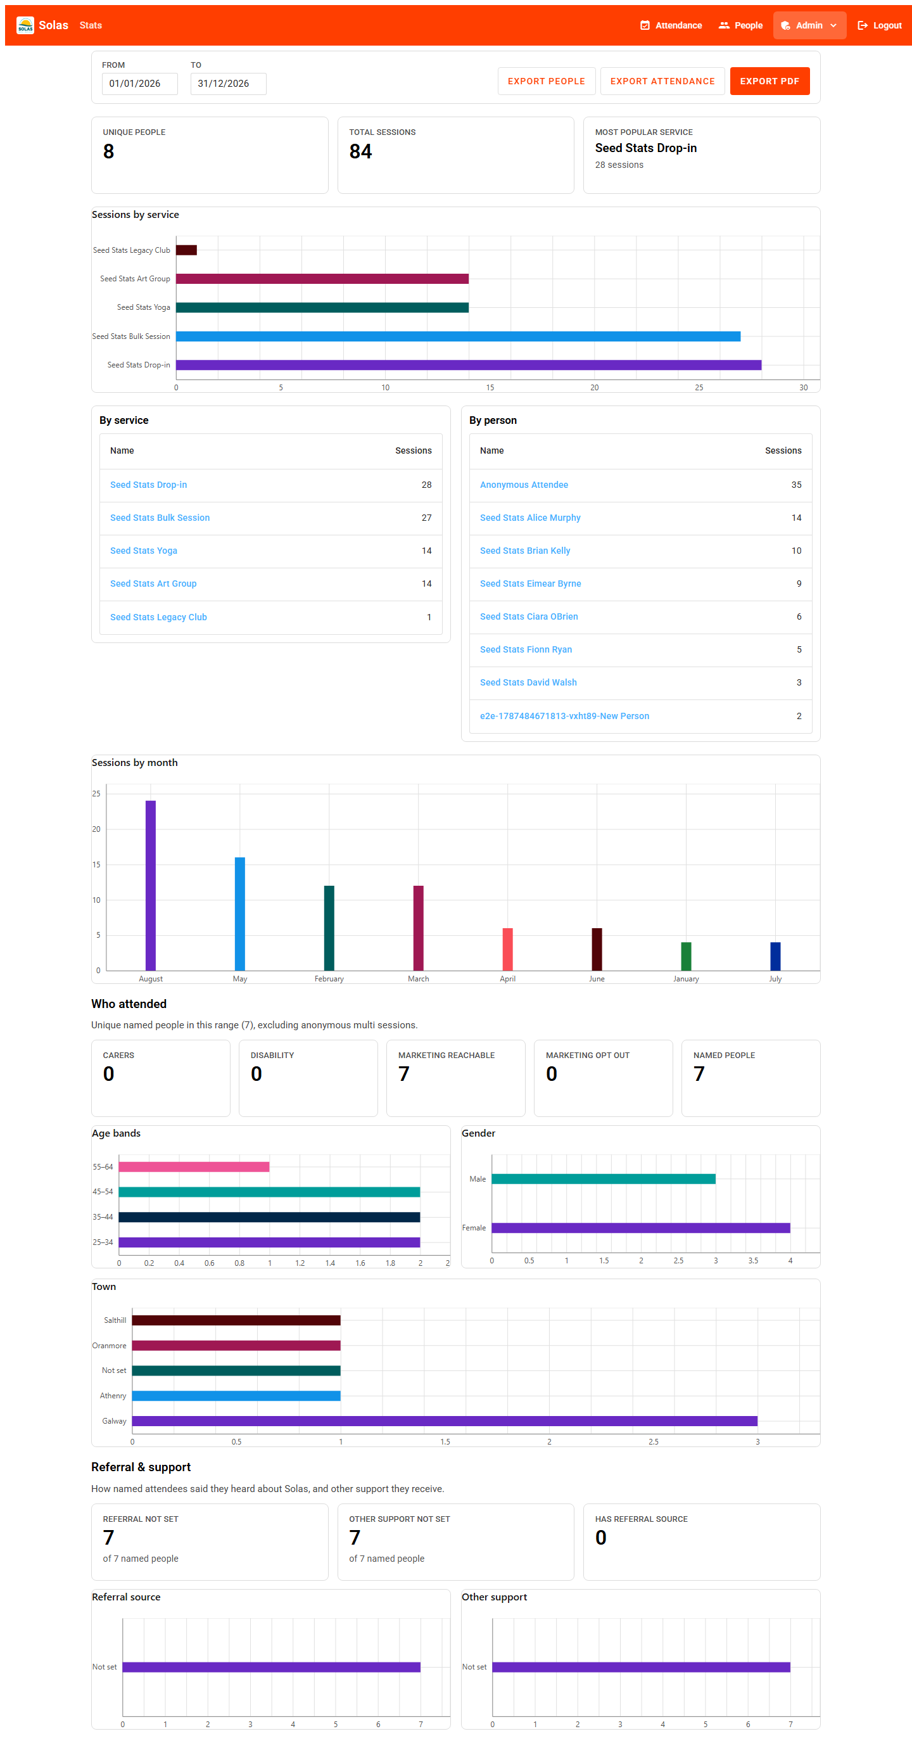

Figure 5 - Stats dashboard with date range, exports, summary cards, and charts.
6. Services
Managing the list of services is cleaner, with improved search and a clear way to reset the search filter.
Services page (admin): https://app.solaswellbeing.org.uk/admin/service
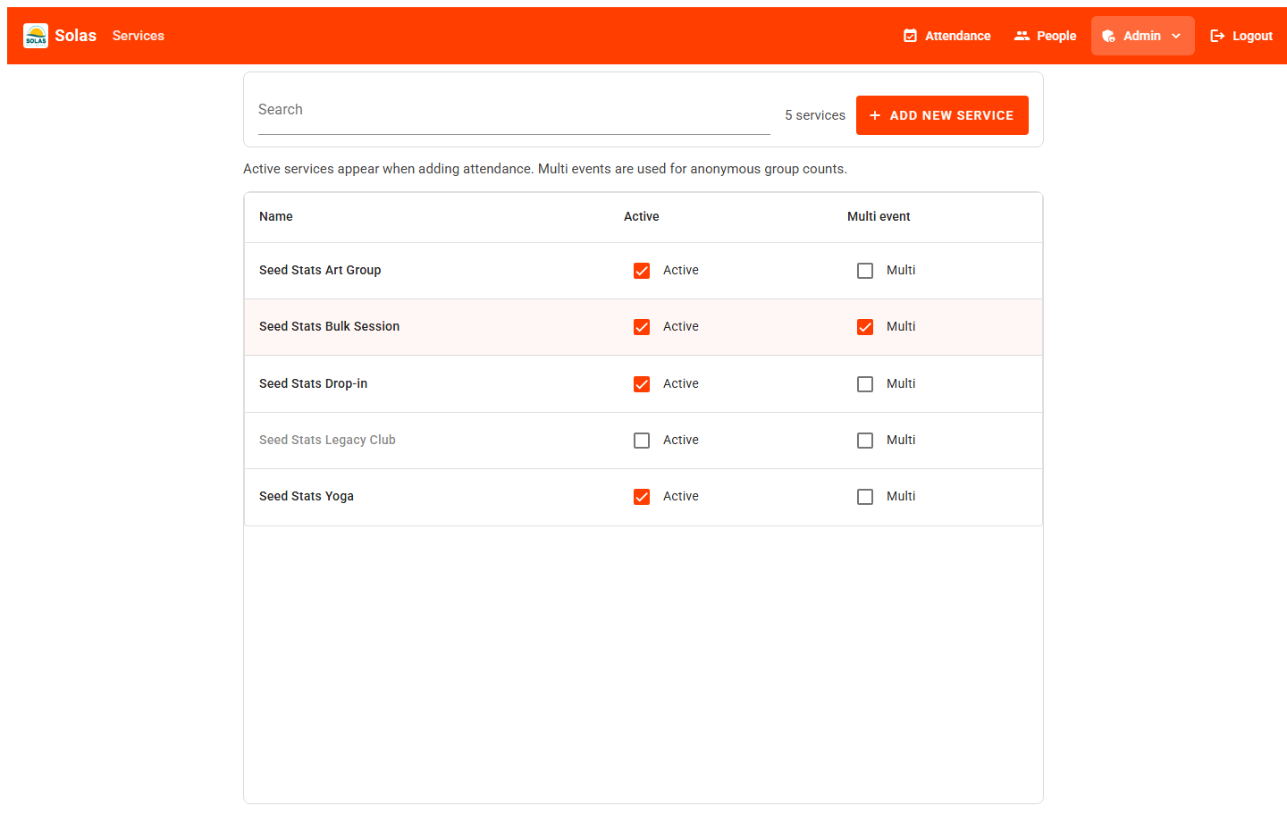

Figure 6 - Services administration with search.
7. Merge duplicate people
If the same person was entered twice, admins can merge the duplicate into the person you want to keep. Attendance moves to the kept record. A confirmation step reduces mistakes. After a successful merge, the leftover duplicate can be removed from the people list if appropriate.
Merge people (admin): https://app.solaswellbeing.org.uk/admin/people/merge
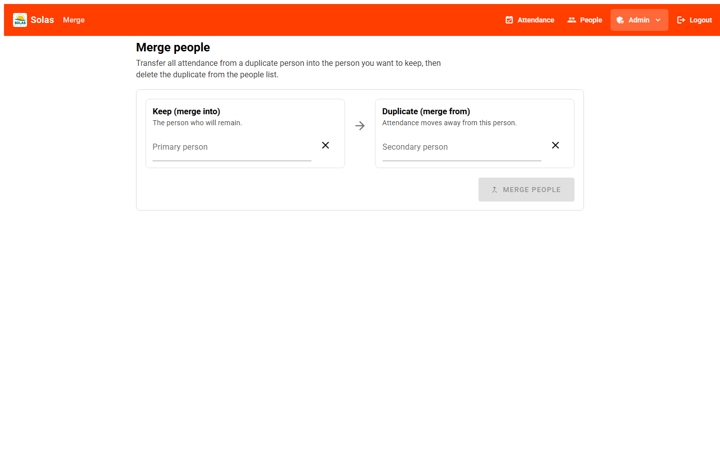

Figure 7 - Merge people: choose who to keep and which duplicate to merge.
8. Sign-in and password reset
The login screen and password-reset flow have been tidied so staff can sign in and set a new password more reliably.
Login: https://app.solaswellbeing.org.uk/login
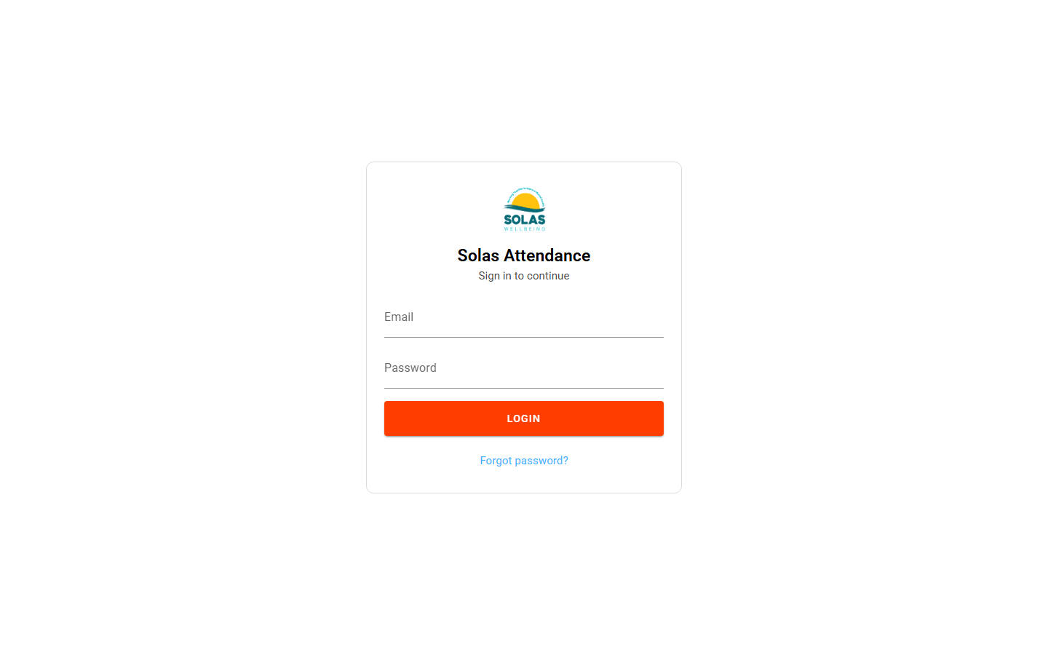

Figure 8 - Login screen.
9. What this means day to day
- Frontline staff: faster, clearer attendance and people workflows.
- Managers / directors: richer stats and PDF/CSV exports for reporting.
- Admins: simpler service management and safer handling of duplicate records.
Quick link list
- Home / login - https://app.solaswellbeing.org.uk/
- Attendance - https://app.solaswellbeing.org.uk/attendance
- People - https://app.solaswellbeing.org.uk/people
- Stats - https://app.solaswellbeing.org.uk/admin/stats
- Services - https://app.solaswellbeing.org.uk/admin/service
- Merge people - https://app.solaswellbeing.org.uk/admin/people/merge

