**Script Encoder Decoder**

1. Run Command Prompt at the JAR location.

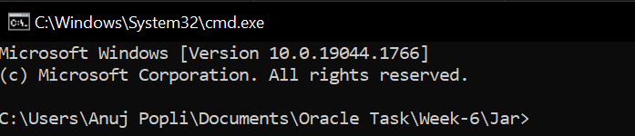

1. Pass the following command to execute the JAR file

java -jar [JAR NAME].jar



Step 1)



Press 1 To Encode a Single File.

Press 2 To encode all the contents of the folder.

Press 3 To quit the program.

Step 2)

Pass the Input path of the specified File or Folder which you wish to Encode/Decode.



In case wrong input path is entered the program allow to enter the correct input path again.

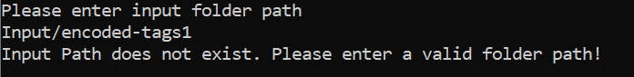

Step 3)

Pass the Output Path of the folder where you wish to export the Encoded/Decoded files. (Leave blank to proceed with default Output Path).



In case wrong input path is entered the program allow to enter the correct input path again.

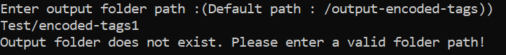

Step 4) Type 1 if you wish to Encode the given files and press 2 to Decode.

