|  |
| --- |
|  |
| Testing Documentation |
|  |
|  |
| **Wayne Wen** |
| **4/2/19** |

Table of Contents

[To update the table of contents, right click the message below and select Update Field (F9 on PC, ⌥⌘U on Mac).]

1. Data Structure 3

1.1. Database tables 3

1.2. Relationships instruction 3

1.3. Data 3

2. Requirements 6

2.1. Functionality requirements 6

2.2. Technique requirements 6

3. Pages 7

3.1. Page Tree 7

3.2. Project Tasks Arrangement Page 8

3.2.1. User Interface 8

3.2.2. Widget Table 8

3.3. Project Tasks Arrangement Page after drag & drop and Submit 9

3.3.1. User Interface 9

1. Data Structure
   1. Database tables

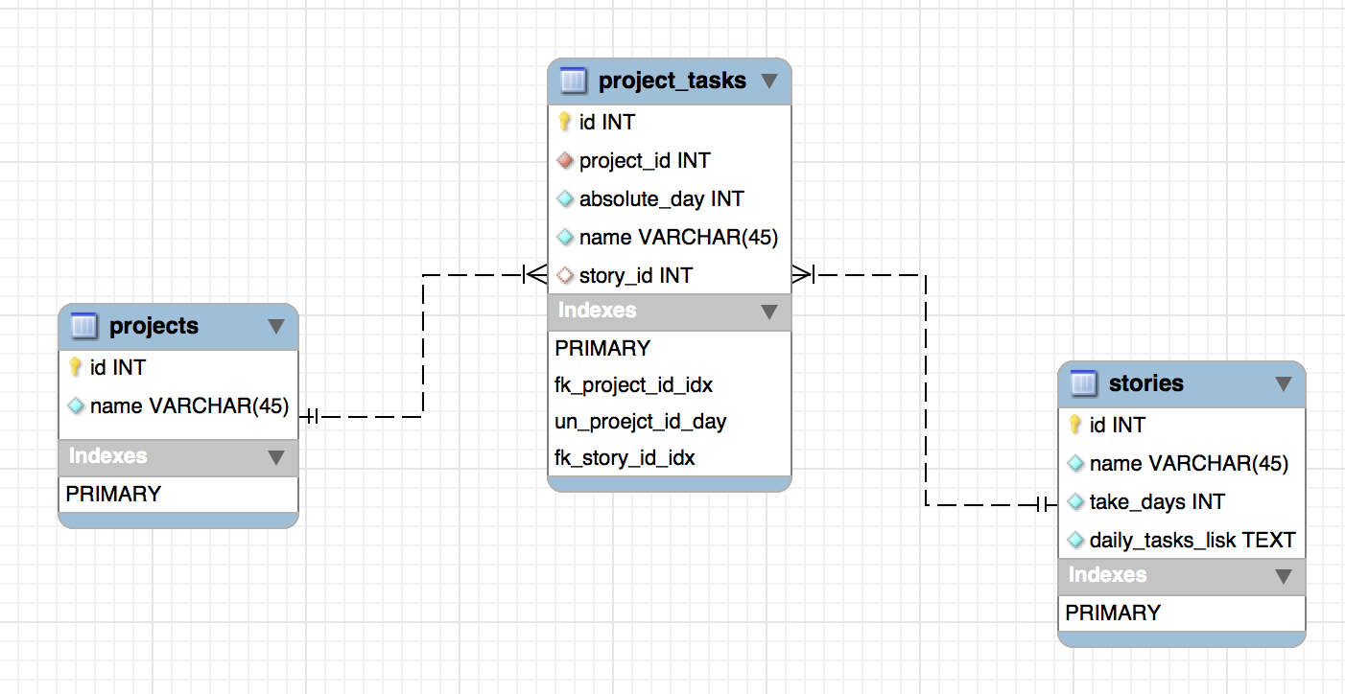

* 1. Relationships instruction

Each project has many daily tasks; (ie. 1 project : n project_tasks)

**For every project, it can only complete one task on a day; (ie. project_id and absolute_day are unique in project_tasks)**

**// project_id should only appears once in the project_tasks table ?**

~~For every task, it will only take one day to be complete;~~

***Every* daily task *might come from a story or standalone daily task.***

* 1. Data

Use sample JSON data

stories.json:

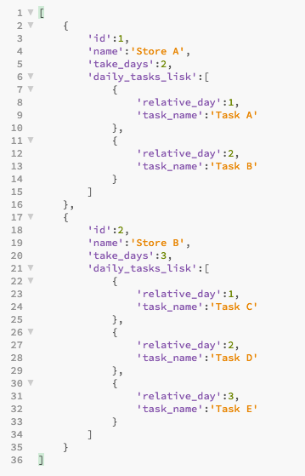

projects.json:

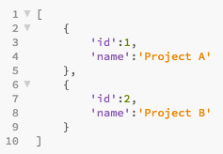

project_tasks.json:

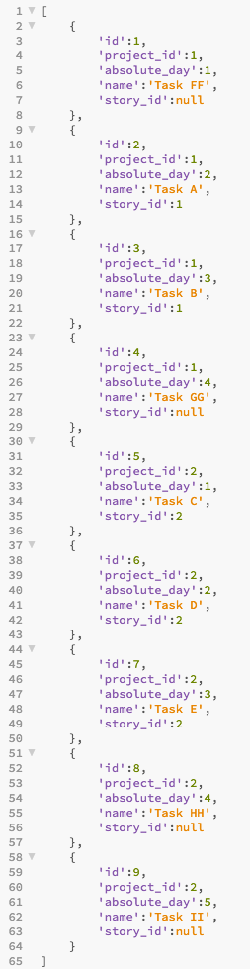

1. Requirements

As a project manager, I would like to arrange a developer’s daily task via “Project Tasks Arrangement Page”. I would like there is a drag and drop function to allow me easily arrange which **task need to done first**.

* 1. Functionality requirements
* I can open the **“**Project Tasks Arrangement Page**”**. (The mock up is provided on the flowing pages.)
* This page will show the currently schedule **tasks based on the data of “project_tasks” table.**
* I can drag and drop to arrange the tasks.
* I can edit the daily task name, and its name on Preview will be change as well.
* Use the **static data** for Story’s task. So, when I click the submit, only the ‘project_tasks’ table will be updated.
  1. Technique requirements
* Database: Mysql/Mariadb (seed your database with provided JSON file)
* Backend Language: Laravel Framework (PHP)
* Frontend Language: vuejs
* RESTFUL API integration: data can only be passed via API

1. Pages
   1. Page Tree

* Project Tasks Arrangement Page  
  - Project Tasks Arrangement Page after drag & drop and Submit
  1. Project Tasks Arrangement Page
     1. User Interface

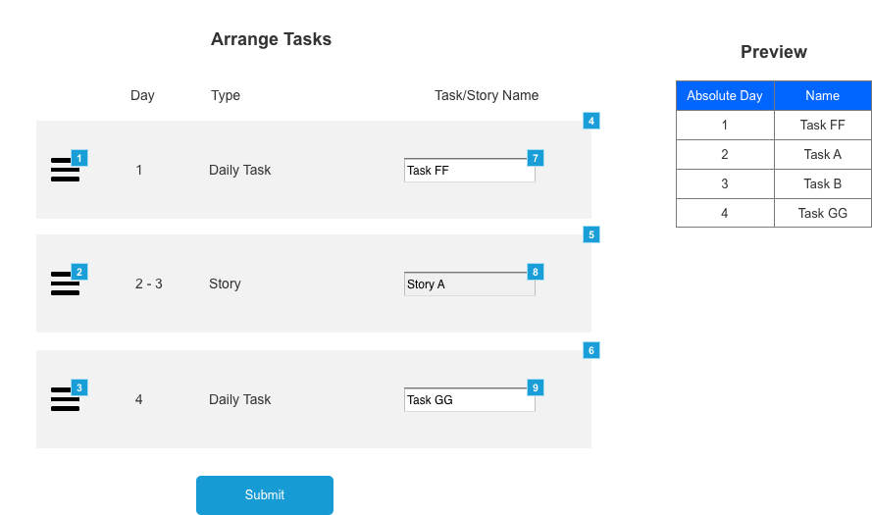

* + 1. Widget Table

|  |  |
| --- | --- |
| **Footnote** | **Note** |
| 1 | User can drag and drop on the icon to arrange the task group |
| 2 | User can drag and drop on the icon to arrange the task group |
| 3 | User can drag and drop on the icon to arrange the task group |
| 4 | This is a task group, the type of this task group called “Daily task” |
| 5 | This is a task group, the type of this task group called “Story” |
| 6 | This is a task group, the type of this task group called “Daily task” |
| 7 | This is a task name input. When this is change, the name on the Preview need to be change as well. (Eg, if you change this to "Task FF 01", in the Preview, the name on Day 1 will be "Task FF 01" as well) |
| 8 | When the task group is a Story, then this input should not be editable. |
| 9 | This is a task name input. When this is change, the name on the Preview need to be change as well. (Eg, if you change this to "Task GG 02", in the Preview, the name on Day 4 will be "Task GG 02" as well) |

* 1. Project Tasks Arrangement Page after drag & drop and Submit
     1. User Interface

