ME 7120: Project 2

Finite Element Method Applications

Due: December 2, 2016

Team Members:

Hao Li

Jeremy Geaslen

Jay Vora

Single Element Test

* Eigenvalue test

Calculate the eigenvalues of the stiffness matrix of a single brick 8 element, 24 eigenvalues are obtained. Different numbers of gauss points are chosen to calculate the eigenvalues listed in the following table. There are 6 values corresponding to the rigid body motion, which are imaginary numbers close to zero with very small imaginary part. The rest of eigenvalues are all positive. For the case with 4 gauss points, all eigenvalues are real.

Table 1. 24 Eigenvalues with 4 Gauss points for integration

|  |  |  |  |
| --- | --- | --- | --- |
| -6.03E-05 | 6.57E+10 | 1.97E+11 | 3.94E+11 |
| -4.71E-05 | 6.57E+10 | 1.97E+11 | 3.94E+11 |
| 3.80E-06 | 1.18E+11 | 2.63E+11 | 3.94E+11 |
| 3.88E-05 | 1.18E+11 | 3.79E+11 | 3.94E+11 |
| 8.99E-05 | 1.18E+11 | 3.79E+11 | 3.94E+11 |
| 1.30E-04 | 1.97E+11 | 3.79E+11 | 1.21E+12 |

Table 2. 24 Eigenvalues with 5 Gauss points for integration

|  |  |  |  |
| --- | --- | --- | --- |
| 2.66E-05 | 6.57E+10 | 1.97E+11 | 3.94E+11 |
| 7.27E-05 -3.44E-05i | 6.57E+10 | 1.97E+11 | 3.94E+11 |
| 7.27E-05 +3.44E-05i | 1.18E+11 | 2.63E+11 | 3.94E+11 |
| -7.66E-05 -2.64E-05i | 1.18E+11 | 3.79E+11 | 3.94E+11 |
| -7.66E-05 +2.64E-05i | 1.18E+11 | 3.79E+11 | 3.94E+11 |
| 1.01E-04 | 1.97E+11 | 3.79E+11 | 1.21E+12 |

* Uniform stress test

Apply uniform load at one direction with appropriate boundary conditions and loading conditions. Check the displacement to make sure the stress is uniform distribution. Fig. 1 and 2 show the uniform displacement field applying uniform load at x and z direction using WFEM, respectively. The same case for loading at x direction has been applied using ANSYS for comparison. The deformed shape is shown in Fig. 3. The comparison of WFEM and ANSYS for x deflection is listed in Table 1. There is a 0.003% difference for the results getting from WFEM and ANSYS.



Fig. 1. Uniform displacement field at x direction (WFEM)

Fig.2. Uniform displacement field at z direction (WFEM)

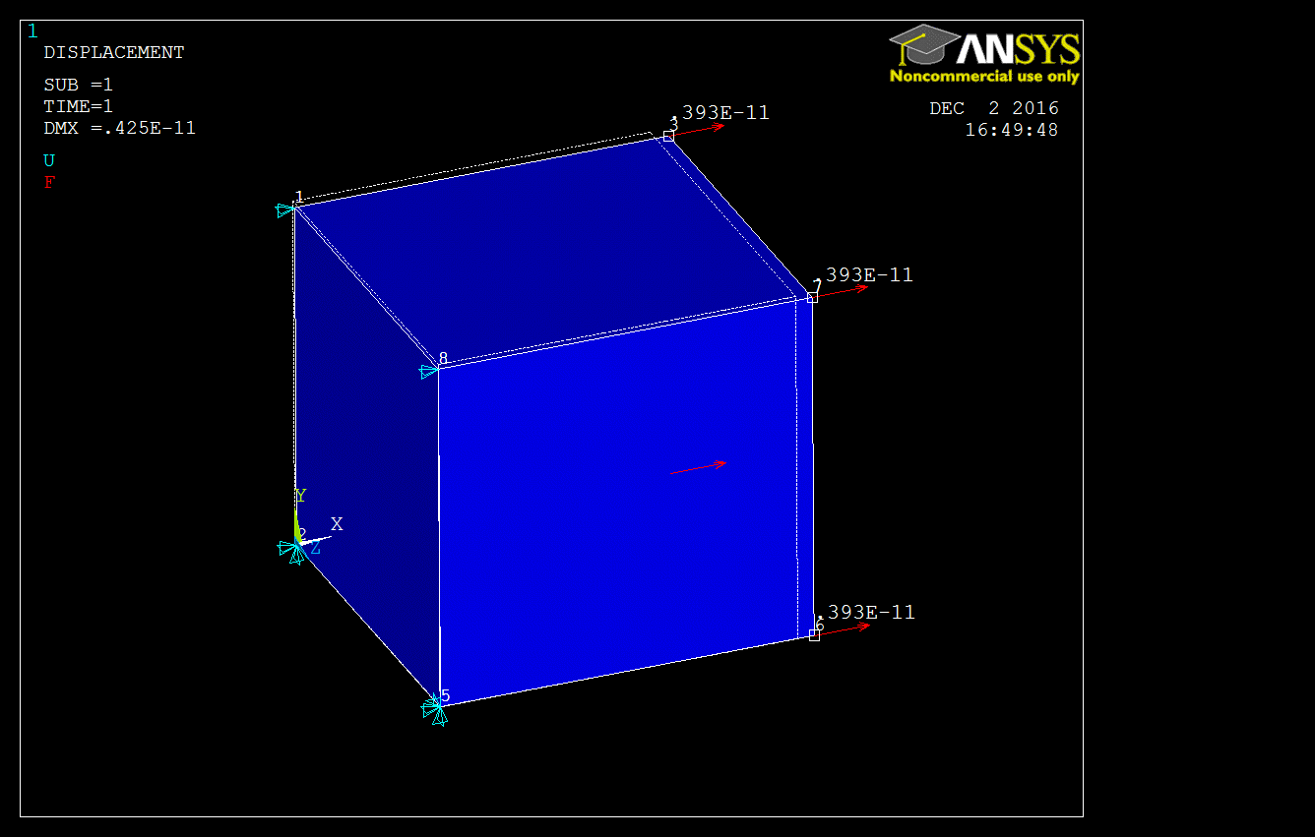

Fig. 3. Deformed shape (ANSYS)

Table 1. Deflection Comparison for x deflection

|  |  |  |  |
| --- | --- | --- | --- |
|  | ANSYS | WFEM | Difference |
| x deflection | 3.93310E-12 | 3.93323E-12 | 0.003% |

* Shear locking test

Three cases are tested in this part. The model is a single brick element with one end fixed and vertical load at the other end, shown in Fig. 4. The first case is to do the analysis using the commercial software ANSYS. The deformed shape is shown in Fig. 4. The second case is to perform the analysis with shear locking fix by WFEM. The third case is to perform the analysis without shear locking fix by WFEM. The deformed shapes are shown in Fig. 5 and Fig. 6. The vertical displacement is compared in Table 2. As it shows, the WFEM code with shear locking fix matches the results from ANSYS. And there is 18% improvement applying shear locking fix. The shear locking indeed makes the element stiffer.

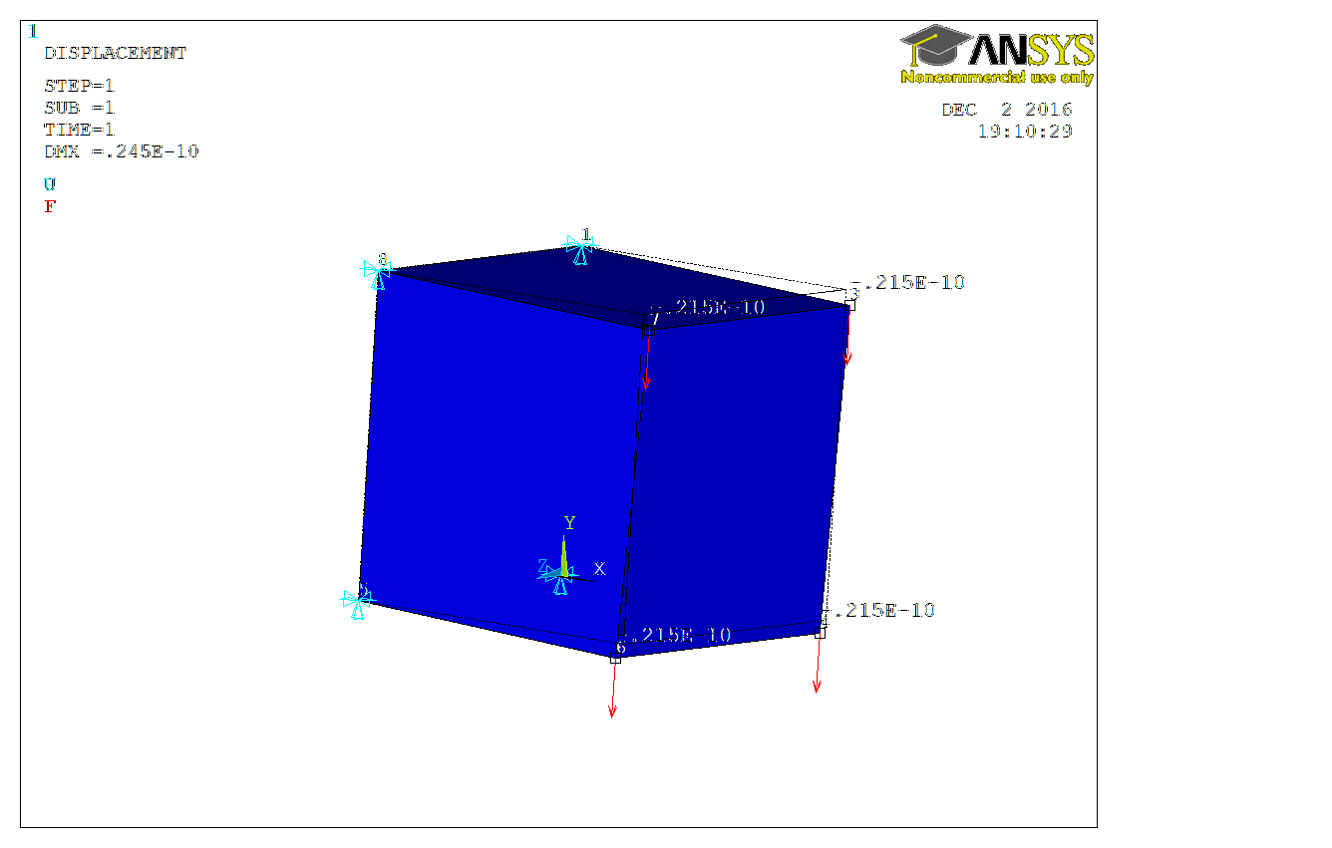

Fig. 4. Deformed shape by ANSYS



Fig. 5. Deformed shape with shear locking fix (WFEM)



Fig. 6. Deformed shape without shear locking fix (WFEM)

Table 2. Comparison including shear locking fix

|  |  |  |  |  |
| --- | --- | --- | --- | --- |
|  | ANSYS | WFEM | | |
| Fix SL | with SL | Diff |
| y deflection | 2.154E-11 | 2.154E-11 | 1.762E-11 | 18.20% |

Brick Element Comparison

* Pyramid

Table 2. Deflection Comparison for x deflection at tip

|  |  |  |  |
| --- | --- | --- | --- |
|  | ANSYS | WFEM | Difference |
| x deflection | 0.346E-9 | 0.356E-9 | 2.89% |

