Mandatory Task for Everyone

1) Create one Github account with your registered email ID. If already created please ignore

2) I've created one GitHub account in the name of dhanvantari software and created one project. The project invitation has been sent to your registered email ID. Please accept the invitation.

3) Now go to the particular project and create one new branch with your roll number and name.

For example: 001_AINAPARTHI SUREKHA

Note: The branch name is mandatory like as your roll number and name

4) Clone the Repository or Project with your personal access token in your local PC with Gitbash.

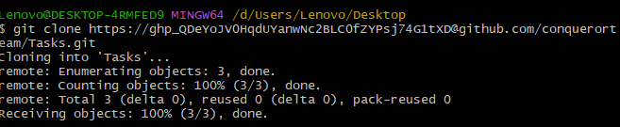

Ex: git clone https://ghp_xri1Cr3JecddscbbDL0Hn1a6Z8Y@github.com/dhanvantarisoftware/project.git

5) After cloning the repository, switch to your branch with the command

# cd Tasks/



# git checkout Task2

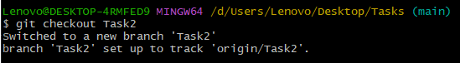

6)Now create one file with your name and add the content about your self introduction and save the file.

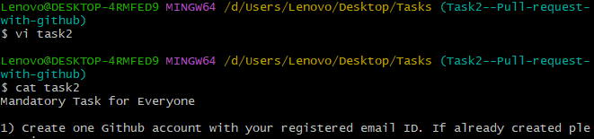

7) Now push the code into your Branch with the below mention commands

# git add .

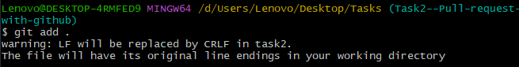

# git commit -m "Your commit message"

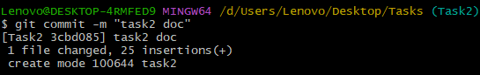

# git push -u origin “task2”

8) Now come to GitHub in your browser and refresh the page. You will see the code in your branch.

9) Now raise a pull request to the main Branch. I will review your code and I will merge it to the main branch

Those who completed the task. For the first 5 members they will get a good surprise from Admin Team