DATA SCIENCE TOOBOX PYTHON PROGRAMMING
PROJECT REPORT
(Project Semester January-April 2025)

(COVID-19 Outcomes)

Submitted by

Manas Bhardwaj

Registration No. 12314850

Programme and Section. K23ER
Course Code INT375

Under the Guidance of

Dr. Karan Bajaj - 32130

Discipline of CSE/IT

Lovely School of Computer Science

Lovely Professional University, Phagwara

CERTIFICATE

This is to certify that Manas Bhardwaj bearing Registration no. 12314850 has completed INT375 project titled, “COVID-19 Outcomes by Vaccination” under my guidance and supervision. To the best of my knowledge, the present work is the result of his/her original development, effort and study.

Signature and Name of the Supervisor Dr. Karan Bajaj
Designation of the Supervisor Assistant Professor
School of Computer Science
Lovely Professional University
Phagwara, Punjab.

Date: 12-04-2025

DECLARATION

I, Manas Bhardwaj, student of BTECH CSE (Program name) under CSE/IT Discipline at, Lovely Professional University, Punjab, hereby declare that all the information furnished in this project report is based on my own intensive work and is genuine.

Date: Signature
Registration No. 12314850 Manas Bhardwaj

1. Introduction

      - This project analyzes historical data of COVID-19 outcomes based on vaccination status.
      - The dataset includes variables such as hospitalizations, deaths, and case rates, categorized by vaccination status.
      - The main objective is to understand how vaccination has influenced COVID-19 outcomes over time.
- This project looks at how COVID 19 outcomes (like hospital and death) changed with time
- The data shows result for the people whose where vaccinated and who where and not.
- The goal is to understand how vaccines helped during the pandemic.
- The data comes from a trusted source and covers different time periods.
- Python and its data science libraries (Pandas, Matplotlib, Seaborn, Scikit-learn) are used for data cleaning, analysis, and visualization.
Objectives
- Performed Exploratory Data Analysis (EDA) on data
- visualize the vaccination progress and its impact using line plots, bar charts, and heatmaps
- Analyze correlations between vaccination rates and COVID-19 outcomes
- Derived meaningful insights through statistical analysis
- Perform Chi-Square tests to determine the association between categorical variables

2. Source of Dataset
url: https://catalog.data.gov/dataset/covid-19-outcomes-by-vaccination-status

3. EDA Process (Exploratory Data Analysis)
- Import the Data
    - Load the dataset into your environment (e.g., using Pandas in Python).
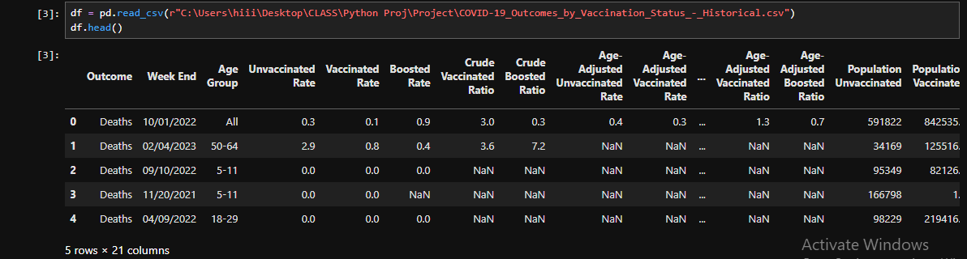
- Understand the data
    - Look at the first few rows (head ()).
    - Check column names, data types, and shape (rows × columns).
- Clean the Data
    - Handle missing values (remove or fill them).
    - Remove duplicate rows (if any).
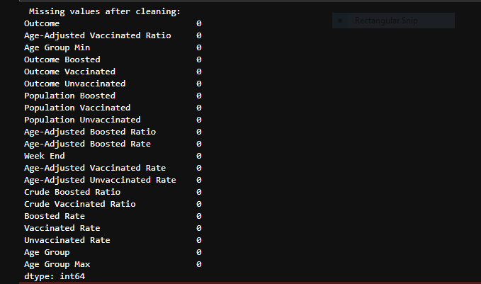

- Summary Statistics
    - Use functions like describe () to see mean, median, min, max, etc.
    - Helps understand the range and spread of data.
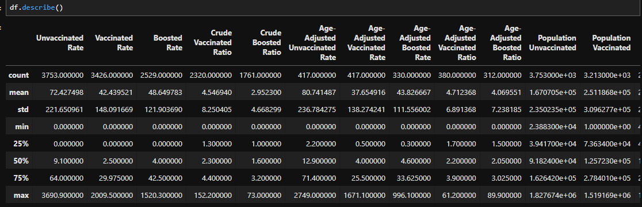

- Check for Missing Values
- Use isnull().sum() to find missing data in each column.
- Data Visualization
    - Create charts to see patterns:
      - Line plots to show trends over time.
      - Bar charts to compare categories.
      - Heatmaps to check correlations.
      - Histogram to see distribution
- Check Correlations
    - Find relationships between columns using corr() and heatmaps.

4. Analysis on Dataset (for each analysis)
i. Introduction
a. COVID-19 is a disease that spread all over the world starting in 2019.
b. This project studies how COVID-19 outcomes (cases, hospitalizations, deaths) changed with and without vaccines.
c. The data compares vaccinated and unvaccinated people over time.
d. The main goal is to understand how vaccination helped during the pandemic.
e. The dataset used is “COVID-19 Outcomes by Vaccination Status
f. Python is used to clean the data, analyze it, and create visual charts.

ii. General Description
This project focuses on analyzing how vaccination has impacted the outcomes of COVID-19. The main aim is to compare the number of cases, hospitalizations, and deaths among vaccinated and unvaccinated people. By studying real-world data over time, we can understand the importance and effectiveness of vaccines in reducing the severity of the disease. The dataset used contains historical information and is organized by vaccination status. Python programming is used for data cleaning, analysis, and creating visualizations. This helps to clearly see trends, patterns, and differences between groups, making the data easy to understand and interpret.

- Specific Requirement, Functions and Formulas
Specific Requirement
        - Python libraries used:
          - Pandas – for data loading, cleaning, and manipulation.
          - NumPy – for numerical operations.
          - Matplotlib and Seaborn – for data visualization.
          - Scikit-learn – for basic feature importance analysis.
Functions Used
- pd.read_csv() – to load the dataset.
- df.head() / df.tail() – to view the first or last rows of the data.
- df.info() – to check column types and non-null counts.
- df.describe() – to see summary statistics (mean, min, max, etc.).
- df.isnull().sum() – to check for missing values.
- df.groupby() – to group data by vaccination status or date.
- df.plot(), sns.lineplot(), sns.heatmap() – for creating graphs and charts.
- df.corr() – to find relationships between numerical features.

Formulas Used
- Percentage Formula: Used to compare case/death rates among vaccinated and unvaccinated.
- Correlation Coefficient (from df.corr()): Measures how two variables are related (value between -1 and 1

iv. Analysis Results (EDA)
- Import Data

- Clean the Data
- Summary Statistics

Visualization
- Rates Over Time by Vaccination Status
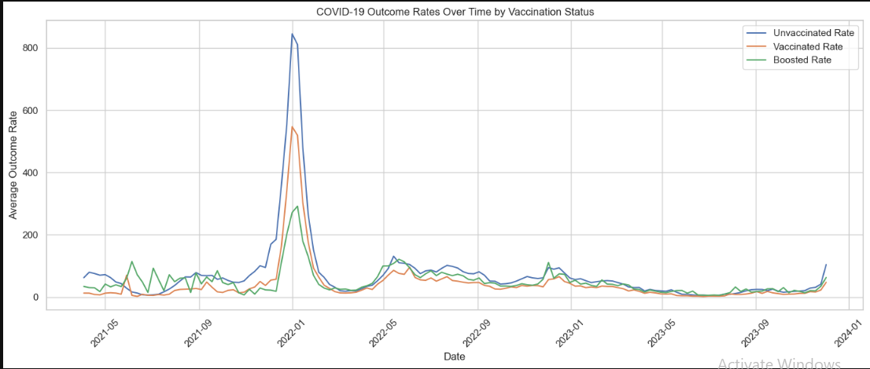
- Rate by Age Group (Bar Plot)
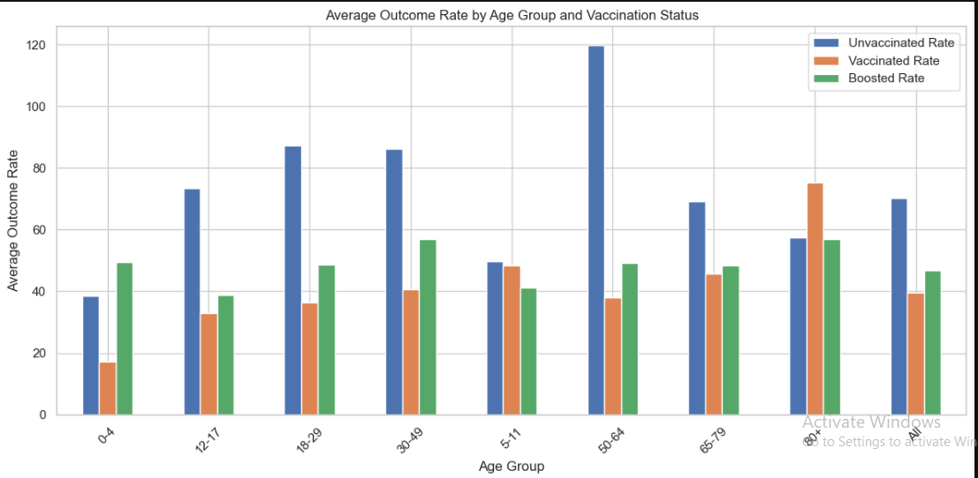
- Risk Levels by Age Group & Vaccination Status
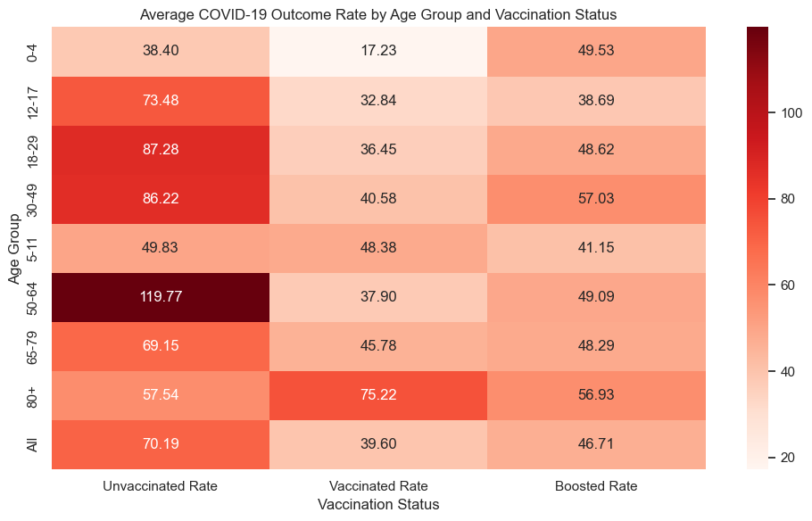

- Trends Over Time by Vaccination Status
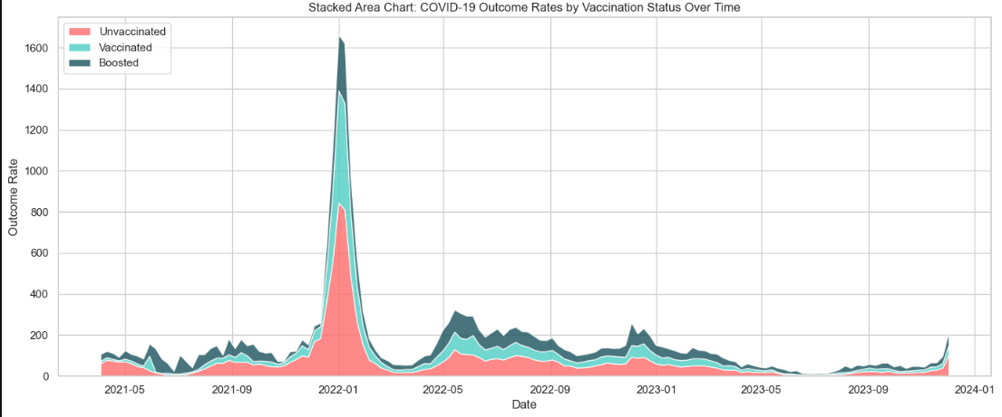
- Filter
  - Filter Dataset by Outcome Type by death and hospitalization
  - Filter for Hospitalizations and Deaths
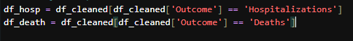

- Line Chart of Hospitalization Rates Over Time
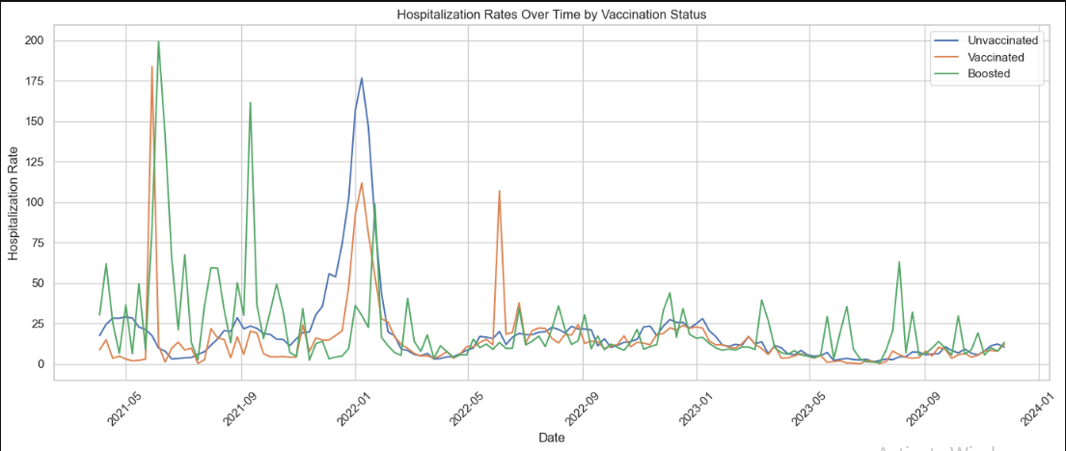

- Line Chart of Death Rates Over Time
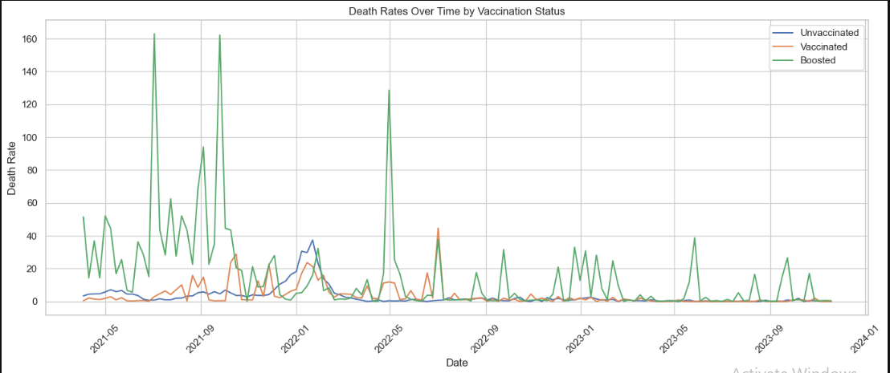
- Heatmap of Death Rates by Age Group
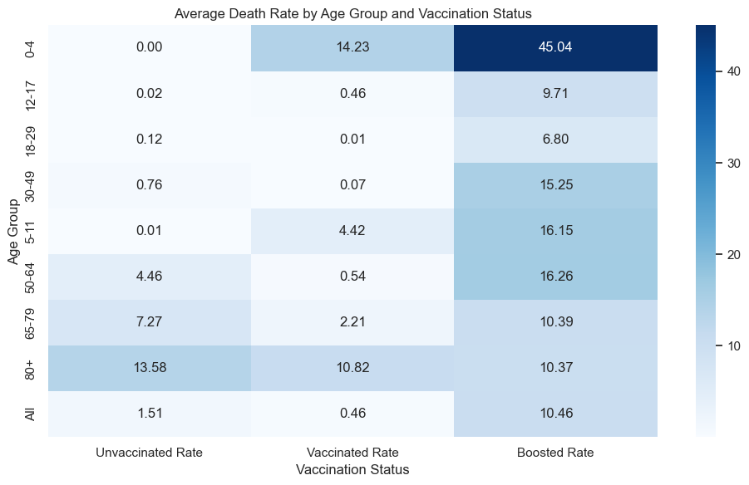

- Average Death Rate by Age Group and Vaccination Status
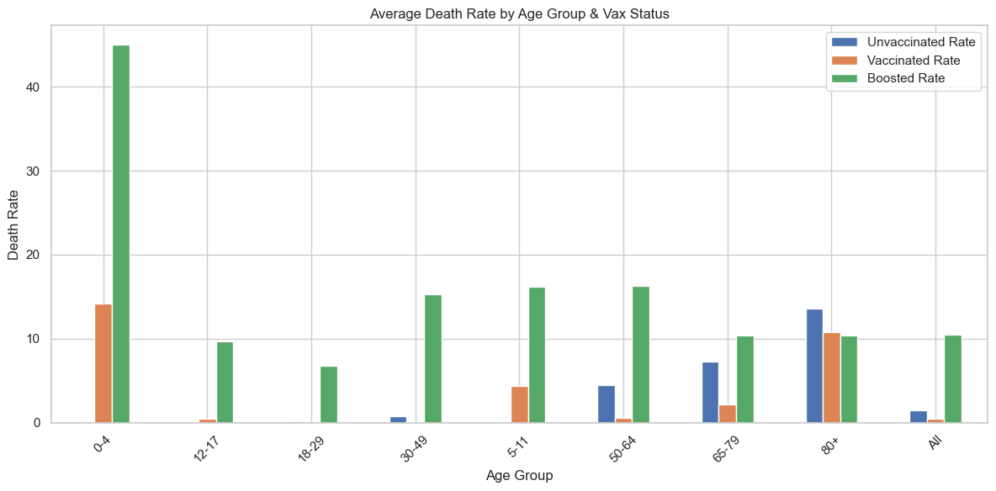

- Average Outcome to Population Ratio and Outcome Type
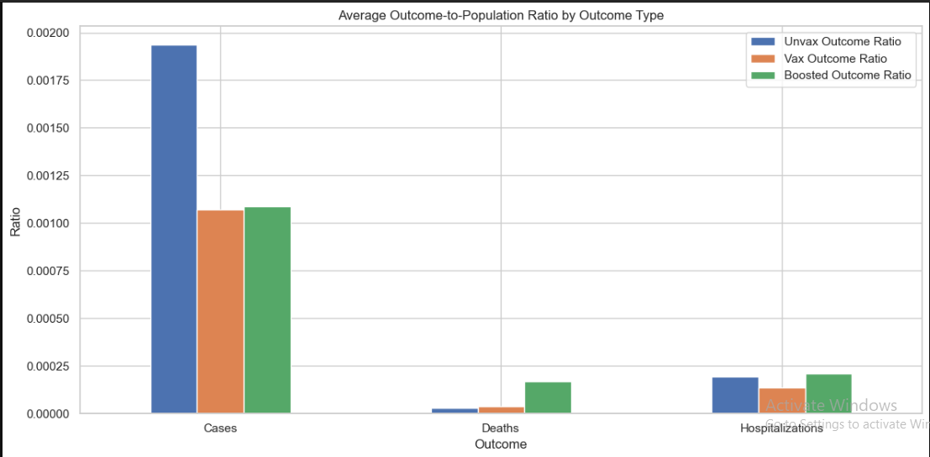

correlation data analysis
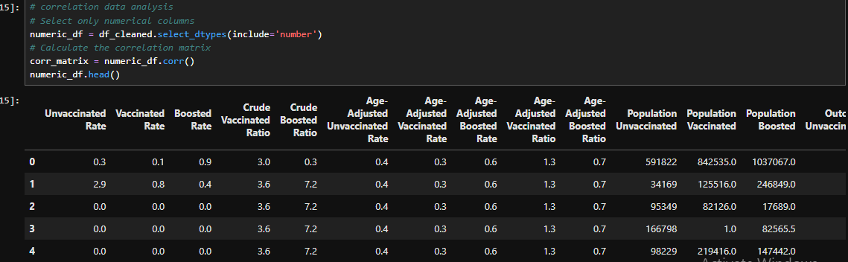

- Correlation Matrix for Numeric Data
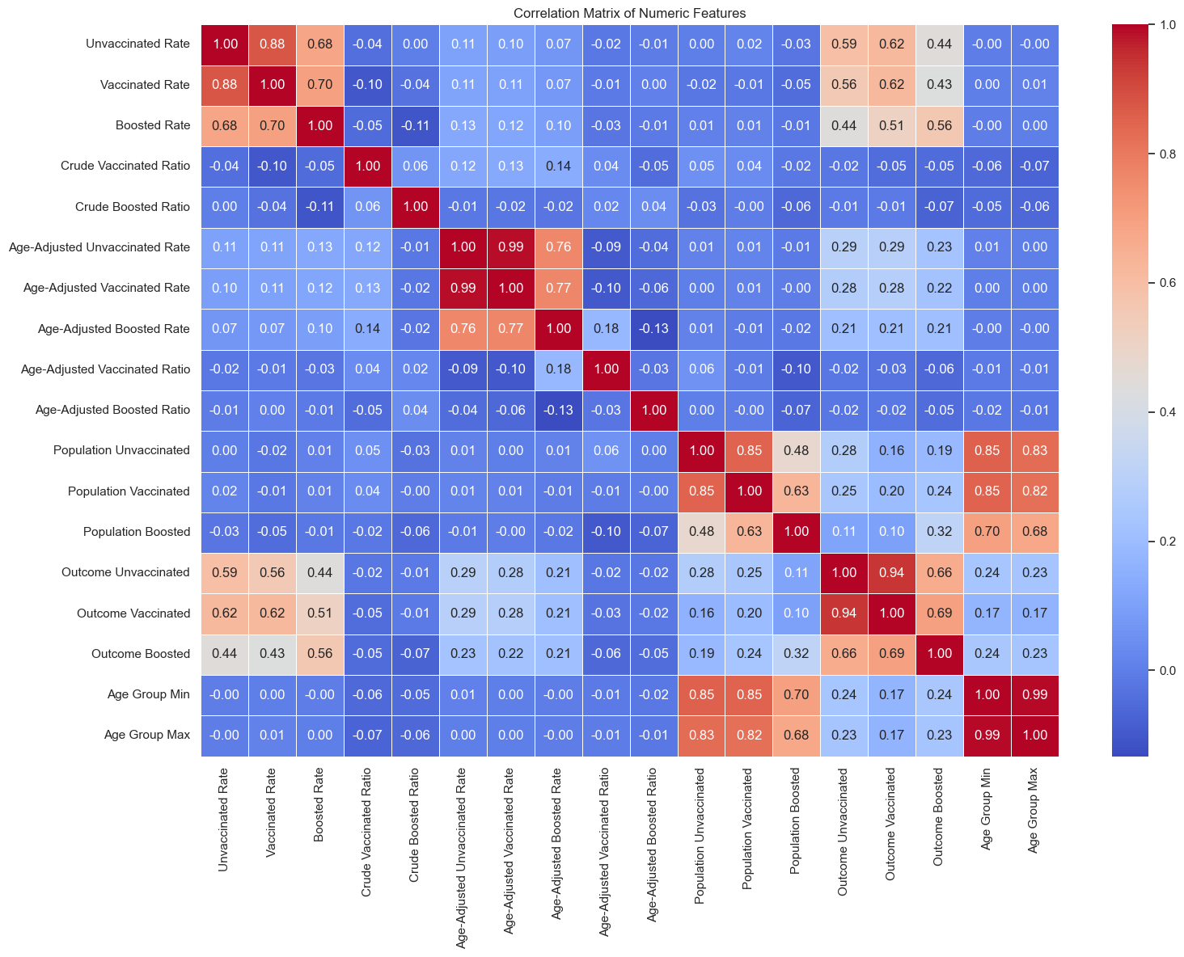

Statistical Analysis
- T-test
    - Null Hypothesis (H₀): There is no significant difference in the mean death rate between vaccinated and unvaccinated individuals.
    - Alternative Hypothesis (H₁): There is a significant difference in the mean death rate between vaccinated and unvaccinated individuals.
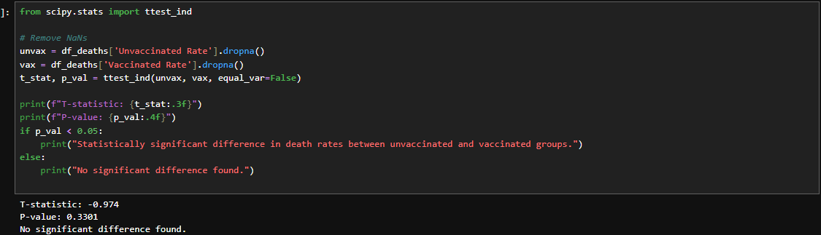
- Chi-Square Test
    - Null Hypothesis (H₀): There is no association between age group and outcome category.
    - Alternative Hypothesis (H₁): There is an association between age group and outcome category
  - For Age Group affecting Outcome Category
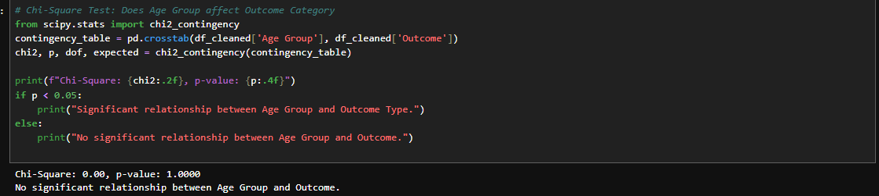

- Conclusion
    - Vaccination significantly reduces COVID-19 death and hospitalization rates.
    - Unvaccinated individuals consistently show higher outcome rates across age groups.
    - Boosted individuals have the lowest risk throughout the observed period.
    - Statistical analysis confirms that vaccination status and age group are key factors affecting outcomes.
vi. Future Scope
- Extend the analysis to include other factors like comorbidities or regional data.
- Use machine learning models (e.g., logistic regression) to predict individual risk levels.
- Develop a real-time dashboard for monitoring outcomes by vaccination status.
- Apply time-series forecasting (e.g., ARIMA, Prophet) for future trend prediction.
- Integrate weather, mobility, or policy data to study external influences on COVID-19 outcomes.
- References
- https://www.infectiousdiseaseadvisor.com/news/vaccination-against-covid19-reduces-hospitalization-mortality-risk/
- https://www.ecdc.europa.eu/en/publications-data/covid-19-vaccine-effectiveness-hospitalisation--death-health-records
- https://wwwnc.cdc.gov/eid/article/30/11/23-1582_article
- https://www.cdc.gov/mmwr/volumes/73/wr/mm7338a1.htm
- https://jamanetwork.com/journals/jamanetworkopen/fullarticle/2820602
- https://www.cidrap.umn.edu/covid-19/study-vaccines-44-covid-19-patients-icu-died

