Backup Procedure for Map Scanning Project

1. Connect to Server

Use Remote Desktop Connection to connect to the server at cartogram.fw.tamucc.edu.

Username is CARTOGRAM\yourusername. Your password and username are not your TAMUCC login credentials.

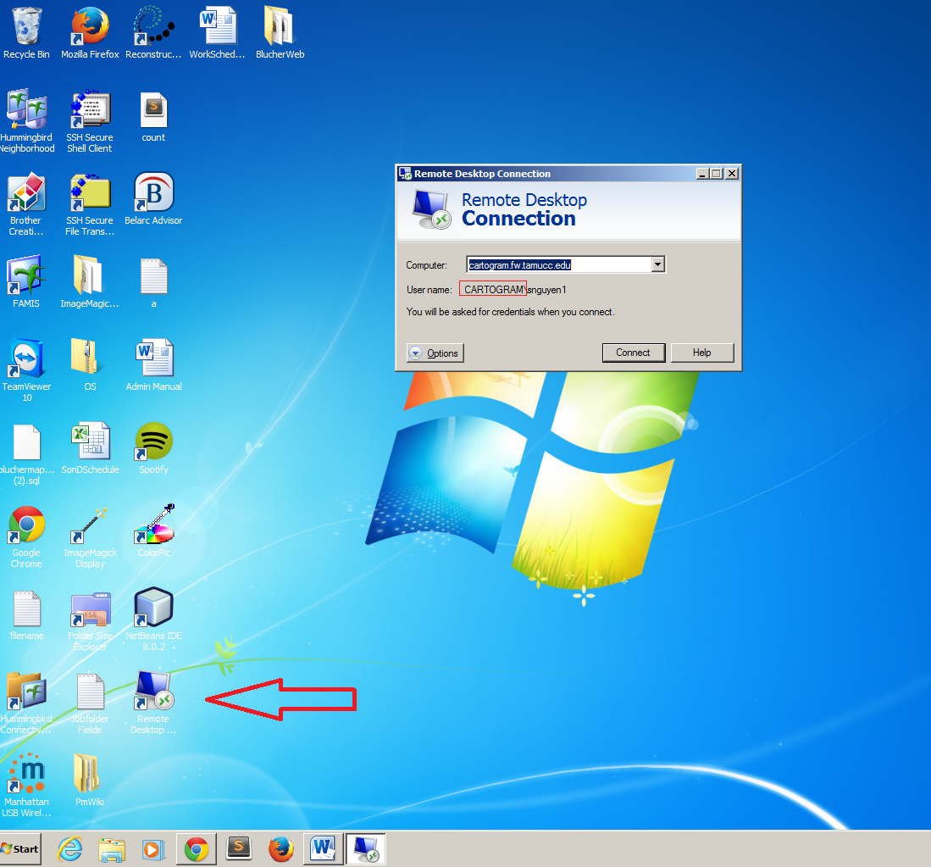

2. Connect Backup Hard Drive to the Computer

a. Connect HDE named Backup2 to the computer.

b. There are two folders: ServerBackup & MapsBackup. ServerBackup stores database backup (.sql files), .php files and thumbnails folders. MapsBackup stores .tiff image files of Blucher Map, Green map and Job Folder.

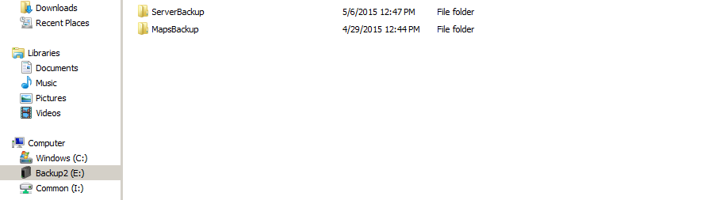

3. Backup php files & thumbnails

a. Go to “ServerBackup” on Backup2. Create a folder named ServerBackupMMDDYY (MMDDYY is today date)

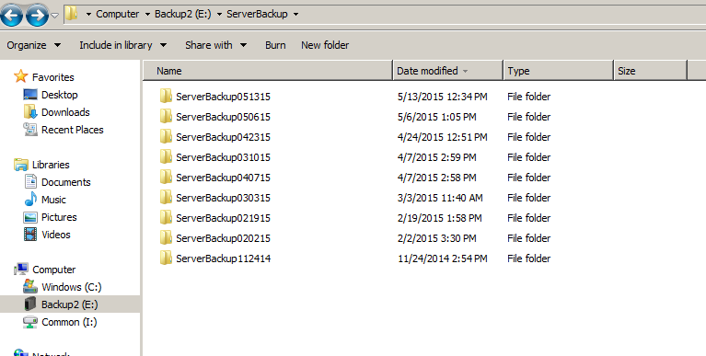

b. Copy folders “BlucherScanning”, “GreenCollection”, ”MapsDB” & “JobsFolder” from D:\BlucherMaps\xampp\htdocs\ in Cartogram server to folder ServerBackupMMDDYY in the Backup2

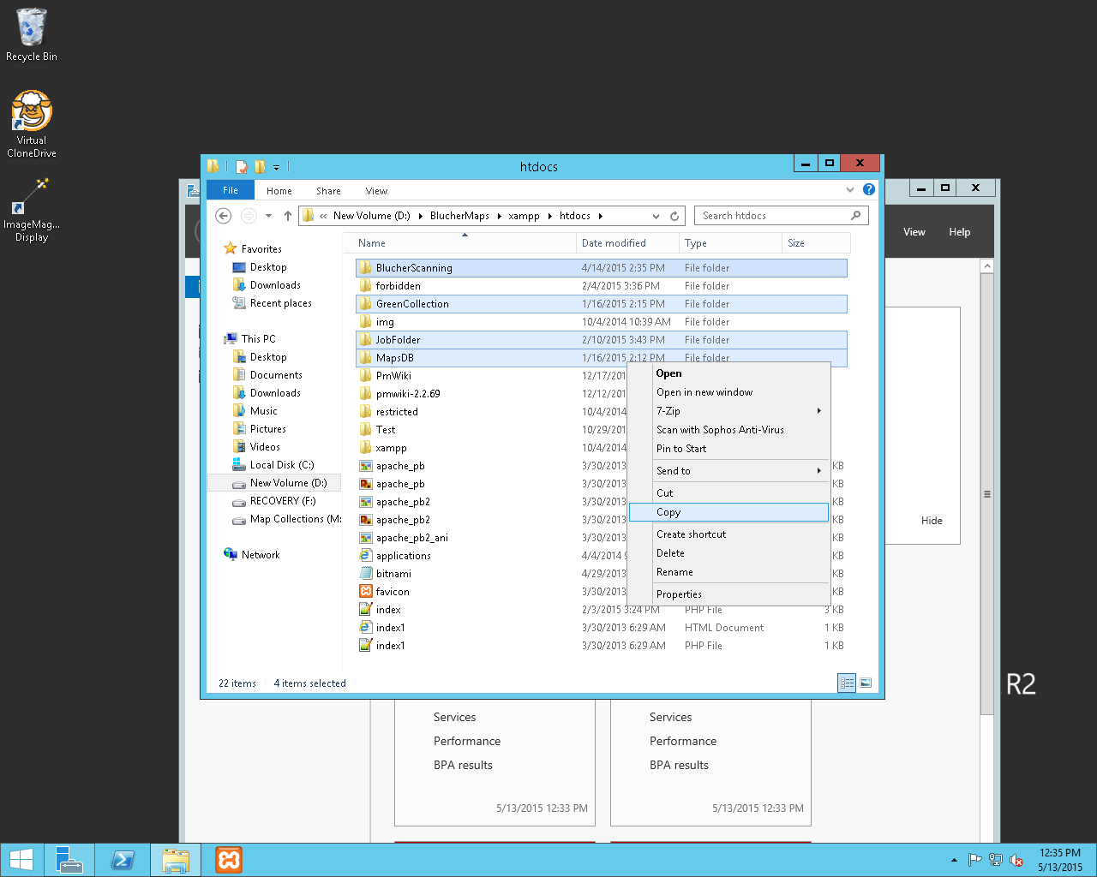

4. Backup Database

a. Open XAMPP Control Panel on Cartogram server

b. On MySQL , choose Admin to go to phpMyAdmin

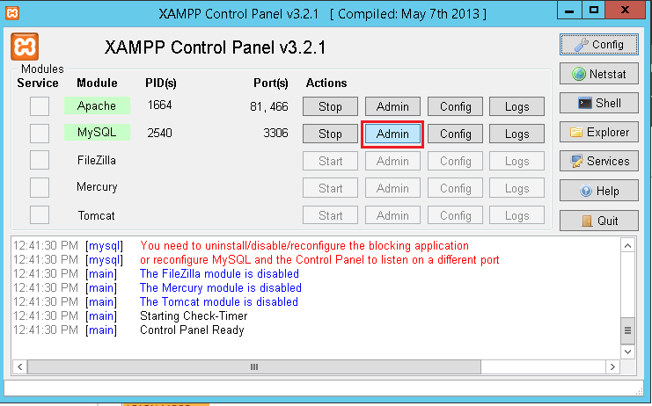

c. Login with using server username and password (HINT: root)

d. On the left panel, choose “bluchermapsinventory”, choose export on the navigation bar, choose “Go” and save the .sql file to the hard drive.

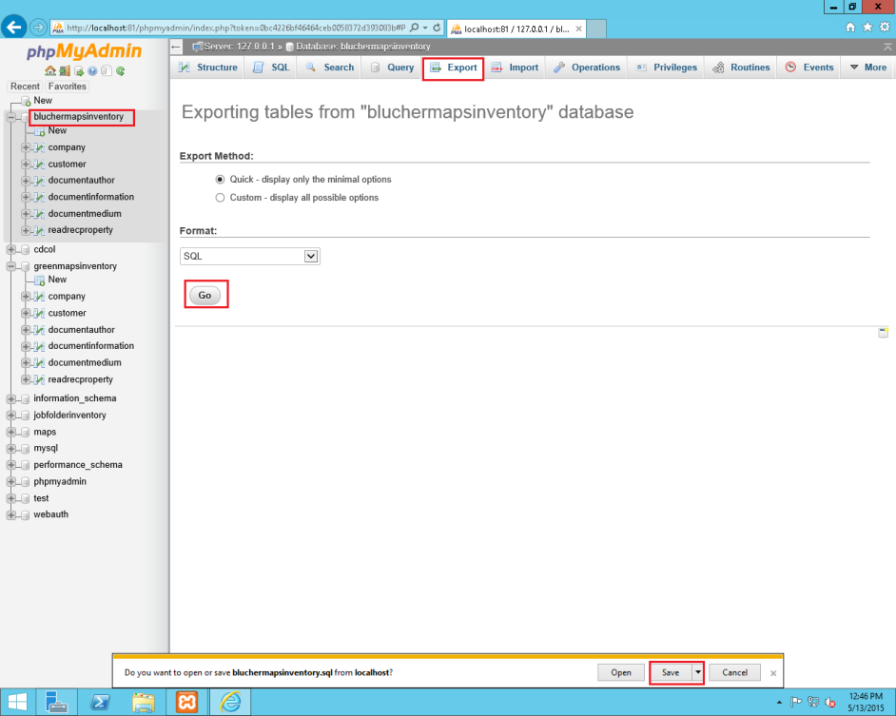

e. Repeat step d for “greenmapsinventory”, “jobfolderinventory” and “maps”

f. Copy all 4 .sql files to folder ServerBackupMMDDYY on the Backup2

5. Backup Images

There are 3 collections at the moment: BlucherCollection, GreenCollection & JobFolder. Image files are stored in M drive (Map Collections) on Cartogram server.

a. Go to the “BlucherCollection/uploads” folder on Cartogram server. Select and copy all map folders.

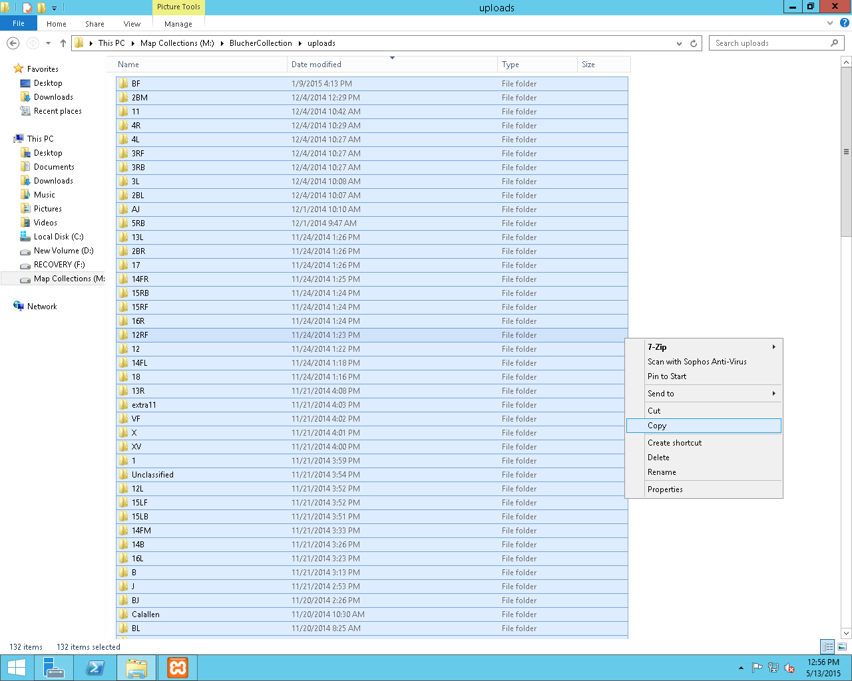

b. Go to the “MapsBackup/Blucher Maps” folder on Backup2

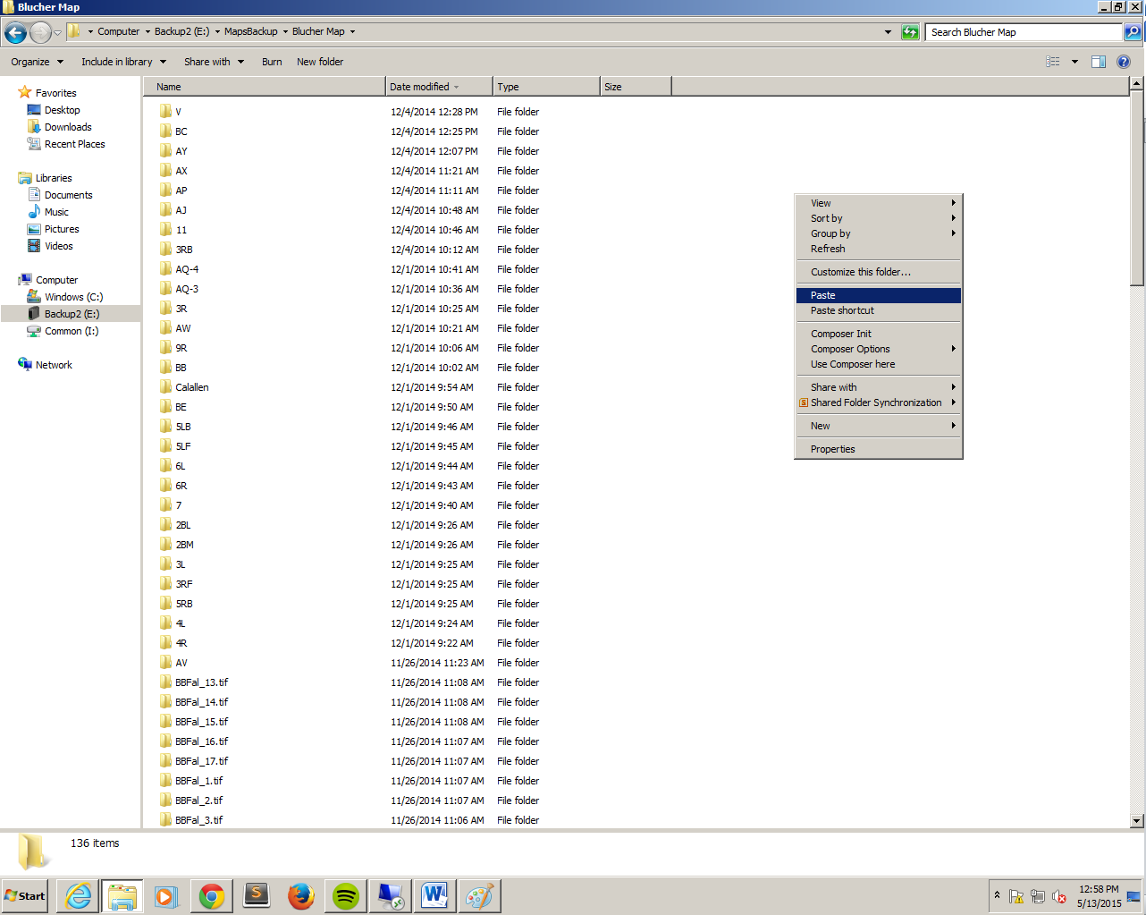

c. Copy all map folders from cartogram server to Backup2. If a message asking for

Overwrite the existing folders appears, click No.

d. Repeat steps a-c for GreenCollection & JobFolder

6. Disconnect from Server

a. Once the backup process is completed, unplug the Backup2 and leave it in the backup drawer.

b. On cartogram server, click to the Window button on bottom-left of the desktop to go to the Start screen. Click to your username and choose “Sign out”.

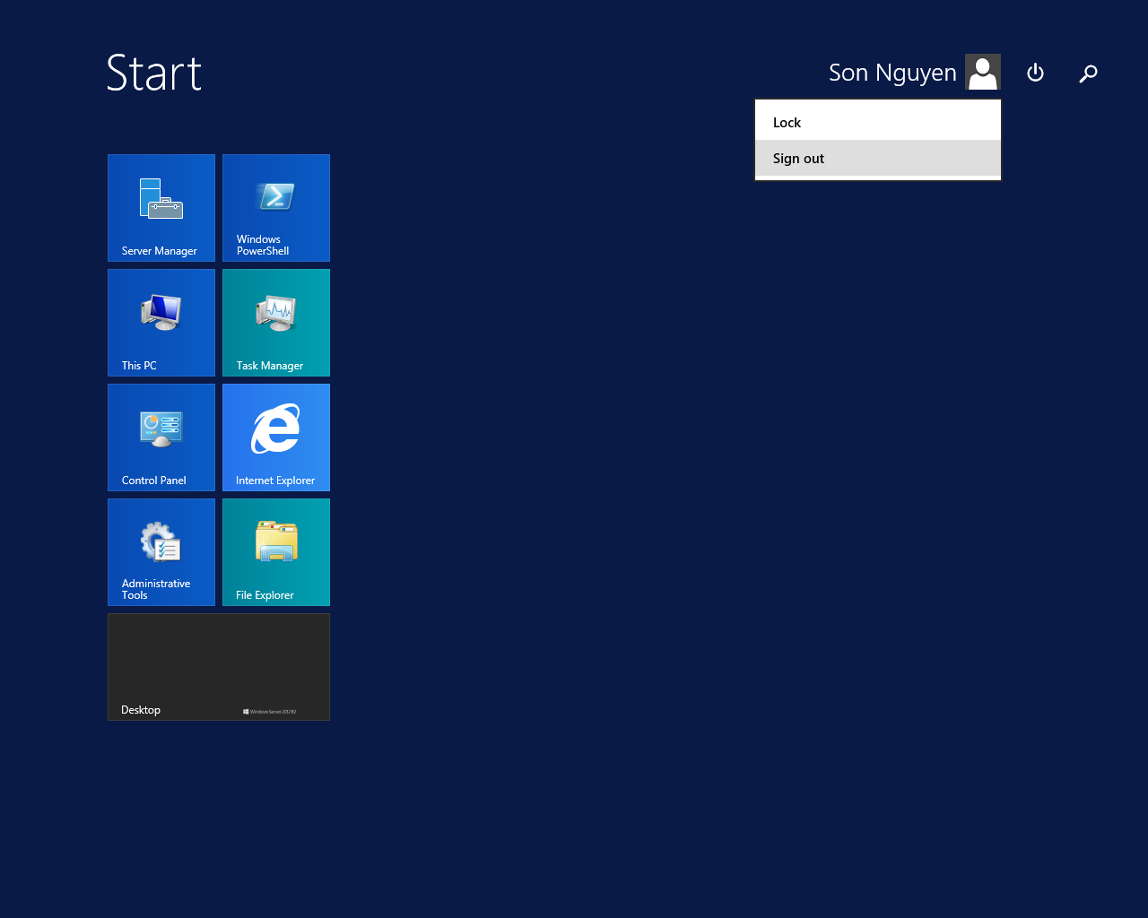

\*Note:

+ Never shutdown cartogram server and XAMPP on cartogram server.

+ Backup process should be done every week.

+ If the storage space available on the M drive on Cartogram server or the Backup2 hard drive is low (less than 20% of total space), notify the supervisor as soon as possible.