Assignment

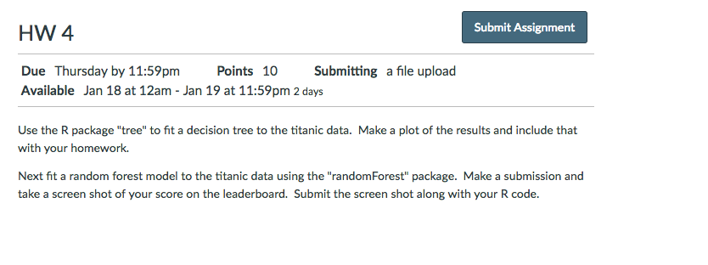

Code

<https://github.com/conradbm/data_science/blob/master/titanic_dataset/hw4/hw4_bmconrad.R>

Results

*On next page.*

