IMSE 884 Exam 1

Name _______________________________

By signing below, I state that

I have neither given nor received any help on this exam. You can look for any sources on the internet or in the book. The mere act of contacting a person, company or website (other than the teacher) who typically helps answer questions is cheating. Regardless of whether or not the person actually helps you. Furthermore, I agree not to provide any form of assistance to any individual who has not completed this exam.

Signature ________________________________

Bonus question 2 pts. Which two people are credited with developing branch and bound? ______________________________

1. Short answer

- Suppose that a polyhedron is defined by {xєR²: x₁-x₂=1} (notice that x_{i} can be negative. Provide all facet defining inequalities of this polyhedron. (5 pts)

b I am so missing sports. I started thinking about basketball. So what are all of the facet defining inequalities of a basketball. That is, in ℜ³ classify any and all facets of the sphere given by the equation x₁²+ x₂²+ x₃²≤36. (Notice that this is a continuous space and not just the convex hull of a bunch of integer points.) (5 pts) You could just describe the facets in words as opposed to equations.

c.. Given the following IP

Max 7x₁+2x₂+8x₃ -x₄+62x₅+4x₆
s.t. 8x₁+6x₂+5x₃ +4x₄+3x₅+x₆ ≤ 12
3x₁+7x₂+4x₃ +x₄+2x₅+x₆ ≤ 10
4x₁+2x₂+4x₃ +2x₄+3x₅ ≤ 7
x₁, x₂, x₃ ≥0 and bin

Find a clique inequality and prove that the clique inequality removes a relaxation point. The clique must have at least 3 nodes in the conflict graph. (5 pts)

D. Given the knapsack problem, let {3,5,7,8} be a cover. Use exact lifting to lift x₂ into the cover inequality. (5 pts)

35x₁+25x₂+16x₃ +15x₄ +12x₅+11x₆+9x₇ +7 x₈ ≤ 38
x_{i} ∈B⁸

2. Solve the following problem by branch and bound, using depth first right and if two variables are fractional, choose to branch on x₁ (20 pts) Please label the nodes for the order and the reason for fathoming (fathom by node number 2).

Max 4x₁+3x₂

subject to 3x₁+ 2x₂ ≤ 11
2x₁+ 4x₂ ≤15
x₁, x₂ ≥0 and integer.

2b 5 pts. In an effort to derive a new branching structure, suppose that I chose to branch on some bizarre inequality. Suppose that I want the branching structure to always be x₁+x₂-3x₃+x₄ with one branch to be <= and the other branch to have a >=. If my current linear relaxation is (.1, .3, 2, .1) what would my two branches be?

3. Use cuts to solve the following IP. Please add these cuts one at a time and resolve and show the next LR until an integer solution is reached. Show that at least one of these cuts is facet defining. (20 pts)

Max 4x₁+3x₂

subject to 3x₁+ 2x₂ ≤ 11
2x₁+ 4x₂ ≤15
x₁, x₂ ≥0 and integer.

4. Given a graph, consider the node packing polytope.

a. Write an IP formulation to the above problem. (3 pts)

b. (17 total pts) A wheel W_{m}, is a graph with m+1 nodes where the nodes 2, 3,..., m+1 form a hole and the there exist edges {1,2}, {1,3}, ..., {1,m+1}. A picture of a W₅ is given below. A big wheel is created by expanding the center node (hub) into a clique. An example of a 3 big wheel (W_{3,5}) is given below. (Not quite as fun as my old big wheeler I use to drive around the neighborhood.) Assume that in some graph, there exists an induced subgraph that forms a big wheel of the form W_{p,q}. The hub vertices are v₁ to v_{p} and the exterior vertices are v_{p+1} to v_{p+q}. Using this structure as a basis, find a valid inequality 5pts, then argue that it is a facet defining inequality for the integer polyhedron in part a 8 pts. You may make any additional assumptions as necessary. (4 pts) for making as few assumptions as possible.)

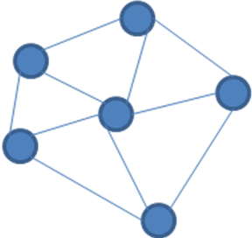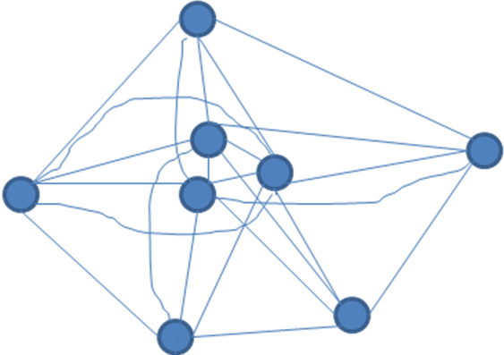
A W₅ A W_{3,5}

