1. My 50 random samples for $X \sim Ber(p=0.2)$ resulted in:

* Number of 0’s: 42
* Number of 1’s: 8

1. Proportion $\hat{p}=8/{42}=0.1904762 ≅0.2$
2. Considering our sample size being 50, we know that after the sample size exceeds 30 our samples start to center around the true mean. Considering we know the true probability is 0.2, which we gave it initially, we can see that this is a true statement. Our probability looks to be centering around ~0.2. So yes, this seems like a reasonable in approximating $\hat{p}$ because of the Central Limit Theorem.
3. Assuming we forget that 0.2 was our true mean or probability center, and we guessed it as 0.4, we can begin to verify this with the application described in part b. After doing simulation for part (b) we get the result of the following image:

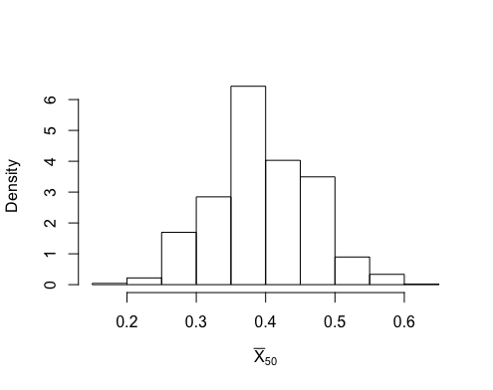

* 4b. We can see our ${\hat{p}}^{*}$ is in an extreme region, so we should not adopt our guess as 0.4. So by calculate the probability that ${\hat{p}}_{50}< \hat{p}$ through the frequency of $k=\{1,2,…N=10,000\}$ in R, we get the probability as **0.0004**.

1. Considering the sum of Bernoulli random variables is a binomial. We can calculate the probability in terms of the binomial distribution as well, this will only change random variable X because we had 50 Bernoulli trails, so X*50 is what we calculate. The following calculator function returns something similar to what we found in 4b: $binomcdf (N=50, p=0.4, 0.19*50=9.5) = 0.0007$. Yes, we can figure out the exact probability because we now using a continuous distribution no longer a simulation as in 4b, however the results are strikingly similar.
2. We can also find a pure probability from our knowledge of the Central Limit Theorem. That said, if we know a binomial can be approximated to being normal, so: $normcdf \left(lb=-99,ub=0.19, μ=0.4,σ=\frac{\sqrt{0.4*0.6}}{\sqrt{50}}\right)=0.0012$. Which seems to be a little higher than our previous to results from 4b and 5.
3. By comparing p values obtained from 4b, 5, and 6 we see them as follows: **0.0004**, **0.0007**, and **0.0012**. We can see the binomial from 5 is pretty close to the simulation results in 4b, but our results from 6 seem to be a little high. This could be because we did not account for the continuity correction. So instead of our upper bound being at 9.5 as before, it should be at 9.0. With the following we can account for this correct, because we went from discrete to continuous we must account for the -0.5 on our lower bound check. $normcdf(lb=-99,ub= 9,np=50*0.4,npq=\sqrt{50*0.4*0.6}=0.000748$. So now we can see that the normal is as good an approximation as the binomial was in 6, which is also very close to 5 and 4b. See *Figure 1* for R Code.

*Figure 1:*

R Code displayed for project 2.

