Solution for HW6

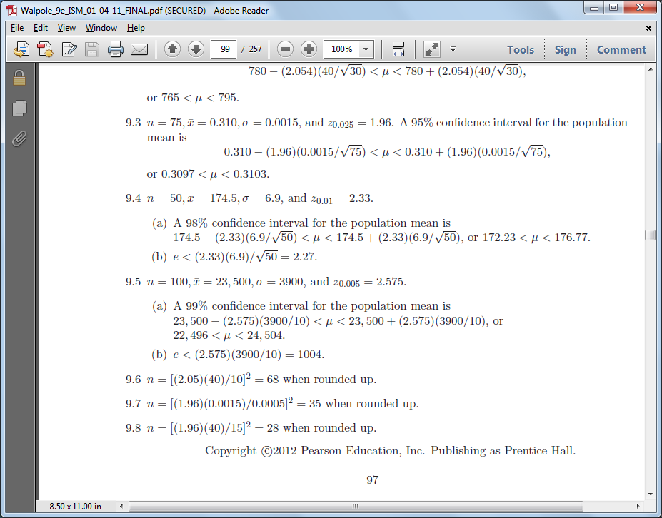



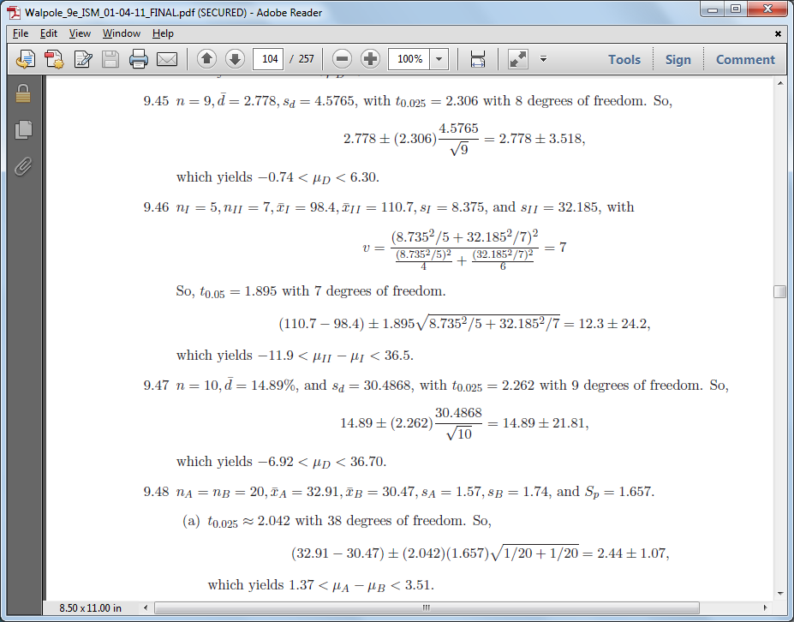



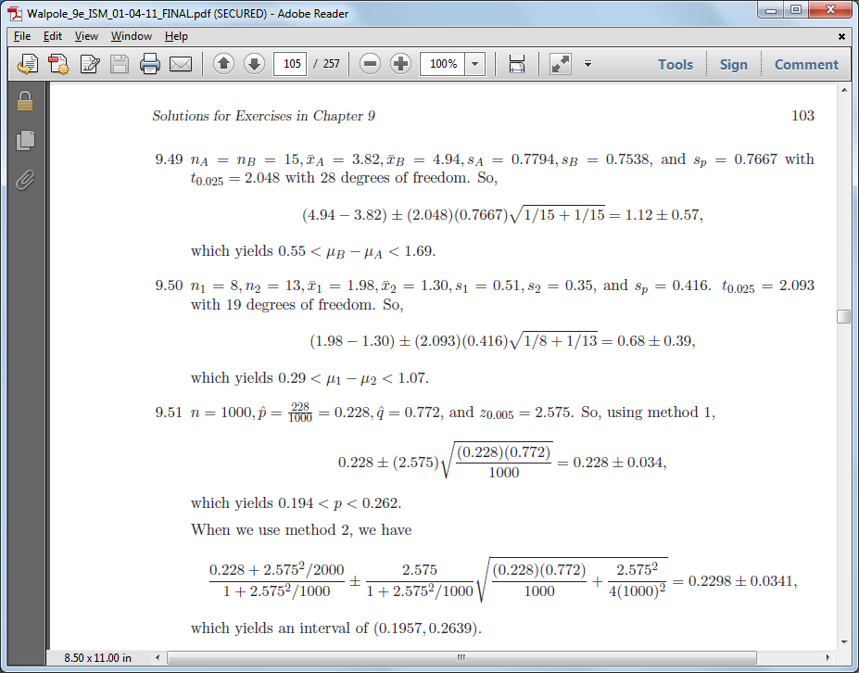

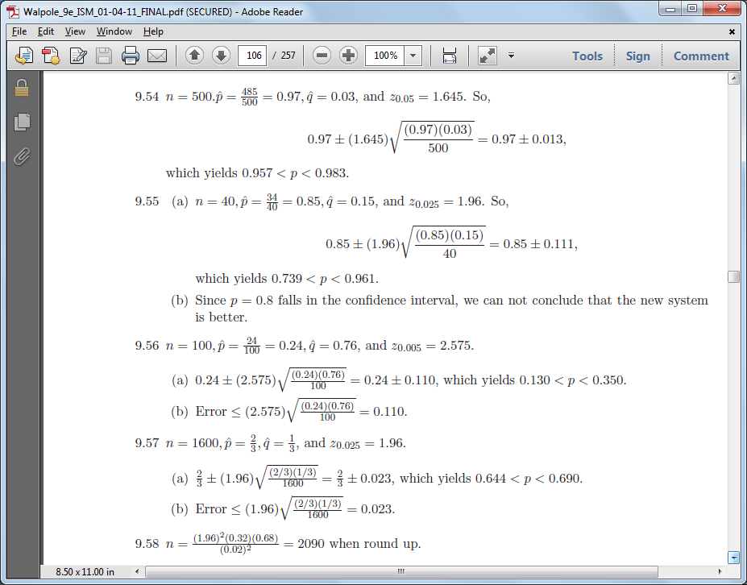



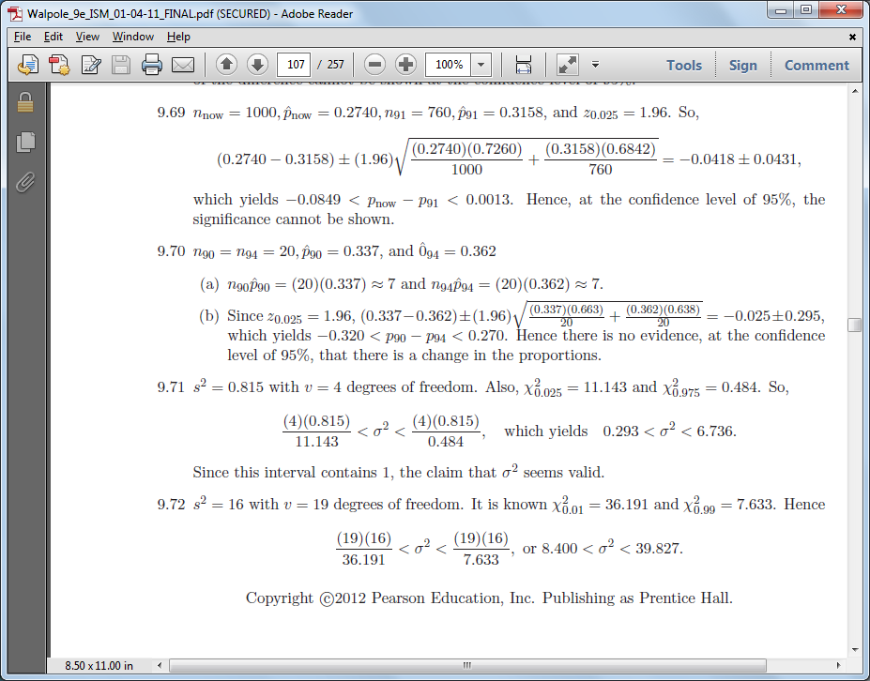

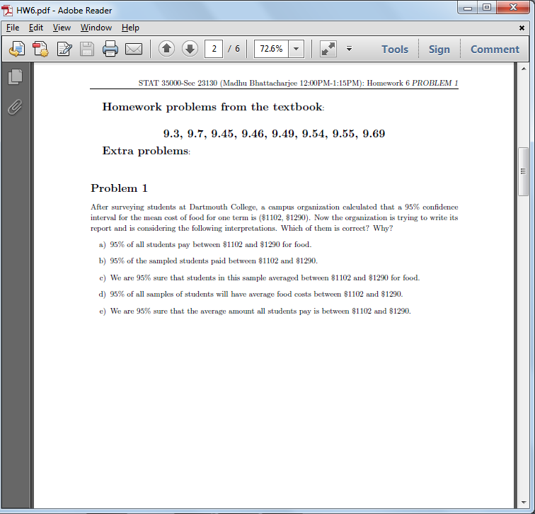

Ans:

a) Not correct. A confidence interval is not about the individuals in the population.

b) Not correct. A confidence interval is not about the individuals in the sample.

c) Not correct. In fact we know the mean cost for students in the sample was $1196 (i.e. (1102+1290)/2).

d) Not correct. A confidence interval is not about other sample means.

e) Correct. A confidence interval estimates the unknown value of a population parameter.

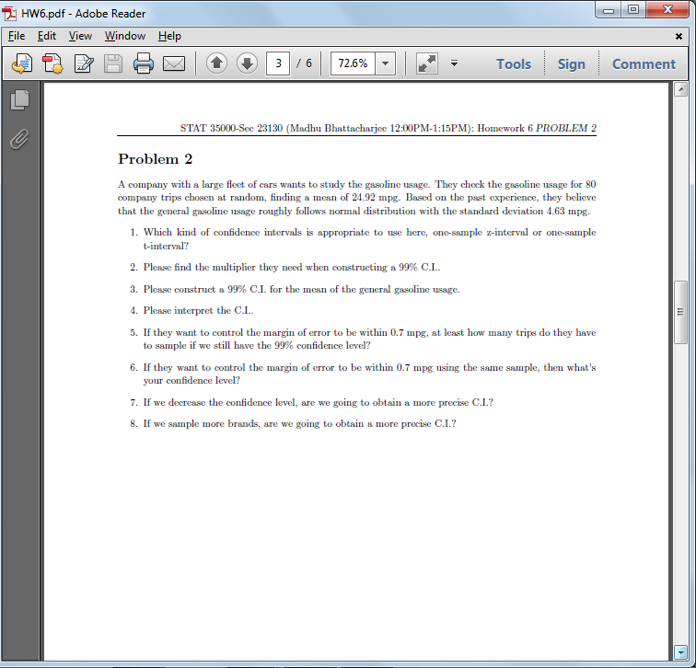

Ans:

1. Since based on their past experience they know the gasoline usage is Normal with known standard deviation 4.63 mpg it would be appropriate to use a z-interval.

2. What if they wanted to use a 99% confidence interval, then they would need the z values that separate the middle 99% from the outer 1%. There will be 1% split between the left and right tails. The z values that separate the middle 99% from the outer 1% are ±2.576.

3. The interval is given by , where , σ = 4.63, n = 80, and thus the CI is given by (23.59, 26.25).

4. Interpretation of the CI: If the company repeated this exercise of taking repeated samples and constructing the 99% confidence interval, then 99% of the intervals would contain the population mean mpg.

5. If they want to control the margin of error to be within 0.7, keeping 99% confidence level, then n should be such that . Therefore n > 291.

6. If they want to control the margin of error within 0.7 mpg using the same sample, then . Therefore and thus α = 0.17629 and confidence level is 0.82%.

7. By decreasing confidence level we would obtain a narrower interval but will do so with less confidence.

8. If we sample more trips then we would obtain a more precise CI since the length of the interval would decrease with increasing n.

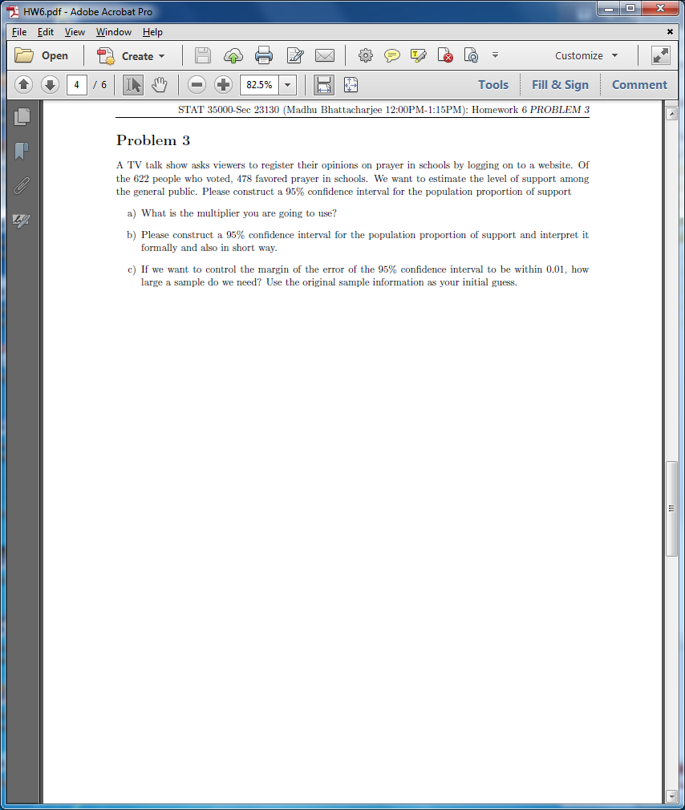

Ans:

1. Since n = 622 is large we could use normal approximation (BY CLT) for the proportion and the multiplier would be 1.956 (approximately).
2. = = (0.7353, 0.8016),
3. => n ≈ 6835

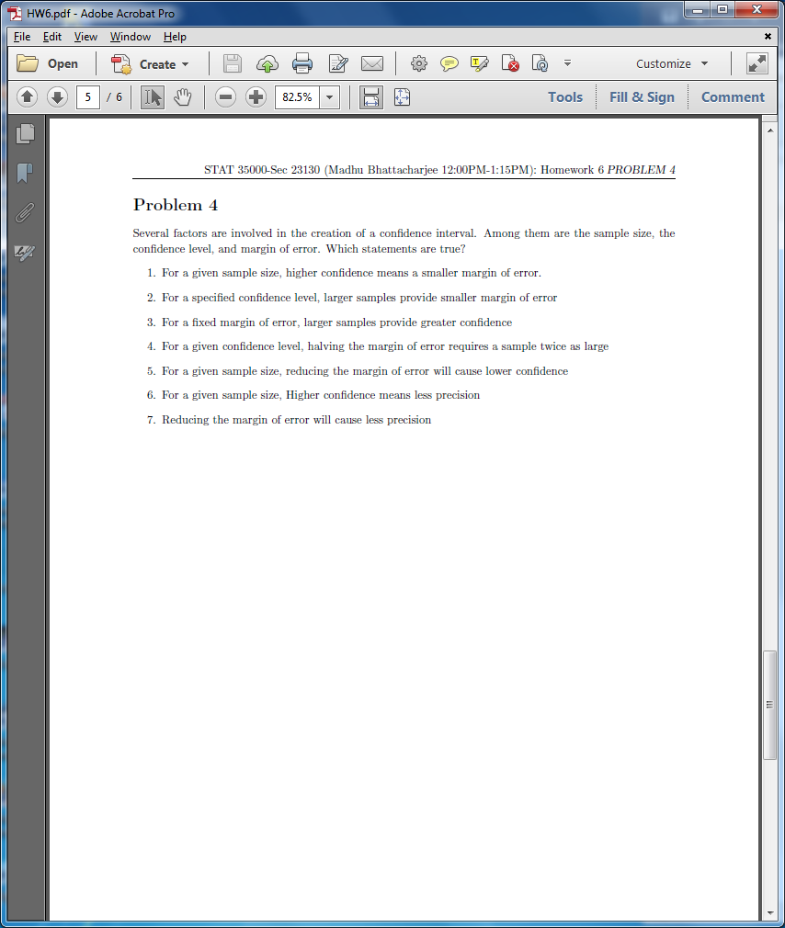

Ans

1. False
2. True
3. True
4. False
5. True
6. True
7. False

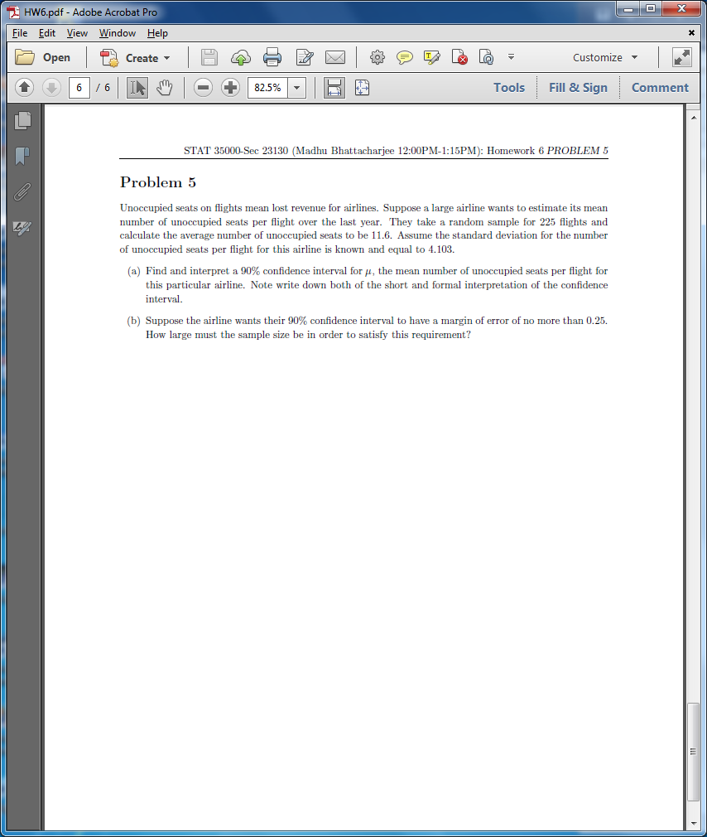

Ans:

n=225

1. For 90% confidence interval for µ, = 1.645 and = (11.15, 12.05 )
2. A 90% confidence interval will have multiplier 1.645. Thus if given that ME = 0.25,

=> => n ≈ 729.