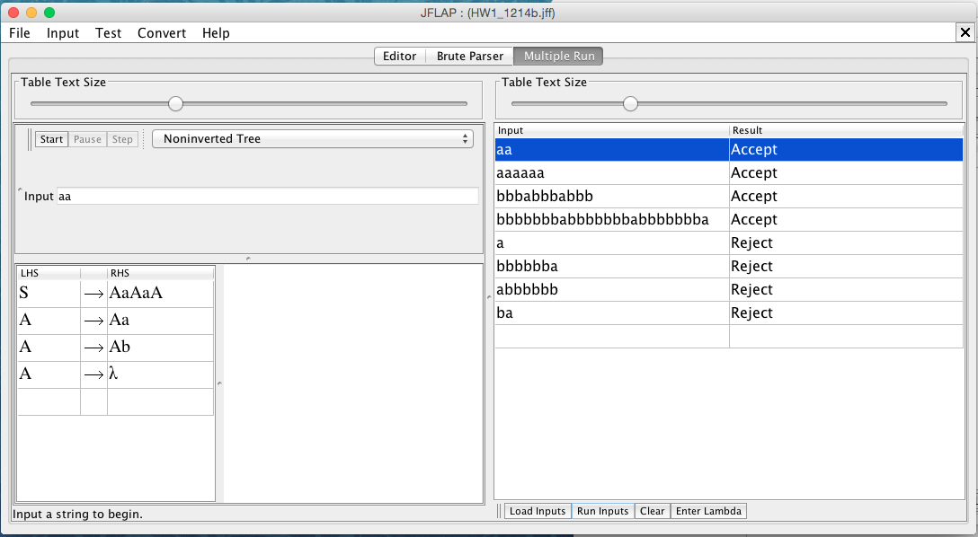

Test input (File included in the extras folder):

Correct:

* aa
* aaaaaa
* bbbabbbabbb
* bbbbbbbabbbbbbbabbbbbbba

Incorrect:

* a
* bbbbbba
* abbbbbb
* ba